INTERNATIONAL ORGANISATION FOR STANDARDISATION
ORGANISATION INTERNATIONALE DE NORMALISATION
ISO/IEC JTC1/SC29/WG11
CODING OF MOVING PICTURES AND AUDIO
ISO/IEC JTC1/SC29/WG11 N1902
Fribourg, Oct. 1997

INFORMATION TECHNOLOGY -
CODING OF AUDIO-VISUAL OBJECTS: VISUAL

ISO/IEC 14496-2
Committee Draft
Draft of 21 November, 1997

Contents
1. Introduction
1.1 Purpose
1.2 Application
1.3 Profiles and levels
1.4 Object based coding syntax
1.4.1 Video object
1.4.2 Face object
1.4.3 Mesh object
1.4.4 Overview of the object based nonscalable syntax
1.4.5 Generalized scalability
1.5 Error Resilience
1. Scope
2. Normative references
3. Definitions
4. Abbreviations and symbols
4.1 Arithmetic operators
4.2 Logical operators
4.3 Relational operators
4.4 Bitwise operators
4.5 Assignment
4.6 Mnemonics
4.7 Constants
5. Conventions
5.1 Method of describing bitstream syntax
5.2 Definition of functions
5.2.1 Definition of bytealigned() function
5.2.2 Definition of nextbits_bytealigned() function
5.2.3 Definition of next_start_code() function
5.2.4 Definition of next_resync_marker() function
5.2.5 Definition of transparent_mb() function
5.2.6 Definition of transparent_block() function
5.3 Reserved, forbidden and marker_bit
5.4 Arithmetic precision
6. Visual bitstream syntax and semantics
6.1 Structure of coded visual data
6.1.1 Visual object sequence
6.1.2 Visual object
6.1.3 Video object
6.1.4 Mesh object
6.1.5 Face object
6.2 Visual bitstream syntax
6.2.1 Start codes
6.2.2 Visual Object Sequence and Visual Object
6.2.3 Video Object
6.2.4 Video Object Layer
6.2.5 Group of Video Object Plane
6.2.6 Video Object Plane
6.2.7 Macroblock
6.2.8 Block
6.2.9 Still Texture Object
6.2.10 Mesh Object
6.2.11 Face Object
6.3 Visual bitstream semantics
6.3.1 Semantic rules for higher syntactic structures
6.3.2 Visual Object Sequence and Visual Object
6.3.3 Video Object
6.3.4 Video Object Layer
6.3.5 Group of Video Object Plane
6.3.6 Video Object Plane
6.3.7 Macroblock related
6.3.8 Block related
6.3.9 Still texture object
6.3.10 Mesh related
6.3.11 Face object
7. The visual decoding process
7.1 Video decoding process
7.2 Higher syntactic structures
7.3 Texture decoding
7.3.1 Variable length decoding
7.3.2 Inverse scan
7.3.3 Intra dc and ac prediction for intra macroblocks
7.3.4 Inverse quantisation
7.3.5 Inverse DCT
7.4 Shape decoding
7.4.1 Higher syntactic structures
7.4.2 Macroblock decoding
7.4.3 Arithmetic decoding
7.5 Motion compensation decoding
7.5.1 Padding process
7.5.2 Half sample interpolation
7.5.3 Motion vectors
7.5.4 Unrestricted motion compensation
7.5.5 Four MV motion compensation
7.5.6 Overlapped motion compensation
7.5.7 Temporal prediction structure
7.5.8 Vector decoding process of non-scalable progressive B-VOPs
7.5.9 Motion compensation in non-scalable progressive B-VOPs
7.6 Interlaced video decoding
7.6.1 Field DCT and DC and AC Prediction
7.6.2 Motion compensation
7.7 Error resilient decoding
7.8 Sprite decoding
7.8.1 Higher syntactic structures
7.8.2 Sprite Reconstruction
7.8.3 Low-latency sprite reconstruction
7.8.4 Sprite reference point decoding
7.8.5 Warping
7.8.6 Sample reconstruction
7.8.7 Scalable sprite decoding
7.9 Generalized scalable decoding
7.9.1 Temporal scalability
7.9.2 Spatial scalability
7.10 Still texture object decoding
7.10.1 Decoding of the DC subband
7.10.2 ZeroTree Decoding of the Higher Bands
7.10.3 Inverse Quantization
7.11 Mesh object decoding
7.11.1 Mesh geometry decoding
7.11.2 Decoding of mesh motion vectors
7.12 Face object decoding
7.12.1 Frame based face object decoding
7.12.2 DCT based face object decoding
7.12.3 Decoding of the viseme parameter fap 1
7.12.4 Decoding of the viseme parameter fap 2
7.12.5 Fap masking
7.13 Output of the decoding process
7.13.1 Video data
7.13.2 2D Mesh data
7.13.3 Face animation parameter data
8. Visual-Systems Composition Issues
8.1 Temporal Scalability Composition
8.2 Sprite Composition
9. Profiles and Levels
9.1 Object Profiles
9.1.1 Simple Video Object Profile
9.1.2 12-bit Video Object Profile
9.1.3 Main Profile (in progress)
10. Annex A
10.1 Discrete cosine transform for video texture
10.2 Discrete wavelet transform for still texture
10.2.1 Adding the mean
10.2.2 wavelet filter
10.2.3 Symmetric extension
10.2.4 Decomposition level
10.2.5 Shape adaptive wavelet filtering and symmetric extension
11. Annex B
11.1 Variable length codes
11.1.1 Macroblock type
11.1.2 Macroblock pattern
11.1.3 Motion vector
11.1.4 DCT coefficients
11.1.5 Shape Coding
11.1.6 Sprite Coding
11.1.7 DCT based facial object decoding
11.2 Arithmetic Decoding
11.2.1 Arithmetic decoding for shape decoding
11.2.2 Face Object Decoding
12. Annex C
13. Annex D
14. Annex E
14.1 Overview
14.2 Object based coding
14.3 Scalability
14.4 Error resilience
14.4.1 Resynchronization
14.4.2 Data Recovery
14.4.3 Error Concealment
14.4.4 Decoder Operation
14.5 Complexity Estimation
14.5.1 Video Object Layer Class
14.5.2 Video Object Plane Class
14.5.3 Video Object Plane
15. Annex F
15.1 Segmentation for VOP Generation
15.1.1 Introduction
15.1.2 Description of a combined temporal and spatial segmentation framework
15.1.3 References
15.2 VOP Formation
15.3 Postprocessing for Coding Noise Reduction
15.3.1 Deblocking filter
15.3.2 Deringing filter
15.3.3 Further issues
16. Annex G
17. Annex H
18. Annex I
19. Annex J

Foreword
(Foreword to be provided by ISO)

Introduction

Purpose
This Part of this specification was developed in response to the growing need for a coding method that can facilitate access to visual objects in natural and synthetic moving pictures and associated natural or synthetic sound for various applications such as digital storage media, internet, various forms of wired or wireless communication etc. The use of this specification means that motion video can be manipulated as a form of computer data and can be stored on various storage media, transmitted and received over existing and future networks and distributed on existing and future broadcast channels.

Application
The applications of this specification cover, but are not limited to, such areas as listed below:
IMM Internet Multimedia
IVG Interactive Video Games
IPC Interpersonal Communications (videoconferencing, videophone, etc.)
ISM Interactive Storage Media (optical disks, etc.)
MMM Multimedia Mailing
NDB Networked Database Services (via ATM, etc.)
RES Remote Emergency Systems
RVS Remote Video Surveillance
WMM Wireless Multimedia

Profiles and levels
This specification is intended to be generic in the sense that it serves a wide range of applications, bitrates, resolutions, qualities and services. Furthermore, it allows a number of modes of coding of both natural and synthetic video in a manner facilitating access to individual objects in images or video, referred to as content based access. Applications should cover, among other things, digital storage media, content based image and video databases, internet video, interpersonal video communications, wireless video etc. In the course of creating this specification, various requirements from typical applications have been considered, necessary algorithmic elements have been developed, and they have been integrated into a single syntax. Hence this specification will facilitate the bitstream interchange among different applications.
This specification includes one or more complete decoding algorithms as well as a set of decoding tools. Moreover, the various tools of this specification as well as that derived from ISO/IEC 13818-2 can be combined to form other decoding algorithms. Considering the practicality of implementing the full syntax of this specification, however, a limited number of subsets of the syntax are also stipulated by means of ÒprofileÓ and ÒlevelÓ.
A ÒprofileÓ is a defined subset of the entire bitstream syntax that is defined by this specification. Within the bounds imposed by the syntax of a given profile it is still possible to require a very large variation in the performance of encoders and decoders depending upon the values taken by parameters in the bitstream.
In order to deal with this problem ÒlevelsÓ are defined within each profile. A level is a defined set of constraints imposed on parameters in the bitstream. These constraints may be simple limits on numbers. Alternatively they may take the form of constraints on arithmetic combinations of the parameters.

Object based coding syntax

Video object
A video object in a scene is an entity that a user is allowed to access (seek, browse) and manipulate (cut and paste). The instances of video objects at a given time are called video object planes (vops). The encoding process generates a coded representation of a vop as well as composition information necessary for display. Further, at the decoder, a user may interact with and modify the composition process as needed.
The full syntax allows coding of individual video objects in a scene as well as the traditional picture based coding., which can be thought of as a single rectangular object. Furthermore, the syntax supports both nonscalable coding and scalable coding. Thus it becomes possible to handle normal scalabilities as well as object based scalabilities. The scalability syntax enables the reconstruction of useful video from pieces of a total bitstream. This is achieved by structuring the total bitstream in two or more layers, starting from a standalone base layer and adding a number of enhancement layers. The base layer can use the non-scalable syntax and can be coded using nonscalable syntax , or in the case of picture based coding, even a different video coding standard.
To ensure the ability to access individual objects, it is necessary to achieve a coded representation of its shape. A natural video object consists of a sequence of 2D representations (at different time intervals) referred to here as vops. For efficient coding of vops, both temporal redundancies as well as spatial redundancies are exploited. Thus a coded representation of a vop includes representation of its shape, its motion and its texture.

Face object
A 3D (or 2D) face object is a representation of the human face that is structured for portraying the visual manifestations of speech and facial expressions adequate to achieve visual speech intelligibility and the recognition of the mood of the speaker. A face object is animated by a stream of face animation parameters (FAP) encoded for low-bandwidth transmission in broadcast (one-to-many) or dedicated interactive (point-to-point) communications. The FAPs manipulate key feature control points in a mesh model of the face to produce animated visemes for the mouth (lips, tongue, teeth), as well as animation of the head and facial features like the eyes. FAPs are quantized with careful consideration for the limited movements of facial features, and then prediction errors are calculated and coded arithmetically. The remote manipulation of a face model in a terminal with FAPs can accomplish lifelike visual scenes of the speaker in real-time without sending pictorial or video details of face imagery every frame.
A simple streaming connection can be made to a decoding terminal that animates a default face model. A more complex session can initialize a custom face in a more capable terminal by downloading face definition parameters (FDP) from the encoder. Thus specific background images, facial textures, and head geometry can be portrayed. The composition of specific backgrounds, face 2D/3D meshes, texture attribution of the mesh, etc. is the function of Systems. The FAP stream for a given user can be generated at the user’s terminal from video/audio, or from text-to-speech. FAPs can be encoded at bitrates up to 2-3kbit/s at necessary speech rates. Optional temporal DCT coding provides further compression efficiency in exchange for delay. Using the facilities of Systems, a composition of the animated face model and synchronized, coded speech audio (low-bitrate speech coder or text-to-speech) can provide an integrated low-bandwidth audio/visual speaker for broadcast applications or interactive conversation.
Limited scalability is supported. Face animation achieves its efficiency by employing very concise motion animation controls in the channel, while relying on a suitably equipped terminal for rendering of moving 2D/3D faces with non-normative models held in local memory. Models stored and updated for rendering in the terminal can be simple or complex. To support speech intelligibility, the normative specification of FAPs intends for their selective or complete use as signaled by the encoder. A masking scheme provides for selective transmission of FAPs according to what parts of the face are naturally active from moment to moment. A further control in the FAP stream allows face animation to be suspended while leaving face features in the terminal in a defined quiescent state for higher overall efficiency during multi-point connections.

Mesh object
A 2D mesh object is a representation of a 2D deformable geometric shape, with which synthetic video objects may be created during a composition process at the decoder, by spatially piece-wise warping of existing video object planes or still texture objects. The instances of mesh objects at a given time are called mesh object planes (mops). The geometry of mesh object planes is coded losslessly. Temporally and spatially predictive techniques and variable length coding are used to compress 2D mesh geometry. The coded representation of a 2D mesh object includes representation of its geometry and motion.

Overview of the object based nonscalable syntax
The coded representation defined in the non-scalable syntax achieves a high compression ratio while preserving good image quality. Further, when access to individual objects is desired, the shape of objects also needs to be coded, and depending on the bandwidth available, the shape information can be coded lossy or losslessly.
The compression algorithm employed for texture data is not lossless as the exact sample values are not preserved during coding. Obtaining good image quality at the bitrates of interest demands very high compression, which is not achievable with intra coding alone. The need for random access, however, is best satisfied with pure intra coding. The choice of the techniques is based on the need to balance a high image quality and compression ratio with the requirement to make random access to the coded bitstream.
A number of techniques are used to achieve high compression. The algorithm first uses block-based motion compensation to reduce the temporal redundancy. Motion compensation is used both for causal prediction of the current vop from a previous vop, and for non-causal, interpolative prediction from past and future vops. Motion vectors are defined for each 16-sample by 16-line region of a vop or 8-sample by 8-line region of a vop as required. The prediction error, is further compressed using the discrete cosine transform (DCT) to remove spatial correlation before it is quantised in an irreversible process that discards the less important information. Finally, the shape information, motion vectors and the quantised DCT information, are encoded using variable length codes.

Temporal processing
Because of the conflicting requirements of random access to and highly efficient compression, three main vop types are defined. Intra coded vops (I-vops) are coded without reference to other pictures. They provide access points to the coded sequence where decoding can begin, but are coded with only moderate compression. Predictive coded vops (P-vops) are coded more efficiently using motion compensated prediction from a past intra or predictive coded vops and are generally used as a reference for further prediction. Bidirectionally-predictive coded vops (B-vops) provide the highest degree of compression but require both past and future reference vops for motion compensation. Bidirectionally-predictive coded vops are never used as references for prediction (except in the case that the resulting vop is used as a reference for scalable enhancement layer). The organisation of the three vop types in a sequence is very flexible. The choice is left to the encoder and will depend on the requirements of the application.

Coding of Shapes
In natural video scenes, vops are generated by segmentation of the scene according to some semantic meaning. For such scenes, the shape information is thus binary (binary shape). Shape information is also referred to as alpha plane. The binary alpha plane is coded on a macroblock basis by a coder which uses the context information, motion compensation and arithmetic coding.
For coding of shape of a vop, a bounding rectangle is first created and is extended to multiples of 16×16 blocks with extended alpha samples set to zero. Shape coding is then initiated on a 16×16 block basis; these blocks are also referred to as binary alpha blocks.

Motion representation - macroblocks
The choice of 16×16 blocks (referred to as macroblocks) for the motion-compensation unit is a result of the trade-off between the coding gain provided by using motion information and the overhead needed to represent it. Each macroblock can further be subdivided to 8×8 blocks for motion estimation and compensation depending on the overhead that can be afforded.
Depending on the type of the macroblock, motion vector information and other side information is encoded with the compressed prediction error in each macroblock. The motion vectors are differenced with respect to a prediction value and coded using variable length codes. The maximum length of the motion vectors allowed is decided at the encoder. It is the responsibility of the encoder to calculate appropriate motion vectors. The specification does not specify how this should be done.

Spatial redundancy reduction
Both source vops and prediction errors vops have significant spatial redundancy. This specification uses a block-based DCT method with optional visually weighted quantisation, and run-length coding. After motion compensated prediction or interpolation, the resulting prediction error is split into 8×8 blocks. These are transformed into the DCT domain where they can be weighted before being quantised. After quantisation many of the DCT coefficients are zero in value and so two-dimensional run-length and variable length coding is used to encode the remaining DCT coefficients efficiently.

Chrominance formats
This specification currently supports the 4:2:0 chrominance format.

Generalized scalability
The scalability tools in this specification are designed to support applications beyond that supported by single layer video. The major applications of scalability include internet video, wireless video, multi-quality video services, video database browsing etc. In some of these applications, either normal scalabilities on picture basis such as those in ISO/IEC 13818-2 may be employed or object based scalabilities may be necessary; both categories of scalability are enabled by this specification. .
Although a simple solution to scalable video is the simulcast technique that is based on transmission/storage of multiple independently coded reproductions of video, a more efficient alternative is scalable video coding, in which the bandwidth allocated to a given reproduction of video can be partially re-utilised in coding of the next reproduction of video. In scalable video coding, it is assumed that given a coded bitstream, decoders of various complexities can decode and display appropriate reproductions of coded video. A scalable video encoder is likely to have increased complexity when compared to a single layer encoder. However, this standard provides several different forms of scalabilities that address non-overlapping applications with corresponding complexities.
The basic scalability tools offered are temporal scalability and spatial scalability. Moreover, combinations of these basic scalability tools are also supported and are referred to as hybrid scalability. In the case of basic scalability, two layers of video referred to as the lower layer and the enhancement layer are allowed, whereas in hybrid scalability up to four layers are supported.

Object based Temporal scalability
Temporal scalability is a tool intended for use in a range of diverse video applications from video databases, internet video, wireless video and multiview/stereoscopic coding of video. Furthermore, it may also provide a migration path from current lower temporal resolution video systems to higher temporal resolution systems of the future.
Temporal scalability involves partitioning of vops into layers, whereas the lower layer is coded by itself to provide the basic temporal rate and the enhancement layer is coded with temporal prediction with respect to the lower layer, these layers when decoded and temporal multiplexed to yield full temporal resolution.. The lower temporal resolution systems may only decode the lower layer to provide basic temporal resolution whereas enhanced systems of future may support both layers. Furthermore, temporal scalability has use in bandwidth constrained networked applications where adaptation to frequent changes in allowed throughput are necessary. An additional advantage of temporal scalability is its ability to provide resilience to transmission errors as the more important data of the lower layer can be sent over channel with better error performance, while the less critical enhancement layer can be sent over a channel with poor error performance. Object based temporal scalability can also be employed to allow graceful control of picture quality by controlling the temporal rate of each video object under the constraint of given bit-budget.

Object based Spatial scalability
Spatial scalability is a tool intended for use in video applications involving multi quality video services, , video database browsing, internet video and wireless video., i.e., video systems with the primary common feature that a minimum of two layers of spatial resolution are necessary. Spatial scalability involves generating two spatial resolution video layers from a single video source such that the lower layer is coded by itself to provide the basic spatial resolution and the enhancement layer employs the spatially interpolated lower layer and carries the full spatial resolution of the input video source.
An additional advantage of spatial scalability is its ability to provide resilience to transmission errors as the more important data of the lower layer can be sent over channel with better error performance, while the less critical enhancement layer data can be sent over a channel with poor error performance. Further, it can also allow interoperability between various standards. Object based spatial scalability can allow better bit budgeting, complexity scalability and ease of decoding.

Hybrid scalability
There are a number of applications where neither the temporal scalability nor the spatial scalability may offer the necessary flexibility and control. This may necessitate use of temporal and spatial scalability simultaneously and is referred to as the hybrid scalability. Among the applications of hybrid scalability are wireless video, internet video, multiviewpoint/stereoscopic coding etc.

Error Resilience
ISO/IEC 14496-2 provides error robustness and resilience to allow accessing of image or video information over a wide range of storage and transmission media. The error resilience tools developed for ISO/IEC 14496-2 can be divided into three major categories. These categories include synchronization, data recovery, and error concealment. It should be noted that these categories are not unique to ISO/IEC 14496-2, and have been used elsewhere in general research in this area. It is, however, the tools contained in these categories that are of interest, and where ISO/IEC 14496-2 makes it contribution to the problem of error resilience.

COMMITTEE DRAFT OF ISO/IEC 14496-2

INFORMATION TECHNOLOGY -
CODING OF AUDIO-VISUAL OBJECTS: VIDEO

Scope
This committee draft of International Standard specifies the coded representation of picture information in the form of natural or synthetic visual objects like video sequences of rectangular of arbitrary shape, moving 2D meshes, animated 3D face models and texture for synthetic objects. The coded representation allows for content based access for digital storage media, digital video communication and other applications. The International Standard specifies also the decoding process of the aforementioned coded representation. The representation supports constant bitrate transmission, variable bitrate transmission, robust transmission, content based random access (including normal random access), object based scalable decoding (including normal scalable decoding), object based bitstream editing, as well as special functions such as fast forward playback, fast reverse playback, slow motion, pause and still pictures. Synthetic objects and coding of special 2D/3D meshes, texture, and animation parameters are provided for use with downloadable models to exploit mixed media and the bandwidth improvement associated with remote manipulation of such models. This committee draft of International Standard is intended to allow some level of interoperability with ISO/IEC 11172-2, ISO/IEC 13818-2 and ITU-T H.263.

Normative references
The following ITU-T Recommendations and International Standards contain provisions which through reference in this text, constitute provisions of this International Standard. At the time of publication, the editions indicated were valid. All Recommendations and Standards are subject to revision, and parties to agreements based on this International Standard are encouraged to investigate the possibility of applying the most recent editions of the standards indicated below. Members of IEC and ISO maintain registers of currently valid International Standards. The Telecommunication Standardisation Bureau maintains a list of currently valid ITU-T Recommendations.
¥ Recommendations and reports of the CCIR, 1990 XVIIth Plenary Assembly, Dusseldorf, 1990 Volume XI - Part 1 Broadcasting Service (Television) Recommendation ITU-RÊBT.601-3 ÒEncoding parameters of digital television for studiosÓ.
¥ CCIR Volume X and XI Part 3 Recommendation ITU-RÊBR.648 ÒRecording of audio signalsÓ.
¥ CCIR Volume X and XI Part 3 Report ITU-RÊ955-2 ÒSatellite sound broadcasting to vehicular, portable and fixed receivers in the range 500 - 3000MhzÓ.
¥ ISO/IEC 11172-1 1993, Information technology Ñ Coding of moving pictures and associated audio for digital storage media at up to about 1,5 Mbit/s Ñ Part 1: Systems.
¥ ISO/IEC 11172-2 1993, Information technology Ñ Coding of moving pictures and associated audio for digital storage media at up to about 1,5 Mbit/s Ñ Part 2: Video.
¥ ISO/IEC 11172-3 1993, Information technology Ñ Coding of moving pictures and associated audio for digital storage media at up to about 1,5 Mbit/s Ñ Part 3: Audio.
¥ ISO/IEC 13818-1 1995, Information technology Ñ Generic Coding of moving pictures and associated audio Ñ Part 1: Systems.
¥ ISO/IEC 13818-2 1995, Information technology Ñ Generic Coding of moving pictures and associated audioÑ Part 2: Video.
¥ ISO/IEC 13818-3 1995, Information technology Ñ Generic Coding of moving pictures and associated audio Ñ Part 3: Audio.
¥ IEEE Standard Specifications for the Implementations of 8 by 8 Inverse Discrete Cosine Transform, IEEE Std 1180-1990, December 6, 1990.
¥ IEC Publication 908:1987, CD Digital Audio System.
¥ IEC Publication 461:1986, Time and control code for video tape recorder.
¥ ITU-T Recommendation H.261 (Formerly CCITT Recommendation H.261) Codec for audiovisual services at px64 kbit/s Geneva, 1990.
¥ ITU-T Recommendation H.263 Video Coding for Low Bitrate Communication Geneva, 1996.
¥ ISO/IEC 10918-1:1994 | Recommendation ITU-TÊT.81 (JPEG) Information Technology ÑDigital compression and coding of continuous-tone still images: Requirements and guidelines.

Definitions
For the purposes of this WD 4.0 of International Standard, the following definitions apply.
- AC coefficient: Any DCT coefficient for which the frequency in one or both dimensions is non-zero.
- B-vop; bidirectionally predictive-coded video object plane (vop): A vop that is coded using motion compensated prediction from past and/or future reference vops
- backward compatibility: A newer coding standard is backward compatible with an older coding standard if decoders designed to operate with the older coding standard are able to continue to operate by decoding all or part of a bitstream produced according to the newer coding standard.
- backward motion vector: A motion vector that is used for motion compensation from a reference vop at a later time in display order.
- backward prediction: Prediction from the future reference vop
- base layer: An independently decodable layer of a scalable hierarchy
- binary alpha block: A block of size 16x16 pels, colocated with macroblock, representing shape information of the binary alpha map; it is also referred to as a bab.
- binary alpha map: A 2D binary mask used to represent the shape of a video object such that the pixels that are opaque are considered as part of the object where as pixels that are transparent are not considered to be part of the object.
- bitstream; stream: An ordered series of bits that forms the coded representation of the data.
- bitrate: The rate at which the coded bitstream is delivered from the storage medium or network to the input of a decoder.
- block: An 8-row by 8-column matrix of samples, or 64 DCT coefficients (source, quantised or dequantised).
- byte aligned: A bit in a coded bitstream is byte-aligned if its position is a multiple of 8-bits from the first bit in the stream.
- byte: Sequence of 8-bits.
- context based arithmetic encoding: The method used for coding of binary shape; it is also referred to as cae.
- channel: A digital medium or a network that stores or transports a bitstream constructed according to this specification.
- chrominance format: Defines the number of chrominance blocks in a macroblock.
- chrominance component: A matrix, block or single sample representing one of the two colour difference signals related to the primary colours in the manner defined in the bitstream. The symbols used for the chrominance signals are Cr and Cb.
- coded B-vop: A B-vop that is coded.
- coded vop: A coded vop is a coded I-vop, a coded P-vop or a coded B-vop.
- coded I-vop: An I-vop that is coded.
- coded P-vop: A P-vop that is coded.
- coded video bitstream: A coded representation of a series of one or more vops as defined in this specification.
- coded order: The order in which the vops are transmitted and decoded. This order is not necessarily the same as the display order.
- coded representation: A data element as represented in its encoded form.
- coding parameters: The set of user-definable parameters that characterise a coded video bitstream. Bitstreams are characterised by coding parameters. Decoders are characterised by the bitstreams that they are capable of decoding.
- component: A matrix, block or single sample from one of the three matrices (luminance and two chrominance) that make up a picture.
- composition process: The (non-normative) process by which reconstructed vops are composed into a scene and displayed.
- compression: Reduction in the number of bits used to represent an item of data.
- constant bitrate coded video: A coded video bitstream with a constant bitrate.
- constant bitrate: Operation where the bitrate is constant from start to finish of the coded bitstream.
- conversion ratio: The size conversion ratio for the purpose of rate control of shape.
- data element: An item of data as represented before encoding and after decoding.
- DC coefficient: The DCT coefficient for which the frequency is zero in both dimensions.
- DCT coefficient: The amplitude of a specific cosine basis function.
- decoder input buffer: The first-in first-out (FIFO) buffer specified in the video buffering verifier.
- decoder: An embodiment of a decoding process.
- decoding (process): The process defined in this specification that reads an input coded bitstream and produces decoded vops or audio samples.
- dequantisation: The process of rescaling the quantised DCT coefficients after their representation in the bitstream has been decoded and before they are presented to the inverse DCT.
- digital storage media; DSM: A digital storage or transmission device or system.
- discrete cosine transform; DCT: Either the forward discrete cosine transform or the inverse discrete cosine transform. The DCT is an invertible, discrete orthogonal transformation. The inverse DCT is defined in Annex A of this specification.
- display order: The order in which the decoded pictures are displayed. Normally this is the same order in which they were presented at the input of the encoder.
- editing: The process by which one or more coded bitstreams are manipulated to produce a new coded bitstream. Conforming edited bitstreams must meet the requirements defined in this specification.
- encoder: An embodiment of an encoding process.
- encoding (process): A process, not specified in this specification, that reads a stream of input pictures or audio samples and produces a valid coded bitstream as defined in this specification.
- enhancement layer: A relative reference to a layer (above the base layer) in a scalable hierarchy. For all forms of scalability, its decoding process can be described by reference to the lower layer decoding process and the appropriate additional decoding process for the enhancement layer itself.
- face animation parameter units, FAPU: Special normalized units (e.g. translational, angular, logical) defined to allow interpretation of FAPs with any facial model in a consistent way to produce reasonable results in expressions and speech pronunciation.
- face animation parameters, FAP: Coded streaming animation parameters that manipulate the displacements and angles of face features, and that govern the blending of visemes and face expressions during speech.
- face animation table, FAT: A downloadable function mapping from incoming FAPs to feature control points in the face mesh that provides piecewise linear weightings of the FAPs for controlling face movements.
- face calibration mesh: Definition of a 3D mesh for calibration of the shape and structure of a baseline face model.
- face definition parameters, FDP: Downloadable data to customize a baseline face model in the decoder to a particular face, or to download a face model along with the information about how to animate it. The FDPs are normally transmitted once per session, followed by a stream of compressed FAPs. FDPs may include feature points for calibrating a baseline face, face texture and coordinates to map it onto the face, animation tables, etc.
- face feature control point: A normative vertex point in a set of such points that define the critical locations within face features for control by FAPs and that allow for calibration of the shape of the baseline face.
- face interpolation transform, FIT: A downloadable node type in Systems for optional mapping of incoming FAPs to FAPs before their application to feature points, through weighted rational polynomial functions, for complex cross-coupling of standard FAPs to link their effects into custom or proprietary face models.
- face model mesh: A 2D or 3D contiguous geometric mesh defined by vertices and planar polygons utilizing the vertex coordinates, suitable for rendering with photometric attributes (e.g. texture, color, normals).
- feathering: A tool that tapers the values around edges of binary alpha mask for composition with the background.
- flag: A one bit integer variable which may take one of only two values (zero and one).
- forbidden: The term ÒforbiddenÓ when used in the clauses defining the coded bitstream indicates that the value shall never be used. This is usually to avoid emulation of start codes.
- forced updating: The process by which macroblocks are intra-coded from time-to-time to ensure that mismatch errors between the inverse DCT processes in encoders and decoders cannot build up excessively.
- forward compatibility: A newer coding standard is forward compatible with an older coding standard if decoders designed to operate with the newer coding standard are able to decode bitstreams of the older coding standard.
- forward motion vector: A motion vector that is used for motion compensation from a reference frame vop at an earlier time in display order.
- forward prediction: Prediction from the past reference vop.
- frame: A frame contains lines of spatial information of a video signal. For progressive video, these lines contain samples starting from one time instant and continuing through successive lines to the bottom of the frame.
- frame period: The reciprocal of the frame rate.
- frame rate: The rate at which frames are be output from the composition process.
- future reference vop: A future reference vop is a reference vop that occurs at a later time than the current vop in display order.
- vop reordering: The process of reordering the reconstructed vops when the coded order is different from the composition order for display. Vop reordering occurs when B-vops are present in a bitstream. There is no vop reordering when decoding low delay bitstreams.
- hybrid scalability: Hybrid scalability is the combination of two (or more) types of scalability.
- interlace: The property of conventional television frames where alternating lines of the frame represent different instances in time. In an interlaced frame, one of the field is meant to be displayed first. This field is called the first field. The first field can be the top field or the bottom field of the frame.
- I-vop; intra-coded vop: A vop coded using information only from itself.
- intra coding: Coding of a macroblock or vop that uses information only from that macroblock or vop.
- intra shape coding: Shape coding that does not use any temporal prediction.
- inter shape coding: Shape coding that uses temporal prediction.
- level: A defined set of constraints on the values which may be taken by the parameters of this specification within a particular profile. A profile may contain one or more levels. In a different context, level is the absolute value of a non-zero coefficient (see ÒrunÓ).
- layer: In a scalable hierarchy denotes one out of the ordered set of bitstreams and (the result of) its associated decoding process.
- layered bitstream: A single bitstream associated to a specific layer (always used in conjunction with layer qualifiers, e.Êg. Òenhancement layer bitstreamÓ)
- lower layer: A relative reference to the layer immediately below a given enhancement layer (implicitly including decoding of all layers below this enhancement layer)
- luminance component: A matrix, block or single sample representing a monochrome representation of the signal and related to the primary colours in the manner defined in the bitstream. The symbol used for luminance is Y.
- Mbit: 1 000 000 bits
- macroblock: The four 8×8 blocks of luminance data and the two (for 4:2:0 chrominance format) corresponding 8×8 blocks of chrominance data coming from a 16×16 section of the luminance component of the picture. Macroblock is sometimes used to refer to the sample data and sometimes to the coded representation of the sample values and other data elements defined in the macroblock header of the syntax defined in this part of this specification. The usage is clear from the context.
- mesh: A 2D triangular mesh refers to a planar graph which tessellates a video object plane into triangular patches. The vertices of the triangular mesh elements are referred to as node points. The straight-line segments between node points are referred to as edges. Two triangles are adjacent if they share a common edge.
- mesh geometry: The spatial locations of the node points and the triangular structure of a mesh.
- mesh motion: The temporal displacements of the node points of a mesh from one time instance to the next.
- motion compensation: The use of motion vectors to improve the efficiency of the prediction of sample values. The prediction uses motion vectors to provide offsets into the past and/or future reference vops containing previously decoded sample values that are used to form the prediction error.
- motion estimation: The process of estimating motion vectors during the encoding process.
- motion vector: A two-dimensional vector used for motion compensation that provides an offset from the coordinate position in the current picture or field to the coordinates in a reference vop.
- motion vector for shape: A motion vector used for motion compensation of shape.
- non-intra coding: Coding of a macroblock or a vop that uses information both from itself and from macroblocks and vops occurring at other times.
- opaque macroblock: A macroblock with shape mask of all 255’s.
- P-vop; predictive-coded vop: A picture that is coded using motion compensated prediction from the past vop.
- parameter: A variable within the syntax of this specification which may take one of a range of values. A variable which can take one of only two values is called a flag.
- past reference picture: A pas.t reference vop is a reference vop that occurs at an earlier time than the current vop in composition order.
- picture: Source, coded or reconstructed image data. A source or reconstructed picture consists of three rectangular matrices of 8-bit numbers representing the luminance and two chrominance signals. A Òcoded vopÓ was defined earlier. For progressive video, a picture is identical to a frame.
- prediction: The use of a predictor to provide an estimate of the sample value or data element currently being decoded.
- prediction error: The difference between the actual value of a sample or data element and its predictor.
- predictor: A linear combination of previously decoded sample values or data elements.
- profile: A defined subset of the syntax of this specification.
- progressive: The property of film frames where all the samples of the frame represent the same instances in time.
- quantisation matrix: A set of sixty-four 8-bit values used by the dequantiser.
- quantised DCT coefficients: DCT coefficients before dequantisation. A variable length coded representation of quantised DCT coefficients is transmitted as part of the coded video bitstream.
- quantiser scale: A scale factor coded in the bitstream and used by the decoding process to scale the dequantisation.
- random access: The process of beginning to read and decode the coded bitstream at an arbitrary point.
- reconstructed vop: A reconstructed vop consists of three matrices of 8-bit numbers representing the luminance and two chrominance signals. It is obtained by decoding a coded vop
- reference vop: A reference frame is a reconstructed vop that was coded in the form of a coded I-vop or a coded P-vop. Reference vops are used for forward and backward prediction when P-vops and B-vops are decoded.
- reordering delay: A delay in the decoding process that is caused by vop reordering.
- reserved: The term ÒreservedÓ when used in the clauses defining the coded bitstream indicates that the value may be used in the future for ISO/IEC defined extensions.
- scalable hierarchy: coded video data consisting of an ordered set of more than one video bitstream.
- scalability: Scalability is the ability of a decoder to decode an ordered set of bitstreams to produce a reconstructed sequence. Moreover, useful video is output when subsets are decoded. The minimum subset that can thus be decoded is the first bitstream in the set which is called the base layer. Each of the other bitstreams in the set is called an enhancement layer. When addressing a specific enhancement layer, Òlower layerÓ refer to the bitstream which precedes the enhancement layer.
- side information: Information in the bitstream necessary for controlling the decoder.
- run: The number of zero coefficients preceding a non-zero coefficient, in the scan order. The absolute value of the non-zero coefficient is called ÒlevelÓ.
- saturation: Limiting a value that exceeds a defined range by setting its value to the maximum or minimum of the range as appropriate.
- source; input: Term used to describe the video material or some of its attributes before encoding.
- spatial prediction: prediction derived from a decoded frame of the lower layer decoder used in spatial scalability
- spatial scalability: A type of scalability where an enhancement layer also uses predictions from sample data derived from a lower layer without using motion vectors. The layers can have different vop sizes or vop rates.
- static sprite: The luminance, chrominance and binary alpha plane for an object which does not vary in time.
- sprite-vop: A picture that is coded using information obtained by warping whole or part of a static sprite.
- start codes [systems and video]: 32-bit codes embedded in that coded bitstream that are unique. They are used for several purposes including identifying some of the structures in the coding syntax.
- stuffing (bits); stuffing (bytes): Code-words that may be inserted into the coded bitstream that are discarded in the decoding process. Their purpose is to increase the bitrate of the stream which would otherwise be lower than the desired bitrate.
- temporal prediction: prediction derived from reference vops other than those defined as spatial prediction
- temporal scalability: A type of scalability where an enhancement layer also uses predictions from sample data derived from a lower layer using motion vectors. The layers have identical frame size, and but can have different vop rates.
- top layer: the topmost layer (with the highest layer_id) of a scalable hierarchy.
- transparent macroblock: A macroblock with shape mask of all zeros.
- variable bitrate: Operation where the bitrate varies with time during the decoding of a coded bitstream.
- variable length coding; VLC: A reversible procedure for coding that assigns shorter code-words to frequent events and longer code-words to less frequent events.
- video buffering verifier; VBV: A hypothetical decoder that is conceptually connected to the output of the encoder. Its purpose is to provide a constraint on the variability of the data rate that an encoder or editing process may produce.
- video session: The highest syntactic structure of coded video bitstreams. It contains a series of one or more coded video objects.
- warping: Processing applied to extract a sprite vop from a static sprite. It consists of a global spatial transformation driven by a few motion parameters (0,2,4,8), to recover luminance, chrominance and shape information.
- zigzag scanning order: A specific sequential ordering of the DCT coefficients from (approximately) the lowest spatial frequency to the highest.

Abbreviations and symbols
The mathematical operators used to describe this specification are similar to those used in the C programming language. However, integer divisions with truncation and rounding are specifically defined. Numbering and counting loops generally begin from zero.

Arithmetic operators
+ Addition.
- Subtraction (as a binary operator) or negation (as a unary operator).
++ Increment. i.e. x++ is equivalent to x = x + 1
- - Decrement. i.e. x-- is equivalent to x = x - 1
 Multiplication.
^ Power.
/ Integer division with truncation of the result toward zero. For example, 7/4 and -7/-4 are truncated to 1 and -7/4 and 7/-4 are truncated to -1.
// Integer division with rounding to the nearest integer. Half-integer values are rounded away from zero unless rwise specified. For example 3//2 is rounded to 2, and -3//2 is rounded to -2.
/// Integer division with sign dependent rounding to the nearest integer. Half-integer values when positive are rounded away from zero, and when negativeare rounded towards zero. For example 3///2 is rounded to 2, and -3//2 is rounded to -1.
//// Integer division with truncation towards the negative infinity.
DIV Integer division with truncation of the result toward minus infinity. For example 3ÊDIVÊ2 is rounded to 1, and -3ÊDIVÊ2 is rounded to -2.
Ö Used to denote division in mathematical equations where no truncation or rounding is intended.
% Modulus operator. Defined only for positive numbers.
Sign( ) 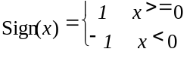
Abs( )
The summation of the f(i) with i taking integral values from a up to, but not including b.

Logical operators
|| Logical OR.
&& Logical AND.
! Logical NOT.

Relational operators
> Greater than.
>= Greater than or equal to.
< Less than.
<= Less than or equal to.
== Equal to.
!= Not equal to.
max [, … ,] the maximum value in the argument list.
min [, … ,] the minimum value in the argument list.

Bitwise operators
& AND
| OR
>> Shift right with sign extension.
<< Shift left with zero fill.

Assignment
= Assignment operator.

Mnemonics
The following mnemonics are defined to describe the different data types used in the coded bitstream.
bslbf Bit string, left bit first, where ÒleftÓ is the order in which bit strings are written in this specification. Bit strings are generally written as a string of 1s and 0s within single quote marks, e.g. Ô1000 0001Õ. Blanks within a bit string are for ease of reading and have no significance. For convenience large strings are occasionally written in hexadecimal, in this case conversion to a binary in the conventional manner will yield the value of the bit string. Thus the left most hexadecimal digit is first and in each hexadecimal digit the most significant of the four bits is first.
uimsbf Unsigned integer, most significant bit first.
simsbf Signed integer, in twos complement format, most significant (sign) bit first.
vlclbf Variable length code, left bit first, where ÒleftÓ refers to the order in which the VLC codes are written. The byte order of multibyte words is most significant byte first.

Constants
Π 3,141Ê592Ê653Ê58…
e 2,718Ê281Ê828Ê45…

Conventions

Method of describing bitstream syntax
The bitstream retrieved by the decoder is described in 6.2. Each data item in the bitstream is in bold type. It is described by its name, its length in bits, and a mnemonic for its type and order of transmission.
The action caused by a decoded data element in a bitstream depends on the value of that data element and on data elements previously decoded. The decoding of the data elements and definition of the state variables used in their decoding are described in 6.3. The following constructs are used to express the conditions when data elements are present, and are in normal type:

while ( condition ) { | If the condition is true, then the group of data elements
data_element | occurs next in the data stream. This repeats until the
. . . | condition is not true.
}
do {
data_element | The data element always occurs at least once.
. . .
} while ( condition ) | The data element is repeated until the condition is not true.
if ( condition ) { | If the condition is true, then the first group of data
data_element | elements occurs next in the data stream.
. . .
} else { | If the condition is not true, then the second group of data
data_element | elements occurs next in the data stream.
. . .
}
for ( i = m; i < n; i++) { | The group of data elements occurs (m-n) times. Conditional
data_element | constructs within the group of data elements may depend
. . . | on the value of the loop control variable i, which is set to
} | m for the first occurrence, incremented by one for
 | the second occurrence, and so forth.
/* comment … */ | Explanatory comment that may be deleted entirely without
 | in any way altering the syntax.

This syntax uses the ÔC-codeÕ convention that a variable or expression evaluating to a non-zero value is equivalent to a condition that is true and a variable or expression evaluating to a zero value is equivalent to a condition that is false. In many cases a literal string is used in a condition. For example;
if ( video_object_layer_shape == ÒrectangularÓ ) …
In such cases the literal string is that used to describe the value of the bitstream element in 6.3. In this example, we see that ÒrectangularÓ is defined in a Table?? to be represented by the two bit binary number Ô00Õ.
As noted, the group of data elements may contain nested conditional constructs. For compactness, the brackets { } are omitted when only one data element follows.
data_element [n] data_element [n] is the n+1th element of an array of data.
data_element [m][n] data_element [m][n] is the m+1, n+1th element of a two-dimensional array of data.
data_element [l][m][n] data_element [l][m][n] is the l+1, m+1, n+1th element of a three-dimensional array of data.
While the syntax is expressed in procedural terms, it should not be assumed that 6.2 implements a satisfactory decoding procedure. In particular, it defines a correct and error-free input bitstream. Actual decoders must include means to look for start codes in order to begin decoding correctly, and to identify errors, erasures or insertions while decoding. The methods to identify these situations, and the actions to be taken, are not standardised.

Definition of functions
Several utility functions for picture coding algorithm are defined as follows:

Definition of bytealigned() function
The function bytealigned () returns 1 if the current position is on a byte boundary, that is the next bit in the bitstream is the first bit in a byte. Otherwise it returns 0.

Definition of nextbits_bytealigned() function
The function nextbits_bytealigned() permits comparison of a bit string with the next bits to be decoded in the bitstream at which the first bit is byte aligned.

Definition of next_start_code() function
The next_start_code() function removes any zero bit and a string of Ô1Õ bits used for stuffing and locates the next start code.
next_start_code() { | No. of bits | Mnemonic
zero_bit | 1 | Ô0Õ
while (!byte_aligned())
one_bit | 1 | Ô1Õ
}
This function checks whether the current position is byte aligned. If it is not, a zero stuffing bit followed by a number of one stuffing bits may be present before the start code.

Definition of next_resync_marker() function
The next_resync_marker() function removes any zero bit and a string of one bits used for stuffing and locates the next resync marker; it thus performs similar operation as next_start_code() but for resync_marker.
next_resync_marker() { | No. of bits | Mnemonic
zero_bit | 1 | Ô0Õ
while (!byte_aligned())
one_bit | 1 | Ô1Õ
}

Definition of transparent_mb() function
The function transparent_mb() returns 1 if thecurrent macroblock consists only of transparent pixels. Otherwise it returns 0.

Definition of transparent_block() function
The function transparent_block(j) returns 1 if the 8x8 with index j consists only of transparent pixels. Otherwise it returns 0. The index value for each block is defined in Figure 6-5.

Reserved, forbidden and marker_bit
The terms ÒreservedÓ and ÒforbiddenÓ are used in the description of some values of several fields in the coded bitstream.
The term ÒreservedÓ indicates that the value may be used in the future for ISO/IEC defined extensions.
The term ÒforbiddenÓ indicates a value that shall never be used (usually in order to avoid emulation of start codes).
The term Òmarker_bitÓ indicates a one bit integer in which the value zero is forbidden (and it therefore shall have the value Ô1Õ). These marker bits are introduced at several points in the syntax to avoid start code emulation.

Arithmetic precision
In order to reduce discrepancies between implementations of this specification, the following rules for arithmetic operations are specified.
(a) Where arithmetic precision is not specified, such as in the calculation of the IDCT, the precision shall be sufficient so that significant errors do not occur in the final integer values
(b) Where ranges of values are given by a colon, the end points are included if a bracket is present, and excluded if the Ôless thanÕ (<) and Ôgreater thanÕ (>) characters are used. For example, [a : b> means from a to b, including a but excluding b.

Visual bitstream syntax and semantics

Structure of coded visual data
Coded visual data can be of several different types, such as video data, still texture data, 2D mesh data or facial animation parameter data.
Synthetic objects and their attribution are structured in a hierarchical manner to support both bitstream scalability and object scalability. The Systems part of the specification provides the approach to spatial-temporal scene composition including normative 2D/3D scene graph nodes and their composition supported by Binary Interchange Format Specification. At this level, synthetic and natural object composition relies on Systems with subsequent (non-normative) rendering performed by the application to generate specific pixel-oriented views of the models.
Coded video data consists of an ordered set of video bitstreams, called layers. If there is only one layer, the coded video data is called non-scalable video bitstream. If there are two layers or more, the coded video data is called a scalable hierarchy.
One of the layers is called base layer, and it can always be decoded independently. Other layers are called enhancement layers, and can only be decoded together with the lower layers (previous layers in the ordered set), starting with the base layer. The multiplexing of these layers is discussed in ISO/IEC 14496-1. The base layer of a scalable set of streams can be coded by other standards. The Enhancement layers shall conform to this specification. In general the visual bitstream can be thought of as a syntactic hierarchy in which syntactic structures contain one or more subordinate structures.
Visual texture, referred to herein as still texture coding, is designed for maintaining high visual quality in the transmission and rendering of texture under widely varied viewing conditions typical of interaction with 2D/3D synthetic scenes. Still texture coding provides for a multi-layer representation of luminance, color and shape. This supports progressive transmission of the texture for image build-up as it is received by a terminal. Also supported is the downloading of the texture resolution hierarchy for construction of image pyramids used by 3D graphics APIs. Quality and SNR scalability are supported by the structure of still texture coding.
Coded mesh data consits of just one non-scalable bitstream. This bitstream defines the structure and motion of the 2D mesh, the texture of the mesh has to be coded as a separate video object.
Coded face animation parameter data consists of one non-scaleable bitstream. It defines the animation of the facemodel of the decoder. Face animation data is structured as standard formats for downloadable models and their animation controls, and a single layer of compressed face animation parameters used for remote manipulation of the face model. The face is a node in a scene graph that includes face geometry ready for rendering. The shape, texture and expressions of the face are generally controlled by the bitstream containing instances of Facial Definition Parameter (FDP) sets and/or Facial Animation Parameter (FAP) sets. Upon initial or baseline construction, the face object contains a generic face with a neutral expression. This face can receive FAPs from the bitstream and be subsequently rendered to produce animation of the face. If FDPs are transmitted, the generic face is transformed into a particular face of specific shape and appearance. A downloaded face model via FDPs is a scene graph for insertion in the face node.

Visual object sequence
Visual object sequence is is the highest syntactic structure of the coded visual bitstream.
A visual object sequence commences with a visual_object_sequence_start_code which is followed by a one or more visual objects coded concurrently. The visual obbject sequence is terminated by a visual_object_sequence_end_code.

Visual object
A visual object commences with a visual_object_start_code, is followed by profile and level identification, and a visual object id, is followed by a video object, a still texture object, a mesh object, or a face object.

Video object
A video object commences with a video_object_start_code, and is followed by one or more video object layers.

Progressive and interlaced sequences
This specification deals mainly with coding of progressive sequences although the tools of this specification can be combined with that of tools derived from ISO/IEC 13818-2 to form algorithms to code interlaced sequences.
The sequence, at the output of the decoding process, consists of a series of reconstructed vops separated in time and are readied for display via the compositor.

Frame
A frame consists of three rectangular matrices of integers; a luminance matrix (Y), and two chrominance matrices (Cb and Cr).

Vop
A reconstructed vop is obtained by decoding a coded vop. A coded vop may have been derived from progressive frame.

Vop types
There are three types of vopsthat use different coding methods.
An Intra-coded (I) vop is coded using information only from itself.
A Predictive-coded (P) vop is a vop which is coded using motion compensated prediction from a past reference vop.
A Bidirectionally predictive-coded (B) vop is a vop which is coded using motion compensated prediction from a past and/or future reference vop(s).

I-vops
I-vops are intended to assist random access into the sequence. Applications requiring random access, fast-forward playback, or fast reverse playback may use I-vops relatively frequently.
I-vops may also be used at scene cuts or other cases where motion compensation is ineffective.

4:2:0 Format
In this format the Cb and Cr matrices shall be one half the size of the Y-matrix in both horizontal and vertical dimensions. The Y-matrix shall have an even number of lines and samples.
The luminance and chrominance samples are positioned as shown in Figure 6-1.
The two variations in the vertical and temporal positioning of the samples for interlaced vops are shown in Figure 6-2 and Figure 6-3.
Figure 6-4 shows the vertical and temporal positioning of the samples in a progressive frame.
Represent luminance samples
Represent chrominance samples
Figure 6-1 -- The position of luminance and chrominance samples in 4:2:0 data.

Figure 6-2 – Vertical and temporal positions of samples in an interlaced frame with top_field_first=1.

Figure 6-3 -- Vertical and temporal position of samples in an interlaced frame with top_field_first=0
Figure 6-4Ð Vertical and temporal positions of samples in a progressive frame.

Vop reordering
When a video object layer contains coded B-vops, the number of consecutive coded B-vops is variable and unbounded. The first coded vop shall not be a B-vop.
A video object layer may contain no coded P-vops. A video object layer may also contain no coded I-vops in which case some care is required at the start of the video object layer and within the video object layer to effect both random access and error recovery.
The order of the coded vops in the bitstream, also called coded order, is the order in which a decoder reconstructs them. The order of the reconstructed vops at the output of the decoding process, also called the display order, is not always the same as the coded order and this section defines the rules of vop reordering that shall happen within the decoding process.
When the video object layer contains no coded B-vops, the coded order is the same as the display order. This is true in particular always when low_delay is one.
When B-vops are present in the video object layer re-ordering is performed according to the following rules:
If the current vop in coded order is a B-vop the output vop is the vop reconstructed from that B-vop.
If the current vop in coded order is a I-vop or P-vop the output vop is the vop reconstructed from the previous I-vop or P-vop if one exists. If none exists, at the start of the video object layer, no vop is output.
The following is an example of vops taken from the beginning of a video object layer. In this example there are two coded B-vops between successive coded P-vops and also two coded B-vops between successive coded I- and P-vops. Vop Ô1IÕ is used to form a prediction for vop Ô4PÕ. Vops Ô4PÕ and Ô1IÕ are both used to form predictions for vops Ô2BÕ and Ô3BÕ. Therefore the order of coded vops in the coded sequence shall be Ô1IÕ, Ô4PÕ, Ô2BÕ, Ô3BÕ. However, the decoder shall display them in the order Ô1IÕ, Ô2BÕ, Ô3BÕ, Ô4PÕ.
At the encoder input,
1  I | 2  B | 3  B | 4  P | 5  B | 6  B | 7  P | 8  B | 9  B | 10  I | 11  B | 12  B | 13  P
At the encoder output, in the coded bitstream, and at the decoder input,
1  I | 4  P | 2  B | 3  B | 7  P | 5  B | 6  B | 10  I | 8  B | 9  B | 13  P | 11  B | 12  B
At the decoder output,
1 | 2 | 3 | 4 | 5 | 6 | 7 | 8 | 9 | 10 | 11 | 12 | 13

Macroblock
A macroblock contains a section of the luminance component and the spatially corresponding chrominance components. The term macroblock can either refer to source and decoded data or to the corresponding coded data elements. A skipped macroblock is one for which no information is transmitted. Presently there is only one chrominance format for a macroblock, namely, 4:2:0 format. The orders of blocks in a macroblock is illustrated below:
A 4:2:0 Macroblock consists of 6 blocks. This structure holds 4 Y, 1 Cb and 1 Cr Blocks and the block order is depicted in Figure 6-5.
Figure 6-5 -- 4:2:0 Macroblock structure
The organisation of vops into macroblocks is as follows.
For the case of a progressive vop, the interlaced flag (in the vop header) is set to “0” and the organisation of lines of luminance vop into macroblocks is called frame organization and is illustrated in Figure 6.4. In this case, frame DCT coding is employed.
For the case of interlaced vop, the interlaced flag is set to “1” and the organisation of lines of luminance vop into macroblocks can be either frame organization or field organization and thus both frame and field DCT coding may be used in the vop.
- In the case of frame DCT coding, each luminance block shall be composed of lines from two fields alternately. This is illustrated in Figure 6-9.
- In the case of field DCT coding, each luminance block shall be composed of lines from only one of the two fields. This is illustrated in Figure 6-10.
Only frame DCT coding is applied to the chrominance blocks. It should be noted that field based predicitons may be applied for these chrominance blocks which will require predictions of 8x4 regions (after half-sample filtering).
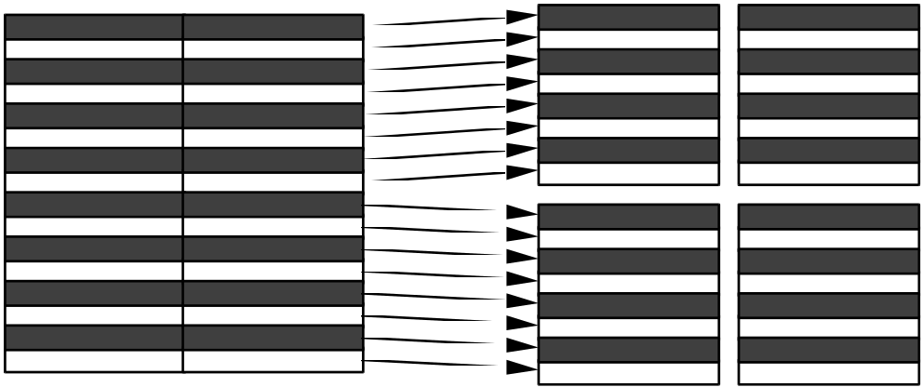
Figure 6-6 -- Luminance macroblock structure in field DCT coding

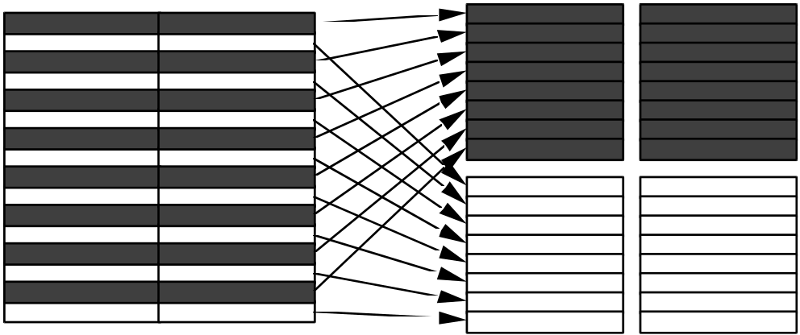
Figure 6-7 -- Luminance macroblock structure in field DCT coding

Block
The term block can refer either to source and reconstructed data or to the DCT coefficients or to the corresponding coded data elements.
When the block refers to source and reconstructed data it refers to an orthogonal section of a luminance or chrominance component with the same number of lines and samples. There are 8 lines and 8 samples/line in the block.

Mesh object
A 2D triangular mesh refers to a tessellation of a 2D visual object plane into triangular patches. The vertices of the triangular patches are called node points. The straight-line segments between node points are called edges. Two triangles are adjacent if they share a common edge.
A dynamic 2D mesh consists of a temporal sequence of 2D triangular meshes, where each mesh has the same topology, but node point locations may differ from one mesh to the next. Thus, a dynamic 2D mesh can be specified by the geometry of the initial 2D mesh and motion vectors at the node points for subsequent meshes, where each motion vector points from a node point of the previous mesh in the sequence to a node point of the current mesh. The dynamic 2D mesh can be used to create 2D animations by mapping texture from e.g. a video object plane onto successive 2D meshes.
A 2D dynamic mesh with implicit structure refers to a 2D dynamic mesh of which the initial mesh has either uniform or Delaunay topology. In both cases, the topology of the initial mesh does not have to be coded (since it is implicitly defined), only the node point locations of the initial mesh have to be coded. Note that in both the uniform and Delaunay case, the mesh is restricted to be simple, i.e. it consists of a single connected component without any holes, topologically equivalent to a disk.
A mesh object represents the geometry and motion of a 2D triangular mesh. A mesh object consists of one or more mesh object planes, each corresponding to a 2D triangular mesh at a certain time instance. An example of a mesh object is shown in the figure below.
A sequence of mesh object planes represents the piece-wise deformations to be applied to a video object plane or still texture object to create a synthetic animated video object. Triangular patches of a video object plane are to be warped according to the motion of corresponding triangular mesh elements. The motion of mesh elements is specified by the temporal displacements of the mesh node points.
The syntax and semantics of the mesh object pertains to the mesh geometry and mesh motion only; the video object to be used in an animation is coded separately. The warping or texture mapping applied to render visual object planes is handled in the context of scene composition.
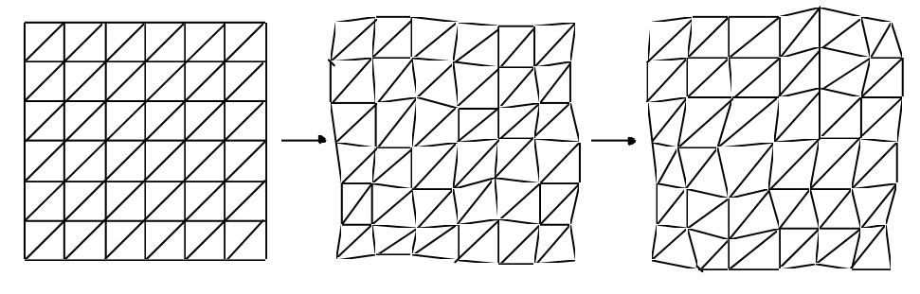
Figure 6-8: Mesh object with uniform triangular geometry.
The syntax and semantics of the mesh object pertains to the mesh geometry and mesh motion only; the video object to be used in an animation is coded separately. The texture mapping applied to render visual object planes is handled in the context of composition. Furthermore, the syntax does not allow explicit encoding of other mesh properties such as colors or texture coordinates.

Mesh object plane
There are two types of mesh object planes that use different coding methods.
An intra-coded mesh object plane codes the geometry of a single 2D mesh. An intra-coded mesh is either of uniform or Delaunay type. In the case of a mesh of uniform type, the mesh geometry is coded by a small set of parameters. In the case of a mesh of Delaunay type, the mesh geometry is coded by the locations of the node points and boundary edge segments. The triangular mesh structure is specified implicitly by the coded information.
A predictive-coded mesh object plane codes a 2D mesh using temporal prediction from a past reference mesh object plane. The triangular structure of a predictive-coded mesh is identical to the structure of the reference mesh used for prediction; however, the locations of node points may change. The displacements of node points represent the motion of the mesh and are coded by specifying the motion vectors of node points from the reference mesh towards the predictive-coded mesh.
Note that each coded mesh is restricted to be simple, i.e. it consists of a single connected component without any holes, topologically equivalent to a disk.

Face object
Conceptually the face object consists of a collection of nodes in a scene graph which are animated by the facial object bitstream. The shape, texture and expressions of the face are generally controlled by the bitstream containing instances of Facial Definition Parameter (FDP) sets and/or Facial Animation Parameter (FAP) sets. Upon construction, the Face object contains a generic face with a neutral expression. This face can already be rendered. It is also immediately capable of receiving the FAPs from the bitstream, which will produce animation of the face: expressions, speech etc. If FDPs are received, they are used to transform the generic face into a particular face determined by its shape and (optionally) texture. Optionally, a complete face model can be downloaded via the FDP set as a scene graph for insertion in the face node.
The FDP and FAP sets are designed to allow the definition of a facial shape and texture, as well as animation of faces reproducing expressions, emotions and speech pronunciation. The FAPs, if correctly interpreted, will produce reasonably similar high level results in terms of expression and speech pronunciation on different facial models, without the need to initialize or calibrate the model. The FDPs allow the definition of a precise facial shape and texture in the setup phase. If the FDPs are used in the setup phase, it is also possible to produce more precisely the movements of particular facial features. Using a phoneme to FAP conversion it is possible to control facial models accepting FAPs via TTS systems. The translation from phonemes to FAPs is not standardized. It is assumed that every decoder has a default face model with default parameters. Therefore, the setup stage is not necessary to create face animation. The setup stage is used to customize the face at the decoder.

Structure of the face object bitstream
A face object is formed by a temporal sequence of face object planes. This is depicted as follows in Figure 6-9.
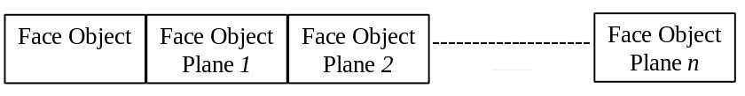
Figure 6-9 Structure of the face object bitstream
A face object represents a node in an MPEG4 scene graph. An MPEG-4 scene is understood as a composition of Audio-Visual objects according to some spatial and temporal relationships. The scene graph is the hierarchical representation of the MPEG-4 scene structure (see the Systems CD).
Alternatively, a face object can be formed by a temporal sequence of face object plane groups (called segments for simplicity), where each face object plane group itself is composed of a temporal sequence of 16 face object planes, as depicted in the following:
face object:
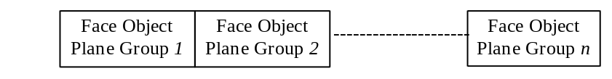
face object plane group:
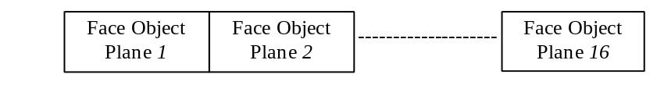
When the alternative face object bitstream structure is employed, the bitstream is decoded by DCT-based face object decoding as described in Section 8.12.2. Otherwise, the bitstream is decoded by the frame-based face object decoding.

Facial animation parameter set
The FAPs are based on the study of minimal facial actions and are closely related to muscle actions. They represent a complete set of basic facial actions, and therefore allow the representation of most natural facial expressions. Exaggerated values permit the definition of actions that are normally not possible for humans, but could be desirable for cartoon-like characters.
The FAP set contains two high level parameters visemes and expressions. A viseme is a visual correlate to a phoneme. The viseme parameter allows viseme rendering (without having to express them in terms of other parameters) and enhances the result of other parameters, insuring the correct rendering of visemes. Only static visemes which are clearly distinguished are included in the standard set. Additional visemes may be added in future extensions of the standard. Similarly, the expression parameter allows definition of high level facial expressions. The facial expression parameter values are defined by textual descriptions. To facilitate facial animation, FAPs that can be used together to represent natural expression are grouped together in FAP groups, and can be indirectly addressed by using an expression parameter. The expression parameter allows for a very efficient means of animating faces. In Annex C, a list of the FAPs is given, together with the FAP grouping, and the definitions of the facial expressions.

Facial animation parameter units
All the parameters involving translational movement are expressed in terms of the Facial Animation Parameter Units (FAPU). These units are defined in order to allow interpretation of the FAPs on any facial model in a consistent way, producing reasonable results in terms of expression and speech pronunciation. The FAPUs are illustrated in Annex C. They correspond to fractions of distances between some key facial features. The fractional units used are chosen to allow enough precision. Annex C contains the list of the FAPs. For each FAP the list contains the name, a short description, definition of the measurement units, whether the parameter is unidirectional (can have only positive values) or bi-directional, definition of the direction of movement for positive values, group number (for coding of selected groups), FDP subgroup number (Annex C) and quantization step size. FAPs act on FDP feature points in the indicated subgroups. The measurement units are shown in Table 6-1 (also see Figure 6-10):
Table 6-1 Facial Animation Parameter Units
IRISD0 | Iris diameter (by definition it is equal to the distance between upper ad lower eyelid) in neutral face | IRISD =  IRISD0 / 1024
ES0 | Eye separation | ES = ES0 / 1024
ENS0 | Eye - nose separation | ENS = ENS0 / 1024
MNS0 | Mouth - nose separation | MNS = MNS0 / 1024
MW0 | Mouth width | MW0 / 1024
AU | Angle Unit | 10E-5 rad

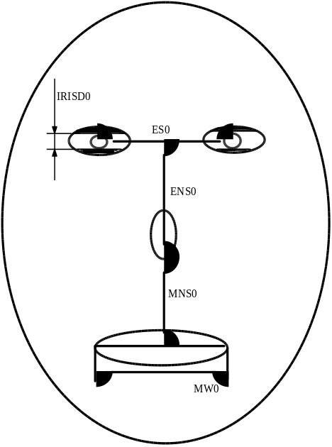
Figure 6-10 The Facial Animation Parameter Units

Description of a neutral face
At the beginning of a sequence, the face is supposed to be in a neutral position. Zero values of the FAPs correspond to a neutral face. All FAPs are expressed as displacements from the positions defined in the neutral face. The neutral face is defined as follows:
- the coordinate system is right-handed; head axes are parallel to the world axes
- gaze is in direction of Z axis
- all face muscles are relaxed
- eyelids are tangent to the iris
- the pupil is one third of IRISD0
- lips are in contact; the line of the lips is horizontal and at the same height of lip corners
- the mouth is closed and the upper teeth touch the lower ones
- the tongue is flat, horizontal with the tip of tongue touching the boundary between upper and lower teeth (feature point 6.1 touching 9.11 in Annex C)

Facial definition parameter set
The FDPs are used to customize the proprietary face model of the decoder to a particular face or to download a face model along with the information about how to animate it. The definition and description of FDP fields is given in Annex C. The FDPs are normally transmitted once per session, followed by a stream of compressed FAPs. However, if the decoder does not receive the FDPs, the use of FAPUs ensures that it can still interpret the FAP stream. This insures minimal operation in broadcast or teleconferencing applications. The FDP set is specified in BIFS syntax (see Systems Committee draft). The FDP node defines the face model to be used at the receiver. Two options are supported:
- calibration information is downloaded so that the proprietary face of the receiver can be configured using facial feature points and optionally a 3D mesh or texture.
- a face model is downloaded with the animation definition of the Facial Animation Parameters. This face model replace the proprietary face model in the receiver.

Visual bitstream syntax

Start codes
Start codes are specific bit patterns that do not otherwise occur in the video stream.
Each start code consists of a start code prefix followed by a start code value. The start code prefix is a string of twenty three bits with the value zero followed by a single bit with the value one. The start code prefix is thus the bit string Ô0000 0000 0000 0000 0000 0001Õ.
The start code value is an eight bit integer which identifies the type of start code. Many types of start code have just one start code value. However video_object_start_code and video_object_layer_start_code are represented by many start code values.
All start codes shall be byte aligned. This shall be achieved by first inserting a bit with the value zero and then, if necessary, inserting bits with the value one before the start code prefix such that the first bit of the start code prefix is the first (most significant) bit of a byte. For stuffing of 1 to 8 bits, the codewords are as follows in Table 6-2.
Table 6-2-- Stuffing codewords
Bits to be stuffed | Stuffing Codeword
1 | 0
2 | 01
3 | 011
4 | 0111
5 | 01111
6 | 011111
7 | 0111111
8 | 01111111

Table 6-3 defines the start code values for all start codes used in the visual bitstream.
Table 6-3 Ñ Start code values
name | start code value  (hexadecimal)
video_object_start_code | 00 through 1F
video_object_layer_start_code | 20 through 2F
reserved | 30 through AF
visual_object_sequence__start_code | B0
visual_object_sequence_end_code | B1
user_data_start_code | B2
group_of_vop_start_code | B3
video_session_error_code | B4
visual_object_start_code | B5
vop_start_code | B6
reserved | B7-B9
face_object_start_code | BA
face_object_plane_start_code | BB
mesh_object_start_code | BC
mesh_object_plane_start_code | BD
still_texture_object_start_code | BE
texture_spatial_layer_start_code | BF
texture_snr_layer_start_code | C0
reserved | C0-C5
System start codes (see note) | C6 through FF
NOTE - System start codes are defined in Part 1 of this specification
The use of the start codes is defined in the following syntax description with the exception of the video_session_error_code. The video_session_error_code has been allocated for use by a media interface to indicate where uncorrectable errors have been detected.

Visual Object Sequence and Visual Object
VisualObjectSequence() { | No. of bits | Mnemonic
visual_object_sequence_start_code | 32 | bslbf
do {
VisualObject()
}while(nextbits()==visual_object_sequence_start_code)
visual_object_sequence_end_code | 32 | bslbf
}

VisualObject() { | No. of bits | Mnemonic
visual_object_start_code | 32 | bslbf
profile_and_level_indication | 8 | uimsbf
is_visual_object_identifier | 1 | uimsbf
if (is_visual_object_identifier) {
visual_object_verid | 4 | uimsbf
visual_object_priority | 3 | uimsbf
}
visual_object_type | 4 | uimsbf
if (visual_object_type == “video ID”) {
VideoObject()
}
else if (visual_object_type == “still texture ID”) {
StillTextureObject()
}
else if (visual_object_type == “mesh ID”) {
MeshObject()
}
else if (visual_object_type == “face ID”) {
FaceObject()
}
next_start_code()
}

Video Object
VideoObject() { | No. of bits | Mnemonic
video_object_start_code  /* 5 least significant bits specify video_object_id value */ | 32 | bslbf
do{
VideoObjectLayer()
} while (next_bits() == video_object_layer_start_code)
}

Video Object Layer
VideoObjectLayer() { | No. of bits | Mnemonic
video_object_layer_start_code  /* 4 least significant bits specify video_object_layer_id value*/ | 32 | bslbf
is_object_layer_identifier | 1 | uimsbf
if (is_object_layer_identifier) {
visual_object_layer_verid | 4 | uimsbf
visual_object_layer_priority | 3 | uimsbf
}
vol_control_parameters | 1 | bslbf
if (vol_control_parameters)
aspect_ratio_info | 4 | uimsbf
vop_rate_code | 4 | uimsbf
bit_rate | 30 | uimsbf
vbv_buffer_size | 18 | uimsbf
chroma_format | 2 | uimsbf
low_delay | 1 | uimsbf
}
video_object_layer_shape | 2 | uimsbf
vop_time_increment_resolution | 15 | uimsbf
fixed_vop_rate | 1 | bslbf
if (video_object_layer_shape != “binary only”) {
if (video_object_layer_shape == “rectangular”) {
marker_bit | 1 | bslbf
video_object_layer_width | 13 | uimsbf
marker_bit | 1 | bslbf
video_object_layer_height | 13 | uimsbf
}
obmc_disable | 1 | bslbf
sprite_enable | 1 | bslbf
if (sprite_enable) {
sprite_width | 13 | uimsbf
marker_bit | 1 | bslbf
sprite_height | 13 | uimsbf
marker_bit | 1 | bslbf
sprite_left_coordinate | 13 | simsbf
marker_bit | 1 | bslbf
sprite_top_coordinate | 13 | simsbf
marker_bit | 1 | bslbf
no_of_sprite_warping_points | 6 | uimsbf
sprite_warping_accuracy | 2 | uimsbf
sprite_brightness_change | 1 | bslbf
if (video_object_layer_shape == “rectangular”) {
init_sprite_width | 13 | uimsbf
marker_bit | 1 | bslbf
init_sprite_height | 13 | uimsbf
marker_bit | 1 | bslbf
init_sprite_left_coordinate | 13 | simsbf
marker_bit | 1 | bslbf
init_sprite_top_coordinate | 13 | simsbf
}
}
not_8_bit | 1 | bslbf
if (not_8_ bit) {
quant_precision | 4 | uimsbf
bits_per_pixel | 4 | uimsbf
}
quant_type | 1 | bslbf
if (quant_type) {
load_intra_quant_mat | 1 | bslbf
if (load_intra_quant_mat)
intra_quant_mat | 8*[2-64] | uimsbf
load_nonintra_quant_mat | 1 | bslbf
if (load_nonintra_quant_mat)
nonintra_quant_mat | 8*[2-64] | uimsbf
}
complexity_estimation_disable | 1 | bslbf
error_resilient_disable | 1 | bslbf
if (!error_resilient_disable) {
data_partitioned | 1 | bslbf
reversible_vlc | 1 | bslbf
}
scalability | 1 | bslbf
if (scalability) {
ref_layer_id | 4 | uimsbf
ref_layer_sampling_direc | 1 | bslbf
hor_sampling_factor_n | 5 | uimsbf
hor_sampling_factor_m | 5 | uimsbf
vert_sampling_factor_n | 5 | uimsbf
vert_sampling_factor_m | 5 | uimsbf
enhancement_type | 1 | bslbf
}
}
random_accessible_vol | 1 | bslbf
next_start_code()
if (sprite_enable)
decode_init_sprite()
do {
if (next_bits() == group_of_vop_start_code)
Group_of_VideoObjectPlane()
VideoObjectPlane()
} while ((next_bits() == group_of_vop_start_code) ||
(next_bits() == vop_start_code))
}

decode_init_sprite() { | No. of bits | Mnemonic
VideoObjectPlane()
}

Group of Video Object Plane
Group_of_VideoObjectPlane() { | No. of bits | Mnemonic
group_vop_start_code | 32 | bslbf
time_code | 18
closed_gov | 1 | bslbf
broken_link | 1 | bslbf
next_start_code()
}

Video Object Plane

VideoObjectPlane() { | No. of bits | Mnemonic
vop_start_code | 32 | bslbf
vop_coding_type | 2 | uimsbf
do {
modulo_time_base | 1 | bslbf
} while (modulo_time_base != ‘0’)
marker_bit | 1 | bslbf
vop_time_increment | 1-15 | uimsbf
marker_bit | 1 | bslbf
vop_coded | 1 | bslbf
if (vop_coded == ’0’) {
next_start_code()
return()
}
if ((video_object_layer_shape != “binary only”) &&
(vop_coding_type == “P”))
vop_rounding_type | 1 | bslbf
if (video_object_layer_shape != “rectangular”) {
vop_width | 13 | uimsbf
marker_bit | 1 | bslbf
vop_height | 13 | uimsbf
marker_bit | 1 | bslbf
vop_horizontal_mc_spatial_ref | 13 | simsbf
marker_bit | 1 | bslbf
vop_vertical_mc_spatial_ref | 13 | simsbf
if ((video_object_layer_shape != “ binary only”) &&
scalability && enhancement_type)
background_composition | 1 | bslbf
change_conv_ratio_disable | 1 | bslbf
vop_constant_alpha | 1 | bslbf
if (vop_constant_alpha)
vop_constant_alpha_value | 8 | bslbf
}
if (video_object_layer_shape != “binary only”) {
intra_dc_vlc_thr | 3 | uimsbf
interlaced | 1 | bslbf
if (interlaced) {
top_field_first | 1 | bslbf
alternate_scan | 1 | bslbf
}
}
if (sprite_enable && vop_coding_type == “S”) {
if (no_sprite_points > 0)
sprite_trajectory()
if (brightness_change_in_sprite)
brightness_change_factor()
if (sprite_transmit_mode != stop) {
do {
sprite_transmit_mode | 2 | uimsbf
if ((sprite_transmit_mode == piece) ||
(sprite_transmit_mode == update))
decode_sprite_piece()
} while (sprite_transmit_mode != stop &&
sprite_transmit_mode != pause)
}
next_start_code()
return()
}
if (video_object_layer_shape != “binary only”) {
vop_quant | 3-9 | uimsbf
if (vop_coding_type != “I”)
vop_fcode_forward | 3 | uimsbf
if (vop_coding_type == “B”)
vop_fcode_backward | 3 | uimsbf
if (!scalability) {
if (!error_resilience_disable) {
if (video_object_layer_shape != “rectangular”
&& vop_coding_type != “I”)
vop_shape_coding_type | 1 | bslbf
motion_shape_texture()
while (nextbits_bytealigned() == resync_marker) {
video_packet_header()
motion_shape_texture()
}
}
else{
do {
motion_shape_texture()
} while (nextbits_bytealigned() != ‘0000 0000 0000
0000 0000 000’)
}
}
else {
if (enhancement_type) {
load_backward_shape | 1 | bslbf
if (load_backward_shape) {
backward_shape_width | 13 | uimsbf
backward_shape_ height | 13 | uimsbf
backward_shape_horizontal_mc_spatial_ref | 13 | simsbf
marker_bit | 1 | bslbf
backward_shape_vertical_mc_spatial_ref | 13 | simsbf
backward_shape()
load_forward_shape | 1 | bslbf
if (load_forward_shape) {
forward_shape_width | 13 | uimsbf
forward_shape_height | 13 | uimsbf
forward_shape_horizontal_mc_spatial_ref | 13 | simsbf
marker_bit | 1 | bslbf
forward_shape_vertical_mc_spatial_ref | 13 | simsbf
forward_shape()
}
}
}
ref_select_code | 2 | uimsbf
motion_shape_texture()
}
}
else
motion_shape_texture()
next_start_code()
}

video_packet_header() { | No. of bits | Mnemonic
next_resync_marker()
resync_marker | 17-23 | uimsbf
macroblock_number | 1-14 | vlclbf
quant_scale | 5 | uimsbf
header_extension_code | 1 | uimsbf
if (header_extension_code) {
do {
modulo_time_base | 1 | bslbf
} while (modulo_time_base != ‘0’)
marker_bit | 1 | bslbf
vop_time_increment | 1-15 | bslbf
marker_bit | 1 | uimsbf
vop_coding_type | 2 | uimsbf
if (vop_coding_type != “I”)
vop_fcode_forward | 3 | uimsbf
if (vop_coding_type == “B”)
vop_fcode_backward | 3 | uimsbf
}
}

Motion Shape Texture

motion_shape_texture() { | No. of bits | Mnemonic
if (data_partitioning &&
video_object_layer_shape != “binary only” )
data_partitioning_motion _shape_texture()
else
combined_motion_shape_texture()
}

combined_motion_shape_texture() { | No. of bits | Mnemonic
do{
macroblock()
} while (nextbits_bytealigned() != resync_marker && nextbits_bytealigned() != ‘000 0000 0000 0000 0000 0000’)
}

data_partitioning_motion_shape_texture() { | No. of bits | Mnemonic
if (vop_coding_type == “I”) {
data_partitioning_I_vop()
} else if (vop_coding_type == “P”) {
data_partitioning_P_vop()
} else if (vop_coding_type == “B”) {
combined_motion_shape_texture()
}
Note: Data partitioning is not supported in B-vops.

data_partitioned_I_vop() { | No. of bits | Mnemonic
do{
if (video_object_layer_shape != “rectangular”){
bab_type | 1-3
if (bab_type >= 4) {
if (!change_conv_rate_disable) conv_ratio | 1-2
scan_type | 1
binary_arithmetic_code()
}
}
if (!transparent_mb()) {
mcbpc | 1-9 | vlclbf
if (mb_type == 4)
dquant | 2 | bslbf
if (use_intra_dc_vlc) {
for (j = 0; j < 4; j++) {
dct_dc_size_luminance | 2-11 | vlclbf
if (dct_dc_size_luminance > 0)
dct_dc_differential | 1-12 | vlclbf
}
for (j = 0; j < 2; j++) {
dct_dc_size_chrominance | 2-12 | vlclbf
if (dct_dc_size_chrominance > 0)
dct_dc_differential | 1-12 | vlclbf
}
}
}
} while (nextbits() != dc_marker)
dc_marker /* 110 1011 0000 0000 0001 */ | 19 | bslbf
for (i = 0; i < mb_in_video_packet; i++) {
if (!transparent_mb()) {
ac_pred_flag | 1 | bslbf
cbpy | 2-6 | vlclbf
}
}
for (i = 0; i < mb_in_video_packet; i++) {
if (!transparent_mb()) {
for (j = 0; j < block_count; j++)
block(j)
}
} while (nextbits_bytealigned() != resync_marker &&
nextbits_bytealigned() != “000 0000 0000 0000 0000 0000”)
}

data_partitioned_P_vop() { | No. of bits | Mnemonic
do{
if (video_object_layer_shape != “rectangular”){
bab_type | 1-7 | vlclbf
if ((bab_type == 1) || (bab_type == 6)) {
mvds_x | 1-18 | vlclbf
mvds_y | 1-18 | vlclbf
}
if (bab_type >= 4) {
if (!change_conv_rate_disable) conv_ratio | 1-2 | vlclbf
scan_type | 1 | bslbf
binary_arithmetic_code()
}
}
if (!transparent_mb()) {
not_coded | 1 | bslbf
if (!not_coded) {
mcbpc | 1-9 | vlclbf
if (mb_type < 3)
motion_coding()
}
}
} while (nextbits() != motion_marker)
motion_marker /* 1 1111 0000 0000 0001 */ | 17 | bslbf
for (I = 0; i < mb_in_video_packet; i++) {
if (!transparent_mb()) {
if ( !not_coded){
if (mb_type >= 3)
ac_pred_flag | 1 | bslbf
cbpy | 2-6 | vlclbf
if (mb_type == 1 || mb_type == 4)
dquant | 2 | bslbf
if (mb_type >= 3 && use_intra_dc_vlc ) {
for (j = 0; j < 4; j++) {
dct_dc_size_luminance | 2-11 | vlclbf
if (dct_dc_size_luminance > 0)
dct_dc_differential | 1-12 | vlclbf
}
for (j = 0; j < 2; j++) {
dc_size_chrominance | 2-11 | vlclbf
if (dct_dc_size_chrominance > 0)
dct_dc_differential | 1-12 | vlclbf
}
}
}
}
}
for (i = 0; i < mb_in_video_packet; i++) {
if (!transparent_mb()) {
if ( ! not_coded) {
for (j = 0; j < block_count; j++)
block(j)
}
}
} while (nextbits_bytealigned() != resync_marker &&
nextbits_bytealigned() != “000 0000 0000 0000 0000 0000”)
}

motion_coding() { | No. of bits | Mnemonic
motion_vector()
if (mb_type == 2) {
for (i = 0; i < 3; i++)
motion_vector()
}
}

Sprite coding

encode_sprite_piece() { | No. of bits | Mnemonic
piece_quant | 5 | bslbf
piece_width | 9 | bslbf
piece_height | 9 | bslbf
piece_xoffset | 9 | bslbf
piece_yoffset | 9 | bslbf
sprite_shape_texture()
}

sprite_shape_texture() { | No. of bits | Mnemonic
if (sprite_transmit_mode == “piece”) {
for (i=0; i < piece_height; i++) {
for (j=0; j < piece_width; j++) {
if ( !send_mb()) {
macroblock()
}
}
}
}
if (sprite_transmit_mode == “update”) {
for (i=0; i < piece_height; i++) {
for (j=0; j < piece_width; j++) {
macroblock()
}
}
}
}

sprite_trajectory() { | No. of bits | Mnemonic
for (i=0; i < no_of_sprite_warping_points; i++) {
warping_mv_code(du[i])
warping_mv_code(dv[i])
}
}

warping_mv_code(d) { | No. of bits | Mnemonic
dmv_length | 2-9 | uimsbf
dmv_code | 0-11 | uimsbf
}

brightness_change_factor() { | No. of bits | Mnemonic
brightness_change_factor_size | 1-4 | uimsbf
brightness_change_factor_code | 5-10 | uimsbf
}

Macroblock
macroblock() { | No. of bits | Mnemonic
if (vop_coding_type != “B”) {
if (video_object_layer_shape != “rectangular”)
mb_binary_shape_coding()
if (video_object_layer_shape != “binary only”) {
if (!transparent_mb()) {
if (vop_coding_type != “I”))
not_coded | 1 | bslbf
if (!not_coded || vop_coding_type == “I”) {
mcbpc | 1-9 | vlclbf
if (derived_mb_type == 3 ||
derived_mb_type == 4)
ac_pred_flag | 1 | bslbf
if (derived_mb_type != ÒstuffingÓ)
cbpy | 2-6 | vlclbf
else
return()
if (derived_mb_type == 1 ||
derived_mb_type == 4)
dquant | 2 | uimsbf
if (interlaced)
interlaced_information()
if ( !(ref_select_code==‘11’ && scalability)) {
if (derived_mb_type == 0 ||
derived_mb_type == 1) {
motion_vector()
if (interlaced)
motion_vector()
}
if (derived_mb_type == 2) {
for (j=0; j < 4; j++)
if (!transparent_block(j))
motion_vector()
}
}
for (i = 0; i < block_count; i++)
block(i)
}
}
}
}
else if (co_located_not_coded != 1 || (ref_select_code == ’00’
&& scalability)) {
if (video_object_layer_shape != “rectangular”)
mb_binary_shape_coding()
if (video_object_layer_shape != “binary only”) {
if (!transparent_mb()) {
modb | 1-2 | vlclbf
if (!(modb == 0 && ref_select_code == ’00’ &&
scalability)) {
if (modb > 0)
mb_type | 1-4 | vlclbf
if (modb == 2)
cbpb | 6 | uimsbf
if (ref_select_code != Ô00Õ || !scalability) {
if (mb_type != Ò1Ó && cbpb!=0)
dquant | 2 | uimsbf
if (interlaced)
interlaced_information()
if (mb_type == ‘01’ ||
mb_type == ‘0001’) {
motion_vector(ÒforwardÓ)
if (interlaced)
motion_vector(“forward”)
}
if (mb_type == ‘01’ || mb_type == ‘001’) {
motion_vector(ÒbackwardÓ)
if (interlaced)
motion_vector(“backward”)
}
if (mb_type == Ò1Ó)
motion_vector(ÒdirectÓ)
}
if (ref_select_code == Ô00Õ && scalability &&
cbpb !=0 ) {
dquant | 2 | uimsbf
if (mb_type == ‘01’ || mb_type == ‘1’)
motion_vector(ÒforwardÓ)
}
for (i = 0; i < block_count; i++)
block(i)
}
}
}
}
}

MB Binary Shape Coding

mb_binary_shape_coding() { | No. of bits | Mnemonic
bab_type | 1-7 | vlclbf
if ((vop_coding_type == ‘P’) || (vop_coding_type == ‘B’)) {
if ((bab_type==1) || (bab_type == 6)) {
mvds_x | 1-18 | vlclbf
mvds_y | 1-18 | vlclbf
}
}
if (bab_type >=4) {
if (change_conv_ratio_disable)
conv_ratio | 1-2 | vlcbf
scan_type | 1 | bslbf
binary_arithmetic_code()
}
}

backward_shape () { | No. of bits | Mnemonic
for(i=0; i<backward_shape_height/16; i++)
for(j=0; j<backward_shape_width/16; j++) {
bab_type | 1-3 | vlclbf
if (bab_type >=4) {
if (change_conv_ratio_disable)
conv_ratio | 1-2 | vlcbf
scan_type | 1 | bslbf
binary_arithmetic_code()
}
}
}

forward_shape () { | No. of bits | Mnemonic
for(i=0; i<forward_shape_height/16; i++)
for(j=0; j<forward_shape_width/16; j++) {
bab_type | 1-3 | vlclbf
if (bab_type >=4) {
if (change_conv_ratio_disable)
conv_ratio | 1-2 | vlcbf
scan_type | 1 | bslbf
binary_arithmetic_code()
}
}
}

Motion vector

motion_vector ( mode ) { | No. of bits | Mnemonic
if ( mode == „direct“ ) {
horizontal_mv_data | 1-13 | vlclbf
vertical_mv_data | 1-13 | vlclbf
}
else if ( mode == „forward“ ) {
horizontal_mv_data | 1-13 | vlclbf
if ((vop_fcode_forward != 1)&&(horizontal_mv_data != 0))
horizontal_mv_residual | 1-6 | uimsbf
vertical_mv_data | 1-13 | vlclbf
if ((vop_fcode_forward != 1)&&(vertical_mv_data != 0))
vertical_mv_residual | 1-6 | uimsbf
}
else if ( mode == „backward“ ) {
horizontal_mv_data | 1-13 | vlclbf
if ((vop_fcode_backward != 1)&&(horizontal_mv_data != 0))
horizontal_mv_residual | 1-6 | uimsbf
vertical_mv_data | 1-13 | vlclbf
if ((vop_fcode_backward != 1)&&(vertical_mv_data != 0))
vertical_mv_residual | 1-6 | uimsbf
}
}

Interlaced Information

interlaced_information ( ) { | No. of bits | Mnemonic
if ((derived_mbtype == 3) || (derived_mbtype == 4) ||
(cbp != 0) )
dct_type | 1 | bslbf
if ( ((vop_coding_type == “P”) &&
((derived_mbtype == 0) || (derived_mbtype == 1)) ) ||
((vop_coding_type == “B”) && (mb_type != “1”)) ) {
field_prediction | 1 | bslbf
if (field_prediction) {
if (vop_coding_type == “P” ||
(vop_coding_type == “B” &&
mb_type != “001”) ) {
forward_top_field_reference | 1 | bslbf
forward_bottom_field_reference | 1 | bslbf
}
if ((vop_coding_type == “B”) &&
(mb_type != “0001”) ) {
backward_top_field_reference | 1 | bslbf
backward_bottom_field_reference | 1 | bslbf
}
}
}
}

Block
The detailed syntax for the terms ÒFirst DCT coefficientÓ, ÒSubsequent DCT coefficientÓ and ÒEnd of BlockÓ is fully described in the clause 7.

block( i ) { | No. of bits | Mnemonic
if ( pattern_code[i] ) {
if(mb_intra&&intra_acdc_pred_disable==0&&use_intra_dc_vlc
&& !(!error_resilient_disable && data_partitioning) {
if ( i<4 ) {
dct_dc_size_luminance | 2-11 | vlclbf
if(dct_dc_size_luminance != 0)
dct_dc_differential | 1-11 | uimsbf
} else {
dct_dc_size_chrominance | 2-12 | vlclbf
if(dct_dc_size_chrominance !=0)
dct_dc_differential | 1-11 | uimsbf
}
} else {
First DCT coefficient | 2-24 | vlclbf
}
while ( nextbits() != lastcoef)
Subsequent DCT coefficients | 3-24 | vlclbf
}
}

Still Texture Object

TextureObjectLayer() { | No. of bits | Mnemonic
still_texture_object_start_code | 32 | bslbf
texture_object_id | 16 | uimsbf
marker_bit | 1 | bslbf
wavelet_filter_type | 1 | uimsbf
wavelet_download | 1 | uimsbf
if (wavelet_download == “1” ){
download_wavelet_filters( )
}
wavelet_decomposition_levels | 8 | uimsbf
texture_object_layer_shape | 2 | uimsbf
wavelet_stuffing | 3 | uimsbf
if(texture_object_layer_shape == “00”){
texture_object_layer_width | 15 | uimsbf
marker_bit | 1 | bslbf
texture_object_layer_height | 15 | uimsbf
marker_bit | 1 | bslbf
}
else {
horizontal_ref | 15 | imsbf
marker_bit | 1 | bslbf
vertical_ref | 15 | imsbf
marker_bit | 1 | bslbf
object_width | 15 | uimsbf
marker_bit | 1 | bslbf
object_height | 15 | uimsbf
marker_bit | 1 | bslbf
shape_object_decoding ( )
}
spatial_scalability_levels | 5 | uimsbf
quantization_type | 2 | uimsbf
snr_start_code_enable | 1 | bslbf
y_mean | 8 | uimsbf
u_mean | 8 | uimsbf
v_mean | 8 | uimsbf
quant_dc_y | 8 | uimsbf
quant_dc_uv | 8 | uimsbf
for (color = “y”, “u”, “v”){
wavelet_dc_decode()
}
do {
TextureSpatialLayer ( )
} while ( nextbits == texture_spatial_layer_start_code )
next_start_code ( )
}

TextureSpatialLayer

TextureSpatialLayer() { | No. of bits | Mnemonic
texture_spatial_layer_start_code | 32 | bslbf
texture_spatial_layer_id | 5 | uimsbf
if(quantization_type == 1){
for (color = “y”, “u”, “v”){
if (texture_spatial_layer_id ==0 )
quant | 8 | uimsbf
wavelet_ higher_bands_decode()
}
}
else if ( quantization_type == 2){
snr_scalability_levels | 5 | uimsbf
if (snr_start_code_enable == 1) {
do {
TextureSNRLayerMQ( )
} while ( nextbits == texture_snr_layer_start_code )
} else {
for (i =0; i<SNR_scalability_levels; i++)
TextureSNRLayerMQNSC ( )
}
}
else if ( quantization_type == 3){
for (color = “y”, “u”, “v”)
quant | 8 | uimsbf
snr_scalability_levels | 5 | uimsbf
if (snr_start_code_enable == 1) {
do {
TextureSNRLayer BQ( )
} while ( nextbits == texture_snr_layer_start_code )
} else {
for (i =0; i<SNR_scalability_levels; i++)
TextureSNRLayerBQNSC ( )
}
}
next_start_code ( )
}

TextureSNRLayer

TextureSNRLayerMQ(){
texture_snr_layer_start_code | 32 | bslbf
texture_snr_layer_id | 5 | uimsbf
for (color = “y”, “u”, “v”){
quant | 8 | uimsbf
snr_all_zero | 1 | bslbf
if( snr_all_zero == 0)
wavelet_ higher_bands_decode( )
}
next_start_code ( )
}

TextureSNRLayerMQNSC(){
for (color = “y”, “u”, “v”){
quant | 8 | uimsbf
snr_all_zero | 1 | bslbf
if( snr_all_zero == 0)
wavelet_ higher_bands_decode()
}
}

TextureSNRLayerBQ( ){
texture_snr_layer_start_code | 32 | bslbf
texture_snr_layer_id | 5 | uimsbf
for (color = “y”, “u”, “v”){
snr_all_zero | 1 | bslbf
if( snr_all_zero == 0)
wavelet_ higher_bands_decode_bilevel()
}
next_start_code ( )
}

TextureSNRLayerBQNSC( ){
for (color = “y”, “u”, “v){
snr_all_zero | 1 | bslbf
if( snr_all_zero == 0)
wavelet_ higher_bands_decode_bilevel()
}
}

DownloadWaveletFilters

download_wavelet_filters( ){ | No. of bits | Mnemonic
lowpass_filter_length | 4 | uimsbf
highpass_filter_length | 4 | uimsbf
do{
if ( wavelet_filter_type == 0) {
filter_tap_integer | 15 | imsbf
marker_bit | 1 | bslbf
} else {
filter_tap_float_high | 16 | uimsbf
marker_bit | 1 | bslbf
filter_tap_float_low | 16 | uimsbf
marker_bit | 1 | bslbf
}
} while (lowpass_filter_length--)
do{
if ( wavelet_filter_type == 0){
filter_tap_integer | 15 | imsbf
marker_bit | 1 | bslbf
} else {
filter_tap_float_high | 16 | uimsbf
marker_bit | 1 | bslbf
filter_tap_float_low | 16 | uimsbf
marker_bit | 1 | bslbf
}
} while (highpass_filter_length--)
if ( wavelet_filter_type == 0)
integer_scale | 16 | uimsbf
}

Wavelet dc decode

wavelet_dc_decode() { | No. of bits | Mnemonic
do{
band_offset_byte | 8 | uimsbf
} while (band_offset_byte >>7)
do{
band_max_byte | 8 | uimsbf
} while (band_max_byte >>7)
cacll()
}

Wavelet higher bands decode

wavelet_ higher_bands_decode() { | No. of bits | Mnemonic
do{
root_max_alphabet_byte | 8 | uimsbf
} while (root_max_alphabet_byte >>7)
do{
valz_max_alphabet_byte | 8 | uimsbf
} while (valz_max_alphabet_byte >>7)
do{
valnz_max_alphabet_byte | 8 | uimsbf
} while (valnz_max_alphabet_byte >>7)
cachb()
}

wavelet_ higher_bands_decode_bilevel() { | No. of bits | Mnemonic
cachbilevel()
}

Shape Object Decoding

shape_object_decoding() { | No. of bits | Mnemonic
change_conv_ratio_disable | 1 | bslbf
for ( i=0; i<((object_width*object_height)/(16*16)); i++ ) {
bab_type | 1-3 | vlclbf
if (bab_type ==4) {
if (change_conv_ratio_disable)
conv_ratio | 1-2 | vlcbf
scan_type | 1 | bslbf
binary_arithmetic_code()
}
}
}

Mesh Object

MeshObject() { | No. of bits | Mnemonic
mesh_object_start_code | 32 | bslbf
do{
MeshObjectPlane()
} while (nextbits() == mesh_object_plane_start_code)
}

Mesh Object Plane

MeshObjectPlane() { | No. of bits | Mnemonic
mesh_object_plane_start_code | 32 | bslbf
new_mesh_flag | 1
if (new_mesh_flag == 1)
mesh_geometry()
else
mesh_motion()
next_start_code()
}

Mesh geometry

mesh_geometry() { | No. of bits | Mnemonic
mesh_type _code | 2 | bslbf
if (mesh_type_code == ‘00’) {
nr_of_mesh_nodes_hor | 10 | uimsbf
nr_of_mesh_nodes_vert | 10 | uimsbf
marker_bit | 1 | uimsbf
mesh_rect_size_hor | 8 | uimsbf
mesh_rect_size_vert | 8 | uimsbf
triangle_split_code | 2 | bslbf
}
else if (mesh_type_code == ‘01’) {
nr_of_mesh_nodes | 16 | uimsbf
marker_bit | 1 | uimsbf
nr_of_boundary_nodes | 10 | uimsbf
marker_bit | 1 | uimsbf
node0_x | 10 | uimsbf
node0_y | 10 | uimsbf
marker_bit | 1 | uimsbf
for (n=1; n < nr_of_mesh_nodes; n++) {
delta_x_len_vlc | 2-9 | vlcbf
if (delta_x_len_vlc)
delta_x | 1-11 | vlcbf
delta_y_len_vlc | 2-9 | vlcbf
if (delta_y_len_vlc)
delta_y | 1-11 | vlcbf
}
}
}

Mesh motion

mesh_motion() { | No. of bits | Mnemonic
motion_range_code | 3 | bslbf
for (n=0; n <nr_of_mesh_nodes; n++) {
node_motion_vector_flag | 1 | bslbf
if (node_motion_vector_flag == ‘0’) {
delta_mv_x_vlc | 1-13 | vlcbf
if ((motion_range_code != 1) && (delta_mv_x_vlc != 0))
delta_mv_x_res | 1-6 | vlcbf
delta_mv_y_vlc | 1-13 | vlcbf
if ((motion_range_code != 1) && (delta_mv_y_vlc != 0))
delta_mv_y_res | 1-6 | vlcbf
}
}
}

Face Object

face_object() { | No. of bits | Mnemonic
face_object_start_code | 32 | bslbf
face_object_coding_type | 2 | bslbf
if(face_object_coding_type == 1)
do {
face_object_plane_group()
} while (nextbits() == face_object_start_code)
if(face_object_coding_type == 0)
do {
face_object_plane()
} while (nextbits() == face_object_start_code)
next_start_code()
}

Face Object Plane

face_object_plane() { | No. of bits | Mnemonic
face_object_plane_start_code | 32 | bslbf
face_paramset_mask | 2 | bslbf
is_frame_rate | 1 | bslbf
if(is_frame_rate)
decode_frame_rate()
is_time_code | 1 | bslbf
if (is_time_code)
time_code | 18
skip_frames | 1 | bslbf
if(skip_frames)
decode_skip_frames()
if(face_paramset_mask ==’01’) {
fap_quant | 5 | uimsbf
is_i_new_max | 1 | bslbf
is_i_new_min | 1 | bslbf
is_p_new_max | 1 | bslbf
is_p_new_min | 1 | bslbf
for (group_number = 1 to 10) {
marker_bit | 1 | uimsbf
fap_mask_type | 2 | bslbf
if(fap_mask_type == ‘01’|| fap_mask_type == ‘10’)
fap_group_mask[group_number] | 2-16 | vlcbf
}
decode_new_minmax()
decode_ifap()
}
while (nextbits_bytealigned() != ‘000 0000 0000 0000 0000 0000’) {
face_object_prediction()
}
next_start_code()
}

Face Object Prediction
face_object_prediction() { | No. of bits | Mnemonic
skip_frames | 1 | bslbf
if(skip_frames)
decode_skip_frames()
if(face_paramset_mask ==’01’) {
decode_pfap()
}
}

Decode frame rate and skip frames

decode_frame_rate(){ | No. of bits | Mnemonic
frame_rate | 8 | uimsbf
seconds | 4 | uimsbf
frequency_offset | 1 | uimsbf
}

decode_skip_frames(){ | No. of bits | Mnemonic
do{
number_of_frames_to_skip | 4 | uimsbf
} while (number_of_frames_to_skip = “1111”)
}

Decode new minmax

decode_new_minmax() { | No. of bits | Mnemonic
if (is_i_new_max) {
for (group_number = 2, j=0, group_number <= 10, group_number++)
for (i=0; i < NFAP[group_number]; i++, j++) {
if (!(i & 0x3))
marker_bit | 1 | uimsbf
if (fap_group_mask[group_number] & (1 <<i))
i_new_max[j] | 5 | uimsbf
}
if (is_i_new_min) {
for (group_number = 2, j=0, group_number <= 10, group_number++)
for (i=0; i < NFAP[group_number]; i++, j++) {
if (!(i & 0x3))
marker_bit | 1 | uimsbf
if (fap_group_mask[group_number] & (1 <<i))
i_new_min[j] | 5 | uimsbf
}
if (is_p_new_max) {
for (group_number = 2, j=0, group_number <= 10, group_number++)
for (i=0; i < NFAP[group_number]; i++, j++) {
if (!(i & 0x3))
marker_bit | 1 | uimsbf
if (fap_group_mask[group_number] & (1 <<i))
p_new_max[j] | 5 | uimsbf
}
if (is_p_new_min) {
for (group_number = 2, j=0, group_number <= 10, group_number++)
for (i=0; i < NFAP[group_number]; i++, j++) {
if (!(i & 0x3))
marker_bit | 1 | uimsbf
if (fap_group_mask[group_number] & (1 <<i))
p_new_min[j] | 5 | uimsbf
}
}
}

Decode ifap

decode_ifap(){ | No. of bits | Mnemonic
for (group_number = 1, j=0; group_number <= 10; group_number++) {
if (group_number == 1) {
if(fap_group_mask[1] & 0x1)
decode_viseme()
if(fap_group_mask[1] & 0x2)
decode_expression()
} else {
for (i= 0; i<NFAP[group_number]; i++, j++) {
if(fap_group_mask[group_number] & (1 << i)) {
aa_decode(ifap_Q[j],ifap_cum_freq[j])
}
}
}
}
}

Decode pfap

decode_pfap(){ | No. of bits | Mnemonic
for (group_number = 1, j=0; group_number <= 10; group_number++) {
if (group_number == 1) {
if(fap_group_mask[1] & 0x1)
decode_viseme()
if(fap_group_mask[1] & 0x2)
decode_expression()
} else {
for (I= 0; i<NFAP[group_number]; i++, j++) {
if(fap_group_mask[group_number] & (1 << i)) {
aa_decode(pfap_diff[j], pfap_cum_freq[j])
}
}
}
}
}

Decode viseme and expression

decode_viseme() { | No. of bits | Mnemonic
aa_decode(viseme_select1Q, viseme_select1_cum_freq) |  | vlclbf
aa_decode(viseme_select2Q, viseme_select2_cum_freq) |  | vlclbf
aa_decode(viseme_blendQ, viseme_blend_cum_freq) |  | vlclbf
viseme_def | 1 | bslbf
}

decode_expression() { | No. of bits | Mnemonic
aa_decode(expression_select1Q, expression_select1_cum_freq) |  | vlclbf
aa_decode(expression_intensity1Q,  expression_intensity1_cum_freq) |  | vlclbf
aa_decode(expression_select2Q, expression_select2_cum_freq) |  | vlclbf
aa_decode(expression_intensity2Q,  expression_intensity2_cum_freq) |  | vlclbf
aa_decode(expression_blendQ, expression_blend_cum_freq) |  | vlclbf
init_face | 1 | bslbf
expression_def | 1 | bslbf
}

Face Object Plane Group

face_object_plane_group() { | No. of bits | Mnemonic
face_object_plane_start_code | 32 | bslbf
is_intra | 1 | bslbf
if (is_intra) {
face_paramset_mask | 2 | bslbf
is_frame_rate | 1 | bslbf
if(is_frame_rate)
decode_frame_rate()
is_time_code | 1 | bslbf
if(is_time_code)
time_code | 18
skip_frames | 1 | bslbf
if(skip_frames)
decode_skip_frames()
if(face_paramset_mask ==’01’) {
fap_quant_index | 5 | uimsbf
for (group_number = 1 to 10) {
marker_bit | 1 | uimsbf
fap_mask_type | 2 | bslbf
if(fap_mask_type == ‘01’|| fap_mask_type == ‘10’)
fap_group_mask[group_number] | 2-16 | vlcbf
}
decode_i_segment()
} else {
face_object_group_prediction()
}
next_start_code()
}

Face Object Group Prediction

face_object_group_prediction() { | No. of bits | Mnemonic
skip_frames | 1 | bslbf
if(skip_frames)
decode_skip_frames()
if(face_paramset_mask ==’01’) {
decode_p_segment()
}
}

Decode i_segment

decode_i_segment(){ | No. of bits | Mnemonic
for (group_number= 1, j=0; group_number<= 10; group_number++) {
if (group_number == 1) {
if(fap_group_mask[1] & 0x1)
decode_i_viseme_segment()
if(fap_group_mask[1] & 0x2)
decode_i_expression_segment()
} else {
for(i=0; i<NFAP[group_number]; i++, j++) {
if(fap_group_mask[group_number] & (1 << i)) {
decode_i_dc(dc_Q[j])
decode_ac(ac_Q[j])
}
}
}
}
}

Decode p_segment

decode_p_segment(){ | No. of bits | Mnemonic
for (group_number = 1, j=0; group_number <= 10; group_number++) {
if (group_number == 1) {
if(fap_group_mask[1] & 0x1)
decode_p_viseme_segment()
if(fap_group_mask[1] & 0x2)
decode_p_expression_segment()
} else {
for (i=0; i<NFAP[group_number]; i++, j++) {
If(fap_group_mask[group_number] & (1 << i)) {
decode_p_dc(dc_Q[j])
decode_ac(ac_Q[j])
}
}
}
}
}

Decode viseme and expression

decode_i_viseme_segment(){ | No. of bits | Mnemonic
viseme_segment_select1Q[0] | 4 | uimsbf
viseme_segment_select2Q[0] | 4 | uimsbf
viseme_segment_blendQ[0] | 6 | uimsbf
viseme_segment_def[0] | 1 | bslbf
for (k=1; k<16, k++) {
viseme_segment_select1Q_diff[k] |  | vlclbf
viseme_segment_select2Q_diff[k] |  | vlclbf
viseme_segment_blendQ_diff[k] |  | vlclbf
viseme_segment_def[k] | 1 | bslbf
}
}

decode_p _viseme_segment(){ | No. of bits | Mnemonic
for (k=0; k<16, k++) {
viseme_segment_select1Q_diff[k] |  | vlclbf
viseme_segment_select2Q_diff[k] |  | vlclbf
viseme_segment_blendQ_diff[k] |  | vlclbf
viseme_segment_def[k] | 1 | bslbf
}
}

decode_i_expression_segment(){ | No. of bits | Mnemonic
expression_segment_select1Q[0] | 4 | uimsbf
expression_segment_select2Q[0] | 4 | uimsbf
expression_segment_intensity1Q[0] | 6 | uimsbf
expression_segment_intensity2Q[0] | 6 | uimsbf
expression_segment_init_face[0] | 1 | bslbf
expression_segment_def[0] | 1 | bslbf
for (k=1; k<16, k++) {
expression_segment_select1Q_diff[k] |  | vlclbf
expression_segment_select2Q_diff[k] |  | vlclbf
expression_segment_intensity1Q_diff[k] |  | vlclbf
expression_segment_intensity2Q_diff[k] |  | vlclbf
expression_segment_init_face[k] | 1 | bslbf
expression_segment_def[k] | 1 | bslbf
}
}

decode_p _expression_segment(){ | No. of bits | Mnemonic
for (k=0; k<16, k++) {
expression_segment_select1Q_diff[k] |  | vlclbf
expression_segment_select2Q_diff[k] |  | vlclbf
expression_segment_intensity1Q_diff[k] |  | vlclbf
expression_segment_intensity2Q_diff[k] |  | vlclbf
expression_segment_init_face[k] | 1 | bslbf
expression_segment_def[k] | 1 | bslbf
}
}

Decode i_dc, p_dc, and ac

decode_i_dc(dc_Q) { | No. of bits | Mnemonic
dc_Q | 16 | simsbf
if(dc_Q == -256*128)
dc_Q | 31 | simsbf
}

decode_p_dc(dc_Q_diff) { | No. of bits | Mnemonic
dc_Q_diff |  | vlclbf
dc_Q_diff = dc_Q_diff- 256
if(dc_Q_diff == -256)
dc_Q_diff | 16 | simsbf
if(dc_Q == 0-256*128)
dc_Q_diff | 32 | simsbf
}

decode_ac(ac_Q[i]) { | No. of bits | Mnemonic
this = 0
next = 0
while(next < 15) {
count_of_runs |  | vlclbf
if (count_of_runs == 15)
next = 16
else {
next = this+1+count_of_runs
for (n=this+1; n<next; n++)
ac_Q[i][n] = 0
ac_Q[i][next] |  | vlclbf
if( ac_Q[i][next] == 256)
decode_i_dc(ac_Q[i][next])
else
ac_Q[i][next] = ac_Q[i][next]-256
this = next
}
}
}

Visual bitstream semantics

Semantic rules for higher syntactic structures
This clause details the rules that govern the way in which the higher level syntactic elements may be combined together to produce a legal bitstream. Subsequent clauses detail the semantic meaning of all fields in the video bitstream.

Visual Object Sequence and Visual Object
visual_object_sequence_start_code -- The visual_session_start_code is the bit string Ô000001B0Õ in hexadecimal. It initiates a visual session.
visual_object_sequence_end_code -- The visual_session_end_code is the bit string Ô000001B1Õ in hexadecimal. It terminates a visual session.
visual_object_start_code -- The visual_object_start_code is the bit string Ô000001B5Õ in hexadecimal. It initiates a visual object.
profile_and_level_indication – This is an 8-bit integer used to signal the profile and level identification. The meaning of the bits is given in Annex G.

visual_object_type -- The visual_object_type is a 4-bit code given in Table 6-4 which identifies the type of the visual object.

Table 6-4 Meaning of visual object type
code | visual object type
0000 | reserved
0001 | video ID
0010 | still texture ID
0011 | mesh ID
0100 | face ID
0101 | reserved
: | :
: | :
1111 | reserved
is_visual_object_identifier – This is a 1-bit code which when set to ‘1’ indicates that version identification and priority is specified for the visual object. When set to ‘0’, no version identification or priority needs to be specified.
visual_object_verid – This is a 4-bit code which identifies the version number of the visual object. It takes values between 1 and 15, a zero value is disallowed.
visual_object_priority – This is a 3-bit code which specifies the priority of the visual object. It takes values between 1 and 7, with 1 representing the highest priority and 7, the lowest priority. The value of zero is reserved.

Video Object
video_object_start_code -- The video_object_start_code is a string of 32 bits. The first 27 bits are ‘0000 0000 0000 0000 0000 0001 000‘ in binary and the last 5-bits represent one of the values in the range of ‘00000’ to ‘11111’ in binary. The video_object_start_code marks a new video object.
video_object_id -- This is given by the last 5-bits of the video_object_start_code. The video_object_id uniquely identifies a video object.

Video Object Layer
video_object_layer_start_code -- The video_object_layer_start_code is a string of 32 bits. The first 28 bits are ‘0000 0000 0000 0000 0000 0001 0010‘ in binary and the last 4-bits represent one of the values in the range of ‘0000’ to ‘1111’ in binary. The video_object_layer_start_code marks a new video object layer.
is_visual_object_identifier – This is a 1-bit code which when set to ‘1’ indicates that version identification and priority is specified for the visual object layer. When set to ‘0’, no version identification or priority needs to be specified.
visual_object_layer_verid – This is a 4-bit code which identifies the version number of the visual object layer. It takes values between 1 and 15, a zero value is disallowed.
video_object_layer_priority – This is a 3-bit code which specifies the priority of the video object layer. It takes values between 1 and 7, with 1 representing the highest priority and 7, the lowest priority. The value of zero is reserved.
vol_control_parameters – This a one-bit flag which when set to ‘1’ indicates presence of following vol control parameters.
aspect_ratio_info -- This is a four-bit integer which defines the value of aspect ratio.
vop_rate_code -- This is a four-bit integer which defines the value of vop rate.
bit_rate -- This is a 30-bit integer which specifies the bitrate of the bitstream measured in units of 400 bits/second, rounded upwards. The value zero is forbidden.
vbv_buffer_size -- The vbv_buffer_size is a 18-bit integer.
chroma_format - This is a two bit integer indicating the chrominance format as defined in the Table 6-5.
Table 6-5 Meaning of chroma_format
chroma_format | Meaning
00 | reserved
01 | 4:2:0
10 | reserved
11 | reserved
low_delay - This flag, when set to 1, indicates that the sequence does not contain any B-vops, that the vop reordering delay is not present.When set to 0, it indicates that the sequence may contain B-vops, and that the vop reordering delay is present. This flag is not used during the decoding process and therefore can be ignored by decoders, but it is necessary to define and verify the compliance of low-delay bitstreams.
video_object_layer_id -- This is given by the last 4-bits of the video_object_layer_start_code. The video_object_layer_id uniquely identifies a video object layer.
video_object_layer_shape -- This is a 2-bit integer defined in Table 6-6. It identifies the shape type of a video object layer.
Table 6-6 Video Object Layer shape type
shape format | Meaning
00 | rectangular
01 | binary
10 | binary only
11 | reserved
vop_time_increment_resolution -- This is a 15-bit unsigned integer that indicates the resolution in terms of ticks in terms within one modulo time (one second in this case). The zero value is forbidden.
fixed_vop_rate -- This is a one-bit flag which when set to ‘1’ indicates that all vops are coded with a fixed frame rate.
video_object_layer_width -- The video_object_layer_width is a 13-bit unsigned integer representing the width of the displayable part of the luminance component in pixel units.
video_object_layer_height -- The video_object_layer_height is a 13-bit unsigned integer representing the height of the displayable part of the luminance component in pixel units.
obmc_disable -- This is a one-bit flag which when set to ‘1’ disables overlapped block motion compensation.
sprite_enable -- This is a one-bit flag which when set to ‘1’ indicates the presence of sprites.
sprite_width – This is a 13-bit unsigned integer which identifies the horizontal dimension of the sprite.
sprite_height -- This is a 13-bit unsigned integer which identifies the vertical dimension of the sprite.
sprite_left_coordinate – This is a 13-bit signed integer which defines the left-edge of the sprite.
sprite_top_coordinate – This is a 13-bit signed integer which defines the top edge of the sprite.
no_of_sprite_warping_points – This is a 6-bit unsigned integer which represents the number of points used in sprite warping. When its value is 0 and when sprite_enable is set to ‘1’, warping is identity (stationary sprite) and no coordinates need to be coded. When its value is 4, perspective transform is used. When its value is 1,2 or 3, affine transform is used. Further, the case of value 1 is separated as a special case from that of values 2 or 3. Table 6-7 shows the various choices.
Table 6-7 Number of point and implied warping function
Number of points | warping function
0 | Stationary
1 | Translation
2,3 | Affine
4 | Perspective

sprite_warping_accuracy – This is a 2-bit code which indicates the quantization accuracy of motion vectors used in the warping process for sprites. Table 6-8 shows the meaning of various codewords
Table 6-8 Meaning of sprite warping accuracy codewords
code | sprite_warping_accuracy
00 | ½ pixel
01 | ¼ pixel
10 | 1/8 pixel
11 | 1/16 pixel

sprite_brightness_change – This is a one-bit flag which when set to ‘1’ indicates a change in brightness during sprite warping, alternatively, a value of ‘0’ means no change in brightness.
encode_init_sprite():
It uses VideoObjectPlane () to encode the initial sprite piece as an I-VOP, vop_coding_type is set to “I”. Consisting of multiples of 16x16 macroblocks, the initial sprite piece is the portion of the sprite object needed to reconstruct the first few frames, as dictated by the decoding requirements. The upper left corner of the initial sprite piece is offset by multiples of 16-pixel units from the top left of the sprite object.
send_mb():
This function returns 1 if the current macroblock has already been sent previously and “not coded”. Otherwise it returns 0.

quant_type -- This is a one-bit flag which when set to ‘1’ indicates MPEG-style quantization. If it is set to ‘0’ then H.263-style quantization is selected.
In MPEG-style quantization, two matrices are used, one for intra blocks the other for non-intra blocks.
The default matrix for intra blocks is:
8 | 17 | 18 | 19 | 21 | 23 | 25 | 27
17 | 18 | 19 | 21 | 23 | 25 | 27 | 28
20 | 21 | 22 | 23 | 24 | 26 | 28 | 30
21 | 22 | 23 | 24 | 26 | 28 | 30 | 32
22 | 23 | 24 | 26 | 28 | 30 | 32 | 35
23 | 24 | 26 | 28 | 30 | 32 | 35 | 38
25 | 26 | 28 | 30 | 32 | 35 | 38 | 41
27 | 28 | 30 | 32 | 35 | 38 | 41 | 45
The default matrix for non-intra blocks is:
16 | 17 | 18 | 19 | 20 | 21 | 22 | 23
17 | 18 | 19 | 20 | 21 | 22 | 23 | 24
18 | 19 | 20 | 21 | 22 | 23 | 24 | 25
19 | 20 | 21 | 22 | 23 | 24 | 26 | 27
20 | 21 | 22 | 23 | 25 | 26 | 27 | 28
21 | 22 | 23 | 24 | 26 | 27 | 28 | 30
22 | 23 | 24 | 26 | 27 | 28 | 30 | 31
23 | 24 | 25 | 27 | 28 | 30 | 31 | 33

load_intra_quant_mat -- This is a one-bit flag which is set to ‘1’ when intra_quant_mat follows. If it is set to ‘0’ then there is no change in the values that shall be used.
intra_quant_mat -- This is a list of 2 to 64 eight-bit unsigned integers. The new values are in zigzag scan order and replace the previous values. A value of 0 indicates that no more values are transmitted and the remaining, non-transmitted values are set equal to the last non-zero value. The first value shall always be 8.
load_nonintra_quant_mat -- This is a one-bit flag which is set to ‘1’ when nonintra_quant_mat follows. If it is set to ‘0’ then there is no change in the values that shall be used.
nonintra_quant_mat -- This is a list of 2 to 64 eight-bit unsigned integers. The new values are in zigzag scan order and replace the previous values. A value of 0 indicates that no more values are transmitted and the remaining, non-transmitted values are set equal to the last non-zero value. The first value shall not be 0.
complexity_estimation_disable – This is a one-bit flag which disables complexity estimation header in each vop.
init_sprite_width -- This is a 13-bit unsigned integer (in multiples of 16-pixel units) which defines the horizontal dimension of the initial sprite.
init_sprite_height -- This is a 13-bit unsigned integer (in multiples of 16-pixel units) which defines the vertical dimension of the initial sprite.
init_sprite_left_coordinate -- This is a 13-bit unsigned integer which defines the offset between the left edge of the initial sprite and the left edge of the sprite object. It is given in multiples of 16-pixel units.
init_sprite_top_coordinate -- This is a 13-bit unsigned integer which defines the offset between the top edge of the initial sprite and the top edge of the sprite object. It is given in multiples of 16-pixel units.
error_resilient_disable -- This is a one-bit flag which when set to ‘1’ indicates that the error resilient mode is disabled. If it is set to ‘0’ then error resilient mode is enabled.
data_partitioned -- This is a one-bit flag which when set to ‘1’ indicates that the macroblock data is rearranged differently, specifically, motion vector data is separated from the texture data (i.e., DCT coefficients).
reversible_vlc -- This is a one-bit flag which when set to ‘1’ indicates that the reversible variable length tables should be used when decoding DCT coefficients. These tables can only be uses when data_partition flag is enabled.
scalability -- This is a one-bit flag which when set to ‘1’ indicates if the current layer uses scalable coding. If the current layer is used as base-layer this flag is set to ‘0’.
ref_layer_id -- This is a 4-bit unsigned integer with value between 0 and 15. It indicates the layer to be used as reference for prediction(s) in the case of scalability.
ref_layer_sampling_direc -- This is a one-bit flag which when set to ‘1’ indicates that the resolution of the reference layer (specified by reference_layer_id) is higher than the resolution of the layer being coded. If it is set to ‘0’ then the reference layer has the same or lower resolution then the resolution of the layer being coded.
hor_sampling_factor_n -- This is a 5-bit unsigned integer which forms the numerator of the ratio used in horizontal spatial resampling in scalability. The value of zero is forbidden.
hor_sampling_factor_m -- This is a 5-bit unsigned integer which forms the denominator of the ratio used in horizontal spatial resampling in scalability. The value of zero is forbidden.
vert_sampling_factor_n -- This is a 5-bit unsigned integer which forms the numerator of the ratio used in vertical spatial resampling in scalability. The value of zero is forbidden.
vert_sampling_factor_m -- This is a 5-bit unsigned integer which forms the denominator of the ratio used in vertical spatial resampling in scalability. The value of zero is forbidden.
enhancement_type -- This is a 1-bit flag which is set to ‘1’ when the current layer enhances the partial region of the reference layer. If it is set to ‘0’ then the enhancement layer enhances the entire region of the reference layer. The default value of this flag is ‘0’.
random_accessible_vol -- This flag may be set to Ò1Ó to indicate that every VOP in this VOL is individually decodable. If all of the VOPs in this VOL are intra-coded VOPs and some more conditions are satisfied then random_accessible_vol may be set to Ò1Ó. random_accessible_vol may be omitted from the bitstream (by setting random_access_flag to Ò0Ó) in which case it shall be assumed to have the value zero. The flag random_accessible_vol is not used by the decoding process. random_accessible_vol is intended to aid random access or editing capability. This shall be set to Ò0Ó if any of the VOPs in the VOL are non-intra coded or certain other conditions are not fulfilled.
not_8_bit
This one bit flag is set when the video data precision is not 8 bits per pixel.
quant_precision
This field specifies the number of bits used to represent quantiser parameters. Values between 3 and 9 are allowed. When not_8_bit is zero, and therefore quant_precision is not transmitted, it takes a default value of 5.
bits_per_pixel
This field specifies the video data precision in bits per pixel. It may take different values for different video object layers within a single video object. A value of 12 in this field would indicate 12 bits per pixel. This field may take values between 4 and 12.
When not_8_bit is zero and bits_per_pixel is not present, the video data precision is always 8 bits per pixel, which is equivalent to specifying a value of 8 in this field.

Group of Video Object Plane
group_vop_start_code -- The group_start_code is the unique code of length of 32bit. It identifies the beginning of a GOV header.
time_code -- This is a 18-bit integer containing the following: time_code_hours, time_code_minutes, marker_bit and time_code_seconds as shown in Table 6-9. The parameters correspond to those defined in the IEC standard publication 461 for “time and control codes for video tape recorders”. The time code refers to the first plane (in display order) after the GOV header.
Table 6-9 Meaning of time_code
time_code | range of value | No. of bits | Mnemonic
time_code_hours | 0 - 23 | 5 | uimsbf
time_code_minutes | 0 - 59 | 6 | uimsbf
marker_bit | 1 | 1 | bslbf
time_code_seconds | 0 - 59 | 6 | uimsbf

closed_gov -- This is a one-bit flag which indicates the nature of the predictions used in the first consecutive B-VOPs (if any) immediately following the first coded I-vop after the GOV header .The closed_gov is set to ‘1’ to indicate that these B-vops have been encoded using only backward prediction or intra coding. This bit is provided for use during any editing which occurs after encoding. If the previous pictures have been removed by editing, broken_link may be set to ‘1’ so that a decoder may avoid displaying these B-VOPs following the first I-vop following the group of plane header. However if the closed_gov bit is set to ‘1’, then the editor may choose not to set the broken_link bit as these B-vops can be correctly decoded.
broken_link -- This is a one-bit flag which shall be set to ‘0’ during encoding. It is set to ‘1’ to indicate that the first consecutive B-vops (if any) immediately following the first coded I-vop following the group of plane header may not be correctly decoded because the reference frame which is used for prediction is not available (because of the action of editing). A decoder may use this flag to avoid displaying frames that cannot be correctly decoded.

Video Object Plane
vop_start_code -- This is the bit string Ô000001B6Õ in hexadecimal. It marks the start of a video object plane.
vop_coding_type -- The vop_coding_type identifies whether a vop is an intra-coded vop (I), predictive-coded vop (P), bidirectionally predictive-coded vop (B) or sprite coded vop (S). The meaning of vop_coding_type is defined in Table 6-10.
Table 6-10 Meaning of vop_coding_type
vop_coding_type | coding method
00 | intra-coded (I)
01 | predictive-coded (P)
10 | bidirectionally-predictive-coded (B)
11 | sprite (S)
modulo_time_base -- This represents the local time base in one second resolution units (1000 milliseconds). This is thus a time marker and consist of a number of consecutive ‘1’ followed by a ‘0’. It indicates the number of seconds elapsed since the synchronization point marked by last encoded/decoded modulo_time_base.
vop_time_increment – This value represents the absolute vop_time_increment from the synchronization point marked by the modulo_time_base measured in the number of clock ticks. It can take a value in the range of [0,vop_time_increment_resolution). The number of bits representing the value is calculated as the minimum number of bits required to represent the above range. The local time base in the units of seconds is recovered by dividing this value by the vop_time_increment_resolution.
vop_coded -- This is a 1-bit flag which when set to ‘0’ indicates that no subsequent data exists for the VOP. In this case, the following decoding rule applies: For an arbitrarily shaped VO (i.e. when the shape type of the VO is either ‘binary’ or ‘binary only’), the alpha plane of the reconstructed VOP shall be completely transparent. For a rectangular VO (i.e. when the shape type of the VO is ‘rectangular’), the corresponding rectangular alpha plane of the VOP, having the same size as its luminance component, shall be completely transparent. If there is no alpha plane being used in the decoding and composition process of a rectangular VO, the reconstructed VOP is filled with the respective content of the immediately preceeding VOP for which vop_coded!=0.
vop_rounding_type -- This is a one-bit flag which signals the value of the parameter rounding_control used for pixel value interpolation in motion compensation for P-VOPs. When this flag is set to ‘0’, the value of rounding_control is 0, and when this flag is set to ‘1’, the value of rounding_control is 1. When vop_rounding_type is not present in the VOP header, the value of rounding_control is 0.
The encoder should control vop_rounding_type so that each P-vop have a different value for this flag from its reference vop for motion compensation. vop_rounding_type can have an arbitrary value if the reference picture is an I-vop.
sprite_transmit_mode – This is a 2-bit code which signals the transmission mode of the sprite object. At video object layer initialization, the code is set to “piece” mode. When all object and quality update pieces are sent for the entire video object layer, the code is set to the “stop”mode. When an object piece is sent, the code is set to “piece” mode. When an update piece is being sent, the code is set to the “update” mode. When all sprite object pieces andquality update pieces for the current vop are sent, the code is set to “pause” mode. Table 6-11 shows the different sprite transmit modes.
Table 6-11 Meaning of sprite transmit modes
code | sprite_transmit_mode
00 | stop
01 | piece
10 | update
11 | pause
vop_width -- This is a 13-bit unsigned integer which specifies the horizontal size, in pixel units, of the rectangle that includes the vop. A zero value is forbidden.
vop_height -- This is a 13-bit unsigned integer which specifies the vertical size, in pixel units, of the rectangle that includes the vop. A zero value is forbidden.
vop_horizontal_mc_spatial_ref -- This is a 13-bit signed integer which specifies, in pixel units, the horizontal position of the top left of the rectangle defined by horizontal size of vop_width. This is used for decoding and for picture composition.
marker_bit -- This is one-bit that shall be set to 1. This bit prevents emulation of start codes.
vop_shape_coding_type – This is a 1 bit flag which specifies whether inter shape decoding is to be carried out for the current P vop. If vop_shape_coding_type is equal to ‘0’, intra shape decoding is carried out, otherwise inter shape decoding is carried out.
vop_vertical_mc_spatial_ref -- This is a 13-bit signed integer which specifies, in pixel units, the vertical position of the top left of the rectangle defined by vertical size of vop_width. This is used for decoding and for picture composition.
background_composition -- This flag only occurs when scalability flag has a value of “1. This flag is used in conjunction with enhancement_type flag. If enhancement_type is “1” and this flag is “1”, background composition specified earlier is performed. If enhancement type is “1” and this flag is “0”, any method can be used to make a background for the enhancement layer.
change_ratio_disable – This is a 1-bit flag which when set to ‘1’ indicates that conv_ratio is not sent at the macroblock layer and is assumed to be 1 for all the macroblocks of the vop. When set to ‘0’, the conv_ratio is coded at macroblock layer.
intra_dc_vlc_thr -- This is a 3-bit code allows a mechanism to switch between two VLC’s for coding of Intra DC coefficients as per Table 6-12.
Table 6-12 Meaning of intra_dc_vlc_thr
index | meaning of intra_dc_vlc_thr | code
0 | Use Intra DC VLC for entire VOP | 000
1 | Switch to Intra AC VLC at running Qp >=13 | 001
2 | Switch to Intra AC VLC at running Qp >=15 | 010
3 | Switch to Intra AC VLC at running Qp >=17 | 011
4 | Switch to Intra AC VLC at running Qp >=19 | 100
5 | Switch to Intra AC VLC at running Qp >=21 | 101
6 | Switch to Intra AC VLC at running Qp >=23 | 110
7 | Use Intra AC VLC for entire VOP | 111
Where running Qp is defined as Qp value used for immediately previous coded macroblock.
interlaced -- This is a 1-bit flag which being set to “1” indicates that the VOP may contain interlaced video. When this flag is set to “0”, the VOP is of non-interlaced (or progressive) format.
top_field_first -- This is a 1-bit flag which when set to “1” indicates that the top field (i.e., the field containing the top line) of reconstructed VOP is the first field to be displayed (output by the decoding process). When top_field_first is set to “0” it indicates that the bottom field of the reconstructed VOP is the first field to be displayed.
alternate_vertical_scan_flag -- This is a 1-bit flag which when set to “1” indicates the use of alternate vertical scan for interlaced vops.
vop_quant -- This is an unsigned integer which specifies the absolute value of quant to be used for dequantizing the next macroblock. The default length is 5-bits which carries the binary representation of quantizer values from 1 to 31 in steps of 1.
vop_fcode_forward -- This is a 3-bit unsigned integer taking values from 1 to 7; the value of zero is forbidden. It is used in decoding of motion vectors.
vop_fcode_backward -- This is a 3-bit unsigned integer taking values from 1 to 7; the value of zero is forbidden. It is used in decoding of motion vectors.
vop_shape_coding_type -- This is a 1-bit flag which when set to ‘0’ indicates the shape coding is INTRA. When inter_prediction_shape is set to ‘1’ indicates the shape coding is INTER.
resync_marker -- This is a binary string of at least 16 zero’s followed by a one‘0 0000 0000 0000 0001’. The length of this resync marker is dependent on the value of vop_fcode_forward, for a P-VOP, and the larger value of either vop_fcode_forward and vop_fcode_backward. The relationship between the length of the resync_marker and appropriate fcode is given by 16 + fcode. The resync_marker is (15+fcode) zeros followed by a one. It is only present when error_resilient_disable flag is set to ‘0’. A resync marker shall only be located immediately before a macroblock and aligned with a byte
macroblock_number -- This is a variable length code with length between 1 and 14 bits and is only present when error_resilient_disable flag is set to ‘0’. It identifies the macroblock number within a vop. The number of the top-left macroblock in a vop shall be zero. The macroblock number increases from left to right and from top to bottom. The actual length of the code depends on the total number of macroblocks in the vop calculated according to Table 6-13, the code itself is simply a binary representation of the macroblock number.
Table 6-13 Length of macroblock_number code
length of macroblock_number code | ((vop_width+15)/16) * ((vop_height+15)/16)
1 | 1-2
2 | 3-4
3 | 5-8
4 | 9-16
5 | 17-32
6 | 33-64
7 | 65-128
8 | 129-256
9 | 257-512
10 | 513-1024
11 | 1025-2048
12 | 2049-4096
13 | 4097-8192
14 | 8193-16384
quant_scale – This is an unsigned integer which specifies the absolute value of quant to be used for dequantizing the next macroblock. The default length is 5-bits.
motion_marker -- This is a 17-bit binary string ‘1 1111 0000 0000 0001’. It is only present when error_resilient_disable flag is set to ‘0’ and the data_partitioning flag is set to ‘1’. It is used in conjunction with the resync_marker fields, macroblock_number, quant_scale and header_extension_code, a motion_marker is inserted after the motion data (prior to the texture data). The motion_marker is unique from the motion data and enables the decoder to determine when all the motion information has been received correctly.
dc_marker -- This is a 19 bit binary string ‘110 1011 0000 0000 0001’. It is present when the error_resilient_disable flag is set to ‘0’ and the data_partitioning flag is set to ‘1’. It is used for I-VOPs only, in conjunction with the resync_marker field, macroblock_number, quant_scale and header_extension_code. A dc_marker is inserted into the bitstream after the mcbpc, dquant and dc data but before the ac_pred flag and remaining texture information.
header_extension_code -- This is a 1-bit flag which when set to ‘1’ indicates the prescence of additional fields in the header. When header_extension_code is is se to ‘1’, modulo_time_base, vop_time_increment and vop_coding_type are also included in the video packet header. Furthermore, if the vop_coding_type is equal to either a P or B vop, the appropriate fcodes are also present.
load_backward_shape -- This is a one-bit flag which when set to ‘1’ implies that the backward shape of the previous vop is copied to the forward shape for the current vop and the backward shape of the current vop is decoded from the bitstream. When ths flag is set to ‘1’, the forward shape of the previous vop is copied to the forward_shape of the current vop and the backward shape of the previous vop is copied to the backward shape of the current vop.
backward_shape_width -- This is a 13-bit unsigned integer which specifies the horizontal size, in pixel units, of the rectangle that includes the backward shape. A zero value is forbidden.
backward_shape_height -- This is a 13-bit unsigned integer which specifies the vertical size, in pixel units, of the rectangle that includes the backward shape. A zero value is forbidden.
backward_shape_horizontal_mc_spatial_ref -- This is a 13-bit signed integer which specifies, in pixel units, the horizontal position of the top left of the that includes the backward shape. This is used for decoding and for picture composition.
marker_bit -- This is one-bit that shall be set to 1. This bit prevents emulation of start codes.
backward_shape_vertical_mc_spatial_ref -- This is a 13-bit signed integer which specifies, in pixel units, the vertical position of the top left of the rectangle that includes the backward shape. This is used for decoding and for picture composition.
backward_shape() -- The decoding process of the backward shape is identical to the decoding process for the shape of I-VOP with binary only mode (video_object_layer_shape = “10”).
load_forward_shape -- This is a one-bit flag which when set to ‘1’ implies that the forward shape is decoded from the bitstream.
forward_shape_width -- This is a 13-bit unsigned integer which specifies the horizontal size, in pixel units, of the rectangle that includes the forward shape. A zero value is forbidden.
forward_shape_height -- This is a 13-bit unsigned integer which specifies the vertical size, in pixel units, of the rectangle that includes the forward shape. A zero value is forbidden.
forward_shape_horizontal_mc_spatial_ref -- This is a 13-bit signed integer which specifies, in pixel units, the horizontal position of the top left of the that includes the forward shape. This is used for decoding and for picture composition.
marker_bit -- This is one-bit that shall be set to 1. This bit prevents emulation of start codes.
forward_shape_vertical_mc_spatial_ref -- This is a 13-bit signed integer which specifies, in pixel units, the vertical position of the top left of the rectangle that includes the forward shape. This is used for decoding and for picture composition.
forward_shape() -- The decoding process of the backward shape is identical to the decoding process for the shape of I-VOP with binary only mode (video_object_layer_shape = “10”).
ref_select_code -- This is a 2-bit unsigned integer which specifies prediction reference choices for P- and B-vops in enhancement layer with respect to decoded reference layer identified by ref_layer_id. The meaning of allowed values is specified in Table 7-14 and Table 7-15.

Shape coding
bab_type – This is a variable length code between 1 and 6 bits. It indicates the coding mode used for the bab. There are seven bab_types as depicted in Table 6-14 . The VLC tables used depend on the decoding context i.e. the bab_types of blocks already received. For I-vops, the context-switched VLC table of Table 11-26 is used. For P-vops and B-vops, the context switched table of Table 11-27 is used.
Table 6-14 List of bab_types and usage
bab_type | Semantic | Used in
0 | MVDs==0 && No Update | P,B VOPs
1 | MVDs!=0 && No Update | P,B VOPs
2 | transparent | All VOP types
3 | opaque | All VOP types
4 | intraCAE | All VOP types
5 | MVDs==0 && interCAE | P,B VOPs
6 | MVDs!=0 && interCAE | P,B VOPs
The bab_type determines what other information fields will be present for the bab shape. No further shape information is present if the bab_type = 0, 2 or 3. opaque means that all pixels of the bab are part of the object. transparent means that none of the bab pixels belong to the object. IntraCAE means the intra-mode CAE decoding will be required to reconstruct the pixels of the bab. No_update means that motion compensation is used to copy the bab from the previous VOP’s binary alpha map. InterCAE means the motion compensation and inter_mode CAE decoding are used to reconstruct the bab. MVDs refers to the motion vector difference for shape.
mvds_x – This is a VLC code between 1 and 18 bits. It represents the horizontal element of the motion vector difference for the bab. The motion vector difference is in full integer precision. The VLC table is shown is Table 11-28.
mvds_y -- This is a VLC code between 1 and 18 bits. It represents the vertical element of the motion vector difference for the bab. The motion vector difference is in full integer precision. If mvds_x is ‘1’, then the VLC table of Table 11-29 , otherwise the VLC table of Table 11-29 is used.
conv_ratio – This is VLC code of length 1-2 bits. It specifies the factor used for sub-sampling the 16x16 pixel bab. The decoder must up-sample the decoded bab by this factor. The possible values for this factor are 1, 2 and 4 and the VLC table used is given in Table 11-30.
scan_type– This is a 1-bit flag where a value of ‘0’ implies that the bab is in transposed form i.e. the BAB has been transposed prior to coding. The decoder must then transpose the bab back to its original form following decoding. If this flag is ‘1’, then no transposition is performed.
binary_arithmetic_code() – This is a binary arithmetic decoder representing the pixel values of the bab. This code may be generated by intra cae or inter cae depending on the bab_type. Cae decoding relies on the knowledge of intra_prob[] and inter_prob[], probability tables given in Annex B.

Sprite coding
warping_mv_code(dmv)
The codeword for each differential motion vector consists of a VLC indicating the length of the dmv code (dmv_length) and a FLC, dmv_code-, with dmv_length bits. The codewords are listed in Table X.
brightness_change_factor ()
The codeword for brightness_change_factor consists of a variable length code denoting brightness_change_factor_size and a fix length code, brightness_change_factor, of brightness_change_factor_size bits (sign bit included).
piece_quant -- This is a 5-bit unsigned interger which indicates the quant to be used for a sprite-piece until updated by a subsequent dquant. The piece_quant carries the binary representation of quantizer values from 1 to 31 in steps of 1.
piece_width -- This value specifies the width of the sprite piece measured in macroblock units.
piece_height -- This value specifies the height of the sprite piece measured in macroblock units.
piece_xoffset -- This value specifies the horizontal offset location, measured in macroblock units from the left edge of the sprite object, for the placement of the sprite piece into the sprite object buffer at the decoder.
piece_yoffset -- This value specifies the vertical offset location, measured in macroblock units from the top edge of the sprite object.
decode_sprite_piece ():
It decodes a selected region of the sprite object or its update. It also decodes the parameters required by the decoder to properly incorporate the pieces. All the static-sprite-object pieces will be encoded using a subset of the I-VOP syntax. And the static-sprite-update pieces use a subset of the P-VOP syntax. The sprite update is defined as the difference between the original sprite texture and the reconstructed sprite assembled from all the sprite object pieces.
sprite_shape_texture ():
For the static-sprite-object pieces, shape and texture are coded using the macroblock layer structure in I-VOPs. And the static-sprite-update pieces use the P-VOP inter-macroblock syntax -- except that there are no motion vectors and shape information included in this syntax structure. Macroblocks raster scanning is employed to encode a sprite piece; however, whenever the scan encounters a macroblock which has been part of some previously sent sprite piece, then the block is not coded and the corresponding macroblock layer is empty.

Macroblock related
not_coded -- This is a 1-bit flag which signals if a macroblock is coded or not. When set toÕ1Õ it indicates that a macroblock is not coded and no further data is included in the bitstream for this macroblock; decoder shall treat this macroblock as ‘inter’ with motion vector equal to zero and no DCT coefficient data. When set to ‘1’ it indicates that the macroblock is coded and its data is included in the bitstream.
mcbpc -- This is a variable length code that is used to derive the macroblock type and the coded block pattern for chrominance . It is always included for coded macroblocks. Table 11-6 and Table 11-7 list all allowed codes for mcbpc in I- and P-vops respectively.
ac_pred_flag -- This is a 1-bit flag which when set to ‘1’ indicates that either the first row or the first column of ac coefficients are differentially coded for intra coded macroblocks.
modb -- This is a variable length code present only in coded macroblocks of B-vops. It indicates whether mb_type and/or cbpb information is present for a macroblock. The codes for modb are listed in Table 11-2.
mb_type -- This variable length code is present only in coded macroblocks of B-vops. Further, it is present only in those macroblocks for which one motion vector is included. The codes for mb_type are shown in Table 11-4 for B-vops for no scalability and in Table 11-5 for B-vops with scalability.
cbpb -- This is a 3 to 6 bit code representing coded block pattern in B-vops, if indicated by modb. Each bit in the code represents a coded/no coded status of a block; the leftmost bit corresponds to the top left block in the macroblock. For each non-transparent blocks with coefficients, the corresponding bit in the code is set to ‘1’.
dquant -- This is a 2-bit code which specifies the change in the quantizer, quant, for I- and P-vops. Table 6-15 lists the codes and the differential values they represent. The value of quant lies in range of 1 to 31; if the value of quant after adding dquant value is less than 1 or exceeds 31, it shall be correspondingly clipped to 1 and 31.
Table 6-15 dquant codes and corresponding values
dquant code | value
00 | -1
01 | -2
10 | 1
11 | 2
dbquant -- This is a variable length code which specifies the change in quantizer for B-vops. Table 6-16 lists the codes and the differential values they represent. If the value of quant after adding dbquant value is less than 1 or exceeds 31, it shall be correspondingly clipped to 1 and 31.
Table 6-16 dbquant codes and corresponding values
dbquant code | value
10 | -2
0 | 0
11 | 2

MB Binary Shape Coding
babtype – This defines the coding type of the current bab according to Table 11-26 and Table 11-27 for intra and inter mode, respectively.
mvds_x –This defines the size of the x-component of the differential motion vector for the current bab according to Table 11-28.
mvds_y -- This defines the size of the y-component of the differential motion vector for the current bab according to Table 11-28 if mvds_x!=0 and according to Table 11-29 if mvds_x==0.
conv_ratio –This defines the upsampling factor according to Table 11-30 to be applied after decoding the current shape information
scan_type –This defines according to Table 6-17 whether the current bordered to be decoded bab and the eventual bordered motion compensated bab need to be transposed
Table 6-17 scan_type
scan_type | meaning
0 | transpose bab as in matrix transpose
1 | do not transpose

binary_arithmetic_code() –This is a binary arithmetic decoder that defines the context dependent arithmetically to be decoded binary shape information. The meaning of the bits is defined by the arithmetic decoder according to Section 8.4.3

Motion vector
horizontal_mv_data Ñ This is a variable length code, as defined in Table 11-9, which is used in motion vector decoding as described in section 8.5.3.
horizontal_mv_residual Ñ This is an unsigned integer which is used in motion vector decoding as described in section 8.5.3. The number of bits in the bitstream for horizontal_mv_residual, r_size, is derived from either vop_fcode_forward or vop_fcode_backward as follows;
r_size = vop_fcode_forward - 1 or r_size = vop_fcode_backward - 1
vertical_mv_data Ñ This is a variable length code, as defined in Table 11-9, which is used in motion vector decoding as described in section 8.5.3.
vertical_mv_residual Ñ This is an unsigned integer which is used in motion vector decoding as described in section 8.5.3. The number of bits in the bitstream for vertical_mv_residual, r_size, is derived from either vop_fcode_forward or vop_fcode_backward as follows;
r_size = vop_fcode_forward - 1 or r_size = vop_fcode_backward - 1

Interlaced Information
dct_type – This is a 1-bit flag indicating whether the macroblock is frame DCT coded or field DCT coded. If this flag is set to “1”, the macroblock is field DCT coded; otherwise, the macroblock is frame DCT coded. This flag is only present in the bitstream if the interlaced flag is set to “1” and the macroblock is coded (coded blcok pattern is non-zero) or intra-coded.
field_prediction – This is a 1-bit flag indicating whether the macroblock is field predicted or frame predicted. This flag is set to ‘1’ when the macroblock is predicted using field motion vectors. If it is set to ‘0’ then frame prediction (16x16 or 8x8) will be used. This flag is only present in the bitstream if the interlaced flag is set to “1” and the derived_mb_type is “0” or “1” in the P-VOP or an non-direct mode macroblock in the B-VOP.
forward_top_field_reference – This is a 1-bit flag which indicates the reference field for the forward motion compensation of the top field. When this flag is set to ‘0’, the top field is used as the reference field. If it is set to ‘1’ then the bottom field will be used as the reference field. This flag is only present in the bitstream if the field_prediction flag is set to “1” and the macroblock is not backward predicted.
forward_bottom_field_reference – This is a 1-bit flag which indicates the reference field for the forward motion compensation of the bottom field. When this flag is set to ‘0’, the top field is used as the reference field. If it is set to ‘1’ then the bottom field will be used as the reference field. This flag is only present in the bitstream if the field_prediction flag is set to “1” and the macroblock is not backward predicted.
backward_top_field_reference – This is a 1-bit flag which indicates the reference field for the backward motion compensation of the top field. When this flag is set to ‘0’, the top field is used as the reference field. If it is set to ‘1’ then the bottom field will be used as the reference field. This flag is only present in the bitstream if the field_prediction flag is set to “1” and the macroblock is not forward predicted.
backward_bottom_field_reference – This is a 1-bit flag which indicates the reference field for the backward motion compensation of the bottom field. When this flag is set to ‘0’, the top field is used as the reference field. If it is set to ‘1’ then the bottom field will be used as the reference field.. This flag is only present in the bitstream if the field_prediction flag is set to “1” and the macroblock is not forward predicted.

Block related
dct_dc_size_luminance -- This is a variable length code as defined in Table 11-12 that is used to derive the value of the differential dc coefficients of luminance values in blocks in intra macroblocks. This value categorizes the coefficients according to their size.
dct_dc_size_chrominance -- This is a variable length code as defined in Table 11-13 that is used to derive the value of the differential dc coefficients of chrominance values in blocks in intra macroblocks. This value categorizes the coefficients according to their size.
dct_dc_differential -- This is a variable length code as defined in Table 11-14 that is used to derive the value of the differential dc coefficients in blocks in intra macroblocks. After identifying the category of the dc coefficient in size from dct_dc_size_luminance or dct_dc_size_chrominance, this value denotes which actual difference in that category occurred.

Still texture object
still_texture_object_start_code -- The texture_object_layer_start_code is a string of 32 bits. The first 28 bits are ‘0000 0000 0000 0000 0000 1011 1110‘ in binary and the last 4-bits represent one of the values in the range of ‘0000’ to ‘1111’ in binary. The texture_object_layer_start_code marks a new texture object layer.
texture_object_id -- This is given by 16-bits representing one of the values in the range of ‘0000 0000 0000 0000’ to ‘1111 1111 1111 1111’ in binary. The texture_object_layer_id uniquely identifies a texture object layer.
wavelet_filter_type -- This field indicates the arithmetic precision which is used for the wavelet decomposition as the following:
Table 6-18 Wavelet type
wavelet_filter_type | Meaning
0 | integer
1 | Double float
wavelet_download – This field indicates if the 2-band filter bank is specificed in the bitstream:

Table 6-19 Wavelet downloading flag
wavelet_download | meaning
0 | default filters
1 | specified in bitstream
The default filter banks are described in the 12.2.1.
wavelet_decomposition_levels -- This field indicates the number of levels in the wavelet decomposition of the texture.
texture_spatial_layer_start_code -- The texture_spatial_layer_start_code is a string of 32 bits. The 32 bits are ‘0000 0000 0000 0000 0000 0001 1011 1111’ in binary. The texture_spatial_layer_start_code marks the start of a new spatial layer.
texture_spatial_layer_id -- This is given by 5-bits representing one of the values in the range of ‘00000’ to ‘11111’ in binary. The texture_spatial_layer_id uniquely identifies a spatial layer.
texture_snr_layer_start_code -- The texture_snr_layer_start_code is a string of 32 bits. The 32 bits are ‘0000 0000 0000 0000 0000 0001 1100 0000’ in binary. The texture_snr_layer_start_code marks the start of a new snr layer.
texture_snr_layer_id -- This is given by 5-bits representing one of the values in the range of ‘00000’ to ‘11111’ in binary. The texture_snr_layer_id uniquely identifies an SNR layer.
Note: All the start codes start at the byte boundary. Appropriate number of bits is stuffed before any start code to byte-align the bitstream.
texture_object_layer_shape -- This is a 2-bit integer defined in Table 6-20. It identifies the shape type of a texture object layer.
Table 6-20 Texture Object Layer Shape type
chroma_format | Meaning
00 | rectangular
01 | binary
10 | reserved
11 | reserved

wavelet_stuffing -- These 3 stuffing bits are reserved for future expansion. It is currently defined to be ‘111’.
texture_object_layer_width -- The texture_object_layer_width is a 15-bit unsigned integer representing the width of the displayable part of the luminance component in pixel units. A zero value is forbidden.
texture_object_layer_height -- The texture_object_layer_width is a 15-bit unsigned integer representing the height of the displayable part of the luminance component in pixel units. A zero value is forbidden.
horizontal_ref -- This is a 15-bit integer which specifies, in pixel units, the horizontal position of the top left of the rectangle defined by horizontal size of object_width. This is used for decoding and for picture composition.
vertical_ref -- This is a 15-bit integer which specifies, in pixel units, the vertical position of the top left of the rectangle defined by vertical size of object_height. This is used for decoding and for picture composition.
object_width -- This is a 15-bit unsigned integer which specifies the horizontal size, in pixel units, of the rectangle that includes the object. A zero value is forbidden.
object_height -- This is a 15-bit unsigned integer which specifies the vertical size, in pixel units, of the rectangle that includes the object. A zero value is forbidden.
lowpass_filter_length – This field defines the length of the low pass filter in binary ranging from “0000” (no filter) to “1111” (length of 15.)
highpass_filter_length – This field defines the length of the high pass filter in binary ranging from “0000” (no filter) to “1111” (length of 15.)
filter_tap_integer – This field defines an integer filter coefficient in 16bit signed integer. The filter coefficients are decoded from the left most tap to the right most tap order.
filter_tap_float_high– This field defines the left 16 bits of a floating filter coefficient which is defined in 32-bit IEEE floating format. The filter coefficients are decoded from the left most tap to the right most tap order.
filter_tap_float_low– This field defines the right 16 bits of a floating filter coefficient which is defined in 32-bit IEEE floating format. The filter coefficients are decoded from the left most tap to the right most tap order.
integer_scale – This field defines the scaling factor of the integer wavelet, by which the output of each composition level is divided by // operation. A zero value is forbidden.
y_mean -- This field indicates the mean value of the Y component of the texture.
u_mean -- This field indicates the mean value of the U component of the texture.
v_mean -- This field indicates the mean value of the V component of the texture.
quant_dc_y -- This field indicates the quantization step size for the Y component of the DC subband ranging from 1 to 255. A zero value is forbidden.
quant_dc_uv -- This field indicates the quantization step size for the U and V components of the DC subband ranging from 1 to 255. A zero value is forbidden.
spatial_scalability_levels -- This field indicates the number of spatial scalability layers supported in the bitstream. This number can be from 1 to wavelet_decomposition_levels.
quantization_type -- This field indicates the type of quantization as shown in Table 6-21

Table 6-21 The quantization type
Quantization_type | Code
single quantizer | 01
multi quantizer | 10
bi-level quantizer | 11

snr_start_code_enable -- If this flag is enabled ( disable =0; enabled = 1), each SNR layer starts with a start code followed by an id.
quant -- This field defines the quantization step size for each scalability layer.
snr_scalability_levels -- This field indicates the number of levels of SNR scalability supported in this spatial scalability level.
snr_all_zero -- This flag indicates whether all the coefficients in the SNR layer are zero or not. The value ‘0’ for this flag indicates that the SNR layer contains some nonzero coefficients which are coded after this flag. The value ‘1’ for this flag indicates that the current SNR layer only contains zero coefficients and therefore the layer is skipped.
band_offset_byte-- This field defines one byte of the absolute value of the parameter band_offset. This parameter is added to each DC band coefficient obtained by arithmetic decoding. The parameter band_offset is decoded using the function get_param( ):
band_offset = -get_param( 7 );
where function get_param() is defined as

int get_param(int nbit)
{
int count = 0;
int word =0;
int value = 0;
int module = 1<<(nbit);
do{
word= get_next_word_from_bitstream( nbit+1);
value += (word & (module-1) ) << (count * nbit);
count ++;
} while( word>> nbit);
return value;
}

The function get_next_word_from_bitstream( x ) reads the next x bits from the input bitstream.
band_max_byte -- This field defines one byte of the maximum value of the DC band. The parameter band_max_value is decoded using function get_param( ):
band_max_value = get_param( 7 );
root_max_alphabet_byte-- This field defines one byte of the maximum absolute value of the quantized coefficients of the three lowest AC bands. This parameter is decode using the function get_param( ):
root_max_alphabet = get_param ( 7 );
valz_max_alphabet_byte-- This field defines one byte of the maximum absolute value of the quantized coefficients of the 3 highest AC bands. The parameter valz_max is decoded using the function get_param( ):
valz_max_alphabet = get_param ( 7 );
valnz_max_alphabet_byte-- This field defines one byte of the maximum absolute value of the quantized coefficients which belong to the middle AC bands (the bands between the 3 lowest and the 3 highest AC bands). The parameter valnz_max_alphabet is decoded using the function get_param( ):
valnz_max_alphabet = get_param ( 7 );
cacll() – This is an arithmetic decoder for decoding the quantized coefficient values of DC band. This bitstream is generated by an adaptive arithmetic encoder. The arithmetic decoding relies on the initialization of an uniform probability distribution model described in 12.2.1. The decoding procedure is same as Cachb(). The Cacll() function uses the same arithmetic decoder as described in Cachb(), but it uses different scanning, and a different probability model (DC).
cachb() -- This is an arithmetic decoder for decoding the quantized coefficient values of the higher bands (all bands except DC band). This bitstream is generated by an adaptive arithmetic encoder. The arithmetic decoding relies on the initialization of the uniform probability distribution models described in 12.2.1. This decoder uses only integer arithmetic. It also uses an adaptive probability model based on the frequency counts of the previously decoded symbols. The maximum range (or precision) specified is (2^16) - 1 (16 bits). The maximum frequency count is (2^14) - 1 (14 bits).
cachbilevel() -- This is an arithmetic decoder for decoding the quantized coefficient values of the higher bands in the bilevel_quant mode (all bands except DC band). The bitstream is generated by an adaptive arithmetic encoder. The arithmetic decoding relies on the initialization of the uniform probability distribution models described. The decoding procedure is same as cachb(). The cachbilevel() function uses the same arithmetic decoder as described in Cachb(), but it uses bitplane scanning, and a different probability model as described in 12.2.1. In this mode, The maximum range (or precision) specified is (2^16) - 1 (16 bits). The maximum frequency count is 127.

Shape Object decoding
change_conv_ratio_disable –This specifies whether conv_ratio is encoded at the shape object decoding function. If it is set to “1” when disable.
VOP_constant_alpha -- This is a 1-bit flag when set to ‘1’, the opaque alpha values of the binary mask are replaced with the alpha value specified by VOP_constant_alpha_value.
VOP_constant_alpha_value -- This is an 8-bit code that gives the alpha value to replace the opaque pixels in the binary alpha mask. Value ‘0’ is forbidden.
bab_type – This is a variable length code of 1-2 bits. It indicates the coding mode used for the bab. There are three bab_types as depicted in Table 6-14 . The VLC tables used depend on the decoding context i.e. the bab_types of blocks already received.
Table 6-22 List of bab_types and usage
bab_type | Semantic | code
2 | transparent | 10
3 | opaque | 0
4 | intraCAE | 11

The bab_type determines what other information fields will be present for the bab shape. No further shape information is present if the bab_type = 2 or 3. opaque means that all pixels of the bab are part of the object. transparent means that none of the bab pixels belong to the object. IntraCAE means the intra-mode CAE decoding will be required to reconstruct the pixels of the bab.
conv_ratio – This is VLC code of length 1-2 bits. It specifies the factor used for sub-sampling the 16x16 pixel bab. The decoder must up-sample the decoded bab by this factor. The possible values for this factor are 1, 2 and 4 and the VLC table used is given in Table 11-30.
scan_type– This is a 1-bit flag where a value of ‘0’ implies that the bab is in transposed form i.e. the bab has been transposed prior to coding. The decoder must then transpose the bab back to its original form following decoding. If this flag is ‘1’, then no transposition is performed.
binary_arithmetic_code() – This is a binary arithmetic decoder representing the pixel values of the bab. Cae decoding relies on the knowledge of intra_prob[], probability tables given in Annex B.

Mesh related
mesh_object_start_code – The mesh_object_start_code is the bit string ‘000001BC’ in hexadecimal. It initiates a mesh object.

Mesh object plane
mesh_object_plane_start_code – The mesh_object_plane_start_code is the bit string ‘000001BD’ in hexadecimal. It initiates a mesh object plane.
new_mesh_flag -- This is a 1-bit flag which when set to ‘1’ indicates that a new mesh is following in the bitstream. When set to ‘0’ it indicates that the current mesh is coded with respect to the previous mesh by using node motion vectors

Mesh geometry
mesh_type_code -- This is a 2-bit integer defined in Table 6-23. It indicates the type of initial mesh geometry being encoded.
Table 6-23 Mesh type code
mesh type code | mesh geometry
00 | uniform
01 | Delaunay
10 | reserved
11 | reserved
nr_of_mesh_nodes_hor -- This is a 10-bit unsigned integer specifying the number of nodes in one row of a uniform mesh.
nr_of_mesh_nodes_vert -- This is a 10-bit unsigned integer specifying the number of nodes in one column of a uniform mesh.
mesh_rect_size_hor -- This is a 8-bit unsigned integer specifying the width of a rectangle of a uniform mesh (containing two triangles) in half pixel units.
mesh_rect_size_vert -- This is a 8-bit unsigned integer specifying the height of a rectangle of a uniform mesh (containing two triangles) in half pixel units.
triangle_split_code - This is a 2-bit integer defined in Table 6-24. It specifies how rectangles of a uniform mesh are split to form triangles.
Table 6-24 Specification of the triangulation type
triangle split code | Split
00 | top-left to right bottom
01 | bottom-left to top right
10 | alternately top-left to bottom-right and bottom-left to top-right
11 | alternately bottom-left to top-right and top-left to bottom-right
nr_of_mesh_nodes -- This is a 16-bit unsigned integer defining the total number of nodes (vertices) of a (non-uniform) Delaunay mesh. These nodes include both interior nodes as well as boundary nodes.
nr_of_boundary_nodes -- This is a 10-bit unsigned integer defining the number of nodes (vertices) on the boundary of a (non-uniform) Delaunay mesh.
node0_x -- This is a 10-bit integer specifying the x-coordinate of the first boundary node (vertex) of a mesh in half-pixel units with respect to a local coordinate system.
node0_y -- This is a 10-bit integer specifying the y-coordinate of the first boundary node (vertex) of a mesh in half-pixel units with respect to a local coordinate system.
delta_x_len_vlc - This is a variable-length code specifying the length of the delta_x code that follows. The delta_x_len_vlc and delta_x codes together specify the difference between the x-coordinates of a node (vertex) and the previously encoded node (vertex). The definition of the delta_x_len_vlc and delta_x codes are given in Table 11-32, the table for sprite motion trajectory coding.
delta_x -- This is an integer that defines the value of the difference between the x-coordinates of a node (vertex) and the previously encoded node (vertex) in half pixel units.
delta_y_len_vlc -- This is a variable-length code specifying the length of the delta_y code that follows. The delta_y_len_vlc and delta_y codes together specify the difference between the y-coordinates of a node (vertex) and the previously encoded node (vertex). The definition of the delta_y_len_vlc and delta_y codes are given in Table 11-32, the table for sprite motion trajectory coding.
delta_y -- This is an integer defines the value of the difference between the y-coordinates of a node (vertex) and the previously encoded node (vertex) in half pixel units.

Mesh motion
motion_range_code -- This is a 2-bit integer defined in Table 6-25. It specifies the dynamic range of motion vectors in half pel units.
Table 6-25 motion range code
motion range code | motion vector range
1 | [-32, 31]
2 | [-64, 63]
3 | [-128, 127]
node_motion_vector_flag -- This is a 1 bit code specifying whether a node has a zero motion vector. When set to ‘1’ it indicates that a node has a zero motion vector, in which case the motion vector is not encoded. When set to ‘0’, it indicates the node has a nonzero motion vector and that motion vector data shall follow.
delta_mv_x_vlc -- This is a variable-length code defining (together with delta_mv_x_res) the value of the difference in the x-component of the motion vector of a node compared to the x-component of a predicting motion vector. The definition of the delta_mv_x_vlc codes are given in Table 11-11, the table for motion vector coding (MVD). The value delta_mv_x_vlc is given in half pixel units.
delta_mv_x_res -- This is an integer which is used in motion vector decoding as described in the section on video motion vector decoding, section 8.5.3. The number of bits in the bitstream for delta_mv_x_res is motion_range_code-1.
delta_mv_y_vlc -- This is a variable-length code defining (together with delta_mv_y_res) the value of the difference in the y-component of the motion vector of a node compared to the y-component of a predicting motion vector. The definition of the delta_mv_y_vlc codes are given in Table 11-11, the table for motion vector coding (MVD). The value delta_mv_y_vlc is given in half pixel units.
delta_mv_y_res -- This is an integer which is used in motion vector decoding as described in the section on video motion vector decoding, section 8.5.3. The number of bits in the bitstream for delta_mv_y_res is motion_range_code-1.

Face object
face_object_start_code -- The face_object_start_code is the bit string ‘000001BA’ in hexadecimal. It initiates a face object.
Face_object_coding_type – This is a 2-bit integer indicating which coding method is used. Its meaning is described in Table 6-26.
Table 6-26 Face_object_coding_type
type value | Meaning
00 | predictive coding
01 | DCT
10 | reserved
11 | reserved

Face object plane
face_paramset_mask -- This is a 2-bit integer defined in Table 6-27. It indicates whether FAP data are present in the face_frame.
Table 6-27 Face parameter set mask
mask value | Meaning
00 | unused
01 | FAP present
10 | reserved
11 | reserved
face_object_plane_start_code -- The face_frame_start_code is the bit string ‘000001BB’ in hexadecimal. It initiates a face object plane.
is_frame_rate – This is a 1-bit flag which when set to ‘1’ indicates that frame rate information follows this bit field. When set to ‘0’ no frame rate information follows this bit field.
is_time_code -- This is a 1-bit flag which when set to ‘1’ indicates that time code information follows this bit field. When set to ‘0’ no time code information follows this bit field.
time_code -- This is a 18-bit integer containing the following: time_code_hours, time_code_minutes, marker_bit and time_code_seconds as shown in . The parameters correspond to those defined in the IEC standard publication 461 for “time and control codes for video tape recorders”. The time code refers to the first plane (in display order) after the GOV header. Table 6-28 shows the meaning of time_code.
Table 6-28 Meaning of time_code
time_code | range of value | No. of bits | Mnemonic
time_code_hours | 0 - 23 | 5 | uimsbf
time_code_minutes | 0 - 59 | 6 | uimsbf
marker_bit | 1 | 1 | bslbf
time_code_seconds | 0 - 59 | 6 | uimsbf
skip_frames – This is a 1-bit flag which when set to ‘1’ indicates that information follows this bit field that indicates the number of skipped frames. When set to ‘0’ no such information follows this bit field.
fap_mask_type -- This is a 2-bit integer. It indicates if the group mask will be present for the specified , or if the complete faps will be present; its meaning is described in Table 6-29. In the case the type is ‘10’ the ‘0’ bit in the group mask indicates interpolate fap.
Table 6-29 fap mask type
mask type | Meaning
00 | no mask nor fap
01 | group mask
10 | group mask’
11 | fap
fap_group_mask[group_number] - This is a variable length bit entity that indicates, for a particular group_number which fap is represented in the bitstream. The value is interpreted as a mask of 1-bit fields. A 1-bit field in the mask that is set to ‘1’ indicates that the corresponding fap is present in the bitstream. When that 1-bit field is set to ‘0’ it indicates that the fap is not present in the bitstream. The number of bits used for the fap_group_mask depends on the group_number, and is given in Table 6-30.
Table 6-30 fap group mask bits
group_number | No. of bits
1 | 2
2 | 16
3 | 12
4 | 8
5 | 4
6 | 5
7 | 3
8 | 10
9 | 4
10 | 4

NFAP[group_number] - This indicates the number of FAPs in each FAP group. Its values are specified in the following table:
Table 6-31 NFAP definition
group_number | NFAP[group_number]
1 | 2
2 | 16
3 | 12
4 | 8
5 | 4
6 | 5
7 | 3
8 | 10
9 | 4
10 | 4

fap_quant – This is a 5-bit unsigned integer which is the quantization scale factor used to compute the FAPi table step size.
is_i_new_max – This is a 1-bit flag which when set to ‘1’ indicates that a new set of maximum range values for I frame follows these 4, 1-bit fields.
is_i_new_min – This is a 1-bit flag which when set to ‘1’ indicates that a new set of minimum range values for I frame follows these 4, 1-bit fields.
is_p_new_max – This is a 1-bit flag which when set to ‘1’ indicates that a new set of maximum range values for P frame follows these 4, 1-bit fields.
is_p_new_min – This is a 1-bit flag which when set to ‘1’ indicates that a new set of minimum range values for P frame follows these 4, 1-bit fields.

Face Object Prediction
skip_frames – This is a 1-bit flag which when set to ‘1’ indicates that information follows this bit field that indicates the number of skipped frames. When set to ‘0’ no such information follows this bit field.

Decode frame rate and frame skip
frame_rate – This is an 8 bit unsigned integer indicating the reference frame rate of the sequence.
seconds – This is a 4 bit unsigned integer indicating the fractional reference frame rate. The frame rate is computed as follows frame rate = (frame_rate + seconds/16).
frequency_offset -- This is a 1-bit flag which when set to ‘1’ indicates that the frame rate uses the NTSC frequency offset of 1000/1001. This bit would typically be set when frame_rate = 24, 30 or 60, in which case the resulting frame rate would be 23.97, 29.94 or 59.97 respectively. When set to ‘0’ no frequency offset is present. I.e. if (frequency_offset ==1) frame rate = (1000/1001) * (frame_rate + seconds/16).
number_of_frames_to_skip – This is a 4-bit unsigned integer indicating the number of frames skipped. If the number_of_frames_to skip is equal to 15 (pattern “1111”) then another 4-bit word follows allowing to skip up to 29 frames(pattern “11111110”). If the 8-bits pattern equals “11111111”, then another 4-bits word will follow and so on, and the number of frames skipped is incremented by 30. Each 4-bit pattern of ‘1111’ increments the total number of frames to skip with 15.

Decode new minmax
i_new_max[j] – This is a 5-bit unsigned integer used to scale the maximum value of the arithmetic decoder used in the I frame.
i_new_min[j] – This is a 5-bit unsigned integer used to scale the minimum value of the arithmetic decoder used in the I frame.
p_new_max[j] – This is a 5-bit unsigned integer used to scale the maximum value of the arithmetic decoder used in the P frame.
p_new_min[j] – This is a 5-bit unsigned integer used to scale the minimum value of the arithmetic decoder used in the P frame.

Decode viseme and expression
viseme_def -- This is a 1-bit flag which when set to ‘1’ that the mouth FAPs sent with the viseme FAP may be stored in the decoder to help with FAP interpolation in the future.
expression_def - This is a 1-bit flag which when set to ‘1’ indicates that the FAPs sent with the expression FAP may be stored in the decoder to help with FAP interpolation in the future.

Face object plane group
face_object_plane_start_code – Defined in Section 6.3.11.1.
is_intra -- This is a 1-bit flag which when set to ‘1’ indicates that the face object is coded in intra mode. When set to ‘0’ it indicates that the face object is coded in predictive mode.
face_paramset_mask – Defined in Section 6.3.11.1.
is_frame_rate – Defined in Section 6.3.11.1.
is_time_code – Defined in Section 6.3.11.1.
time_code – Defined in Section 6.3.11.1.
skip_frames – Defined in Section 6.3.11.1
Fap_quant_index – This is a 5-bit unsigned integer used as the index to a fap_scale table for computing the quantization step size of DCT coefficients. The value of fap_scale is specified in the following list:
fap_scale[0 - 31] = { 1, 1, 2, 3, 5, 7, 8, 10, 12, 15, 18, 21, 25, 30, 35, 42,
50, 60, 72, 87, 105, 128, 156, 191, 234, 288, 355, 439, 543, 674, 836, 1039}
fap_mask_type -- Defined in Section 6.3.11.1
fap_group_mask[group_number] - Defined in Section 6.3.11.1

Face Object Group Prediction
skip_frames – See the definition in Section 6.3.11.1.

Decode frame rate and frame skip
frame_rate – See the definition in Section 6.3.11.3.
frequency_offset -- See the definition in Section 6.3.11.3.
number_of_frames_to_skip – See the definition in Section 6.3.11.3.

Decode viseme_segment and expression_segment
viseme_segment_select1Q[k] – This is the quantized value of viseme_select1 at frame k of a viseme FAP segment.
viseme_segment_select2Q[k] – This is the quantized value of viseme_select2 at frame k of a viseme FAP segment.
viseme_segment_blendQ[k] – This is the quantized value of viseme_blend at frame k of a viseme FAP segment.
viseme_segment_def[k] – This is a 1-bit flag which when set to ‘1’ indicates that the mouth FAPs sent with the viseme FAP at frame k of a viseme FAP segment may be stored in the decoder to help with FAP interpolation in the future.
viseme_segment_select1Q_diff[k] -- This is the prediction error of viseme_select1 at frame k of a viseme FAP segment.
viseme_segment_select2Q_diff[k] – This is the prediction error of viseme_select2 at frame k of a viseme FAP segment.
viseme_segment_blendQ_diff[k] – This is the prediction error of viseme_blend at frame k of a viseme FAP segment.
expression_segment_select1Q[k] – This is the quantized value of expression_select1 at frame k of an expression FAP segment.
expression_segment_select2Q[k] – This is the quantized value of expression_select2 at frame k of an expression FAP segment.
expression_segment_intensity1Q[k] – This is the quantized value of expression_intensity1 at frame k of an expression FAP segment
expression_segment_intensity2Q[k] – This is the quantized value of expression_intensity2 at frame k of an expression FAP segment
expression_segment_select1Q_diff[k] -- This is the prediction error of expression_select1 at frame k of an expression FAP segment.
expression_segment_select2Q_diff[k] – This is the prediction error of expression_select2 at frame k of an expression FAP segment.
expression_segment_intensity1Q_diff[k] – This is the prediction error of expression_intensity1 at frame k of an expression FAP segment.
expression_segment_intensity2Q_diff[k] – This is the prediction error of expression_intensity2 at frame k of an expression FAP segment.
expression_segment_init_face[k] - This is a 1-bit flag which indicates the value of init_face at frame k of an expression FAP segment.
expression_segment_def[k] - This is a 1-bit flag which when set to ‘1’ indicates that the FAPs sent with the expression FAP at frame k of a viseme FAP segment may be stored in the decoder to help with FAP interpolation in the future.

6.3.11.10 Decode i_dc, p_dc, and ac
dc_Q - This is the quantized DC component of the DCT coefficients. For an intra FAP segment, this component is coded as a signed integer of either 16 bits or 31 bits. The DCT quantization parameters of the 68 FAPs are specified in the following list:
DCTQP[1 - 68] = {1, 1, 7.5, 7.5, 7.5, 7.5, 7.5, 7.5, 7.5, 7.5,
7.5, 7.5, 7.5, 15, 15, 15, 15, 5, 10, 10,
10, 10, 425, 425, 425, 425, 5, 5, 5, 5,
7.5, 7.5, 7.5, 7.5, 7.5, 7.5, 7.5, 7.5, 20, 20,
20, 20, 10, 10, 10, 10, 255, 170, 255, 255,
7.5, 7.5, 7.5, 7.5, 7.5, 7.5, 7.5, 7.5, 7.5, 7.5,
15, 15, 15, 15, 10, 10, 10, 10}
For DC coefficients, the quantization stepsize is obtained as follows:
qstep[i] = fap_scale[fap_quant_inex] * DCTQP[i] ÷ 3.0
dc_Q_diff - This is the quantized prediction error of a DC coefficient of an inter FAP segment. Its value is computed by subtracting the decoded DC coefficient of the previous FAP segment from the DC coefficient of the current FAP segment. It is coded by a variable length code if its value is within [-255, +255]. Outside this range, its value is coded by a signed integer of 16 or 32 bits.
count_of_runs - This is the run length of zeros preceding a non-zero AC coefficient.
ac_Q[i][next] - This is a quantized AC coefficients of a segment of FAPi. For AC coefficients, the quantization stepsize is three times larger than the DC quantization stepsize and is obtained as follows:
qstep[i] = fap_scale[fap_quant_inex] * DCTQP[i]

The visual decoding process
This clause specifies the decoding process that the decoder shall perform to recover visual data from the coded bit-stream. As shown in Figure 7-1, the visual decoding process includes several decoding processes such as shape-motion-texture decoding, still texture decoding, mesh decoding, and face decoding processes. After decoding the coded bit stream, it is then sent to the compositor to integrate various visual objects.

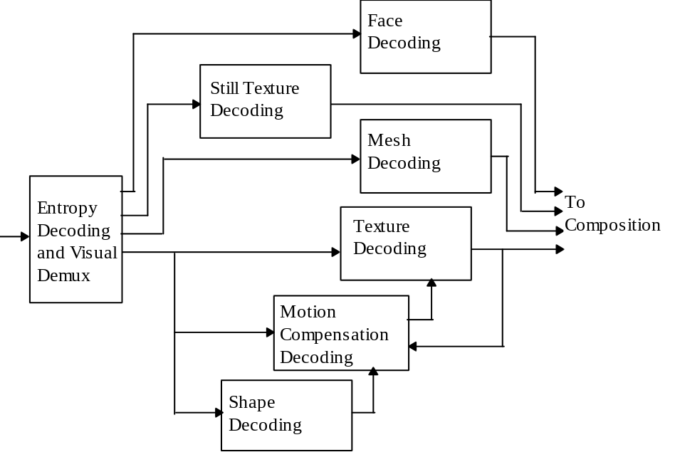
Figure 7-1 A high level view of basic visual decoding; specialized decoding such as scalable, sprite and error resilient decoding are not shown
In clauses 7.1 through 7.6 the vop decoding process is specified in which shape, motion, texture decoding processes are the major contents. Still texture object decoding process along with view dependent object decoding are described in clauses 7.7 and 7.8, respectively. Clause 7.9 includes mesh decoding process, and clause 7.10 features face object decoding. Output of the decoding process is explained at the end of clause 7.

Video decoding process
This clause specifies the decoding process that a decoder shall perform to recover VOP data from the coded video bitstream.
With the exception of the Inverse Discrete Cosine Transform (IDCT) the decoding process is defined such that all decoders shall produce numerical identical results. Any decoding process that produces identical results to the process described here, by definition, complies with this specification.
The IDCT is defined statistically such that different implementations for this function are allowed. The IDCT specification is given in Annex A.
Figure 7-2 is a diagram of the Video Decoding Process without any scalability feature. The diagram is simplified for clarity. The same decoding scheme is applied when decoding all the vops of a given session
Note: Throughout this specification two dimensional arrays are represented as name[q][p] where ‘q’ is the index in the vertical dimension and ‘p’ the index in the horizontal dimension.
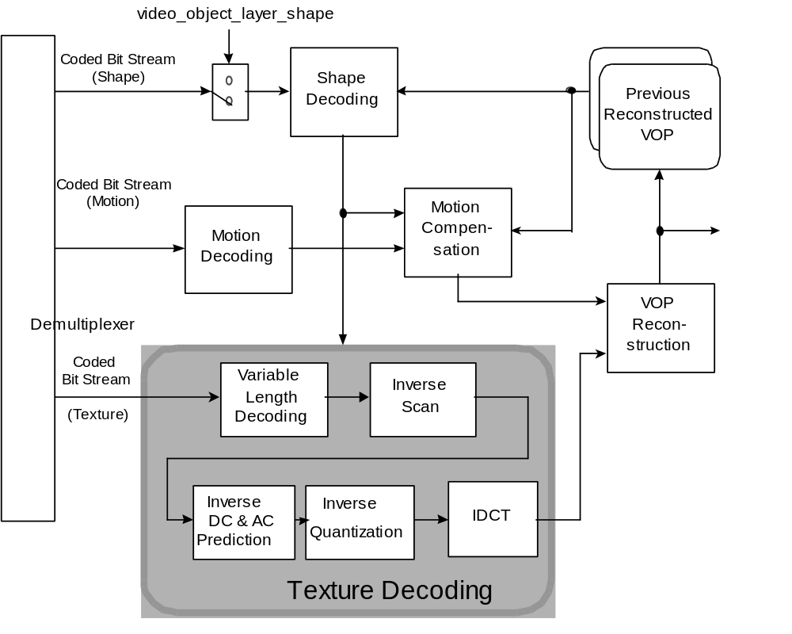
Figure 7-2 Simplified Video Decoding Process
The decoder is mainly composed of three parts : the shape decoder, motion decoder and texture decoder. The reconstructed VOP is obtained by combining the decoded shape, texture and motion information.

Higher syntactic structures
The various parameters and flags in the bitstream for VideoObjectLayer(), Group_of_VideoObjectPlane(), VideoObjectPlane(), macroblock() and block(), as well as other syntactic structures related to them shall be interpreted as discussed earlier. Many of these parameters and flags affect the decoding process. Once all the macroblocks in a given vop have been processed, the entire vop will have been reconstructed. In case the bitstream being decoded contains B-vops, reordering of vops may be needed as discussed in sec. 6.1.1.7.

Texture decoding
This clause describes the process used to decode the texture information of a vop. The process of video texture is given in Figure 7-3.
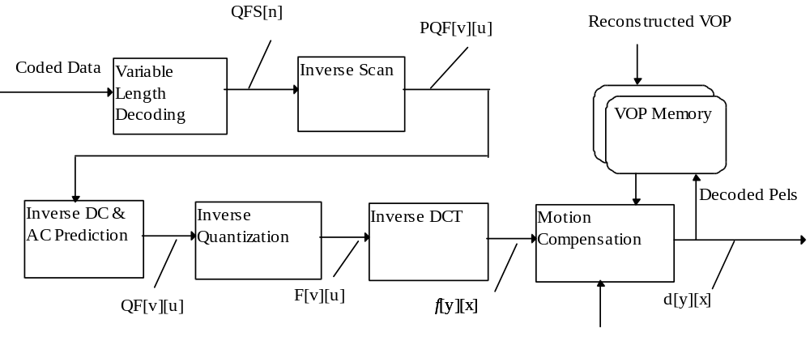
Figure 7-3 Video Texture Decoding Process

Variable length decoding
This section explains the decoding process. Section 8.3.1.1 specifies the process used for the DC coefficients (n=0) in an intra coded block. (n is the index of the coefficient in the appropriate zigzag scan order). Section 8.3.1.2 specifies the decoding process for all other coefficients; AC coefficients (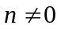) and DC coefficients in non-intra coded blocks.
Let cc denote the color component. It is related to the block number as specified in Table 7-1; thus cc is zero for the Y component, one or two for the first and second chrominance components.
Table 7-1 Color component identification
Block Number | cc
 | 4:2:0
0 | 0
1 | 0
2 | 0
3 | 0
4 | 1
5 | 2

DC coefficients decoding in intra blocks
Differential dc coefficients in blocks in intra macroblocks are encoded as variable length code denoting dct_dc_size as defined in Table 11-12 and Table 11-13 in Annex B. The dct_dc_size categorizes the c coefficients according to their “size”. For each category additional bits are appended to the dct_dc_size code to uniquely identify which difference in that category actually occurred (Table 11-14). This is done by appending a fixed length code, dc_dct_differential, of dct_dc_size bits. The final value of the decoded dc coefficient is this latter differential dc value to which a predictor value is added.
When intra dc prediction is not used, the dc coefficient is transmitted as a fixed length code of size bits_per_pixel.

Other coefficients
All the coefficients with the exception of the DC intra coefficients shall be coded using a variable length code and according to the following process.
The most commonly occurring EVENTs for intra luminance blocks are coded with the variable length codes given in Table 11-15. The most common occurring EVENTs for intra chrominance and inter blocks are coded with the variable length codes given in Table 11-16, which is also used for coding of inter TCOEF.
This can be clearly summarized as follows.
- VLC table (Table 11-15) is used for coding of AC coefficients of intra luminance blocks.
- The TCOEF table (Table 11-16) used for coding of coefficients of inter blocks is also employed for coding of AC coefficients of intra chrominance blocks.
The last bit “s” denotes the sign of the level, “0” for positive and “1” for negative.
An EVENT is a combination of a last non-zero coefficient indication (LAST; “0”: there are more nonzero coefficients in this block, “1”: this is the last nonzero coefficient in this block), the number of successive zeros preceding the coded coefficient (RUN), and the non-zero value of the coded coefficient (LEVEL).
The remaining combinations of (LAST, RUN, LEVEL) are coded with a 22 bit word consisting of 7 bits ESCAPE, 1 bit LAST, 6 bits RUN and 8 bits LEVEL. Use of this 22-bit word for encoding the combinations listed in Table 11-15 and Table 11-16 is not prohibited. For the 8-bit word for LEVEL, the codes 0000 0000 and 1000 0000 are not used. The codes for RUN and for LEVEL are given in Table 11-17.

Escape code
Many possible combinations of runs and levels have no variable length code to represent them. In order to encode these statistically rare combinations an Escape Coding method is used.
The escape codes of DCT coefficients are encoded in three modes. Their decoding process is specified below.
Type 1 : the code following ESC + “0” is decoded as variable length codes, using the VLC tables depending on the coding type. The restored values of LEVEL, LEVEL^{S}, is obtained as follows :
LEVEL^{S}= sign(LEVEL⁺) x [ abs( LEVEL⁺) + LMAX ]
where LEVEL⁺ is the value after variable length decoding. LMAX is given in Table 11-18 and Table 11-19.
Type 2 : the code following ESC + “10” is decoded as variable length codes, using the VLC tables depending on the coding type. The restored values of RUN, RUN^{S}, is retrieved as follows :
RUN^{S}= RUN⁺ + (RMAX + 1)
where RUN⁺ is the value after variable length decoding. RMAX is given in Table 11-20 and Table 11-21.
Type 3 : the code following ESC + “11” is decoded as fixed length codes. This type of escape codes are represented by 1-bit LAST, 6-bit RUN and 8-bit LEVEL.

Intra dc coefficient decoding for the case of switched vlc encoding
At the VOP layer, using quantizer value as the threshold, a 3 bit code (intra_dc_vlc_thr) allows switching between 2 VLCs (DC Intra VLC and AC Intra VLC) when decoding DC coefficients of Intra macroblocks.
Note: When the intra AC VLC is turned on, Intra DC coefficients are not handled separately any more, but treated the same as all other coefficients. That means that a zero Intra DC coefficient will not be coded but will simply increase the run for the following AC coefficients. The definitions of MCBPC and CBPY in Section 7.3.7 7.3.6 are changed accordingly.

Inverse scan
Let the data at the output of the variable length decoder be denoted by QFS[n]. n is in the range 0 to 63.
This clause specifies the way in which the one dimensional data, QFS[n] is converted into a two-dimensional array of coefficients denoted by PQF[v][u]. u and v both lie in the range 0 to 7.
Three scan patterns are defined (). The scan that shall be used is determined by the following method.
For intra blocks, if acpred_flag=0, zigzag scan is selected for all blocks in a macroblock, otherwise, DC prediction direction is used to select a scan on block basis. For instance if the DC prediction refers to the horizontally adjacent block, alternate-vertical scan is selected for the current block, otherwise (for DC prediction referring to vertically adjacent block), alternate-horizontal scan is used for the current block.
For all other blocks, the 8x8 blocks of transform coefficients are scanned with “zigzag” scanning

0 | 1 | 2 | 3 | 10 | 11 | 12 | 13 |  | 0 | 4 | 6 | 20 | 22 | 36 | 38 | 52 |  | 0 | 1 | 5 | 6 | 14 | 15 | 27 | 28
4 | 5 | 8 | 9 | 17 | 16 | 15 | 14 |  | 1 | 5 | 7 | 21 | 23 | 37 | 39 | 53 |  | 2 | 4 | 7 | 13 | 16 | 26 | 29 | 42
6 | 7 | 19 | 18 | 26 | 27 | 28 | 29 |  | 2 | 8 | 19 | 24 | 34 | 40 | 50 | 54 |  | 3 | 8 | 12 | 17 | 25 | 30 | 41 | 43
20 | 21 | 24 | 25 | 30 | 31 | 32 | 33 |  | 3 | 9 | 18 | 25 | 35 | 41 | 51 | 55 |  | 9 | 11 | 18 | 24 | 31 | 40 | 44 | 53
22 | 23 | 34 | 35 | 42 | 43 | 44 | 45 |  | 10 | 17 | 26 | 30 | 42 | 46 | 56 | 60 |  | 10 | 19 | 23 | 32 | 39 | 45 | 52 | 54
36 | 37 | 40 | 41 | 46 | 47 | 48 | 49 |  | 11 | 16 | 27 | 31 | 43 | 47 | 57 | 61 |  | 20 | 22 | 33 | 38 | 46 | 51 | 55 | 60
38 | 39 | 50 | 51 | 56 | 57 | 58 | 59 |  | 12 | 15 | 28 | 32 | 44 | 48 | 58 | 62 |  | 21 | 34 | 37 | 47 | 50 | 56 | 59 | 61
52 | 53 | 54 | 55 | 60 | 61 | 62 | 63 |  | 13 | 14 | 29 | 33 | 45 | 49 | 59 | 63 |  | 35 | 36 | 48 | 49 | 57 | 58 | 62 | 63
Figure 7-4 (a) Alternate-Horizontal scan (b) Alternate-Vertical scan (c) Zigzag scan

Intra dc and ac prediction for intra macroblocks
This clause specifies the prediction process for decoding of coefficients.

DC and AC Prediction Direction
This adaptive selection of the DC and AC prediction direction is based on comparison of the horizontal and vertical DC gradients around the block to be decoded.
Figure 7-5 shows the three blocks surrounding the block to be decoded. Block ‘X’, ‘A’, ‘B’ and ‘C’ respectively refer to the current block, the previous block, the above-left block, and the block immediately above, as shown.
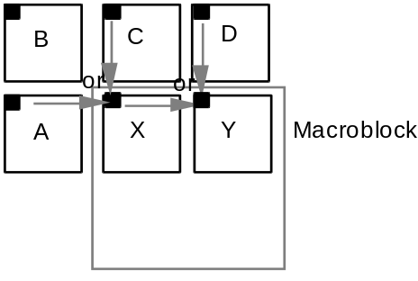
Figure 7-5 Previous neighboring blocks used in DC prediction
The inverse quantized DC values of the previous decoded blocks, F[0][0], are used to determine the direction of the DC and AC prediction as follows.
if ( |F_{A}[0][0] – F_{B}[0][0]| < |F_{B}[0][0] – F_{C}[0][0]|)
predict from block C
else
predict from block A
If any of the blocks A, B or C are outside of the vop boundary, or they do not belong to an intra coded macroblock, their F[0][0] values are assumed to take a value of 2^{(bits_per_pixel+3)} and are used to compute the prediction values.

Adaptive DC Coefficient Prediction
The adaptive DC prediction method involves selection of either the F[0][0] value of immediately previous block or that of the block immediately above it (in the previous row of blocks) depending on the prediction direction determined above.
if (predict from block C)
QF_{X}[0][0] = PQF_{X}[0][0] + F_{C}[0][0] // dc_scaler
else
QF_{X}[0][0] = PQF_{X}[0][0] + F_{A}[0][0] // dc_scaler
This process is independently repeated for every block of a macroblock using appropriate immediately horizontally adjacent block ‘A’ and immediately vertically adjacent block ‘C’.
DC predictions are performed similarly for the luminance and each of the two chrominance components.

Adaptive ac coefficient prediction
This process is used when ac_pred_flag = ‘1’, which indicates that AC prediction is performed when decoding the coefficients.
Either coefficients from the first row or the first column of a previous coded block are used to predict the co-sited coefficients of the current block. On a block basis, the best direction (from among horizontal and vertical directions) for DC coefficient prediction is also used to select the direction for AC coefficients prediction; thus, within a macroblock, for example, it becomes possible to predict each block independently from either the horizontally adjacent previous block or the vertically adjacent previous block. The AC coefficients prediction is illustrated in Figure 7-6.
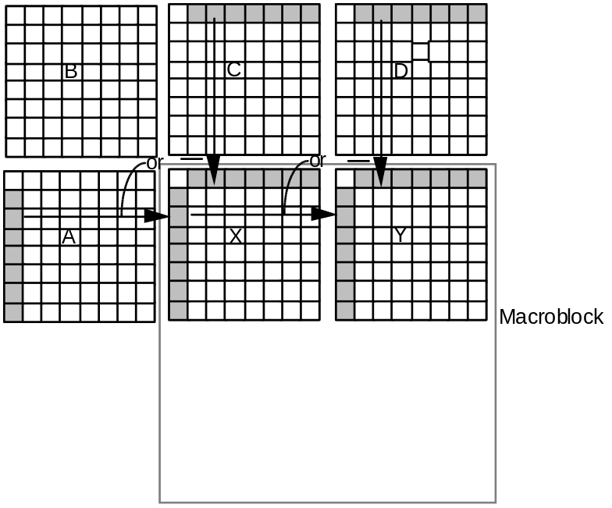
Figure 7-6 Previous neighboring blocks and coefficients used in AC prediction
To compensate for differences in the quantization of previous horizontally adjacent or vertically adjacent blocks used in AC prediction of the current block, scaling of prediction coefficients becomes necessary. Thus the prediction is modified so that the predictor is scaled by the ratio of the current quantisation stepsize and the quantisation stepsize of the predictor block. The definition is given in the equations below.
If block ‘A’ was selected as the predictor for the block for which coefficient prediction is to be performed, we calculate the horizontal AC prediction as follows.
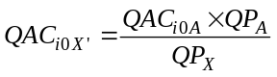
If block ‘C’ was selected as the predictor for the block for which coefficient prediction is to be performed, we calculate the vertical AC prediction as follows.
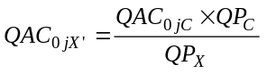
If block ‘A’ or block ‘C’ are outside of the VOP, then the corresponding QP values are assumed to be equal to QPx.
Note - When ac and dc DCT coefficient prediction is used in conjunction with error resilience, predictions shall not occur across video packet boundaries.

Inverse quantisation
The two-dimensional array of coefficients, QF[v][u], is inverse quantised to produce the reconstructed DCT coefficients. This process is essentially a multiplication by the quantiser step size. The quantiser step size is modified by two mechanisms; a weighting matrix is used to modify the step size within a block and a scale factor is used in order that the step size can be modified at the cost of only a few bits (as compared to encoding an entire new weighting matrix).
Figure 7-7 Inverse quantisation process
Figure 7-7 illustrates the overall inverse quantisation process. After the appropriate inverse quantisation arithmetic the resulting coefficients, F''[v][u], are saturated to yield F'[v][u] and then a mismatch control operation is performed to give the final reconstructed DCT coefficients, F[v][u].
NOTE - Attention is drawn to the fact that the method of achieving mismatch control in this specification is identical to that employed by ISO/IEC 13818-2.

First inverse quantisation method
This clause specifies the first of the two inverse quantisation methods.

Intra dc coefficient
The DC coefficients of intra coded blocks shall be inverse quantised in a different manner to all other coefficients.
In intra blocks F’’[0][0] shall be obtained by multiplying QF[0][0] by a constant multiplier,
The reconstructed DC values are computed as follows.
F’’[0][0] = dc_scaler* QF[0][0]

Other coefficients
All coefficients other than the DC coefficient of an intra block shall be inverse quantised as specified in this clause.
Two weighting matrices are used. One shall be used for intra macroblocks and the other for non-intra macroblocks. Each matrix has a default set of values which may be overwritten by down-loading a user defined matrix.
Let the weighting matrices be denoted by W[w][v][u] where w takes the values 0 to 1 indicating which of the matrices is being used. W[0][v][u] is for intra macroblocks, and W[1][v][u] is for non-intra macroblocks.
The following equation specifies the arithmetic to reconstruct F''[v][u] from QF[v][u] (for all coefficients except intra DC coefficients).
NOTE - The above equation uses the “/” operator as defined in 4.1.

Second inverse quantisation method
The quantization parameter quantiser_scale may take integer values from 1 to 31. The quantization stepsize is 2x quantiser_scale.

Dequantisation
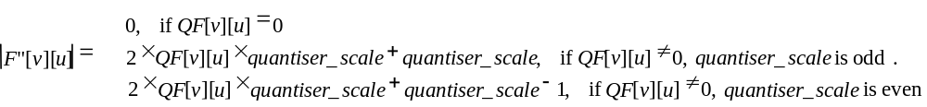
The sign of QF[v][u] is then added to obtain F"[v][u]´: F"[v][u]= Sign(QF[v][u])x|F"[v][u]|
Clipping to [-2048:2047] is performed before IDCT.

Optimised nonlinear inverse quantisation
Note: This section is valid for both quantization methods.
Within an Intra macroblock, luminance blocks are called type 1 blocks, chroma blocks are classified as type 2.
- DC coefficients of Type 1 blocks are quantized by Nonlinear Scaler for Type 1
- DC coefficients of Type 2 blocks are quantized by Nonlinear Scaler for Type 2
Table 7-2 specifies the nonlinear dc_scaler expressed in terms of piece-wise linear characteristics.
Table 7-2 Non linear scaler for DC coefficients of DCT blocks, expressed in terms of relation with quantizer_scale
Component:Type | dc_scaler for quantiser_scale range
 | 1 through 4 | 5 through 8 | 9 through 24 |  | 25 through 31
Luminance: Type1 | 8 | 2x quantiser_scale | quantiser_scale +8 |  | 2 x quantiser_scale -16
Chrominance: Type2 | 8 | (quantiser_scale +13)/2 |  | quantiser_scale -6
The reconstructed DC values are computed as follows.
F"[0][0]= QF[0][0]x dc_scaler

Saturation
The coefficients resulting from the Inverse Quantisation Arithmetic are saturated to lie in the range . Thus:

Mismatch control
This mismatch control is only applicable to the first inverse quantization method. Mismatch control shall be performed by any process equivalent to the following. Firstly all of the reconstructed, saturated coefficients, F'[v][u] in the block shall be summed. This value is then tested to determine whether it is odd or even. If the sum is even then a correction shall be made to just one coefficient; F[7][7]. Thus:
NOTES -
1 It may be useful to note that the above correction for F[7][7] may simply be implemented by toggling the least significant bit of the twos complement representation of the coefficient. Also since only the “oddness” or “evenness” of the sum is of interest an exclusive OR (of just the least significant bit) may be used to calculate “sum”.
2 Warning. Small non-zero inputs to the IDCT may result in zero output for compliant IDCTs. If this occurs in an encoder, mismatch may occur in some pictures in a decoder that uses a different compliant IDCT. An encoder should avoid this problem and may do so by checking the output of its own IDCT. It should ensure that it never inserts any non-zero coefficients into the bitstream when the block in question reconstructs to zero through its own IDCT function. If this action is not taken by the encoder, situations can arise where large and very visible mismatches between the state of the encoder and decoder occur.

Summary of quantiser process for method 1
In summary the inverse quantisation process is any process numerically equivalent to:

for (v=0; v<8;v++) {
for (u=0; u<8;u++) {
if (QF[v][u] == 0)
F’’[v][u] = 0;
else if ( (u==0) && (v==0) && (macroblock_intra) ) {
F''[v][u] = dc_scaler * QF[v][u];
} else {
if ( macroblock_intra ) {
F''[v][u] = ( QF[v][u] * W[0][v][u] * quantiser_scale * 2 ) / 32;
} else {
F''[v][u] = ( ( ( QF[v][u] * 2 ) + Sign(QF[v][u]) ) * W[1][v][u]
* quantiser_scale ) / 32;
}
}
}
}

sum = 0;
for (v=0; v<8;v++) {
for (u=0; u<8;u++) {
if ( F’'[v][u] > 2047 ) {
F’[v][u] = 2047;
} else {
if ( F’'[v][u] < -2048 ) {
F’[v][u] = -2048;
} else {
F’[v][u] = F'‘[v][u];
}
}
sum = sum + F’[v][u];
F[v][u] = F’[v][u];
}
}

if ((sum & 1) == 0) {
if ((F[7][7] & 1) != 0) {
F[7][7] = F'[7][7] - 1;
} else {
F[7][7] = F'[7][7] + 1;
}
}

Inverse DCT
Once the DCT coefficients, F[u][v] are reconstructed, the inverse DCT transform defined in Annex A shall be applied to obtain the inverse transformed values, 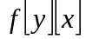.These values shall be saturated so that: 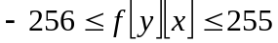, for all x, y.

Shape decoding
Binary shape decoding is based on a block-based representation. The primary coding methods are block-based context-based binary arithmetic decoding and block-based motion compensation. The primary data structure used is denoted as the binary alpha block (bab). The bab is a square block of binary valued pixels representing the opacity/transparency for the pixels in a specified block-shaped spatial region of size 16x16 pels. In fact, each bab is co-located with each texture macroblock.

Higher syntactic structures

Vol decoding
If video_object_layer_shape is equal to ‘00’ then no binary shape decoding is required. Otherwise, binary shape decoding is carried out.

Vop decoding
If video_object_layer_shape is not equal to ‘00’ then, for each subsequent vop, the dimensions of the bounding box of the reconstructed vop are obtained from:
- vop_width
- vop_height
If these decoded dimensions are not multiples of 16, then the values of vop_width and vop_height are rounded up to the nearest integer, which is a multiple of 16.
Additionally, in order to facilitate motion compensation, the horizontal and spatial position of the vop are obtained from:
- vop_horizontal_mc_spatial_ref
- vop_vertical_mc_spatial_ref
These spatial references may be different for each VOP but the same coordinate system must be used for all vops within a vol. Additionally, the decoded spatial references must have an even value.
- vop_shape_coding_type
This flag is used in error resilient mode and allows to have intra shape codes in P-VOPs.
Finally, in the VOP class, it is necessary to decode
- change_conv_ratio_disable
This specifies whether conv_ratio is encoded at the macroblock layer.
Once the above elements have been decoded, the binary shape decoder may be applied to decode the shape of each macroblock within the bounding box.

Macroblock decoding
The shape information for each macroblock residing within the bounding box of the vop is decoded into the form of a 16x16 bab.

Mode decoding
Each bab belongs to one of seven types listed in Table 7-3. The type information is given by the bab_type field which influences decoding of further shape information. For I-vops only three out of the seven modes are allowed as shown in Table 7-3.
Table 7-3 List of bab types
bab_type | Semantic | Used in
0 | MVDs==0 && No Update | P- ,B-vops
1 | MVDs!=0 && No Update | P- ,B-vops
2 | Transparent | All vop types
3 | Opaque | All vop types
4 | IntraCAE | All vop types
5 | MVDs==0 && interCAE | P- ,B-vops
6 | MVDs!=0 && interCAE | P- ,B-vops

I-vops
Suppose that f(x,y) is the bab_type of the bab located at (x,y), where x is the BAB column number and y is the BAB row number. The code word for the bab_type at the position (i,j) is determined as follows. A context C is computed from previously decoded bab_type’s.
C = 27*(f(i-1,j-1)-2) + 9*(f(i,j-1)-2) + 3*(f(i+1,j-1)-2) + (f(i-1,j)-2)
If f(x,y) references a bab outside the current vop, bab_type is assumed to be transparent for that bab (i.e. f(x,y)=2). If error_resilient_disable == 0, the bab_type of babs outside the current video packet is also assumed to be transparent. The VLC used to decode bab_type for the current bab is switched according to the value of the context C. This context-switched VLC table is given in Table 11-26.

P- and B-vops
The decoding of the current bab_type is dependent on the bab_type of the co-located bab in the forward reference vop: The forward reference vop is defined as the most recent valid reference vop in display order. If closed_GOV ==1, a valid reference vop is defined as an I-vop, or a P-vop for which vop_coded is != 0. If closed_GOV ==0, a valid reference vop is defined as an I-vop or a P-vop for which vop_coded is != 0.
If the sizes of the current and previous vops are different, some babs in the current block may not have a co-located equivalent in the previous vop. Therefore the bab_type matrix of the previous vop is manipulated to match the size of the current vop. Two rules are defined for that purpose, namely a cut rule and a copy rule:
- cut rule. If the number of lines (respectively columns) is smaller in the current VOP than in the previous one, the bottom lines (respectively rightmost columns) are eliminated from the previous VOP such that both VOP sizes match.
- copy rule. If the number of lines (respectively columns) is larger in the current VOP than in the previous one, the bottom line (respectively rightmost column) is replicated as many times as needed in the previous VOP such that both VOP sizes match.
An example is shown in Figure 7-8 where both rules are applied.

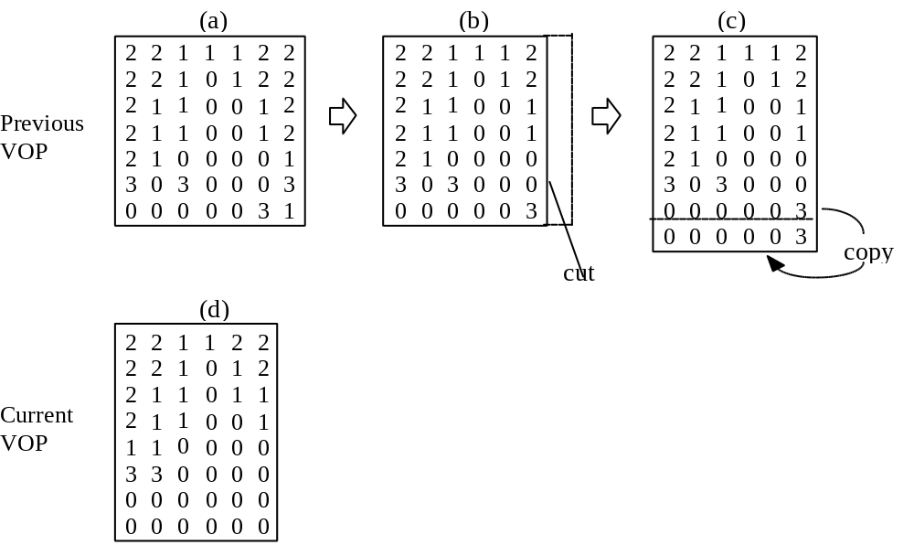
Figure 7-8 Example of size fitting between current vop and previous vop. The numbers represent the type of each bab.
The VLC to decode the current bab_type is switched according to the value of bab_type of the co-located bab in the previous vop. This context-switched VLC tables for I, P and B vops are given in.Table 11-26 and Table 11-27. If the type of the bab is transparent, then the current bab is filled with zero (transparent) values. A similar procedure is carried out if the type is opaque, where the reconstructed bab is filled with values of 255 (opaque). For both transparent and opaque types, no further decoding of shape-related data is required for the current bab. Otherwise further decoding steps are necessary, as listed in Table 7-4. Decoding for motion compensation is described in Section 8.4.2.2, and cae decoding in Section 8.4.2.5.
Table 7-4 Decoder components applied for each type of bab
bab_type | Motion compensation | CAE decoding
0 | yes | no
1 | yes | no
2 | no | no
3 | no | no
4 | no | yes
5 | yes | yes
6 | yes | yes

Binary alpha block motion compensation
Motion Vector of shape (MVs) is used for motion compensation (MC) of shape. The value of MVs is reconstructed as described in section 8.4.2.3. Integer pixel motion compensation is carried out on a 16x16 block basis according to section 8.4.2.4. Overlapped MC, half sample MC and 8x8 MC are not carried out.
If bab_type is MVDs==0 && No Update or MVDs!=0 && No Update then the motion compensated bab is taken to be the decoded bab, and no further decoding of the bab is necessary. Otherwise, cae decoding is required.

Motion vector decoding
If bab_type indicates that MVDs!=0, then mvds_x and mvds_y are VLC decoded. For decoding mvds_x, the VLC given in Table 11-28 is used. The same table is used for decoding mvds_y, unless the decoded value of mvds_x is zero. In this case, the VLC given in Table 11-29 is used for decoding mvds_y.
If bab_type indicates that MVDs==0, then both mvds_x and mvds_y are set to zero.
The integer valued shape motion vector MVs=(MVs_x,MVs_y) is determined as the sum of a predicted motion vector MVPs and MVDs = (MVDs_x,MVDs_y), where MVPs is determined as follows.
MVPs is determined by analysing certain candidate motion vectors of shape (MVs) and motion vectors of selected texture blocks (MV) around the MB corresponding to the current bab. They are located and denoted as shown in Figure 7-9 where MV1, MV2 and MV3 are rounded up to integer values. Regarding the texture MVs, the convention is that a MB possessing only 1 MV is considered the same as a MB possessing 4 MVs, where the 4 MVs are equal. By traversing MVs1, MVs2, MVs3, MV1, MV2 and MV3 in this order, MVPs is determined by taking the first encountered MV that is defined. That is, for INTER coded MBs, there will exist a defined motion vector for texture. For BABs, with bab_type = 0,1,5 or 6, there will exist a defined motion vector of shape. No valid motion vectors will exist in INTRA coded MBs and BABs. If no candidate motion vectors is defined, MVPs = (0,0).
In the case that video_object_layer_shape is “binary_shape_only” or vop_coding_type indicates B-VOP or error_resilient_disable==0, MVPs is determined by considering the motion vectors of shape (MVs1, MVs2 and MVs3) only. The following sections explain the definition of MVs1, MVs2, MVs3, MV1, MV2 and MV3 of in more detail.
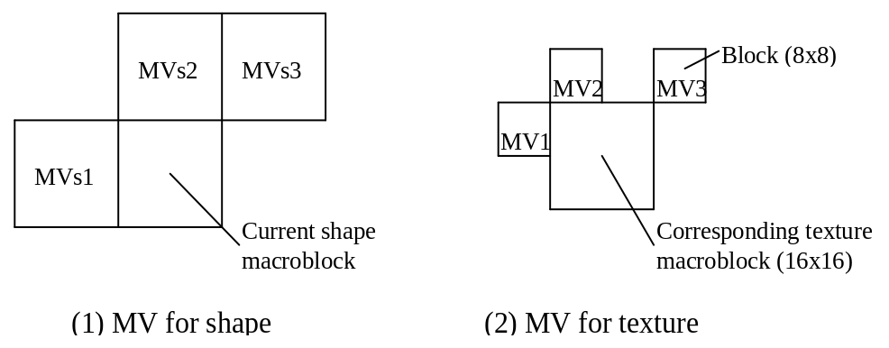
Figure 7-9 Candidates for MVPs
Defining candidate predictors from texture motion vectors:
One shape motion vector predictor MV_{i} ( i =1,2,3 ) is defined for each block located around the current bab according to Figure 7-9. The definition depends on the MB type of the MB of the block. It is outlined in Table 7-5.
Table 7-5 Definition of candidate shape motion vector predictors MV_{i} (MV1, MV2, and MV3) from texture motion vector for P-vops. Note that interlaced modes are not included.
MB type of reference MB | MV_{i}
INTER or INTER + Q | All four blocks (transparent or not) in the reference MB share the same MV as Mv_{i}, hence MV_{i} = MV
INTER4V | MV_{i} is set to the motion vector of that block that is located at the positions shown in Figure 7-9 (2). If the block is transparent, MV_{i} not defined.
INTRA or INTRA + Q | All four blocks (transparent or not) in the reference MB share the same MV = (0, 0). MV_{i}=(0,0).
COD=1 (skipped MB) | All four blocks (transparent or not) in the reference MB share the same MV = (0, 0). MV_{i}=(0,0).
MB outside VOP | MV_{i} is undefined.
Defining candidate predictors from shape motion vectors:
The candidate motion vector predictors MVs_{i} are defined by the shape motion vectors of neighbouring bab located according to Figure 7-9 (1). The MVs_{i} are defined according to Table 7-6.
Table 7-6 Definition of candidate shape motion vector predictors MVs1, MVs2, and MVs3 from shape motion vectors for P and B-vops. Note that interlaced modes are not included
Shape mode of reference MB | MVs_{i} for each reference shape block-i (a shape block is 16x16)
MVDs == 0 or MVDs !=0  bab_type 0, 1, 5,6 | The retrieved shape motion vector of the said reference MB is defined as MVs_{i} . Note that MVs_{i} is defined, and hence valid, even if the reconstructed shape block is transparent.
all_0, bab_type 2 | MVs_{i} is undefined
all=255, bab_type 3 | MVs_{i} is undefined
Intra, bab_type 4 | MVs_{i} is undefined

Motion compensation
For inter mode babs (bab_type = 0,1,5 or 6), motion compensation is carried out by simple MV displacement according to the MVs.
Specifically, when bab_type is equal to 0 or 1 i.e. for the no-update modes, a displaced block of 16x16 pixels is copied from the binary alpha map of the previously decoded I or P vop for which vop_coded is not equal to ‘0’. When the bab_type is equal to 5 or 6 i.e. when interCAE decoding is required, then the pixels immediately bordering the displaced block (to the left, right, top and bottom) are also copied from the most recent valid reference vop’s (as defined in Section 7.3.6) binary alpha map into a temporary shape block of 18x18 pixels size (see Figure 7-12). If the displaced position is outside the binary alpha map, then these pixels are assumed to be “transparent”.

Context based arithmetic decoding
Before decoding the binary_arithmetic_code field, border formation (see Section 8.4.2.5.2) needs to be carried out. Then, if the scan_type field is equal to 0, the bordered to-be decoded bab and the eventual bordered motion compensated bab need to be transposed (as for matrix transposition). If change_conv_rate_disable is equal to 0, then conv_ratio is decoded to determine the size of the sub-sampled BAB, which is 16/conv_ratio by 16/conv_ratio pixels large. If change_conv_rate_disable is equal to 1, then the decoder assumes that the bab is not subsampled and thus the size is simply 16x16 pixels. Binary_arithmetic_code is then decoded by a context-based arithmetic decoder as follows. The arithmetic decoder is firstly initialised (see Section 8.4.3.3). The pixels of the sub-sampled bab are decoded in raster order. At each pixel,
- A context number is computed based on a template, as described in Section 8.4.2.5.1.
- The context number is used to access the probability table (Table 11-28).
- Using the accessed probability value, the next bits of binary_arithmetic_code are decoded by the arithmetic decoder to give the decoded pixel value.
When all pixels in sub-sampled BAB have been decoded, the arithmetic decoder is terminated (see Section 8.4.3.6).
If the scan_type field is equal to 0, the decoded bab is transposed. Then up-sampling is carried out if conv_ratio is different from 1, as described in Section 8.4.2.5.3. Then the decoded bab is copied into the decoded shape map.

Context computation
For INTRA coded BABs, a 10 bit context 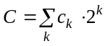is built for each pixel as illustrated in Figure 7-10 (a), where c_{k}==0 for transparent pixels and c_{k}==1 for opaque pixels.

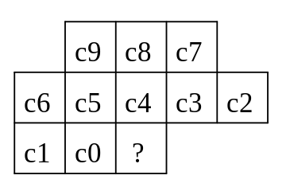 | 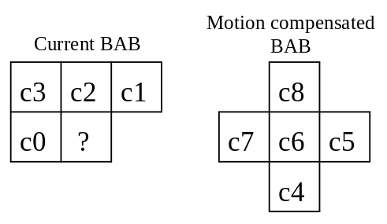
(a) | (b)
Figure 7-10 (a) The INTRA template (b) The INTER template where c6 is aligned with the pixel to be decoded. The pixel to be decoded is marked with ‘?’.
For INTER coded BABs, temporal redundancy is exploited by using pixels from the bordered motion compensated BAB (depicted in Figure 7-12) to make up part of the context. Specifically, a 9 bit context 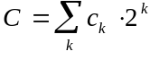 is built as illustrated in Figure 7-10 (b).
There are some special cases to note.
- When building contexts, any pixels outside the bounding box of the current VOP to the left and above are assumed to be zero (transparent).
- When building contexts and error_resilient_disable==0, any pixels outside the space of the current video packet to the left and above are assumed to be zero (transparent).
- The template may cover pixels from BABs which are unknown at decoding time. Unknown pixels are defined as area U in Figure 7-11. The values of these unknown pixels are defined by the following procedure:
- When constructing the INTRA context, the following steps are taken in the sequence
- if (c7 is unknown) c7=c8,
- if (c3 is unknown) c3=c4,
- if (c2 is unknown) c2=c3.
- When constructing the INTER context, the following conditional assignment is performed.
if (c1 is unknown) c1=c2

Border formation
When decoding a BAB, pixels from neighbouring BABs can be used to make up the context. For both the INTRA and INTER cases, a 2 pixel wide border about the current BAB is used where pixels values are known, as depicted in Figure 7-11.
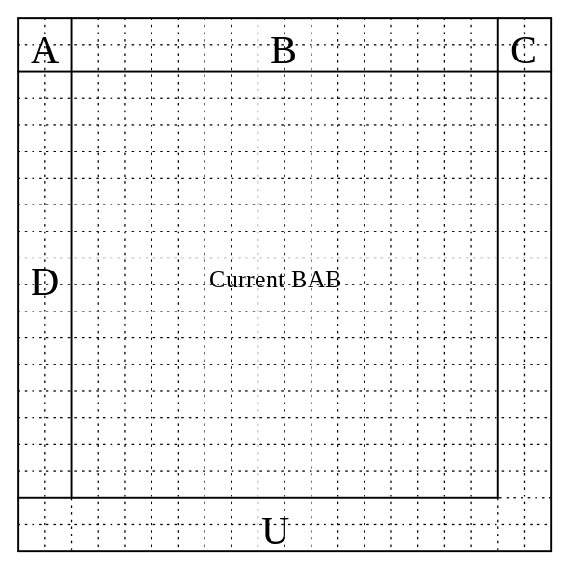
Figure 7-11 Bordered BAB. A: TOP_LEFT_BORDER. B: TOP_BORDER. C: TOP_RIGHT_BORDER. D: LEFT_BORDER. U: pixels which are unknown when decoding the current BAB.
If the value of conv_ratio is not equal to 1, a sub-sampling procedure is further applied to the BAB borders for both the current BAB and the motion compensated BAB.
The border of the current BAB is partitioned into 4:
- TOP_LEFT_BORDER, which contains pixels from the BAB located to the upper-left of the current BAB and which consists of 2 lines of 2 pixels
- TOP_BORDER, which contains pixels from the BAB located above the current BAB and which consists of 2 lines of 16 pixels
- TOP_RIGHT_BORDER, which contains pixels from the BAB located to the upper-right of the current BAB and which consists of 2 lines of 2 pixels
- LEFT_BORDER, which contains pixels from the BAB located to the left of the current BAB and which consists of 2 columns of 16 pixels
The TOP_LEFT_BORDER and TOP_RIGHT_BORDER are not sub-sampled, and kept as they are. The TOP_BORDER and LEFT_BORDER are sub-sampled such as to obtain 2 lines of 16/conv_ratio pixels and 2 columns of 16/conv_ratio pixels, respectively.
The sub-sampling procedure is performed on a line-basis for TOP_BORDER, and a column-basis for LEFT_BORDER. For each line (respectively column), the following algorithm is applied: the line (respectively column) is split into groups of conv_ratio pixels. For each group of pixels, one pixel is associated in the sub-sampled border. The value of the pixel in the sub-sampled border is OPAQUE if half or more pixels are OPAQUE in the corresponding group. Otherwise the pixel is TRANSPARENT.
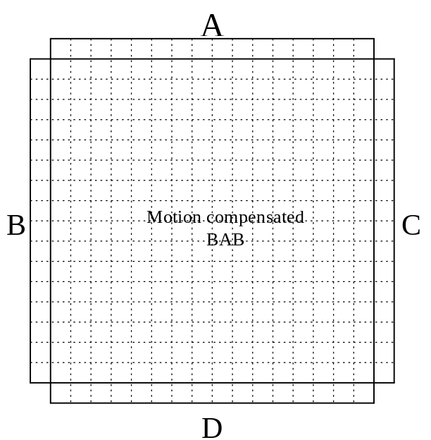
Figure 7-12 Bordered motion compensated BAB. A: TOP_BORDER. B: LEFT_BORDER. C: RIGHT_BORDER. D: BOTTOM_BORDER.
In case of a motion compensated BAB, the border is also partitioned into 4, as shown Figure 7-12:
- TOP_BORDER, which consists of a line of 16 pixels
- LEFT_BORDER, which consists of a column of 16 pixels
- RIGHT_BORDER, which consists of a column of 16 pixels
- BOTTOM_BORDER, which consists of a line of 16 pixels
The very same sub-sampling process as described above is applied to each of these borders.

Upsampling
When conv_ratio is different from 1, up-sampling is carried out for the BAB. This is illustrated in Figure 7.13 where “O” in this figure is the coded pixel and “X” is the interpolated pixel. To compute the value of the interpolated pixel, a filter context from the neighboring pixels is first calculated. For the pixel value calculation, the value of “0” is used for a transparent pixel, and “1” for an opaque pixel. The values of the interpolated pixels (Pi, i=1,2,3,4, as shown in Figure 7-14) can then be determined by the following equation:
P1 : if( 4*A + 2*(B+C+D) + (E+F+G+H+I+J+K+L) > Th[Cf]) then "1" else "0"
P2 : if( 4*B + 2*(A+C+D) + (E+F+G+H+I+J+K+L) > Th[Cf]) then "1" else "0"
P3 : if( 4*C + 2*(B+A+D) + (E+F+G+H+I+J+K+L) > Th[Cf]) then "1" else "0"
P4 : if( 4*D + 2*(B+C+A) + (E+F+G+H+I+J+K+L) > Th[Cf]) then "1" else "0"
The 8-bit filter context, Cf, is calculated as follows:
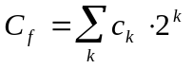
Based on the calculated Cf, the threshold value (Th[Cf]) can be obtained from the look-up table as follows:
Th[256] = {
3, 6, 6, 7, 4, 7, 7, 8, 6, 7, 5, 8, 7, 8, 8, 9,
6, 5, 5, 8, 5, 6, 8, 9, 7, 6, 8, 9, 8, 7, 9, 10,
6, 7, 7, 8, 7, 8, 8, 9, 7, 10, 8, 9, 8, 9, 9, 10,
7, 8, 6, 9, 6, 9, 9, 10, 8, 9, 9, 10, 11, 10, 10, 11,
6, 9, 5, 8, 5, 6, 8, 9, 7, 10, 10, 9, 8, 7, 9, 10,
7, 6, 8, 9, 8, 7, 7, 10, 8, 9, 9, 10, 9, 8, 10, 9,
7, 8, 8, 9, 6, 9, 9, 10, 8, 9, 9, 10, 9, 10, 10, 9,
8, 9, 11, 10, 7, 10, 10, 11, 9, 12, 10, 11, 10, 11, 11, 12,
6, 7, 5, 8, 5, 6, 8, 9, 5, 6, 6, 9, 8, 9, 9, 10,
5, 8, 8, 9, 6, 7, 9, 10, 6, 7, 9, 10, 9, 10, 10, 11,
7, 8, 6, 9, 8, 9, 9, 10, 8, 7, 9, 10, 9, 10, 10, 11,
8, 9, 7, 10, 9, 10, 8, 11, 9, 10, 10, 11, 10, 11, 9, 12,
7, 8, 6, 9, 8, 9, 9, 10, 10, 9, 7, 10, 9, 10, 10, 11,
8, 7, 7, 10, 7, 8, 8, 9, 9, 10, 10, 11, 10, 11, 11, 12,
8, 9, 9, 10, 9, 10, 10, 9, 9, 10, 10, 11, 10, 11, 11, 12,
9, 10, 10, 11, 10, 11, 11, 12, 10, 11, 11, 12, 11, 12, 12, 13 };
TOP_LEFT_BORDER, TOP_RIGHT_BORDER, sub-sampled TOP_BORDER and sub-sampled LEFT_BORDER described in the previous section are used. The other pixels outside the BAB are extended from the outermost pixels inside the BAB as shown in Figure 7-13.
In the case that conv_ratio=4, the interpolation is processed twice. The above mentioned borders of 4x4 BAB are used for the interpolation from 4x4 to 8x8, and top-border (resp. left-border) for the interpolation from 8x8 to 16x16 are up-sampled from the 4x4 BAB top-border (resp. left-border) by simple repetition.
When the BAB is on the left (and/or top) border of VOP, the borders outside VOP are set to zero value. The upsampling filter should be constrained to avoid using pixel values outside of the current video packet.

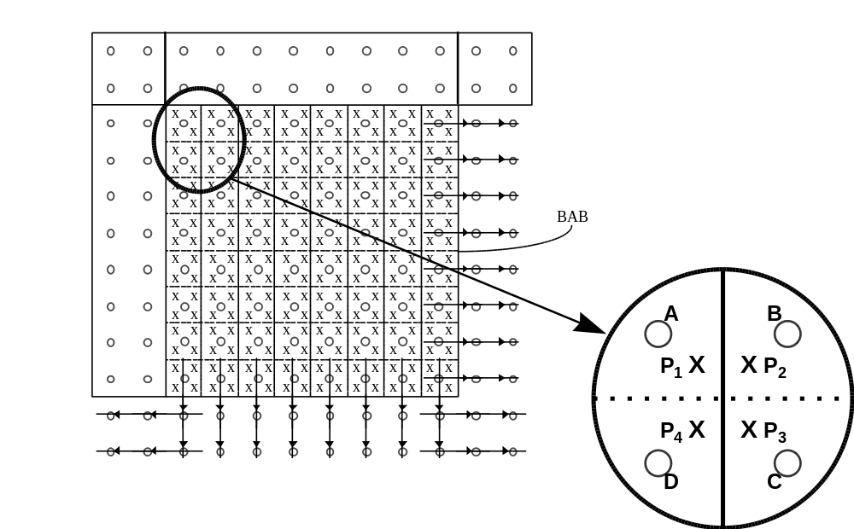
Figure 7-13 Upsampling

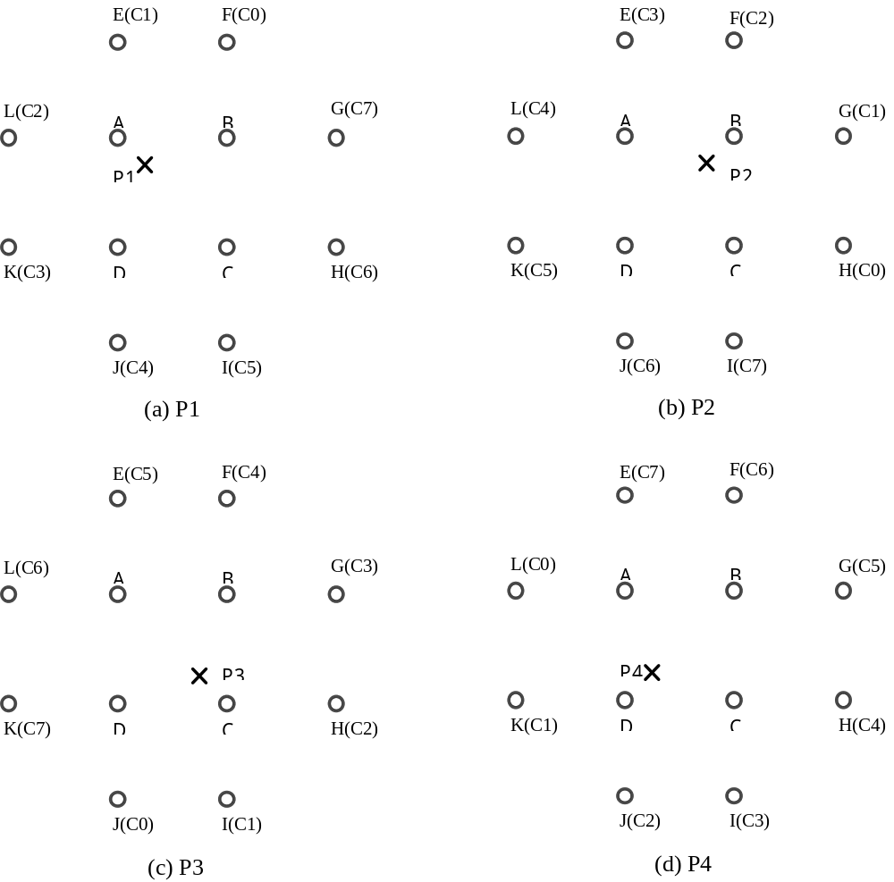
Figure 7-14 Interpolation filter and interpolation construction.

Down-sampling process in inter case
If bab_type is ‘5’ or ‘6’ (see Table 7.3), downsampling of the motion compensated bab is needed for calculating the 9 bit context in the case that conv_ratio is not 1. The motion compensated bab of size 16x16 pixels is down sampled to bab of size 16/conv_ratio by 16/conv_ratio pixels by the following rules:
- conv_ratio==2
If the average of pixel values in 2 by 2 pixel block is equal to or greater than 127.5 the pixel value of the downsampled bab is set to 255 otherwise it is set to 0.
- conv_ratio==4
If the average of pixel values in 4 by 4 pixel block is equal to or greater than 127.5 the pixel value of the downsampled bab is set to 255 otherwise it is set to 0.

Arithmetic decoding
Arithmetic decoding consists of four main steps:
- Removal of stuffed bits
- Initialization which is performed prior to the decoding of the first symbol
- Decoding of the symbol themselves. The decoding of each symbol may be followed by a re-normalization step.
Termination which is performed after the decoding of the last symbol

Registers, symbols and constants
Several registers, symbols and constants are defined to describe the arithmetic decoder.
- HALF: 32-bit fixed point constant equal to ½ (0x80000000)
- QUARTER: 32-bit fixed point constant equal to ¼ (0x40000000)
- L: 32-bit fixed point register. Contains the lower bound of the interval
- R: 32-bit fixed point register. Contains the range of the interval.
- V: 32-bit fixed point register. Contains the value of the arithmetic code. V is always larger than or equal to L and smaller than L+R.
- p0: 16-bit fixed point register. Probability of the ‘0’ symbol.
- p1: 16-bit fixed point register. Probability of the ‘1’ symbol.
- LPS: boolean. Value of the least probable symbol (‘0’ or ‘1’).
- bit: boolean. Value of the decoded symbol.
- pLPS: 16-bit fixed point register. Probability of the LPS.
- rLPS: 32-bit fixed point register. Range corresponding to the LPS.

Bit stuffing
In order to avoid start code emulation, 1’s are stuffed into the bitstream whenever there are too many successive 0’s. If the first MAX_HEADING bits are 0’s, then a 1 is transmitted after the MAX_HEADING-th 0. If more than MAX_MIDDLE 0’s are sent successively a 1 is inserted after the MAX_MIDDLE-th 0. If the number of trailing 0’s is larger than MAX_TRAILING, then a 1 is appended to the stream. The decoder shall properly skip these inserted 1’s when reading data into the V register (see Section 7.4.3.3 and 7.4.3.5).
MAX_HEADING equals 8, MAX_MIDDLE equals 16, and MAX_TRAILIING equals 8. For error_resilience_diable==0, MAX_HEADING equals 3, MAX_MIDDLE equals 10, and MAX_TRAILIING equals 2.

Initialization
The lower bound L is set to 0, the rangeR to HALF-0x1 (0x7fffffff) and the first 31 bits are read in register V.

Decoding a symbol
When decoding a symbol, the probability p0 of the ‘0’ symbol is provided according to the context computed in Section 8.4.2.5.1 and using Table 11-32. p0 uses a 16-bit fixed-point number representation. Since the decoder is binary, the probability of the ‘1’ symbol is defined to be 1 minus the probability of the ‘0’ symbol, i.e. p1 = 1-p0.
The least probable symbol LPS is defined as the symbol with the lowest probability. If both probabilities are equal to ½ (0x8000), the ‘0’ symbol is considered to be the least probable.
The range rLPS associated with the LPS may simply be computed as R*pLPS: The 16 most significant bits of register R are multiplied by the 16 bits of pLPS to obtain the 32 bit rLPS number.
The interval [L,L+R) is split into two intervals [L,L+R-rLPS) and [L+R-rLPS,L+R). If V is in the latter interval then the decoded symbol is equal to LPS. Otherwise the decoded symbol is the opposite of LPS. The interval [L,L+R) is then reduced to the sub-interval in which V lies.
After the new interval has been computed, the new range R might be smaller than QUARTER. If so, re-normalization is carried out, as described below.

Re-normalization
As long as R is smaller than QUARTER, re-normalization is performed.
- If the interval [L,L+R) is within [0,HALF), the interval is scaled to [2L,2L+2R). V is scaled to 2V.
- If the interval [L,L+R) is within [HALF,1) the interval is scaled to [2(L-HALF),2(L-HALF)+2R). V is scaled to 2(V-HALF).
- Otherwise the interval is scaled to [2(L-QUARTER),2(L-QUARTER)+2R). V is scaled to 2(V-QUARTER).
After each scaling, a bit is read and copied into the least significant bit of register V.

Termination
After the last symbol has been decoded, additional bits need to be “consumed”. They were introduced by the encoder to guarantee decodability.
In general 3 further bits need to be read. However, in some cases, only two bits need to be read. These cases are defined by:
- if the current interval covers entirely [QUARTER,HALF)
- if the current interval covers entirely [HALF, 3QUARTER)
After these additional bits have been read, 32 bits shall be “unread”, i.e. put the content of register V back into the bit buffer.

Software
The example software for arithmetic decoding for binary shape decoding is included in Annex B.

Motion compensation decoding
In order to perform motion compensated prediction on a per vop basis, a special padding technique, i.e. the macroblock-based repetitive padding, is applied for the reference VOP. The details of these techniques are described in the following sections.
Since a vop may have arbitrary shape, and this shape can change from one instance to another, conventions are necessary to ensure the consistency of the motion compensation process.
The absolute (frame) coordinate system is used for referencing every vop. At every given instance, a bounding rectangle that includes the shape of that vop, as described in clause 8.4, is defined. The left and top corner, in the absolute coordinates, of the bounding box is decoded from vop spatial reference. Thus, the motion vector for a particular feature inside a vop, e.g. a macroblock, refers to the displacement of the feature in absolute coordinates. No alignment of vop bounding boxes at different time instances is performed.
In addition to the above motion compensation processing, two additional processes are supported, namely, unrestricted motion compensation and four MV motion compensation. In addition to the above, an overlapped motion compensation can be performed optionally. Note that in all three modes, macroblock-based padding of the reference vop is performed for motion compensation.

Padding process
The padding process defines the values of luminance and chrominance samples outside the vop for prediction of arbitrarily shaped objects. Figure 7-15 shows a simplified diagram of this process.
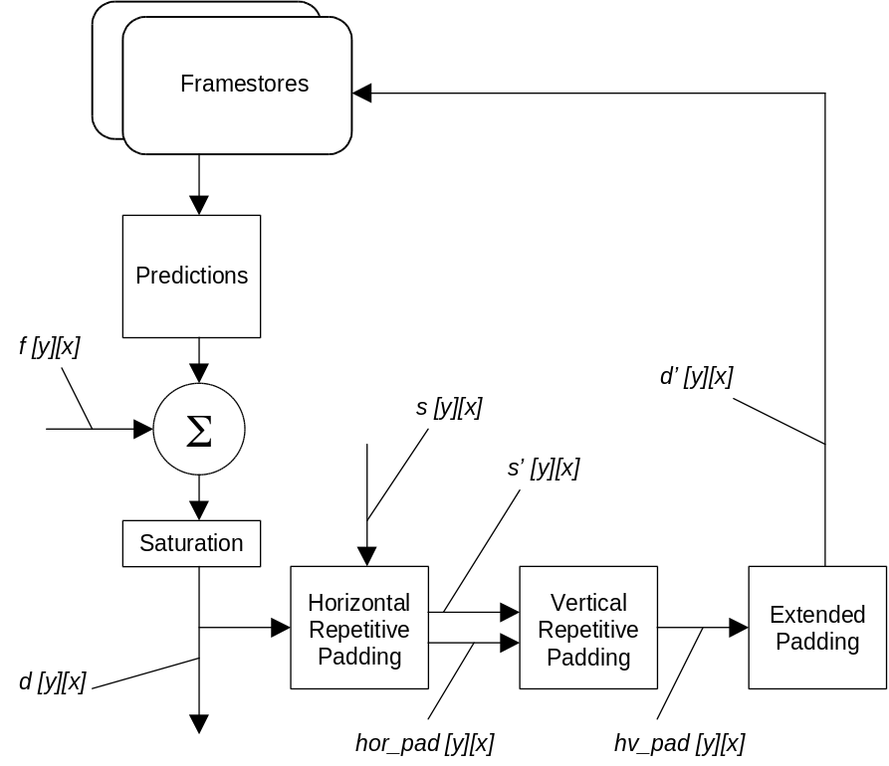
Figure 7-15 Simplified padding process
A decoded macroblock d[y][x] is padded by referring to the corresponding decoded shape block s[y][x]. The luminance component is padded per 16 x 16 samples, while the chrominance components are padded per 8 x 8 samples. A macroblock that lies on the vop boundary (hereafter referred to as a boundary macroblock) is padded by replicating the boundary samples of the vop towards the exterior. This process is divided into horizontal repetitive padding and vertical repetitive padding. The remaining macroblocks that are completely outside the vop (hereafter referred to as exterior macroblocks) are filled by extended padding.
Note - The padding process is applied to all macroblocks inside the bounding rectangle of a vop. The bounding rectangle of the luminance component is defined by vop_width and vop_height extended to multiple of 16, while that of the chrominance components is defined by (vop_width>>1) and (vop_height>>1) extended to multiple of 8.

Horizontal repetitive padding
Each sample at the boundary of a vop is replicated horizontally to the left and/or right direction in order to fill the transparent region outside the vop of a boundary macroblock. If there are two boundary sample values for filling a sample outside of a vop, the two boundary samples are averaged (//2).
hor_pad[y][x] is generated by any process equivalent to the following example. For every line with at least one shape sample s[y][x] == 1(inside the vop) :
for (x=0; x<N; x++) {
if (s[y][x] == 1) { hor_pad[y][x] = d[y][x]; s’[y][x] = 1; }
else {
if ( s[y][x’] == 1 && s[y][x”] == 1) {
hor_pad[y][x] = (d[y][x’]+ d[y][x”])//2;
s’[y][x] = 1;
} else if ( s[y][x’] == 1 ) {
hor_pad[y][x] = d[y][x’]; s’[y][x] = 1;
} else if ( s[y][x”] == 1 ) {
hor_pad[y][x] = d[y][x”]; s’[y][x] = 1;
}
}
}
where x’ is the location of the nearest valid sample (s[y][x’] == 1) at the vop boundary to the left of the current location x, x” is the location of the nearest boundary sample to the right, and N is the number of samples of a line. s’[y][x] is initialized to 0.

Vertical repetitive padding
The remaining unfilled transparent horizontal samples (where s’[y][x] == 0) from Section 8.5.1.1 are padded by a similar process as the horizontal repetitive padding but in the vertical direction. The samples already filled in Section 8.5.1.1 are treated as if they were inside the vop for the purpose of this vertical pass.
hv_pad[y][x] is generated by any process equivalent to the following example. For every column of hor_pad[y][x] :
for (y=0; y<M; y++) {
if (s’[y][x] == 1)
hv_pad[y][x] =hor_pad[y][x];
else {
if ( s’[y’][x] == 1 && s’[y”][x] == 1 )
hv_pad[y][x] = (hor_pad[y’][x] + hor_pad[y”][x])//2;
else if ( s’[y’][x] == 1 )
hv_pad[y][x] = hor_pad[y’][x];
else if (s’[y”][x] == 1 )
hv_pad[y][x] = hor_pad[y”][x];
}
}
where y’ is the location of the nearest valid sample (s’[y’][x] == 1) above the current location y at the boundary of hv_pad, y” is the location of the nearest boundary sample below y, and M is the number of samples of a column.

Extended padding
Exterior macroblocks immediately next to boundary macroblocks are filled by replicating the samples at the border of the boundary macroblocks. Note that the boundary macroblocks have been completely padded in Section 8.5.1.1 and Section 8.5.1.2. If an exterior macroblock is next to more than one boundary macroblocks, one of the macroblocks is chosen, according to the following convention, for reference.
The boundary macroblocks surrounding an exterior macroblock are numbered in priority according to Figure 7-16. The exterior macroblock is then padded by replicating upwards, downwards, leftwards, or rightwards the row of samples from the horizontal or vertical border of the boundary macroblock having the largest priority number.
The remaining exterior macroblocks (not located next to any boundary macroblocks) are filled with 2^{bits_pixel-1}. For 8-bit luminance component and associated chrominance this implies filling with 128.

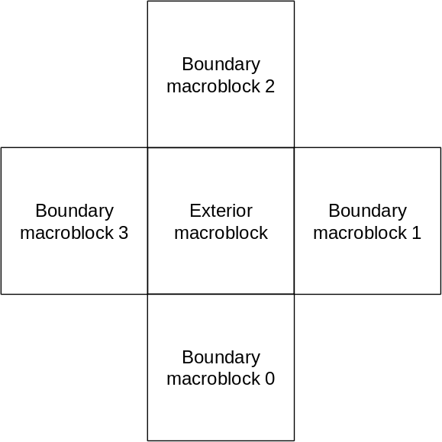
Figure 7-16 Priority of boundary macroblocks surrounding an exterior macroblock

Padding for chrominance components
Chrominance components are padded according to clauses 8.5.1.1 through 8.5.1.3 for each 8 x 8 block. The padding is performed by referring to a shape block generated by decimating the shape block of the corresponding luminance component. For each 2 x 2 adjacent luminance shape samples, the corresponding chrominance shape sample is set to 1 if any of the four luminance shape samples are 1. Otherwise the chrominance shape sample is set to 0.

Padding of interlaced macroblocks
Macroblocks of interlaced vop (interlaced = 1) are padded according to clauses 8.5.1.1 through 8.5.1.3. The vertical padding of the luminance component, however, is performed for each field independently. A sample outside of a vop is therefore filled with the value of the nearest boundary sample of the same field.

Half sample interpolation
Pixel value interpolation for block matching when rounding is used corresponds to bilinear interpolation as depicted in Figure 7-17. The value of rounding_control is defined using the vop_rounding_type bit in the vop header (see clause 7.3.6). Note that the samples outside the padded region cannot be used for interpolation.
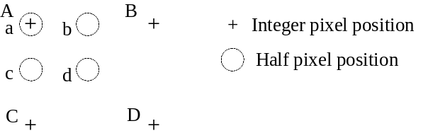
a = A,
b = (A + B + 1 - rounding_control) / 2
c = (A + C + 1 - rounding_control) / 2,
d = (A + B + C + D + 2 - rounding_control) / 4

Figure 7-17 Interpolation scheme for half sample search.

Motion vectors
When using motion compensated coding, a motion vector must be decoded. The horizontal and vertical motion vector components are decoded differentially by using a prediction from the spatial neighborhood consisting of three motion vectors already decoded, as depicted in Figure 7-18. The final motion vector is obtained by adding the predictors component-wise to the decoded differential vector which is indicated by MVDx and MVDy, respectively.
In the special cases at the borders of the current vop or video packet the following decision rules are applied:
1. If the macroblock of one and only one candidate predictor is outside of the vop or video packet, it is set to zero.
2. If the macroblocks of two and only two candidate predictors are outside of the vop or video packet, they are set to the third candidate predictor.
3. If the macroblocks of all three candidate predictors are outside of the vop or video packet, they are set to zero.
The motion vector decoding is performed separately on the horizontal and vertical components. Therefore, first for each component, the median value of the three candidates for the same component is computed as predictor, denoted by Px and Py:
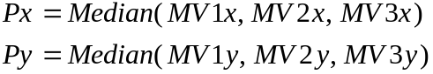
For instance, if MV1=(-2,3), MV2=(1,5) and MV3=(-1,7), then Px = -1 and Py = 5.
If the error_resilient_disable_flag is not set, one dimensional prediction is used:
Px = MV1x
Py = MV1y
MV1 takes the value 0 after a resynchronisation marker.
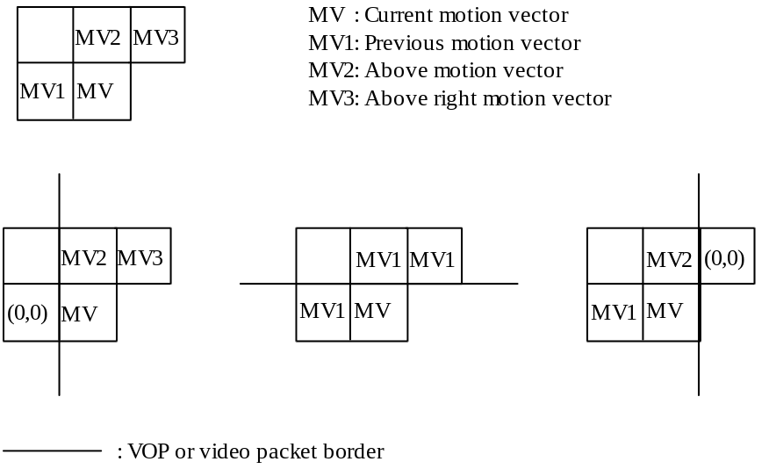
Figure 7-18 Motion vector prediction.
Finally, each component of the motion vector, MVx and MVy, shall be calculated by any process that is equivalent to the following one. All calculations are carried out in halfpel units in the following.
r_size = vop_fcode - 1
f = 1 << r_size
high = ( 32 * f ) - 1;
low = ( (-32) * f );
range = ( 64 * f );

if ( (f == 1) || (horizontal_mv_data == 0) )
MVDx = horizontal_mv_data;
else {
MVDx = ( ( Abs(horizontal_mv_data) - 1 ) * f ) + horizontal_mv_residual + 1;
if (horizontal_mv_data < 0)
MVDx = - MVDx;
}

if ( (f == 1) || (vertical_mv_data == 0) )
MVDy = vertical_mv_data;
else {
MVDy = ( ( Abs(vertical_mv_data) - 1 ) * f ) + vertical_mv_residual + 1;
if (vertical_mv_data < 0)
MVDy = - MVDy;
}

MVx = Px + MVDx;
if ( MVx < low )
MVx = MVx + range;
if (MVx > high)
MVx = MVx - range;

MVy = Py + MVDy;
if ( MVy < low )
MVy = MVy + range;
if (MVy > high)
MVy = MVy - range;

The parameters in the bitstream shall be such that the components of the reconstructed differential motion vector, MVDx andd MVDy, shall lie in the range [low:high]. In addition the components of the reconstructed motion vector, MVx and MVy, shall also lie in the range [low : high]. The allowed range [low : high] for the motion vectors depends on the parameter vop_fcode; it is shown in Table 11-11.
The variables r_size, f, MVDx, MVDy, high , low and range are temporary variables that are not used in the remainder of this specification.
The parameters horizontal_mv_data, vertical_mv_data, horizontal_mv_residual and vertical_mv_residual are parameters recovered from the bitstream.
The variable vop_fcode refers either to the parameter vop_fcode_forward or to the parameter vop_fcode_backward which have been recovered from the bitstream, depending on the respective prediction mode. In case of P-VOP prediction, which is described in this section, only forward prediciton applies. In case of B-VOP prediction, forward as well as backward prediction may apply.

vop_fcode_forward or vop_fcode_backward | motion vector range in halfsample units  [low:high]
1 | [-32,31]
2 | [-64,63]
3 | [-128,127]
4 | [-256,255]
5 | [-512,511]
6 | [-1024,1023]
7 | [-2048,2047]
Table 7-7 Range for motion vectors
When interlaced video is decoded, if one or more of MV1, MV2 or MV3 refers to a field motion compensated macroblock, the value of MVi is the average of the two field motion vectors. If a 1/4 or 3/4 pixel offset is obtained by the average, it is replaced with a 1/2 pixel offset.
If the current macroblock is a field motion compensated macroblock, then the same prediction motion vector (Px, Py) is used for both field motion vectors. Because the vertical component of a field motion vector is integral, the vertical differential motion vector encoded in the bitstream is
MVy = MVDy_{field} + (int) PY/2
where (int)Py means truncate Py toward zero to the nearest integer value.

Unrestricted motion compensation
Motion vectors are allowed to point outside the decoded area of a reference vop. For an arbitrary shape vop, the decoded area refers to the area within the bounding box, padded as described in clause Section 8.5.1. A bounding box is defined by vop_width and vop_height extended to multiple of 16. When a sample referenced by a motion vector stays outside the decoded vop area, an edge sample is used. This edge sample is retrieved by limiting the motion vector to the last full pel position inside the decoded vop area. Limitation of a motion vector is performed on a sample basis and separately for each component of the motion vector.
The coordinates of a reference sample in the reference vop, (yref, xref) is determined as follows :
xref = MIN ( MAX (x+dx, vhmcsr), xdim+vhmcsr-1 ) )
yref = MIN ( MAX (y+dy, vvmcsr), ydim+vvmcsr-1) )
where vhmcsr = vop_horizontal_mc_spatial_reference, vvmcsr = vop_vertical_mc_spatila_reference, (y, x) are the coordinates of a sample in the current vop, (yref, xref) are the coordinates of a sample in the reference vop, (dy, dx) is the motion vector, and (ydim, xdim) are the dimensions of the bounding box of the reference vop. Note that for rectangular vop, a reference vop is defined by video_object_layer_width and video_object_layer_height. For an arbitrary shape vop, a reference vop of luminance is defined by vop_width and vop_height extended to multiple of 16, while that of chrominance is defined by (vop_width>>1) and (vop_height>>1) extended to multiple of 8.

Four MV motion compensation
One, two, or four vectors can be decoded for each macroblock. This number is indicated by the mcbpc codeword and field_prediction flag. If one motion vector is present for a certain macroblock, this is defined as four vectors with the same value as the MV. When two field motion vectors are present each of the four block prediction motion vectors has the value equal to the average of the field motion vectors (rounded such that all fractional pixel offsets become the half pixel offset). If mcbpc indicates that four motion vectors are present for the current macroblock, the horizontal and vertical component of each motion vector is decoded by adding predictors to the components of the differential vectors indicated by MVD and MVD2-4 in a similar way as when only one motion vector per macroblock is present, as is described in section 8.5.3. For calculating the predictors, the same decision rules given in section 8.5.3 apply. The predictors are calculated separately for the horizontal and vertical components. However, the candidate predictors MV1, MV2 and MV3 are redefined as indicated Figure 7-19. If only one vector per macroblock is present, MV1, MV2 and MV3 are defined as for the 8*8 block numbered 1 in Figure 6-5.
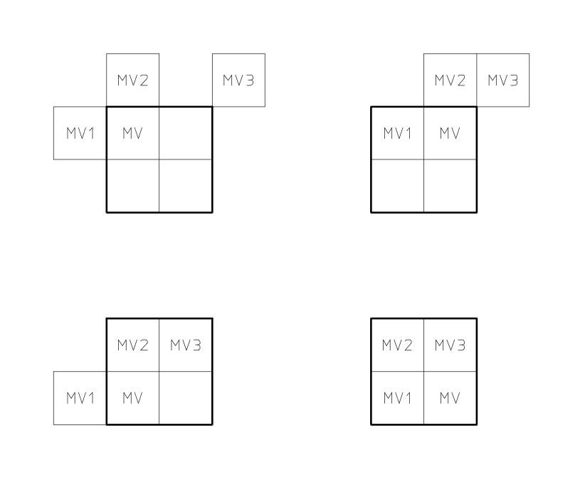
Figure 7-19 Redefinition of the candidate predictors MV1, MV2 and MV3 for each of the luminance blocks in a macroblock
If four vectors are used, each of the motion vectors is used for all pixels in one of the four luminance blocks in the macroblock. The numbering of the motion vectors is equivalent to the numbering of the four luminance blocks as given in Figure 6-5. Motion vector MVDCHR for both chrominance blocks is derived by calculating the sum of the K luminance vectors, that corresponds to K 8x8 blocks that do not lie outside the vop shape and dividing this sum by 2*K; the component values of the resulting sixteenth/twelfth/eighth/fourth sample resolution vectors are modified towards the nearest half sample position as indicated below.
Table 7-8 Modification of sixteenth sample resolution chrominance vector components
sixteenth pixel position | 0 | 1 | 2 | 3 | 4 | 5 | 6 | 7 | 8 | 9 | 10 | 11 | 12 | 13 | 14 | 15 | //16
resulting position | 0 | 0 | 0 | 1 | 1 | 1 | 1 | 1 | 1 | 1 | 1 | 1 | 1 | 1 | 2 | 2 | //2

Table 7-9 Modification of twelfth sample resolution chrominance vector components
twelfth pixel position | 0 | 1 | 2 | 3 | 4 | 5 | 6 | 7 | 8 | 9 | 10 | 11 | //12
resulting position | 0 | 0 | 0 | 1 | 1 | 1 | 1 | 1 | 1 | 1 | 2 | 2 | //2

Table 7-10 Modification of eighth sample resolution chrominance vector components
eighth pixel position | 0 | 1 | 2 | 3 | 4 | 5 | 6 | 7 | //8
resulting position | 0 | 0 | 1 | 1 | 1 | 1 | 1 | 2 | //2

Table 7-11 Modification of fourth sample resolution chrominance vector components
fourth pixel position | 0 | 1 | 2 | 3 | //4
resulting position | 0 | 1 | 1 | 1 | //2
Half sample values are found using bilinear interpolation as described in cluase 8.5.2. The prediction for luminance is obtained by overlapped motion compensation as described in clause 8.5.6. The prediction for chrominance is obtained by applying the motion vector MVDCHR to all pixels in the two chrominance blocks (as it is done in the default prediction mode).
The predictor for MVD and MVD₂₋₄ is defined as the median value of the vector components MV1, MV2 and MV3 as defined in this section

Overlapped motion compensation
This clause specifies the overlapped motion compensation process. This process is performed when the flag obmc_disable=0.
Each pixel in an 8*8 luminance prediction block is a weighted sum of three prediction values, divided by 8 (with rounding). In order to obtain the three prediction values, three motion vectors are used: the motion vector of the current luminance block, and two out of four "remote" vectors:
- the motion vector of the block at the left or right side of the current luminance block;
- the motion vector of the block above or below the current luminance block.
For each pixel, the remote motion vectors of the blocks at the two nearest block borders are used. This means that for the upper half of the block the motion vector corresponding to the block above the current block is used, while for the lower half of the block the motion vector corresponding to the block below the current block is used. Similarly, for the left half of the block the motion vector corresponding to the block at the left side of the current block is used, while for the right half of the block the motion vector corresponding to the block at the right side of the current block is used.
The creation of each pixel, 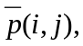 in an 8*8 luminance prediction block is governed by the following equation:
where 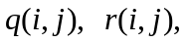 and 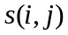 are the pixels from the referenced picture as defined by
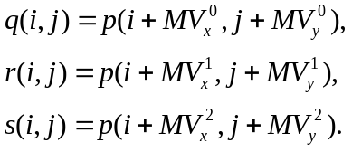
Here, 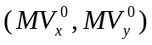 denotes the motion vector for the current block, 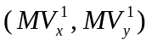 denotes the motion vector of the block either above or below, and 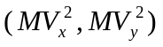denotes the motion vector either to the left or right of the current block as defined above.
The matrices 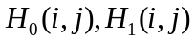 and 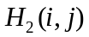 are defined in Figure 7-20, Figure 7-21, and Figure 7-22, where 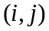 denotes the column and row, respectively, of the matrix.
If one of the surrounding blocks was not coded, the corresponding remote motion vector is set to zero. If one of the surrounding blocks was coded in intra mode, the corresponding remote motion vector is replaced by the motion vector for the current block. If the current block is at the border of the vop and therefore a surrounding block is not present, the corresponding remote motion vector is replaced by the current motion vector. In addition, if the current block is at the bottom of the macroblock, the remote motion vector corresponding with an 8*8 luminance block in the macroblock below the current macroblock is replaced by the motion vector for the current block.

4 | 5 | 5 | 5 | 5 | 5 | 5 | 4
5 | 5 | 5 | 5 | 5 | 5 | 5 | 5
5 | 5 | 6 | 6 | 6 | 6 | 5 | 5
5 | 5 | 6 | 6 | 6 | 6 | 5 | 5
5 | 5 | 6 | 6 | 6 | 6 | 5 | 5
5 | 5 | 6 | 6 | 6 | 6 | 5 | 5
5 | 5 | 5 | 5 | 5 | 5 | 5 | 5
4 | 5 | 5 | 5 | 5 | 5 | 5 | 4
Figure 7-20 Weighting values, H₀ , for prediction with motion vector of current luminance block

2 | 2 | 2 | 2 | 2 | 2 | 2 | 2
1 | 1 | 2 | 2 | 2 | 2 | 1 | 1
1 | 1 | 1 | 1 | 1 | 1 | 1 | 1
1 | 1 | 1 | 1 | 1 | 1 | 1 | 1
1 | 1 | 1 | 1 | 1 | 1 | 1 | 1
1 | 1 | 1 | 1 | 1 | 1 | 1 | 1
1 | 1 | 2 | 2 | 2 | 2 | 1 | 1
2 | 2 | 2 | 2 | 2 | 2 | 2 | 2
Figure 7-21 Weighting values, H1 , for prediction with motion vectors of the luminance blocks on top or bottom of current luminance block

2 | 1 | 1 | 1 | 1 | 1 | 1 | 2
2 | 2 | 1 | 1 | 1 | 1 | 2 | 2
2 | 2 | 1 | 1 | 1 | 1 | 2 | 2
2 | 2 | 1 | 1 | 1 | 1 | 2 | 2
2 | 2 | 1 | 1 | 1 | 1 | 2 | 2
2 | 2 | 1 | 1 | 1 | 1 | 2 | 2
2 | 2 | 1 | 1 | 1 | 1 | 2 | 2
2 | 1 | 1 | 1 | 1 | 1 | 1 | 2

Figure 7-22 Weighting values, H₂ , for prediction with motion vectors of the luminance blocks to the left or right of current luminance block

Temporal prediction structure
- A target P-vop shall make reference for prediction to the most recently decoded I- or P-vop. If the vop_coded of the most recently decoded I- or P-vop is ”0”, the target P-vop shall make reference to a decoded I- or P-vop which immediately precedes said most recently decoded I- or P-vop, and whose vop_coded is not zero.
- A target B-vop shall make reference for prediction to the most recently decoded forward and/or backward reference vops. The target B-vop shall only make reference to said forward or backward reference vops whose vop_coded is not zero. If the vop_coded flags of both most recently decoded forward and backward reference vops are zero, the following rules applies.
- for texture, the predictor of the target B-vop shall be a gray macroblock of (Y, U, V) = (128, 128, 128).
- for binary alpha planes, the predictor shall be zero (transparent block)
Note that, binary alpha shape in B-vop shall make reference for prediction to the most recently decoded forward reference vop.
- A decoded vop whose vop_coded is not zero but have no shape shall be padded by (128, 128, 128) for (Y, U, V).
The temporal prediction structure is depicted in Figure 7-23.
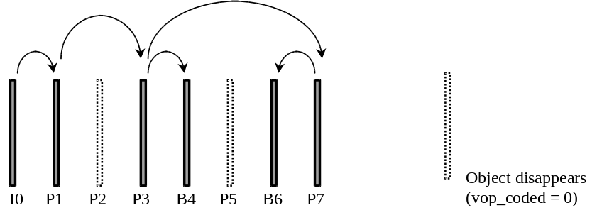
Figure 7-23 Temporal Prediction Structure.

Vector decoding process of non-scalable progressive B-VOPs
In B-VOPs there are three kinds of vectors, namely, 16x16 forward vector, 16x16 backward vector and the delta vector for the direct mode. The vectors are decoded with respect to the corresponding vector predictors. The basic decoding process of a differential vector is the exactly same as defined in P-VOPs except that for the delta vector of the direct mode the f_code is always one. The vector is then reconstructed by adding the decoded differential vector to the corresponding vector predictor. The vector predictor for the delta vector is always set to zero, while the forward and backward vectors have their own vector predictors, which are reset to zero only at the beginning of each macroblock row. The vector predictors are updated in the following three cases:
- after decoding a macroblock of forward mode only the forward predictor is set to the decoded forward vector
- after decoding a macroblock of backward mode only the backward predictor is set to the decoded backward vector.
- after decoding a macroblock of bi-directional mode both the forward and backward predictors are updated separately with the decoded vectors of the same type (forward/backward).

Motion compensation in non-scalable progressive B-VOPs
In B-VOPs the overlapped motion compensation (OBMC) is not employed. The motion-compensated prediction of B-macroblock is generated by using the decoded vectors and taking reference to the padded forward/backward reference VOPs as defined below.

Forward mode
Only the forward vector (MVFx,MVFy) is applied in this mode. The prediction blocks Pf_Y, Pf_U, and Pf_V are generated from the forward reference VOP, ref_Y_for for luminance component and ref_U_for and ref_V_for for chrominance components, as follows:
mc(Pf_Y, ref_Y_for, 16, 16, x, y, MVFx, MVFy, 0, 0, 0, 1);
mc(Pf_U, ref_U_for, 8, 8, x/2, y/2, MVFx_chro, MVFy_chro, 0, 0, 0,1);
mc(Pf_V, ref_V_for, 8, 8, x/2, y/2, MVFx_chro, MVFy_chro, 0, 0, 0,1);
where (MVFx_chro, MVFy_chro) is motion vector derived from the luminance motion vector by dividing each component by 2 then rounding on a basis of Table 7-11. Here (and hereafter) the function MC is defined in section 7.5.9.

Backward mode
Only the backward vector (MVBx,MVBy) is applied in this mode. The prediction blocks Pb_Y, Pb_U, and Pb_V are generated from the backward reference VOP, ref_Y_back for luminance component and ref_U_back and ref_V_back for chrominance components, as follows:
mc(Pb_Y, ref_Y_back, 16, 16, x, y, MVBx, MVBy, 0, 0, 0, 1);
mc(Pb_U, ref_U_back, 8, 8, x/2, y/2, MVBx_chro, MVBy_chro, 0, 0, 0,1);
mc(Pb_V, ref_V_back, 8, 8, x/2, y/2, MVBx_chro, MVBy_chro, 0, 0, 0,1);
where (MVBx_chro, MVBy_chro) is motion vector derived from the luminance motion vector by dividing each component by 2 then rounding on a basis of Table 7-11.

Bi-directional mode
Both the forward vector (MVFx,MVFy) and the backward vector (MVBx,MVBy) are applied in this mode. The prediction blocks Pi_Y, Pi_U, and Pi_V are generated from the forward and backward reference VOPs by doing the forward prediction, the backward prediction and then averaging both predictions pixel by pixel as follows.
mc(Pf_Y, ref_Y_for, 16, 16, x, y, MVFx, MVFy, 0, 0, 0, 1);
mc(Pf_U, ref_U_for, 8, 8, x/2, y/2, MVFx_chro, MVFy_chro, 0, 0, 0,1);
mc(Pf_V, ref_V_for, 8, 8, x/2, y/2, MVFx_chro, MVFy_chro, 0, 0, 0,1);
mc(Pb_Y, ref_Y_back, 16, 16, x, y, MVBx, MVBy, 0, 0, 0, 1);
mc(Pb_U, ref_U_back, 8, 8, x/2, y/2, MVBx_chro, MVBy_chro, 0, 0, 0,1);
mc(Pb_V, ref_V_back, 8, 8, x/2, y/2, MVBx_chro, MVBy_chro, 0, 0, 0,1);
Pi_Y[i][j] = (Pf_Y[i][j] + Pb_Y[i][j] + 1)>>1; i,j=0,1,2…15;
Pi_U[i][j] = (Pf_U[i][j] + Pb_U[i][j] + 1)>>1; i,j=0,1,2…8;
Pi_V[i][j] = (Pf_V[i][j] + Pb_V[i][j] + 1)>>1; i,j=0,1,2…8;
where (MVFx_chro, MVFy_chro) and (MVBx_chro, MVBy_chro) are motion vectors derived from the forward and backward luminance motion vectors by dividing each component by 2 then rounding on a basis of Table 7-11, respectively.

Direct mode
This mode uses direct bi-directional motion compensation derived by employing I- or P-VOP macroblock motion vectors and scaling them to derive forward and backward motion vectors for macroblocks in B-VOP. This is the only mode which makes it possible to use motion vectors on 8x8 blocks. Only one delta motion vector is allowed per macroblock.

Calculation of TRB and TRD for the direct mode
The two parameters TRB, TRD are derived from the temporal references of the forward and backward reference I- or P-VOPs, and the current B-VOP as follows.
TRB = Temp_ref_cur - Temp_ref_forward;
TRD = Temp_ref_backward - Temp_ref_backward;
where the temporal reference of a VOP (Temp_ref_forward for the forward reference VOP, Temp_ref_cur for the backward VOP, or Temp_ref_backward for the current B-VOP as appropriate) is computed by:
Temp_ref = (modulo_time_base + forward_time_base)*vop_time_incresment_resolution
+ vop_time_increment;

Formation of MV vectors for the direct mode
The direct mode utilizes the motion vectors (MV vectors) of the co-located macroblock in the most recently decoded I- or P-VOP. The co-located macroblock is defined as the macroblock which has the same index with the current macroblock in the B-VOP. The MV vectors are generated by applying the vector padding technique on the co-located macroblock as defined below.
The vector padding technique is used for forming the vectors of the transparent blocks within a non-transparent macroblock. It works in a similar way as the repetitive padding, and can be simply regarded as the repetitive padding performed on a 2x2 block except that the padded values are two dimensional vectors. Since a macroblock has four 8x8 luminance blocks, let {MVx[i], MVy[i], i=0,1,2,3} and {Transp[i], i=0,1,2,3} be the vectors and the transparencies of the four 8x8 blocks, respectively, the vector padding is any process numerically equivalent to:
if (the macroblock is INTRA-coded, skipped or transparent) {
MVx[0] = MVx[1] = MVx[2] = MVx[3] = 0
MVy[0] = MVy[1] = MVy[2] = MVy[3] = 0
} else {
if(Transp[0] == TRANSPARENT) {
MVx[0]=(Transp[1] != TRANSPARENT) ? MVx[1] :((Transp[2]!=TRANSPARENT) ? MVx[2]:MVx[3]));
MVy[0]=(Transp[1] != TRANSPARENT) ? MVy[1]:((Transp[2]!=TRANSPARENT) ? MVy[2]:MVy[3]));
}
if(Transp[1] == TRANSPARENT) {
MVx[1]=(Transp[0] != TRANSPARENT) ? MVx[0] :((Transp[3]!=TRANSPARENT) ? MVx[3]:MVx[2]));
MVy[1]=(Transp[0] != TRANSPARENT) ? MVy[0]:((Transp[3]!=TRANSPARENT) ? MVy[3]:MVy[2]));
}
if(Transp[2] == TRANSPARENT) {
MVx[2]=(Transp[3] != TRANSPARENT) ? MVx[3] :((Transp[0]!=TRANSPARENT) ? MVx[0]:MVx[1]));
MVy[2]=(Transp[3] != TRANSPARENT) ? MVy[3]:((Transp[0]!=TRANSPARENT) ? MVy[0]:MVy[1]));
}
if(Transp[3] == TRANSPARENT) {
MVx[3]=(Transp[2] != TRANSPARENT) ? MVx[2] :((Transp[1]!=TRANSPARENT) ? MVx[1]:MVx[0]));
MVy[3]=(Transp[2] !=TRANSPARENT) ? MVy[2]:((Transp[1]!=TRANSPARENT) ? MVy[1]:MVy[0]));
}
}

Calculation of vectors
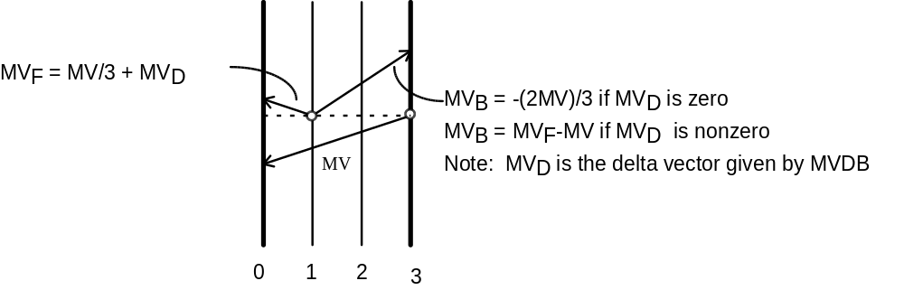
Figure 7-24 Direct Bi-directional Prediction
Figure 7-24 shows scaling of motion vectors. The calculation of forward and backward motion vectors involves linear scaling of the collocated block in temporally next I- or P-VOP, followed by correction by a delta vector (MVDx,MVDy). The forward and the backward motion vectors are {(MVFx[i],MVFy[i]), (MVBx[i],MVBy[i]), i = 0,1,2,3} and are given in half sample units as follows.
MVFx[i] = (TRB x MVx[i]) / TRD + MVDx
MVBx[i] = (MVDx==0)? ((TRB - TRD) x MVx[i]) / TRD : MVFx[i] - MVx[i]
MVFy[i] = (TRB x MVy[i]) / TRD + MVDy
MVBy[i] = (MVDy==0)? ((TRB - TRD) x MVy[i]) / TRD : MVFy[i] - MVy[i]
i = 0,1,2,3.
where {(MVx[i],MVy[i]), i = 0,1,2,3} are the MV vectors of the co-located macroblock, TRD is the difference in temporal reference of the B-VOP and the previous reference VOP. TRD is the difference in temporal reference of the temporally next reference VOP with temporally previous reference VOP, assuming B-VOPs or skipped VOPs in between. The calculation of TRB and TRD is defined in section 7.4.12.4.1.

Generating of prediction blocks
Motion compensation for luminance is performed individually on 8x8 blocks to generate a macroblock. The process of generating a prediction block simply consists of using computed forward and backward motion vectors {(MVFx[i],MVFy[i]), (MVBx[i],MVBy[i]), i = 0,1,2,3} to obtain appropriate blocks from reference VOPs and averaging these blocks, same as the case of bi-directional mode except that motion compensation is performed on 8x8 blocks.
For the motion compensation of both chrominance blocks, the forward motion vector (MVFx_chro, MVFy_chro) is calculated by the sum of K forward luminance motion vectors dividing by 2K and then rounding toward the nearest half sample position as defined in Table 7-8 to Table 7-11. The backward motion vector (MVBx_chro, MVBy_chro) is derived in the same way. The rest process is the same as the chrominance motion compensation of the bi-directional mode described in section 7.5.12.3.

Motion compensation in skipped macroblocks
If the co-located macroblock in the most recently decoded I- or P-VOP is skipped, the current B-macroblock is treated as the forward mode with the zero motion vector (MVFx,MVFy). If the MODB equals zero the current B-macroblock is reconstructed by using the direct mode with zero delta vector.

Interlaced video decoding
This clause specifies the additional decoding process that a decoder shall perform to recover VOP data from the coded bitstream when the interlaced flag in the VOP header is set to “1”. Interlaced information (Sec. 6.3.7.2) specifies the method to decode bitstream of interlaced VOP.

Field DCT and DC and AC Prediction
When dct_type flag is set to ‘1’ (field DCT coding), DCT coefficients of luminance data are formed such that each 8x8 block consists of data from one field as being shown in Figure 6.5. When intra_acdc_pred_disable is set to “0”, DC and optional AC (see “ac_pred_flag”) prediction will be performed for a intra-coded macroblock. For the intra macroblocks which have dct_type flag being set to “1”, DC/AC prediction are performed to field blocks shown in Figure 7.1b. After taking inverse DCT, all luminance blocks will be inverse permuted back to (frame) macroblock. Chrominance (block) data are not effected by dct_type flag.
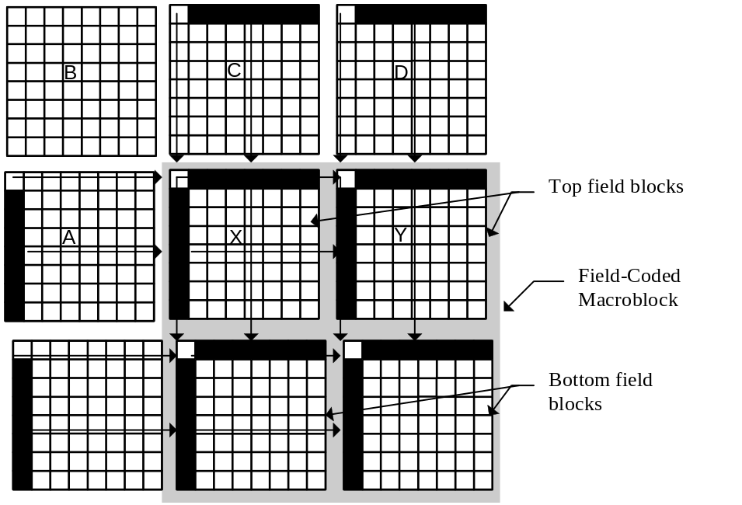
Figure 7.1b Previous neighboring blocks used in DC/AC prediction for interlaced intra blocks.

Motion compensation
For non-intra macroblocks in P- and B-VOPs, motion vectors are extracted syntactically following Section 6.2.7 “Macroblock”. The motion vector decoding is performed separately on the horizontal and vertical components.

Motion vector decoding in P-VOP
For each component of motion vector in P-VOPs, the median value of the candidate predictor vectors for the same component is computed and add to corresponding component of the motion vector difference obtained from the bitstream. To decode the motion vectors in a P-VOP, the decoder shall first extract the differential motion vectors (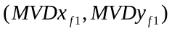 and 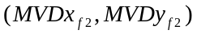 for top and bottom fields of a field predicted macroblock, respectively) by a use of variable length decoding and then determine the predictor vector from three candidate vectors. These candidate predictor vectors are generated from the three motion vectors of three spatial neighborhood decoded macroblocks or blocks as follows.
CASE 1 :
If the current macroblock is a field predicted macroblock and none of the coded spatial neighborhood macroblocks is a field predicted macroblock, then candidate predictor vectors MV1, MV2, and MV3 are defined by Figure 7.1c. If the candidate block i is not in four MV motion (8x8) mode, MVi represents the motion vector for the macroblock. If the candidate block i is in four MV motion (8x8) mode, the 8x8 block motion vector closest to the upper left block of the current MB is used. The predictors for the horizontal and vertical components are then computed by
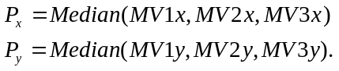
For differential motion vectors both fields use the same predictor and motion vectors are recovered by
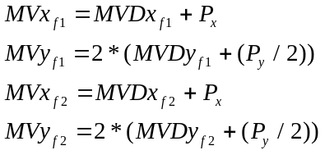
where “/” is integer division with truncation toward 0. Note that all motion vectors described above are specified as integers with one LSB representing a half-pel displacement. The vertical component of field motion vectors always even (in half-pel frame coordinates). Vertical half-pel interpolation between adjacent lines of the same field is denoted by 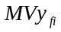 be an odd multiple of 2 (e.g. -2,2,6,..) No vertical interpolation is needed when is an multiple of 4 (it is a full pel value).
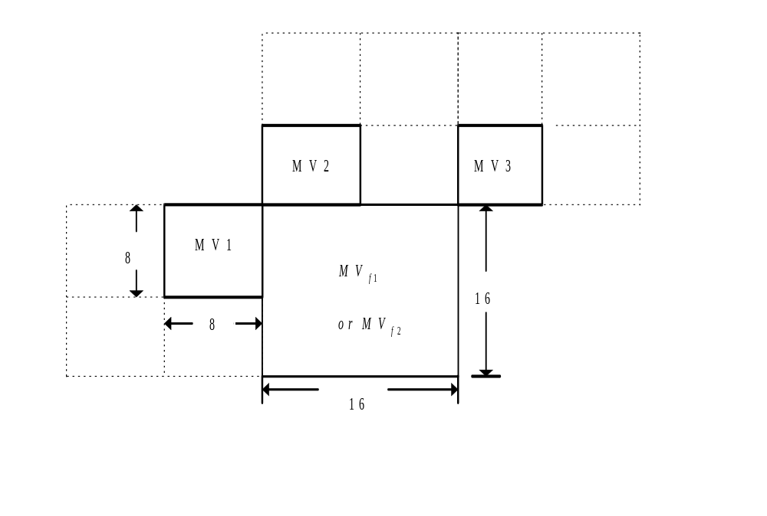
Figure 7.1c Example of motion vector prediction for field predicted macroblocks (Case1)
CASE 2 :
If the current macroblock or block is frame predicted macroblock or block and if at least one of the coded spatial neighborhood macroblocks is a field predicted macroblock, then the candidate predictor vector for each field predicted macroblock will be generated by averaging two field motion vectors such that all fractional pel offsets are mapped into the half-pel displacement. Each component ( 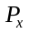 or 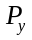) of the final predictor vector is the median value of the candidate predictor vectors for the same component. The motion vector is recovered by
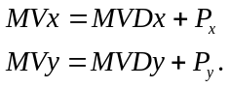.
where
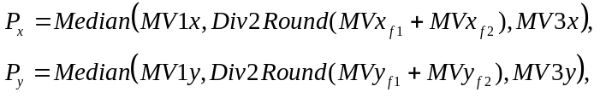
Div2Round(x) make the use of Table 7.1b as follows : Div2Round(x)=((x>>1)&~1)+Table7_1b[x&3].
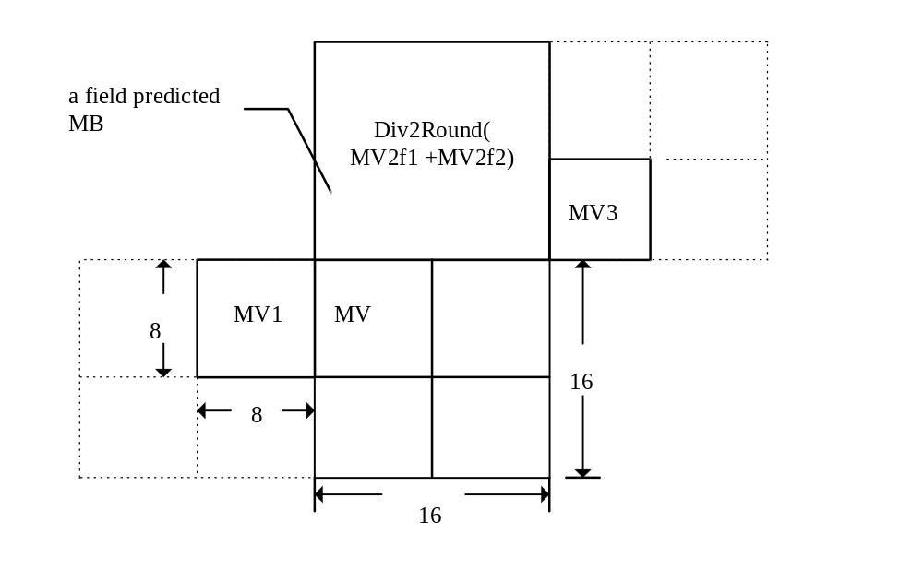
Figure 7.1d Example of motion vector prediction for field predicted macroblocks (Case 2)
CASE 3 :
Assume that the current macroblock is a field predicted macroblock and at least one of the coded spatial neighborhood macroblocks is a field predicted macroblock. If the candidate block i is field predicted, the candidate predictor vector MVi will be generated by averaging two field motion vectors such that all fractional pel offsets are mapped into the half-pel displacement as discribed in CASE 2. If the candidate block i is neither in four MV motion (8x8) mode nor in field prediction mode, MVi represents the frame motion vector for the macroblock. If the candidate block i is in four MV motion (8x8) mode, the 8x8 block motion vector closest to the upper left block of the current MB is used. The predictors for the horizontal and vertical components are then computed by
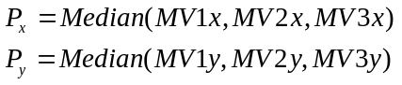
where
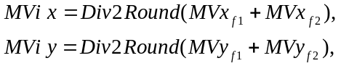
for some i in {1,2,3}.
For differential motion vectors both fields use the same predictor and motion vectors are recovered by (see both Figures 7.1c and 7.1d)
The motion compensated prediction macroblock is calculated calling the “field_compensate_one_reference” using the motion vectors calculated above. The top_field_ref, bottom_field_ref, and rounding type come directly from the syntax as forward_top_field_reference, forward_bottom_field_reference and vop_rounding_type respectively. The reference VOP is defined such the the even lines (0, 2, 4, ...) are the top field and the odd lines (1, 3, 5, ...) are the bottom field.

field_motion_compensate_one_reference(
luma_pred, cb_pred, cr_pred, /* Prediction component pel array */
luma_ref, cb_ref, cr_ref, /* Reference VOP pel arrays */
mv_top_x, mv_top_y, /* top field motion vector */
mv_bot_x, mv_bot_y, /* bottom field motion vector */
top_field_ref, /* top field reference */
bottom_field_ref, /* bottom field reference */
x, y, /* current luma macroblock coords */
rounding_type) /* rounding type */
{
mc(luma_pred, luma_ref, x, y, 16, 16, mv_top_x, mv_top_y,
rounding_type, 0, top_field_ref, 2);
mc(luma_pred, luma_ref, x, y, 16, 16, mv_bot_x, mv_bot_y,
rounding_type, 1, bottom_field_ref, 2);
mc(cb_pred, cb_ref, x/2, y/2, 8, 8,
Div2Round(mv_top_x), Div2Round(mv_top_y),
rounding_type, 0, top_field_ref, 2);
mc(cr_pred, cr_ref, x/2, y/2, 8, 8,
Div2Round(mv_top_x), Div2Round(mv_top_y),
rounding_type, 0, top_field_ref, 2);
mc(cb_pred, cb_ref, x/2, y/2, 8, 8,
Div2Round(mv_bot_x), Div2Round(mv_bot_y),
rounding_type, 0, top_field_ref, 2);
mc(cr_pred, cr_ref, x/2, y/2, 8, 8,
Div2Round(mv_bot_x), Div2Round(mv_bot_y),
rounding_type, 0, top_field_ref, 2);
}

Motion vector decoding in B-VOP
For interlaced B-VOPs, a macroblock can be coded using (1) direct coding, (2) 16x16 motion compensation (includes forward, backward & bidirectional modes), or (3) field motion compensation (includes forward, backward & bidirectional modes). Forward, backward and bidirectional coding modes work in the same manner as in MPEG-1 / 2 with the difference that a VOP is used for prediction instead of a picture. Motion vector in half sample accuracy will be employed for a 16x16 macroblock being coded. Chrominance vectors are derived by scaling of luminance vectors using the rounding tables described in Table 7.1b (i.e. by applying Div2Round to the luminance motion vectors). These coding modes except direct coding mode allow switching of quantizer from the one previously in use. Specification of DQUANT, a differential quantizer involves a 2-bit overhead as discussed earlier. In direct coding mode, the quantizer value for previous coded macroblock is used.
For interlaced B-VOP motion vector predictors, four prediction motion vectors (PMVs) are used:
Table 7-12 Prediction motion vector allocation for interlaced P-vops
Function | PMV
Top field forward | 0
Bottom field forward | 1
Top field backward | 2
Bottom field backward | 3
These PMVs are used as follows for the different macroblock prediction modes:
Table 7-13 Prediction motion vectors for interlaced B-vop decoding
Macroblock mode | PMVs used | PMVs updated
Direct | none | none
Frame forward | 0 | 0,1
Frame backward | 2 | 2,3
Frame bidirectional | 0,2 | 0,1,2,3
Field forward | 0,1 | 0,1
Field backward | 2,3 | 2,3
Field bidirectional | 0,1,2,3 | 0,1,2,3
The PMVs used by a macroblock are set to the value of current macroblock motion vectors after being used.
When a frame macroblock is decoded, the two field PMVs (top and bottom field) for each prediction direction are set to the same (frame value. The prediction motion vectors are reset to zero at the beginning of each row of macroblocks. The predictors are not zeroed by skipped macroblocks or direct mode macroblocks.
The frame based motion compensation modes are described in section 8.5. The field motion compensation modes are calculated using the “field_motion_compensate_one_reference()” pseudo code function described above. The field forward mode is denoted by mb_type == “0001” and field_prediction == “1”. The PMV update and calculation of the motion compensated prediction is shown below. The luma_fwd_ref_VOP[][], cb_fwd_ref_VOP[][], cr_fwd_ref_VOP[][] denote the entire forward (past) anchor VOP pixel arrays. The coordinates of the upper left corner of the luminance macroblock is given by (x, y) and MVD[].x and MVD[].y denote an array of the motion vector differences in the order they occur in the bitstream for the current macroblock.

PMV[0].x = PMV[0].x + MVD[0].x;
PMV[0].y = 2 * (PMV[0].y / 2 + MVD[0].y);
PMV[1].x = PMV[1].x + MVD[1].x;
PMV[1].y = 2 * (PMV[1].y / 2 + MVD[1].y);
field_motion_compensate_one_reference(
luma_pred, cb_pred, cr_pred,
luma_fwd_ref_VOP, cb_fwd_ref_VOP, cr_fwd_ref_VOP,
PMV[0].x, PMV[0].y, PMV[1].x, PMV[1].y,
forward_top_field_reference,
forward_bottom_field_reference,
x, y, 0);

The field backward mode is denoted by mb_type == “001” and field_prediction == “1”. The PMV update and prediction calculation is outlined the following pseudo code. The luma_bak_ref_VOP[][], cb_bak_ref_VOP[][], cr_bak_ref_VOP[][] denote the entire forward (past) anchor VOP pixel arrays.

PMV[2].x = PMV[2].x + MVD[0].x;
PMV[2].y = 2 * (PMV[2].y / 2 + MVD[0].y);
PMV[3].x = PMV[1].x + MVD[1].x;
PMV[3].y = 2 * (PMV[3].y / 2 + MVD[1].y);
field_motion_compensate_one_reference(
luma_pred, cb_pred, cr_pred,
luma_bak_ref_VOP, cb_bak_ref_VOP, cr_bak_ref_VOP,
PMV[2].x, PMV[2].y, PMV[3].x, PMV[3].y,
backward_top_field_reference,
backward_bottom_field_reference,
x, y, 0);

The bidirectional field prediction is used when mb_type == “01” and field_prediction == “1”. The prediction macroblock (in luma_pred[][], cb_pred[][], and cr_pred[][]) is calculated by:

for (mv = 0; mv < 4; mv++) {
PMV[mv].x = PMV[mv].x + MVD[mv].x;
PMV[mv].y = 2 * (PMV[mv].y / 2 + MVD[mv].y);
}
field_motion_compensate_one_reference(
luma_pred_fwd, cb_pred_fwd, cr_pred_fwd,
luma_fwd_ref_VOP, cb_fwd_ref_VOP, cr_fwd_ref_VOP,
PMV[0].x, PMV[0].y, PMV[1].x, PMV[1].y,
forward_top_field_reference,
forward_bottom_field_reference,
x, y, 0);
field_motion_compensate_one_reference(
luma_pred_bak, cb_pred_bak, cr_pred_bak,
luma_bak_ref_VOP, cb_bak_ref_VOP, cr_bak_ref_VOP,
PMV[2].x, PMV[2].y, PMV[3].x, PMV[3].y,
backward_top_field_reference,
backward_bottom_field_reference,
x, y, 0);
for (iy = 0; iy < 16; iy++) {
for (ix = 0; ix < 16; ix++) {
luma_pred[ix][iy] = (luma_pred_fwd[ix][iy] +
luma_pred_bak[ix][iy] + 1) >> 1;
}
}
for (iy = 0; iy < 8; iy++) {
for (ix = 0; ix < 8; ix++) {
cb_pred[ix][iy] = (cb_pred_fwd[ix][iy] +
cb_pred_bak[ix][iy] + 1) >> 1;
cr_pred[ix][iy] = (cr_pred_fwd[ix][iy] +
cr_pred_bak[ix][iy] + 1) >> 1;
}
}
The direct mode prediction can be either progressive (see section 8.5.9.4) or interlaced as described below. Interlaced direct mode is used when ever the co-located macroblock (macroblock with the same coordinates) of the future anchor VOP has field_predition flag is “1”. Note that if the future macroblock is skipped, or intra, the direct mode prediction is progressive. Otherwise, interlaced direct mode is prediction is used.
Interlaced direct coding mode is an extension of progressive direct coding mode. Four derived field motion vectors are calculated from the forward field motion vectors of the co-located future anchor VOP, a single differential motion vector and the temporal position of the B-VOP fields with respect to the fields of the past and future anchor VOPs. The four derived field motion vectors are denoted mvf[0] (top field forward) mvf[1], (bottom field forward), mvb[0] (top field backward), and mvb[1] (bottom field backward). MV[i] is the future anchor picture motion vector for the top (i == 0) and bottom (i == 1) fields. Only one delta motion vector (used for both field), MVD[0], occurs in the bitstream for the field direct mode predicted macroblock. MVD[0] is decoded assuming f_code == 1 regardless of the number in VOP header. The interlaced direct mode prediction (in luma_pred[][], cb_pred[][] and cr_pred[][]) is calculated as shown below.

for (i = 0; i < 2; i++) {
mvf[i].x = (TRB[i] * MV[i].x) / TRD[i] + MVD[0].x;
mvf[i].y = (TRB[i] * MV[i].y) / TRD[i] + MVD[0].y;
mvb[i].x = (MVD[i].x == 0) ?
(((TRB[i] - TRD[i]) * MV[i].x) / TRD[i]) :
mvf[i].x - MV[i].x);
mvb[i].y = (MVD[i].y == 0) ?
(((TRB[i] - TRD[i]) * MV[i].y) / TRD[i]) :
mvf[i].y - MV[i].y);
field_motion_compensate_one_reference(
luma_pred_fwd, cb_pred_fwd, cr_pred_fwd,
luma_fwd_ref_VOP, cb_fwd_ref_VOP, cr_fwd_ref_VOP,
mvf[0].x, mvf[0].y, mvf[1].x, mvf[1].y,
colocated_future_mb_top_field_reference,
colocated_future_mb_bottom_field_reference,
x, y, 0);
field_motion_compensate_one_reference(
luma_pred_bak, cb_pred_bak, cr_pred_bak,
luma_bak_ref_VOP, cb_bak_ref_VOP, cr_bak_ref_VOP,
mvb[1].x, mvb[1].y, mvb[1].x, mvb[1].y,
0, 1, x, y, 0);
for (iy = 0; iy < 16; iy++) {
for (ix = 0; ix < 16; ix++) {
luma_pred[ix][iy] = (luma_pred_fwd[ix][iy] +
luma_pred_bak[ix][iy] + 1) >> 1;
}
}
for (iy = 0; iy < 8; iy++) {
for (ix = 0; ix < 8; ix++) {
cb_pred[ix][iy] = (cb_pred_fwd[ix][iy] +
cb_pred_bak[ix][iy] + 1) >> 1;
cr_pred[ix][iy] = (cr_pred_fwd[ix][iy] +
cr_pred_bak[ix][iy] + 1) >> 1;
}
}
The temporal references (TRB[i] and TRD[i]) are distances in time expressed in field periods. The following figure show how they are defined for the case where i is 0 (top field of the B-VOP). The bottom field is analogously.
Figure 7.1e Interlaced direct mode
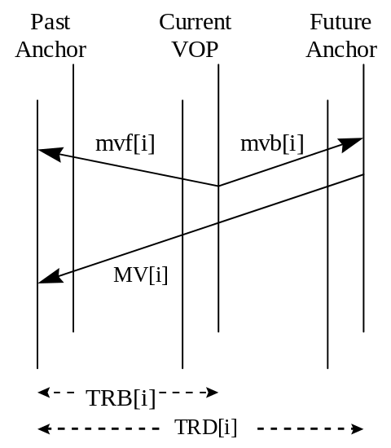
The calculation of TRD[i] and TRB[i] depends not only on the current field, reference field, and frame temporal references, but also on whether the current video is top field first or bottom field first.
TRD[i] = 2*(T(future)//Tframe - T(past)//Tframe) + δ[i]
TRB[i] = 2*(T(current)//Tframe - T(past)//Tframe) + δ[i]
where T(future), T(current) and T(past) are the cumulative VOP times calculated from modulo_time_base and vop_time_increment of the future, current and past VOPs in display order. Tframe is the frame period determined by
Tframe = T(first_B_VOP) - T(past_anchor_of_first B_VOP)
where first_B_VOP denotes the first B-VOP following the Video Object Layer syntax. The important thing about Tframe is that the period of time between consecutive fields which constitute an interlaced frame is assuemed to be 0.5 * Tframe for purposes of scaling the motion vectors.
The value of δ is determined from the table below; it is a function of the current field parity (top or bottom), the reference field of the co-located macroblock (macroblock at the same coordinates in the furture anchor VOP), and the value of top_field_first in the B-VOP’s video object plane syntax.
Table 7.1a Selection of the parameter
future anchor VOP reference fields of the co-located macroblock |  | top_field_first == 0 |  | top_field_first == 1
Top field reference | Bottom field reference | Top field, δ[0] | Bottom field, δ[1] | Top field, δ[0] |  | Bottom field, δ[1]
0 | 0 | 0 | -1 | 0 | 1
0 | 1 | 0 | 0 | 0 | 0
1 | 0 | 1 | -1 | -1 | 1
1 | 1 | 1 | 0 | -1 | 0
The top field prediction is based on the top field motion vector of the P-VOP macroblock of the future anchor picture. The past reference field is the reference field selected by the co-located macroblock of the future anchor picture for the top field. Analogously, the bottom field predictor is the average of pixels obtained from the future anchor’s bottom field and the past anchor field referenced by the bottom field motion vector of the corresponding macroblock of the future anchor picture.

Error resilient decoding
This clause specifies the additional decoding process required for error resilient decoding.
When error resilience is enabled, the local neighborhood used to generate the prediction is modified to remain within a video packet. That is, prediction across a video packet boundaries shall not be used. For instance, the local neighborhood to be used to predict a motion vector of a macroblock which lies on a video packet boundary shall be as shown in Figure 7-25.

 | Video Packet -> Boundary | MB-k | MB-k+1 | MB# Local Neighborhood MB-k None MB-k+1 MB-k MB-1 MB-2
MB-2 | MB-1 | MB |  | MB MB-1, MB-k, MB-k+1
Figure 7-25 Illustration of video packet boundary
Similalrly, when dc and ac DCT coefficient prediction is used in conjunction with error resilience, predictions shall not occur across video packet boundaries.

Sprite decoding
The clause specifies the additional decoding process for a sprite video object. The sprite decoding can operate in three modes: basic sprite decoding, low-latency sprite decoding and scalable sprite decoding. Figure 7-26 is a diagram of the sprite decoding process. It is simplified for clarity.

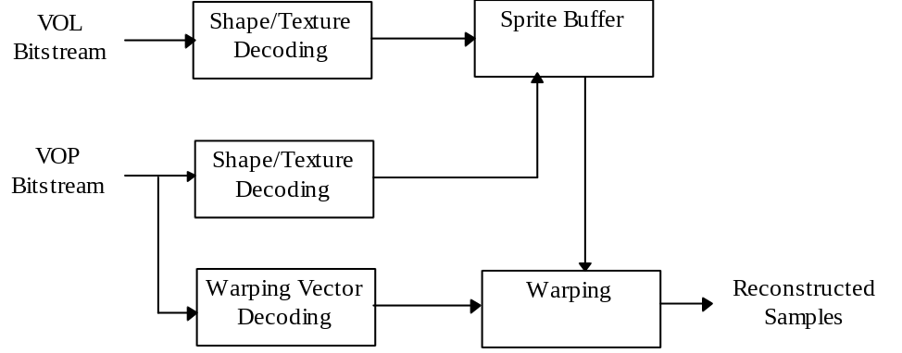

Figure 7-26 The sprite decoding process.

Higher syntactic structures
The various parameters in the VOL and VOP bitstreams shall be interpreted as described in clause 6. In VOP bitstreams, vop_pred_type must be “S” if and only if sprite_enable == 1. A VOP shall be reconstructed according the sprite decoding process described in this clause or any equivalent process if and only if sprite_enable == 1 && vop_pred_type == S.

Sprite Reconstruction
The luminance and chrominance data of a sprite are stored in two-dimensional arrays. The width and height of the luminance array are specified by sprite_width and sprite_height respectively. The samples in the sprite luminance and chrominance arrays are addressed by two-dimensional integer pairs (i’, j’) and (i_{c}’, j_{c}’) as defined in the following:
- Top left luminance sample
(i’, j’) = (sprite_left_coordinate, sprite_top_coordinate)
- Bottom right luminance sample
(i’, j’) = ((sprite_left_coordinate + sprite_width − 1),
((sprite_top_coordinate + sprite_height − 1))
- Top left chrominance sample
(i_{c}’, j_{c}’) = (sprite_left_coordinate / 2, sprite_top_coordinate / 2)
- Bottom right chrominance sample
(i_{c}’, j_{c}’) = (((sprite_left_coordinate + sprite_width) / 2 − 1),
((sprite_top_coordinate + sprite_height) / 2 − 1)).
Likewise, the addresses of the luminance and chrominance samples of the VOP currently being decoded are defined in the following:
- Top left sample of luminance
(i, j) = (0, 0) for rectangular VOPs, and
(i, j) = (vop_horizontal_mc_spatial_ref, vop_vertical_mc_spatial_ref) for non-rectangular VOPs
- Bottom right sample of luminance
(i, j) = (video_object_layer_width - 1, video_object_layer_height - 1) for rectangular VOPs, and
(i, j) = (vop_horizontal_mc_spatial_ref + vop_width - 1,
vop_vertical_mc_spatial_ref + vop_height - 1) for non-rectangular VOPs
- Top left sample of chrominance
(i_{c}, j_{c}) = (0, 0) for rectangular VOPs, and
(i_{c}, j_{c}) = (vop_horizontal_mc_spatial_ref / 2, vop_vertical_mc_spatial_ref / 2) for non-rectangular VOPs
- Bottom right sample of chrominance
(i_{c}, j_{c}) = (video_object_layer_width / 2 - 1, video_object_layer_height / 2 - 1) for rectangular VOPs, and
(i_{c}, j_{c}) = ((vop_horizontal_mc_spatial_ref + vop_width) / 2 - 1,
(vop_vertical_mc_spatial_ref + vop_height) / 2 - 1) for non-rectangular VOPs

Low-latency sprite reconstruction
The current WD allows a large static sprite to be reconstructed at the decoder by properly incorporating its corresponding pieces. There are two types of pieces recognized by the decoder—object and update. The
decoded sprite object-piece is a highly quantized version of the original sprite piece while the sprite update-piece is a residual to improve upon the quality of decoded object-piece. Sprite pieces are rectangular pieces of texture (and shape for the object-piece) and could contain “holes,” corresponding to macroblocks, that do not need to be decoded. Four parameters are required by the decoder to properly incorporate the pieces—piece_width, piece_height, piece_xoffset, and piece_yoffset.
Macroblocks raster scanning is employed to decode each piece. However, whenever the scan encounters a macroblock which has been part of some previously sent sprite piece, then the macroblock is not decoded and its corresponding macroblock layer is empty. In that case, the decoder treats the macroblock as a hole in the current sprite piece. Since a macroblock can be refined as long as there is some available bandwidth, more than one update may be decoded per macroblock and the holes for a given refinement step have no relationship to the holes of later refinement steps. Therefore, the decoding process of a hole for an update piece is different than that for the object-piece. For the object-piece, no information is decoded at all and the decoder must “manage” where “holes” lie. For the update-piece, the COD bit is decoded to indicate whether or not one more refinement should be decoded for this given macroblock. Note that a hole could be non-transparent and have had shape information decoded previously. Multiple intermingled object-pieces and update-pieces may be decoded at the same current VOP. Part of a sequence could consist for example of rapidly showing a zooming out effect, a panning to the right, a zooming in, and finally a panning to the left. In this case, the first decoded object-piece covers regions on all four sides of the previous VOP transmitted piece, which is now treated as a hole and not decoded again. The second decoded object-piece relates to the right panning, and the third object-piece is a smaller left-panning piece due to the zooming-in effect. Finally, the last piece is different; instead of an object, it contains the update for some previous object-piece of zooming-in (thus, the need to update to refine for higher quality). All four pieces will be decoded within the same VOP. When sprite_transmit_mode = =”PAUSE,” the decoder should recognize that all sprite object-pieces and update-pieces for the current VOP have been sent. However, when sprite_transmit_mode = “STOP,” the decoder should understand that all object and update-pieces have been sent for the entire video object layer, not just for the current VOP.
For the sprite object-pieces, shape and texture are decoded using the macroblock layer structure in I-VOPs with the quantization of intra macroblocks. The update-pieces use the P-VOP inter-macroblock syntax (with the quantization of non-intra macroblocks); in this case there are no motion vectors and shape information included in this decoder syntax structure. In summary, this decoding process supports the construction of any large sprite images progressively, both spatially and in terms of quality.

Decoding of initial sprite object-piece
The initial sprite decoding is exactly the same as the decoding of I-VOP. However, initializations of some internal decoder status flags, indicating if some macroblocks have already been decoded, are required so that the decoder can manage where “holes” lie for the rest of the object-pieces.

Decoding of holes in sprite object-piece
Implementation of macroblock scanning must account for the possibility that a macroblock uses prediction based on some macroblock sent in a previous piece. To support DC and AC prediction, as well as bordering of BABs, whenever macroblocks raster scanning encounters a hole, the decoder needs to manage the retrieval of relevant information from the corresponding macroblock decoded previously.

Decoding of holes in sprite update-pieces
When COD = 1 in the P-VOP syntax, the decoder should recognize that the corresponding macroblock is “not coded” because the refinement related to the current piece has been decoded previously. When COD = 0 in the P-VOP syntax, a new refinement should be decoded for this macroblock.

Sprite reference point decoding
The syntatic elements in encode_sprite_trajectory () and below shall be interpreted as specified in clause 6. du[i] and dv[i] (0 =< i < no_sprite_point) specifies the mapping between indexes of some reference points in the VOP and the corresponding reference points in the sprite. These points are referred to as VOP reference points and sprite reference points respectively in the rest of the specification.
The index values for the VOP reference points are defined as:
(i₀, j₀) = (0, 0) when video_object_layer_shape == ‘rectangle’, and
(vop_horizontal_mc_spatial_ref, vop_vetical_mc_spatial_ref) otherwise,
(i₁, j₁) = (i₀+W, j₀),
(i₂, j₂) = (i₀, j₀ + H),
(i₃, j₃) = (i₀+W, j₀+H)
where W = video_object_layer_width and H = video_object_layer_height when video_object_layer_shape == ‘rectangle’ or W = vop_width and H = vop_height otherwise. Only the index values with subscripts less than no_sprite_point shall be used for the rest of the decoding process.
The index values for the sprite reference points shall be calculated as follows:
(i₀’, j₀’) = (s / 2) (2 i₀ + du[0], 2 j₀ + dv[0])
(i₁’, j₁’) = (s / 2) (2 j₁ + du[1] + du[0], 2 j₁ + dv[1] + dv[0])
(i₂’, j₂’) = (s / 2) (2 j₂ + du[2] + du[0], 2 j₂ + dv[2] + dv[0])
(i₃’, j₃’) = (s / 2) (2 j₃ + du[3] + du[2] + du[1] + du[0], 2 j₃ + dv[3] + dv[2] + dv[1] + dv[0])
where i₀’, j₀’, etc are integers in pel accuracy, where s is specified by sprite_warping_accuracy. Only the index values with substcripts less than no_sprite_point need to be calculated.
When no_of_sprite_warping_points == 2 or 3, the index values for the virtual sprite points are additionally calculated as follows:

(i₁’’, j₁’’) = (16 (i₀ + W’) + ((W − W’) (r i₀’ − 16 i₀) + W’ (r i₁’ − 16 i₁)) // W,
16 j₀ + ((W − W’) (r j₀’ − 16 j₀) + W’ (r j₁’ − 16 j₁)) // W)
(i₂’’, j₂’’) = (16 i₀ + ((H − H’) (r i₀’ − 16 i₀) + H’ (r i₂’ − 16 i₂)) // H,
16 (j₀ + H’) + ((H − H’) (r j₀’ − 16 j₀) + H’ (r j₂’ − 16 j₂)) // H)
where i₁’’, j₁’’, i₂’’, and j₂’’ are integers in 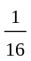 pel accuracy, and r = 16/s. W’ and H’ are defined as:
W’ = 2^{α}, H’ = 2^{β}, W’ ≥ W, H’ ≥ H, α > 0, β > 0, both α and β and are integers.
The calculation of i₂’’, and j₂’’ is not necessary when no_of_sprite_warping_points == 2.

Warping
For any pixel (i, j) inside the VOP boundary, (F(i, j), G(i, j)) and (F_{c}(i_{c}, j_{c}), G_{c}(i_{c}, j_{c})) are computed as described in the following. These quantities are then used for sample reconstruction as specified in clause 8.8.6. The following notations are used to simplify the description:
I = i - i₀,
J = j - j₀,
I_{c} = 4 i_{c} - 2 i₀ + 1,
J_{c} = 4 j_{c} - 2 i₀ + 1,
When no_of_sprite_warping_point == 0,
(F(i, j), G(i, j)) = (s i, s j),
(F_{c}(i_{c}, j_{c}), G_{c}(i_{c}, j_{c})) = (s i_{c}, s j_{c}).
When no_of_sprite_warping_point == 1,
(F(i, j), G(i, j)) = (i₀’ + s i, j₀’ + s j),
(F_{c}(i_{c}, j_{c}), G_{c}(i_{c}, j_{c})) = (s i_{c} + i₀’ /// 2, s j_{c} + j₀’ /// 2).

When no_of_sprite_warping_points == 2,

(F(i, j), G(i, j)) = ( i₀’ + ((−r i₀’ + i₁’’) I + (r j₀’ − j₁’’) J) /// (W’ r) ,
j₀’ + ((−r j₀’ + j₁’’) I + (−r i₀’ + i₁’’) J) /// (W’ r)),
(F_{c}(i_{c}, j_{c}), G_{c}(i_{c}, j_{c})) = (((−r i₀’ + i₁ ’’) I_{c} + (r j₀’ − j₁’’) J_{c} + 2 W’ r i₀’ − 16W’) /// (4 W’ r),
((−r j₀’ + j₁’’) I_{c} + (−r i₀’ + i₁’’) J_{c} + 2 W’ r j₀’ − 16W’) /// (4 W’ r)).

According to the definition of W’ and H’ (i.e. W’’ = 2^{α} and H’ = 2^{β}), the divisions by “///” in these functions can be replaced by binary shift operations.

When no_of_sprite_warping_points == 3,

(F(i, j), G(i, j)) = (i₀’ + ((−r i₀’ + i₁’’) H’ I + (−r i₀’+ i₂’’)W’ J) /// (W’H’r),
j₀’ + ((−r j₀’ + j₁’’) H’ I + (−r j₀’+ j₂’’)W’ J) /// (W’H’r)),
(F_{c}(i_{c}, j_{c}), G_{c}(i_{c}, j_{c})) = (((−r i₀’ + i₁’’) H’ I_{c} + (−r i₀’+ i₂’’)W’ J_{c} + 2 W’H’r i₀’ − 16W’H’) /// (4W’H’r),
((−r j₀’ + j₁’’) H’ I_{c} + (−r j₀’+ j₂’’)W’ J_{c} + 2 W’H’r j₀’ − 16W’H’) /// (4W’H’r)).

According to the definition of W’ and H’, the computation of these functions can be simplified by dividing the denominator and numerator of division beforehand by W’ (when W’ < H’) or H’ (when W’ ≥ H’). As in the case of no_of_sprite_warping_points == 2, the divisions by “///” in these functions can be replaced by binary shift operations.
When no_of_sprite_warping_point == 4,
(F(i, j), G(i, j)) = ((a i + b j + c) /// (g i + h j + D W H),
(d i + e j + f) /// (g i + h j + D W H)),
(F_{c}(i_{c}, j_{c}), G_{c}(i_{c}, j_{c})) = ((2 a I_{c} + 2 b J_{c} + 4 c − (g I_{c} + h J_{c} + 2 D W H) s) /// (4gI_{c} +4 hJ_{c} +8D W H),
(2 d I_{c} + 2 e J_{c} + 4 f − (g I_{c} + h J_{c} + 2 D W H) s) /// (4 g I_{c} +4 hJ_{c} +8D W H))

where
g = ((i₀’ − i₁’ − i₂’ + i₃’ ) (j₂’ − j₃’) − (i₂’ − i₃’) (j₀’ − j₁’ − j₂’ + j₃’)) H ,
h = ((i₁’ − i₃’) (j₀’ − j₁’ − j₂’ + j₃’ ) − (i₀’ − i₁’ − i₂’ + i₃’ ) (j₁’ − j₃’)) W ,
D = (i₁’ − i₃’) (j₂’ − j₃’ ) − (i₂’ − i₃’) (j₁’ − j₃’),
a = D (i₁’ − i₀’ ) H + g i₁’ ,
b = D (i₂’ − i₀’ ) W + h i₂’,
c = D i₀’ W H,
d = D (j₁’ − j₀’ ) H + g j₁’,
e = D (j₂’ − j₀’ ) W + h j₂’,
f = D j₀’ W H.
The implementor should be aware that a 32bit register may not be sufficient for representing the denominator or the numerator in the above transform functions for affine and perspective transform. The usage of a 64 bit floating point representation should be sufficient in such case.

Sample reconstruction
The reconstructed value Y of the luminance sample (i, j) in the currently decoded VOP shall be defined as
Y = ((s - r_{j})((s –r_{i}) Y₀₀ + r_{i} Y₀₁) + r_{j} ((s - r_{i}) Y₁₀ + r_{i} Y₁₁)) // s²,
where Y₀₀, Y₀₁, Y₁₀, Y₁₁ represent the sprite luminance sample at (F(i, j)////s, G(i, j)////s), (F(i, j)////s + 1,G(i, j)////s), (F(i, j)////s, G(i, j)////s + 1), and (F(i, j)////s + 1,G(i, j)////s + 1) respectively, and r_{i} =F(i, j) –F(i, j)////s and r_{j} =G(i, j) – G(i, j)////s. Figure 7-27 illustrates this process.
In case any of Y₀₀, Y₀₁, Y₁₀ and Y₁₁ lies outside the sprite luminance binary mask, it shall be obtained by the padding process as defined in section 8.5.1.

When brightness_change_in_sprite == 1, the final reconstructed luminance sample (i, j) is further computed as Y = Y * (brightness_change_factor * 0.01 + 1), clipped to the range of [0, 255].

Similarly, the reconstructed value C of the chrominance sample (i_{c}, j_{c}) in the currently decoded VOP shall be define as
C = ((s - r_{j})((s –r_{i}) C₀₀ + r_{i} C₀₁) + r_{j} ((s - r_{i}) C₁₀ + r_{i} C₁₁)) // s²,
where C₀₀, C₀₁, C₁₀, C₁₁ represent the sprite chrominance sample at ( F_{c}(i_{c}, j_{c})////s, G_{c}(i_{c}, j_{c})////s), (F_{c}(i_{c}, j_{c})////s + 1, G_{c}(i_{c}, j_{c})////s), (F_{c}(i_{c}, j_{c})////s, G_{c}(i_{c}, j_{c})////s + 1), and (F_{c}(i_{c}, j_{c})////s + 1, G_{c}(i_{c}, j_{c})////s + 1) respectively, and r_{i} = F_{c}(i_{c}, j_{c}) – F_{c}(i_{c}, j_{c}))////s and r_{j} = G_{c}(i_{c}, j_{c}) – G_{c}(i_{c}, j_{c})////s. In case any of C₀₀, C₀₁, C₁₀ and C₁₁ lies outside the sprite chrominance binary mask, it shall be obtained by the padding process as defined in section 8.5.1.

The reconstructed value of luminance binary mask sample BY(i,j) shall be computed following the identical process for the luminance sample. However, corresponding binary mask sample values shall be used in place of luminance samples Y₀₀, Y₀₁, Y₁₀, Y_{11.} Assume the binary mask sample opaque is equal to 255 and the binary mask sample transparent is equal to 0. If the computed value is bigger or equal to 128, BY(i, j) is defined as opaque. Otherwise, BY (i, j) is defined as transparent. The chrominance binary mask samples shall be reconstructed by downsampling of the luminance binary mask samples as specified in 8.5.2.

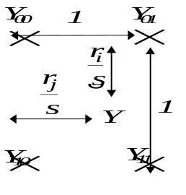
Figure 7-27 Pixel value interpolation (it is assumed that sprite samples are located on an integer grid).

Scalable sprite decoding
The reconstruction of a temporal enhancement VOP follows the clause 8.9.1. If sprite has already been reconstructed for the lower layers, it needs not to be done again. Otherwise, sprite shall be reconstructed from lower layer bitstream following clause 8.9.1.
Spatial enhancement to sprite shall be decoded as described in the clause for spatial scalability. Sprite reference points decoded from lower layer bitstream shall be upsampled according to the spatial enhancement factor. The reconstruction of VOPs follows clause 8.9.2.

Generalized scalable decoding
This clause specifies the additional decoding process required for decoding scalable coded video.
The scalability framework is referred to as generalized scalability which includes the spatial and the temporal scalabilities. The temporal scalability offers scalability of the temporal resolution, and the spatial scalability offers scalability of the spatial resolution. Each type of scalability involves more than one layers. In the case of two layers consisting of a lower layer and a higher layer; the lower layer is referred to as the base layer and the higher layer is called the enhancement layer.
In the case of temporal scalability, both rectangular VOPs as well as arbitrary shaped VOPs are supported. In the case of spatial scalability, only rectangular VOPs are supported. Figure 7-6-1 shows a high level decoder structure for generalized scalability.

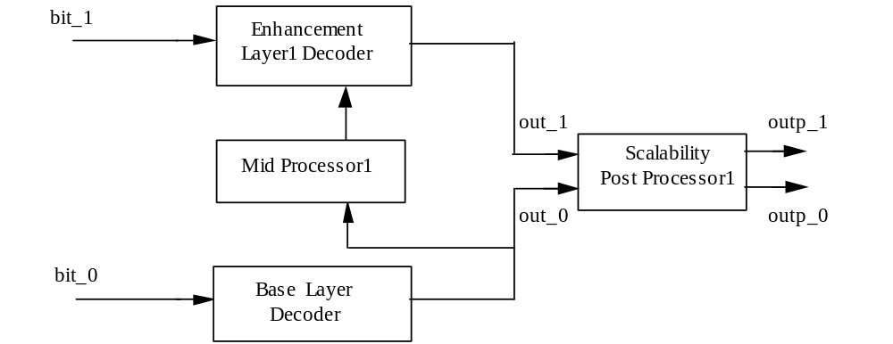
Figure 7-28 High level decoder structure for generalized scalability.
The base layer and enhancement layer bistreams are input for decoding by corresponding base layer decoder and enhancement layer decoder.
When spatial scalability is to be performed, mid processor 1 performs spatial up or down sampling of input. The scalability post processor performs any necessary operations such as spatial up or down sampling of the decoded base layer for display resulting at outp_0 while the enhancement layer without resolution conversion may be output as outp_1.
When temporal scalability is to be performed, the decoding of base and enhancement layer bitstreams occurs in the corresponding base and enhancement layer decoders as shown. In this case, mid processor 1 does not perform any spatial resolution conversion. The post processor simply outputs the base layer VOPs without any conversion, but temporally multiplexes the base and enhancement layer VOPs to produce higher temporal resolution enhancement layer.
The reference VOPs for prediction are selected by reference_select_code as specified in Table 7-14 and Table 7-15. In coding of P-VOPs belonging to an enhancement layer, the forward reference is one of the following three: the most recent decoded VOP of enhancement layer, the most recent VOP of the lower layer in display order, or the next VOP of the lower layer in display order.
In B-VOPs, the forward reference is one of the two: the most recent decoded enhancement VOP or the most recent lower layer VOP in display order. The backward reference is one of the three: the temporally coincident VOP in the lower layer, the most recent lower layer VOP in display order, or the next lower layer VOP in display order.
Table 7-14 Prediction reference choices in enhancement layer P-vops for scalability
ref_select_code | forward prediction reference
00 | Most recent decoded enhancement VOP belonging to the same layer.
01 | Most recent VOP in display order belonging to the reference layer.
10 | Next VOP in display order belonging to the reference layer.
11 | Temporally coincident VOP in the reference layer (no motion vectors)

Table 7-15 Prediction reference choices in enhancement layer P-vops for scalability
ref_select_code | forward temporal reference | backward temporal reference
00 | Most recent decoded enhancement VOP of the same layer | Temporally coincident VOP in the reference layer (no motion vectors)
01 | Most recent decoded enhancement VOP of the same layer. | Most recent VOP in display order belonging to the reference layer.
10 | Most recent decoded enhancement VOP of the same layer. | Next VOP in display order belonging to the reference layer.
11 | Most recent VOP in display order belonging to the reference layer. | Next VOP in display order belonging to the reference layer.

Temporal scalability
Temporal scalability involves two layers, a lower layer and an enhancement layer. Both the lower and the enhancement layers process the same spatial resolution. The enhancement layer enhances the temporal resolution of the lower layer and if temporally remultiplexed with the lower layer provides full temporal rate.

Base layer and enhancement layer
In the case of temporal scalability, the decoded VOPs of enhancement layer are used to increase the frame rate of the base layer. Figure 7-29 shows a simplified diagram of the motion compensation process for the enhancement layer using temporal scalability.

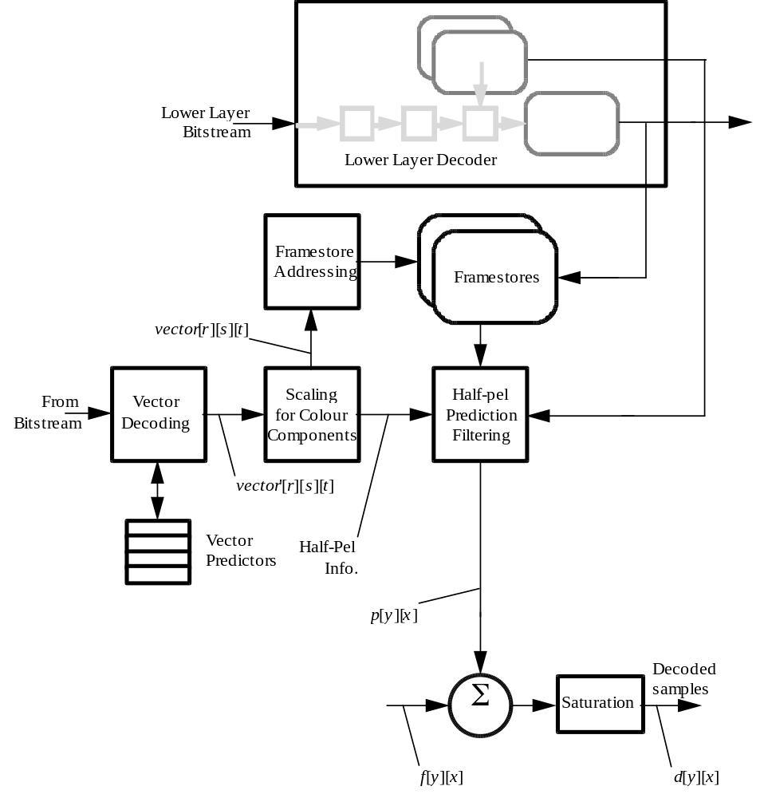
Figure 7-29 Simplified motion compensation process for temporal scalability.
Predicted samples p[y][x] is formed either from frame stores of base layer or from frame stores of enhancement layer. The difference data samples f[y][x] are added to p[y][x] to form the decoded samples d[y][x].
There are two types of enhancement structures indicated by the “enhancement_type” flag. When the value of enhancement_type is “1”, the enhancement layer increases the temporal resolution of a partial region of the base layer. When the value of enhancement_type is “0”, the enhancement layer increases the temporal resolution of an entire region of the base layer.

Base layer
The decoding process of the base layer is as same as non-scalable decoding process.

Enhancement layer
The VOP of the enhancement layer is decoded as either I-VOP, P-VOP or B-VOP. The shape of the VOP is either rectangular(video_object_layer_id is “00”) or arbitrary(video_object_layer_id is “01”).

Decoding of I-VOPs
The decoding process of I-VOPs in enhancement layer is as same as non-scalable decoding process.

Decoding of P-VOPs
The reference layer is indicated by ref_layer_id in Video Object Layer class. Other decoding process is as same as non-scalable P-VOPs except the process specified in 7.6.1.3.4 and 7.6.1.3.5.
For P-VOPs, the ref_select_code is either “00”, “01” or “10”.
When the value of ref_select_code is “00”, the prediction reference is set by the most recent decoded VOP belonging to the same layer.
When the value of ref_select_code is “01”, the prediction reference is set by the previous VOP in display order belonging to the reference layer.
When the value of ref_select_code is “10”, the prediction reference is set by the next VOP in display order belonging to the reference layer.

Decoding of B-VOPs
The reference layer is indicated by ref_layer_id in Video Object Layer class. Other decoding process is as same as non-scalable B-VOPs except the process specified in 7.6.1.3.4 and 7.6.1.3.5.
For B-VOPs, the ref_select_code is either “01”, “10” or “11”.
When the value of ref_select_code is “01”, the forward prediction reference is set by the most recent decoded VOP belonging to the same layer and the backward prediction reference is set by the previous VOP in display order belonging to the reference layer.
When the value of ref_select_code is “10”, the forward prediction reference is set by the most recent decoded VOP belonging to the same layer and the backward prediction reference is set by the next VOP in display order belonging to the reference layer.
When the value of ref_select_code is “11”, the forward prediction reference is set by the previous VOP in display order belonging to the reference layer and the backward prediction reference is set by the next VOP in display order belonging to the reference layer. The picture type of the reference VOP shall be either I or P (vop_coding_type = “00” or “01”).
When the value of ref_select_code is “01” or “10”, direct mode is not allowed. MODB shall always exist in each macroblock, i.e. the macroblock is not skipped even if the co-located macroblock is skipped.

Decoding of arbitrary shaped VOPs
Prediction for arbitrary shape in P-VOPs or in B-VOPs is formed from a forward reference VOP defined by the value of ref_select_code.
For arbitrary shaped VOPs with the value of enhancement_type being “1”, the shape of the reference VOP is defined as an all opaque rectangle whose size is as same as the reference layer when the shape of reference layer is rectangular (video_objbect_layer_shape = “00”).
When the value of ref_select_code is “11” and the value of enhancement_type is “1”, MODB shall always exist in each macroblock, i.e. the macroblock is not skipped even if the co-located macroblock is skipped.

Decoding of backward and forward shape
Backward shape and forward shape are used in background composition process specified in section 9.1. The backward shape is the shape of the enhanced object at the next VOP in display order belonging to the reference layer. The forward shape is the shape of the enhanced object at the previous VOP in display order belonging to the reference layer.
For the VOPs with the value of enhancement_type being “1”, backward shape is decoded when the load_backward_shape is “1” and forward shape is decoded when load_forward_shape is “1”.
When the value of load_backward_shape is “1” and the value of load_forward_shape is “0”, the backward shape of the previous VOP is copied to the forward shape for the current VOP. When the value of load_backward_shape is “0”, the backward shape of the previous VOP is copied to the backward shape for the current VOP and the forward shape of the previous VOP is copied to the forward shape for the current VOP.
The decoding process of backward and forward shape is the same as the decoding process for the shape of I-VOP with binary only mode (video_object_layer_shape = “10”).

Spatial scalability

Base Layer and Enhancement Layer
In the case of spatial scalability, the enhancement bitstream is used to increase the resolution of the image. When the output with lower resolution is required, only the base layer is decoded. And when the output with higher resolution is required, both the base layer and the enhancement layer are decoded.
Figure 7-30 is a diagram of the video decoding process with spatial scalability.

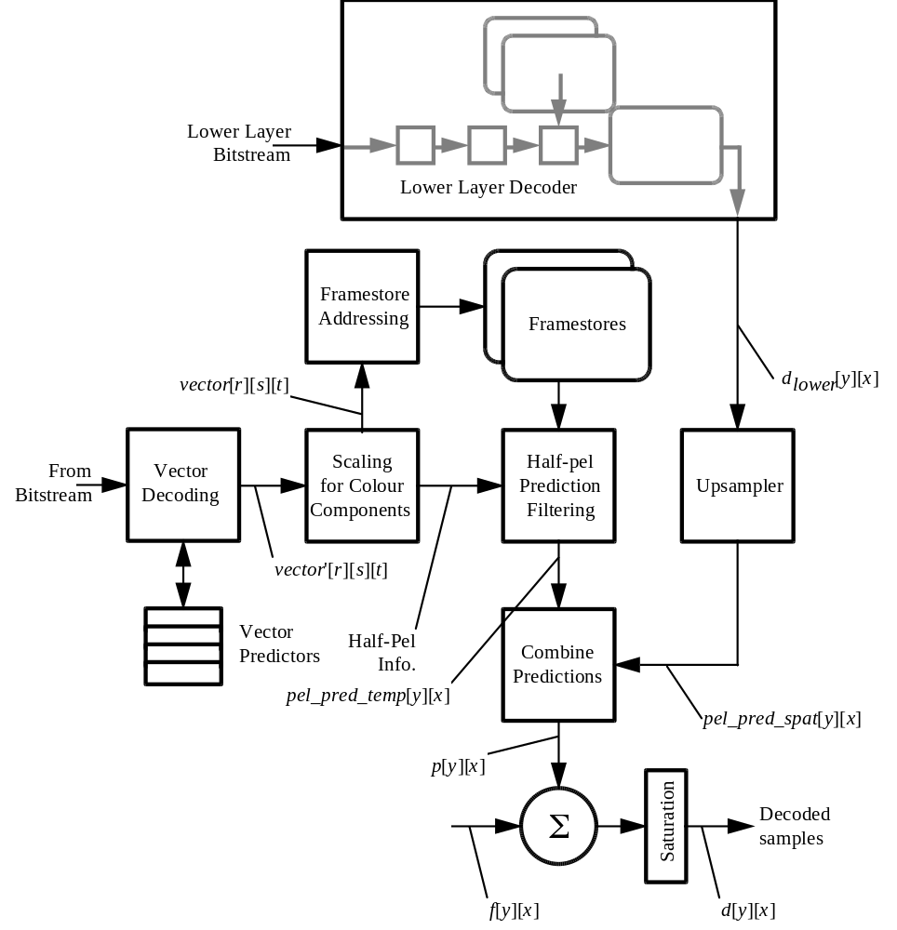
Figure 7-30 Simplified motion compensation process for spatial scalability

Decoding of Base Layer
The decoding process of the base layer is the same as nonscalable decoding process.

Prediction in the enhancement layer
A motion compensated temporal prediction is made from reference VOPs in the enhancement layer. In addition, a spatial prediction is formed from the lower layer decoded frame (dlower[y][x]). These predictions are selected individually or combined to form the actual prediction.
In the enhancement layer, the forward prediction in P-VOP and the backward prediction in B-VOP are used as the spatial prediction. The reference VOP is set to temporally coincident VOP in the base layer. The forward prediction in B-VOP is used as the temporal prediction from the enhancement layer VOP. The reference VOP is set to the most recent decoded VOP of the enhancement layer. The interpolate prediction in B-VOP is the combination of these predictions.
In the case that a macroblock is not coded, either because the entire macroblock is skipped or the specific macroblock is not coded there is no coefficient data. In this case f[y][x] is zero and the decoded samples are simply the prediction, p[y][x].

Formation of spatial prediction
Forming the spatial prediction requires definition of the spatial resampling process. The formation is performed at the mid-processor. The resampling process is defined for a whole VOP, however, for decoding of a macroblock, only the 16x16 region in the upsampled VOP, which corresponds to the position of this macroblock, is needed.
The spatial prediction is made by resampling the lower layer reconstructed VOP to the same sampling grid as the enhancement layer. In the first step, the lower layer VOP is subject to vertical resampling. Then, the vertically resampled image is subject to horizontal resampling.

Vertical resampling
The image subject to vertical resampling, 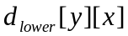, is resampled to the enhancement layer vertical sampling grid using using linear interpolation between the sample sites according to the following formula, where vert_pic is the resulting image:
vert_pic[yh][x] = (16 - phase) * 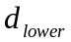[y1][x] + phase * [y2][x]
where yh = output sample coordinate in vert_pic
y1 = (yh * vertical_sampling_factor_m) / vertical_sampling_factor_n
y2 = y1 + 1 if y1 < video_object_layer_height - 1
y1 otherwise
phase = (16 * (( yh * vertical_sampling_factor_m) % vertical_sampling_factor_n))
// vertical_sampling_factor_n
where video_object_layer_width is the width of the reference VOL.
Samples which lie outside the lower layer reconstructed frame which are required for upsampling are obtained by border extension of the lower layer reconstructed frame.
NOTE - The calculation of phase assumes that the sample position in the enhancement layer at yh = 0 is spatially coincident with the first sample position of the lower layer. It is recognised that this is an approximation for the chrominance component if the chroma_format == 4:2:0.

Horizontal resampling
The image subject to horizontal resampling, 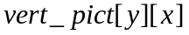, is resampled to the enhancement layer horizontal sampling grid using linear interpolation between the sample sites according to the following formula, where hor_pic is the resulting image:
hor_pic[y][xh] = ((16 - phase) * vert_pic[y][x1] + phase * vert_pic[y][x2]) // 256
where xh = output sample coordinate in hor_pic
x1 = (xh * horizontal_sampling_factor_m) / horizontal_sampling_factor_n
x2 = x1 + 1 if x1 < video_object_layer_width - 1
x1 otherwise
phase = (16 * (( xh * horizontal_sampling_factor_m) % horizontal_sampling_factor_n))
// h_subs_n
where video_object_layer_width is the width of the reference VOL.
Samples which lie outside the lower layer reconstructed frame which are required for upsampling are obtained by border extension of the lower layer reconstructed frame.

Selection and combination of spatial and temporal predictions
The spatial and temporal predictions can be selected or combined to form the actual prediction in B-VOP. The spatial prediction is refer to as “backward prediction”, while the temporal prediction is refer to as “forward prediction”. The combination of these predictions can be used as “interpolate prediction”. In case of P-VOP, only the spatial prediction (prediction from the lower layer) can be used as the forward prediction. The prediction in the enhancement layer is defined in the following formula.
pel_pred[y][x] = pel_pred_temp[y][x] (forward in B-VOP)
pel_pred[y][x] = pel_pred_spat[y][x] = hor_pict[y][x] (forward in P-VOP and backward in B-VOP)
pel_pred[y][x] = (pel_pred_temp[y][x] + pel_pred_spat[y][x])//2 (Interpolate in B-VOP)
pel_pred_temp[y][x] is used to denote the temporal prediction (formed within the enhancement layer). pel_pred_spat[y][x] is denote the prediction formed from the lower layer. pel_pred[y][x] is denoted the resulting prediction.

Decoding process of enhancement layer
The VOP in the enhancement layer is decoded as either I-VOP, P-VOP or B-VOP.

Decoding of I-VOPs
The decoding process of the I-VOP in the enhancement layer is the same as non_scalable decoding process.

Decoding of P-VOPs
In P-VOP, the ref_select_code shall be “11”, i.e., the prediction reference is set to the temporally coincident VOP in the base layer. The reference layer is indicated by ref_layer_id in VideoObjectLayer class. In case of spatial prediction, the motion vector shall be set to 0 at the decoding process and is not encoded in the bitstream.
A variable length codeword giving information about the macroblock type and the coded block pattern for chrominance is MCBPC. The codewords for MCBPC in the enhancement layer are the same as the base layer and shown in Table 11-6. MCBPC shall be included in coded macroblocks.
The macroblock type gives information about the macroblock and which data elements are present. Macroblock types and included elements in the enhancement layer bitstream are listed in Table 11-1-2.
In case of the enhancement layer of spatial scalability, INTER4V shall not be used. The macroblock of INTER or INTER+Q is encoded using the spatial prediction.

Decoding of B-VOPs
In B-VOP, the ref_select_code shall be “00”, i.e., the backward prediction reference is set to the temporally coincident VOP in the base layer, and the forward prediction reference is set to the most recent decoded VOP in the enhancement layer. In case of spatial prediction, the motion vector shall be set to 0 at the decoding process and is not encoded in the bitstream.
MODB shall be present in coded macroblocks belonging to B-VOPs. The codeword is same as the base layer and is shown in Table 11-2. In case MBTYPE does not exist the default shall be set to "Forward MC" (precdiction from the last decoded VOP in the same reference layer). MODB shall be encoded in all macroblock. If its value is equal to ‘0’, further information is not transmitted for this macroblock. The decoder treat the prediction of this macroblock as forward MC with motion vector equal to zero.
MBTYPE is present only in coded macroblocks belonging to B-VOPs. The MBTYPE gives information about the macroblock and which data elements are present. MBTYPE and included elements in the enhancement layer bitstream are listed in Table 11-4.
In case of the enhancement layer of spatial scalability, Direct mode shall not be used. The decoding process of the forward motion vectors are the same as the base layer.

Still texture object decoding
The block diagram of the decoder is shown in Figure 7-31.
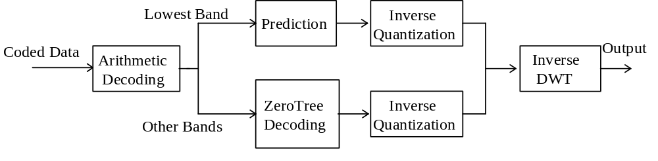
Figure 7-31 Block diagram of the encoder.
The basic modules of a zero-tree wavelet based decoding scheme are as follows:
- Arithmetic decoding of the bitstream into quantized wavelet coefficients and the significance map.
- Decoding of the DC subband using a predictive scheme.
- Zero-tree decoding of the higher subband wavelet coefficients.
- Inverse quantization of the wavelet coefficients.
- Composition of the texture using inverse discrete wavelet transform (IDWT).

Decoding of the DC subband
The wavelet coefficients of DC band are decoded independently from the other bands. First the minimum value of the coefficients “band_offset” and the maximum value of the coefficients “band_max_value” are decoded from bitstream.
The arithmetic coder model is initialized with an uniform distribution of “band_max_value-band_offset” seeds. Then, the quantized wavelet coefficients are decoded using the arithmetic decoder in a raster scan order, starting from the upper left coefficient and ending to the lowest right one. The model is updated with decoding of each wavelet coefficient to adopt the probability model to the statistics of DC band.
The “band_offset” is added to all the decoded values, and an inverse predictive scheme is applied. Each of the current coefficients w_{X} is predicted from three other quantized coefficients in its neighborhood, i.e. w_{A}, w_{B}, and w_{C} (see Figure 7-32), and the predicted value is added to the current decoded coefficient. That is,
if (|w_{A}-w_{B}|) < | w_{B}-w_{C}|)
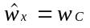
else
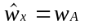
w_{x} = w_{x} +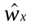
If any of nodes A, B or C is not in the image, its value is set to zero for the purpose of the inverse prediction. Finally, the inverse quantization scheme is applied to all decoded values to obtain the wavelet coefficients of DC band.

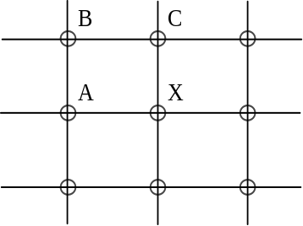
Figure 7-32 DPCM decoding of DC band coefficients

ZeroTree Decoding of the Higher Bands
Zero-tree algorithm is based on the strong correlation between the amplitudes of the wavelet coefficients across scales, and on the idea of partial ordering of the coefficients. The coefficient at the coarse scale is called the parent, and all coefficients at the same spatial location, and of similar orientation, at the next finer scale are that parent’s children. Figure 7-33 shows a wavelet tree where the parents and the children are indicated by dots and connected by lines. Since the DC subband (shown at the upper left in Figure 7-33) is coded separately using a DPCM scheme, the wavelet trees start from the adjacent higher bands.
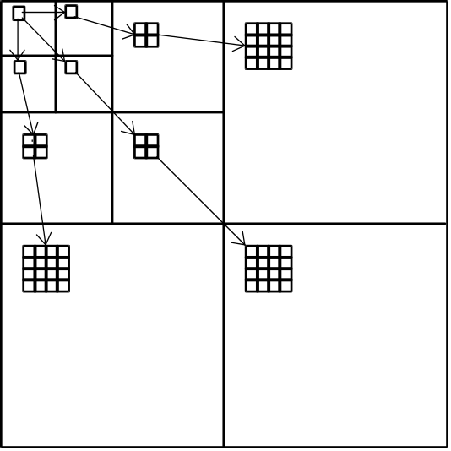
Figure 7-33 Parent-child relationship of wavelet coefficients
In transform-based coding, it is typically true that a large percentage of the transform coefficients are quantized to zero. A substantial number of bits must be spent either encoding these zero-valued quantized coefficients, or else encoding the location of the non-zero-valued quantized coefficients. ZeroTree Coding uses a data structure called a zerotree, built on the parent-child relationships described above, and used for encoding the location of non-zero quantized wavelet coefficients. The zerotree structure takes advantage of the principle that if a wavelet coefficient at a coarse scale is “insignificant” (quantized to zero), then all wavelet coefficients of the same orientation at the same spatial location at finer wavelet scales are also likely to be “insignificant”. Zerotrees exist at any tree node where the coefficient is zero and all the node’s children are zerotrees.
The wavelet trees are efficiently represented and coded by scanning each tree from the root in the 3 lowest AC bands through the children, and assigning one of four symbols to each node encountered: zerotree root (ZTR), value zerotree root (VZTR), isolated zero (IZ) or value (VAL). A ZTR denotes a coefficient that is the root of a zerotree. Zerotrees do not need to be scanned further because it is known that all coefficients in such a tree have amplitude zero. A VZTR is a node where the coefficient has a nonzero amplitude, and all four children are zerotree roots. The scan of this tree can stop at this symbol. An IZ identifies a coefficient with amplitude zero, but also with some nonzero descendant. A VAL symbol identifies a coefficient with amplitude nonzero, but also with some nonzero descendant. The symbols and quantized coefficients are losslessly encoded using an adaptive arithmetic coder. Table 7-16 shows the mapping of indices of the arithmetic decoding model into the zerotree symbols:
Table 7-16 The indexing of zerotree symbols
index | Symbol
0 | IZ
1 | VAL
2 | ZTR
3 | VZTR

In order to achieve a wide range of scalability levels efficiently as needed by different applications, three different zerotree scaaning and associated inverse quantization methods are employed. The encoding mode is speficied in bitstream with qunatization_type field as one of 1) single_quant, 2) multi_quant or 3) bilevel_quant:
Table 7-17 The qunatization types
code | quantization_type
01 | single_quant
10 | multi _quant
11 | bilevel_quant

In single_quant mode, the bitstream contains only one set of zero-tree map for the wavelet coefficients. After arithmetic decoding, the inverse quantization is applied to obtain the reconstructed wavelet coefficients and at the end, the inverse wavelet transform is applied to those coefficients.
In multi_quant mode, a multiscale zerotree decoding scheme is employed. Figure 7-34 shows the concept of this technique.
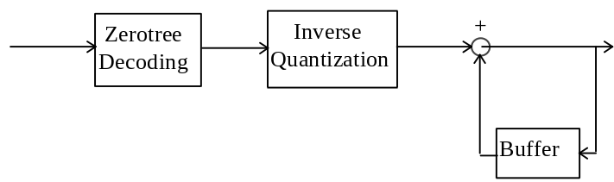
Figure 7-34. Multiscale Zerotree decoding
The wavelet coefficients of the first spatial (and/or SNR) layer are read from bitstream and decoded using arithmetic decoder. The zerotree scanning is used for decoding the significant maps and quantized coefficients and locating them in their corresponding positions in trees. Then, an inverse quantization is applied to these indices to obtain the quantized wavelet coefficients. These values are saved in the buffer to be added to the next layers of scalabilities. An inverse wavelet transform can also be applied to these coefficients to obtain the first decoded image. The above procedure is applied for the next spatial/SNR layers.
The bilevel_quant mode enables fine granular SNR scalability by encoding the wavelet coefficients in a bitplane by bitplane fashion. This mode uses the same zerotree symbols as the multi_quant mode. In this mode, a zero-tree map is decoded for each bitplane, indicating which wavelet coefficients are nonzero relative to that bitplane. The inverse quantization is also performed bitplane by bitplane. After the zero-tree map, additional bits are decoded to refine the accuracy of the previously decoded coefficients.

Zerotree Scanning
In single_quant mode, the wavelet coefficients are scanned in the tree-depth fashion, meaning that all coefficients of each tree is decoded before starting decoding of the next tree. The trees are decoded in a raster-scan fashion, starting form upper left tree and ending to the lower right one. Figure 7-35 shows the scanning order within a wavelet tree, with 4 levels of decomposition. In this figure, the index 0 represents the DC band coefficient of the wavelet tree while indices 1, 86 and 171 represent the coefficients of the 3 lowest AC bands. Likewise, the other indices represent the corresponding coefficient of the higher AC bands. As the DC coefficients are decoded separately, the index 0 is skipped in zerotree decoding.

0 | 1 | 2 | 23 | 3 | 8 | 24 | 29 | 4 | 5 | 9 | 10 | 25 | 26 | 30 | 31
86 | 171 | 44 | 65 | 13 | 18 | 34 | 39 | 6 | 7 | 11 | 12 | 27 | 28 | 32 | 33
87 | 108 | 172 | 193 | 45 | 50 | 66 | 71 | 14 | 15 | 19 | 20 | 35 | 36 | 40 | 41
129 | 150 | 214 | 235 | 55 | 60 | 76 | 81 | 16 | 17 | 21 | 22 | 37 | 38 | 42 | 43
88 | 93 | 109 | 114 | 173 | 178 | 194 | 199 | 46 | 47 | 51 | 52 | 67 | 68 | 72 | 73
98 | 103 | 119 | 124 | 183 | 188 | 204 | 209 | 48 | 49 | 53 | 54 | 69 | 70 | 74 | 75
130 | 135 | 151 | 156 | 215 | 220 | 236 | 241 | 56 | 57 | 61 | 62 | 77 | 78 | 82 | 83
140 | 145 | 161 | 166 | 225 | 230 | 246 | 251 | 58 | 59 | 63 | 64 | 79 | 80 | 84 | 85
89 | 90 | 94 | 95 | 110 | 111 | 115 | 116 | 174 | 175 | 179 | 180 | 195 | 196 | 200 | 201
91 | 92 | 96 | 97 | 112 | 113 | 117 | 118 | 176 | 177 | 181 | 182 | 197 | 198 | 202 | 203
99 | 100 | 104 | 105 | 120 | 121 | 125 | 126 | 184 | 185 | 189 | 190 | 205 | 206 | 210 | 211
101 | 102 | 106 | 107 | 122 | 123 | 127 | 128 | 186 | 187 | 191 | 192 | 207 | 208 | 212 | 213
131 | 132 | 136 | 137 | 152 | 153 | 157 | 158 | 216 | 217 | 221 | 222 | 237 | 238 | 242 | 243
133 | 134 | 138 | 139 | 154 | 155 | 159 | 160 | 218 | 219 | 223 | 224 | 239 | 240 | 244 | 245
141 | 142 | 146 | 147 | 162 | 163 | 167 | 168 | 226 | 227 | 231 | 232 | 247 | 248 | 252 | 253
143 | 144 | 148 | 149 | 164 | 165 | 169 | 170 | 228 | 229 | 233 | 234 | 249 | 250 | 254 | 255
Figure 7-35 Scanning order of a wavelet block in the single_quant mode
In multi_quant mode, the wavelet coefficients are decoded in multi scalability layers. In this mode, the wavelet coefficients are scanned in the subband by subband fashion, from the lowest to the highest frequency subbands. Figure 7-36 shows an example of decoding order for a 16x16 image with 3 levels of decomposition..The DC band is located at upper left corner (with indices 0, 1,2, 3) and is decoded separately as described in DC band decoding. The remainig coeffcinets are decoded on the order which is shown in the figure, starting from index 4 and ending at index 255. At first scalability layer, the zerotree symbols and the corresponding values are decoded for the wavelet coefficients of that scalability layer. For the next scalability layers, the zerotree map is updated along with the corresponding value refinements. In each scalability layer, a new zerotree symbol is decoded for a coefficient only if it was decoded as ZTR, VZTR or IZ in previous scalability layer. If the coefficient was decoded as VAL in previous layer, a VAL symbol is also assigned to it at the current layer and only its refinement value is decoded from bitstream.

0 | 1 | 4 | 5 | 16 | 17 | 18 | 19 | 64 | 65 | 66 | 67 | 68 | 69 | 70 | 71
2 | 3 | 6 | 7 | 20 | 21 | 22 | 23 | 72 | 73 | 74 | 75 | 76 | 77 | 78 | 79
8 | 9 | 12 | 13 | 24 | 25 | 26 | 27 | 80 | 81 | 82 | 83 | 84 | 85 | 86 | 87
10 | 11 | 14 | 15 | 28 | 29 | 30 | 31 | 88 | 89 | 90 | 91 | 92 | 93 | 94 | 95
32 | 33 | 34 | 35 | 48 | 49 | 50 | 51 | 96 | 97 | 98 | 99 | 100 | 101 | 102 | 103
36 | 37 | 38 | 39 | 52 | 53 | 54 | 55 | 104 | 105 | 106 | 107 | 108 | 109 | 110 | 111
40 | 41 | 42 | 43 | 56 | 57 | 58 | 59 | 112 | 113 | 114 | 115 | 116 | 117 | 118 | 119
44 | 45 | 46 | 47 | 60 | 61 | 62 | 63 | 120 | 121 | 122 | 123 | 124 | 125 | 126 | 127
128 | 129 | 130 | 131 | 132 | 133 | 134 | 135 | 192 | 193 | 194 | 195 | 196 | 197 | 198 | 199
136 | 137 | 138 | 139 | 140 | 141 | 142 | 143 | 200 | 201 | 202 | 203 | 204 | 205 | 206 | 207
144 | 145 | 146 | 147 | 148 | 149 | 150 | 151 | 208 | 209 | 210 | 211 | 212 | 213 | 214 | 215
152 | 153 | 154 | 155 | 156 | 157 | 158 | 159 | 216 | 217 | 218 | 219 | 220 | 221 | 222 | 223
160 | 161 | 162 | 163 | 164 | 165 | 166 | 167 | 224 | 225 | 226 | 227 | 228 | 229 | 230 | 231
168 | 169 | 170 | 171 | 172 | 173 | 174 | 175 | 232 | 233 | 234 | 235 | 236 | 237 | 238 | 239
176 | 177 | 178 | 179 | 180 | 181 | 182 | 183 | 240 | 241 | 242 | 243 | 244 | 245 | 246 | 247
184 | 185 | 186 | 187 | 188 | 189 | 190 | 191 | 248 | 249 | 250 | 251 | 252 | 253 | 254 | 255
Figure 7-36 Scanning order for multi_qaunt and bilevel_quant modes
In bilevel_quant mode, the band by band scanning is also employed, similar to the multi_quant mode. When bi-level quantization is applied, the coefficients that are already found significant are replaced with zero symbols for the purpose of zero-tree forming in later scans.

Entropy Decoding
The zero-tree symbols and quantized coefficient values are all decoded using an adaptive arithmetic decoder and a given symbol alphabet. The arithmetic decoder adaptively tracks the statistics of the zerotree symbols and decoded values.
In single_quant mode, four adaptive probability models are used to decode the coefficients of the higher bands. These models are: 1) type to decode the zero-tree symbols, 2) root to decode the values of the nonzero quantized coefficients of the first three AC bands, 3) valnz to decode the values of the nonzero quantized coefficients of the all other bands except the ones which are leaves (have no children), and finally 4) valz to decode the values of the quantized coefficients of the three highest bands, i.e. the coefficients that have no children. All above models are initialized with the uniform probability distribution and are updated with decoding of each corresponding coefficient by appropriately switching between the models. For each model, the alphabet range is read from bitstream before decoding the wavelet coefficients. This value, max_alphabet, is read from the bitstream in the following format:
extension (1 bit) | value (7 bits)
.  .  . | .  .  .
The following scripts shows how max_alphabet is decoded:

max_alphabet = 0;
count=0;
read (byte);
while ( byte/128){
max_alphabet += (byte-128) <<(count*7);
read (byte);
count++;
}
max_alphabet += (byte-128) <<(count*7);

Note that the quantized coefficients which are decoded using root or valnz models, can not be zero. At the encoder, to increase the coding efficiency, all the values which are coded using these models are shifted to left by one (subtracted one from their values before encoding them). Therefore, at the decoder, after decoding these coefficients, all are shifted to right by one (adding one to their value). The wavelet coefficients are decoded in the order which described in previous section. For each coefficient, its zerotree symbol is decoded first and if necessary, then its value is decoded. For the coefficients which are leaves and are decadent of a VAL or IZ, only a value is decoded using valz model. The value is decoded in two steps. First, its sign is decoded using a binary probability model with ‘0’ meaning positive and ‘1’ meaning negative sign. Then, the absolute value is decoded using the appropriate probability model. The sign model is initialized to the uniform probability distribution.
In multi_quant mode, one additional probability model, residual, is used for decoding the refinements of the coefficients that were decoded with VAL or VZTR symbol in any previous scalability layers. If in the previous layer, a VAL symbol was assigned , the same symbol is kept for the current pass and no zerotree symbol is decoded. If in the previous layer, a VZTR symbol was assigend, a new symbol is decoded for the current layer, but it can only be VAL or VZTR. The residual model, same as the other probability models, is also initialized to the uniform probability distribution at the beginning of each scalability layer. The numbers of bins for the residual model is calculated based on the ratio of the quantization step sizes of the current and previous scalability layers (defined in the inverse quantization section). The values of the new VAL or VZTR coefficients are decoded in the same way as in the single_quant mode.
For the bi-level quantization mode, the zero-tree map is decoded for each bitplane, indicating which wavelet coefficients are zeros relative to the current quantization step size. Different probability models for the arithmetic decoder are used and updated according to the local contexts. For instance, if a coefficient is a descendant of ZTR in the previous pass, then its probability of being zero in the current layer is significantly higher than in the case where it is the descendant of VZTR. The additional symbols DZ and DV are used for switching the models only, where DZ refers to the descendant of a ZTR symbol, DV refers to the descendant of a VZTR symbol.
After the zero-tree map, additional bits are received to refine the accuracy of the coefficients that are already marked significant by previously received information at the decoder. For each significant coefficient, the 1-bit bi-level quantized refinement values are entropy coded using the arithmetic coder.

Inverse Quantization
Different quantization step sizes (one for each color component) are specified for each level of scalability.
The quantizer of the DC band is an uniform mid-rise quantizer with a dead zone equal to the quantization step size. The quantization index is a signed integer number and the quantization reconstructed value is obtained using the following equation:
V= id * Qdc,
where V is the reconstructed value, id is the decoded index and Qdc is the quantization step size.
All the quantizers of the higher bands (in all quantization modes) are uniform mid-rise quantizer with a dead zone 2 times the quantization step size. For the single quantization mode, the quantization index is an signed integer. The reconstructed value is obtained using the following algorithm:

if (id == 0)
V =0;
else if ( id > 0 )
V = ROUND ((id + 0.5) * Q);
else
V = ROUND( (id - 0.5) * Q);
where V is the reconstructed value, id is the decoded index and Q is the quantization step size and ROUND rounds to the nearest integer.
In the multi quantization mode, when the quantization index of a nonzero coefficient is decoded for the first time, it is used to reconstruct the coefficients exactly in same procedure as in single quantization mode (as described above). For successive scalability layers, the reconstructed value is refined. The refinement information are called residuals and are calculated by calculating the number of refinement levels
m=ROUND( prevQ/curQ )
where, prevQ is the previous layer Q value, curQ is the current layers Q value, ROUND rounds to the nearest integer and the / is non-integer division. For m larger than 1, the inverse range of the quantized value is partitioned from the previous layer in such a way that makes the partitions as uniform as possible based on the previously calculated number of refinement levels, m. This partitioning always leaves a discrepancy of zero between the partition sizes if prevQ is evenly divisible by curQ (e.g. prevQ = 20 and curQ = 10). If prevQ is not evenly divisible by curQ (e.g. prevQ = 20 and curQ = 7) then a maximum discrepancy of 1 is set between partitions (in this case, 7, 7, 6). The larger partitions are always the ones closer to zero. The partitions are indexed from 0 to m-1, starting from the partition closer to zero (in this case, 0, 1, 2 for 7, 7, 6 partitions). These indeces are decoded from bitstream. At the decoder, the midpoint of any partition is assigned as the reconstruction level of that partition (in this example, 23 for the 20-26 partition, 30 for 26-33 partition, and 37 for the 34-39). For m =0 or m=1, no refinement is decoded from the bitstream.
In the bilevel_quant mode, quant and SNR_scalability_levels are also defined in the bitstream. The initial quantization step size is calculated using the following equation:
Q₀ = quant * (1<< SNR_scalability_levels)
The quanitzation step size at each successive bitplane is half of that at previous bitplane. These quantizers are alsoa uniform mid-rise quantizer with a dead zone 2 times the quantization step size The wavelet coefficients are reconstructed as described in the mulit_quant mode for the case in which m=2.

Shape adaptive zerotree decoding
Decoding shape adaptive wavelet coefficients is the same as decoding regular wavelet coefficients except keeping track of the locations to put the decoded wavelet coefficients according to the shape information. Same as decoding regular wavelet coefficients, the decoded zerotree symbols at a higher layer are used to determine whether decoding is needed at lower layers. The difference is that some zerotree nodes correspond to the pixel locations outside the shape boundary and no bits are to be decoded for these out_nodes.

Root layer
At the root layer (the lowest 3 AC bands), the shape information is examined for every node to determine whether a node is an out_node.
If it is an out_node,
- no bits are deocded for this node;
- the four children nodes of this node are marked “to_be_decoded” (TBD);
otherwise,
- a zerotree symbol is decoded for this node using an adaptive arithmetic decoder.
If the decoded symbol for the node is either isolated_zero (IZ) or value (VAL),
- the four children nodes of this node are marked TBD;
otherwise,
- the symbol is either zerotree_root (ZTR) or valued_zerotree_root (VZTR) and the four children nodes of this node are marked “no_code” (NC).
If the symbol is VAL or VZTR,
- a non-zero wavelet coefficient is decoded for this node by root model;
otherwise,
- the symbol is either IZ or ZTR and the wavelet coefficient is set to zero for this node.

Between root and leaf layer
At any layer between the root layer and the leaf layer, the shape information is examined for every node to determine whether a node is an out_node.
If it is an out_node,
- no bits are decoded for this node;
- the four children nodes of this node are marked as either TBD or NC depending on whether this node itself is marked TBD or NC respectively;
otherwise, if it is marked NC,
- no bits are decoded for this node;
- the wavelet coefficient is set to zero for this node;
- the four children nodes are marked NC;
otherwise,
- a zerotree symbol is decoded for this node using an adaptive arithmetic decoder.
If the decoded symbol for the node is either isolated_zero (IZ) or value (VAL),
- the four children nodes of this node are marked TBD;
otherwise,
- the symbol is either zerotree_root (ZTR) or valued_zerotree_root (VZTR) and the four nodes of this node are marked “no_code” (NC).
If the symbol is VAL or VZTR,
- a non-zero wavelet coefficient is decoded for this node by valnz model;
otherwise,
- the symbol is either IZ or ZTR and the wavelet coefficient is set to zero for this node.

Leaf layer
At the leaf layer, the shape information is examined for every node to determine whether a node is an out_node.
If it is an out_node,
- no bits are decoded for this node;
otherwise, if it is marked NC,
- no bits are decoded for this node;
- the wavelet coefficient is set to zero for this node;
otherwise,
* a wavelet coefficient is decoded for this node by valz adaptive arithmetic model;

Shape decomposition
The shape information for both shape adaptive zerotree decoding and the inverse shape adaptive wavelet transform is obtained by decomposing the reconstructed shape from the shape decoder. Assuming binary shape with 0 or 1 indicating a pixel being outside or inside the arbitrarily shaped object, the shape decomposition procedure can be described as follows:
- For each horizontal line, collect all even-indexed shape pixels together as the shape information for the horizontal low-pass band and collect all odd-indexed shape pixels together as the shape information for the horizontal high-pass band, except the special case where the number of consecutive 1’s is one.
- For an isolated 1 in a horizontal line, whether at an even-indexed location or at an odd-indexed location, it is always put together with the shape pixels for the low-pass band and a 0 is put at the corresponding position together with the shape pixels for the high-pass band.
- Perform the above operations for each vertical line after finishing all horizontal lines.
- Use the above operations to decompose the shape pixels for the horizontal and vertical low-pass band further until the number of decomposition levels is reached.

Mesh object decoding
An overview of the decoding process is show in Figure 7-37.
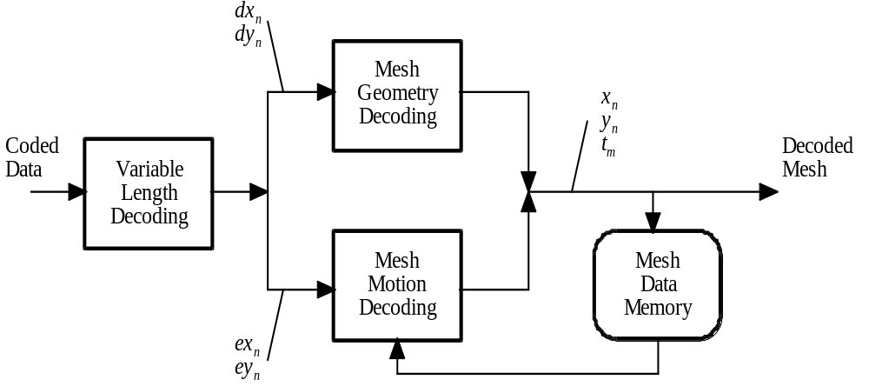
Figure 7-37 Simplified 2D Mesh Object Decoding Process
Variable length decoding takes the coded data and decodes either node point location data or node point motion data. Node point location data is denoted by dx_{n}, dy_{n} and node point motion data is denoted by ex_{n}, ey_{n}, where n is the node point index (n = 0, ..., N-1). Next, either mesh geometry decoding or mesh motion decoding is applied. Mesh geometry decoding computes the node point locations from the location data and reconstructs a triangular mesh from the node point locations. Mesh motion decoding computes the node point motion vectors from the motion data and applies these motion vectors to the node points of the previous mesh to reconstruct the current mesh.
The reconstructed mesh is stored in the mesh data memory, so that it may be used by the motion decoding process for the next mesh. Mesh data consists of node point locations (x_{n}, y_{n}) and triangles t_{m}, where m is the triangle index (m = 0, ..., M-1) and each triangle t_{m} contains a triplet <i, j, k> which stores the indices of the node points that form the three vertices of that triangle.
After the mesh_object_start_code has been decoded, a sequence of mesh object planes is decoded, until a mesh_object_end_code is detected. The new_mesh_flag of the mesh object plane class determines whether the data that follows specifies the initial geometry of a new dynamic mesh, or that it specifies the motion of the previous mesh to the current mesh, in a sequence of meshes. Firstly, the decoding of mesh geometry is described; then, the decoding of mesh motion is described. In this specification, a pixel-based coordinate system is assumed, with the x-axis points to the right from the origin, and the y-axis points down from the origin.

Mesh geometry decoding
Since the initial 2D triangular mesh is either a uniform mesh or a Delaunay mesh, the mesh triangular structure (i.e. the connections between node points) is not coded explicitly. Only a few parameters are coded for the uniform mesh; only the 2D node point coordinates 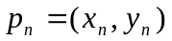 are coded for the Delaunay mesh. In each case, the coded information defines the triangular structure of the mesh implicitly, such that it can be computed uniquely by the decoder. The mesh_type_code specifies whether the initial mesh is uniform or Delaunay.

Uniform mesh
In case of a uniform mesh, five parameters are used to specify the complete triangular structure and node point locations. A 2D uniform mesh can be thought of as consisting of a set of rectangles, where each rectangle in turn consists of two triangles. An example of a 2D uniform mesh is given in Figure 7-38; in this example, the nr_mesh_nodes_hor is equal to 5 and nr_mesh_nodes_vert is equal to 4 and triangle_split_code equal to ‘00’. The meaning of mesh_rect_size_hor and mesh_rect_size vert is indicated by the arrows.
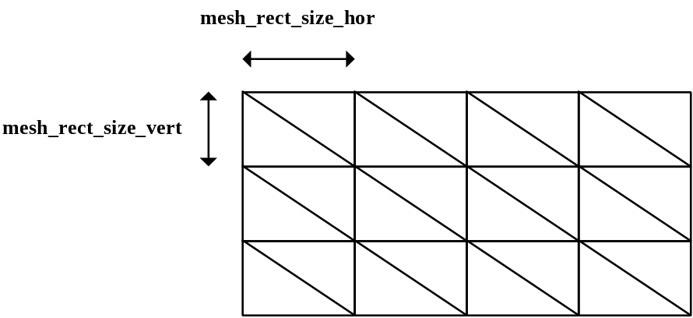
Figure 7-38 Specification of a uniform 2D mesh
In the case of a uniform mesh, the top-left node point of the initial mesh coincides with the origin of a local coordinate system. The first two decoded parameters specify the number of nodes in the horizontal, resp. vertical direction of the uniform mesh. The next two decoded parameters specify the horizontal, resp. vertical size of each rectangle (containing two triangles) in half pixel units. This specifies the layout and dimensions of the mesh. The last parameter specifies how each rectangle is split to form two triangles; four types are allowed as illustrated in Figure 7-39.
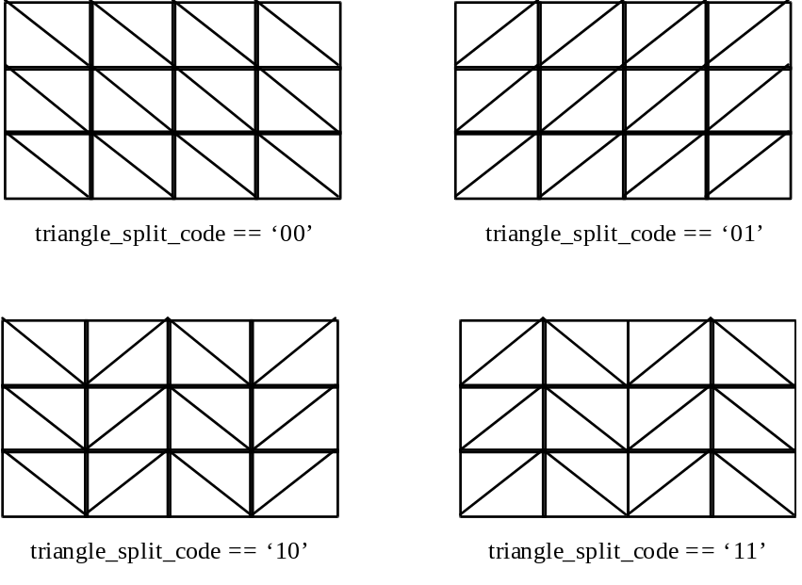
Figure 7-39 Illustration of the types of uniform meshes defined.

Delaunay mesh
First, the total number of node points in the mesh N is decoded; then, the number of node points that are on the boundary of the mesh N_{b} is decoded. Note that N is the sum of the number of nodes in the interior of the mesh, N_{i} and the number of nodes on the boundary, N_{b},
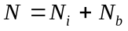 .
Now, the locations of boundary and interior node points are decoded, where we assume the origin of the local coordinate system is at the top left of the bounding box surrounding the initial mesh. The x-, resp. y-coordinate of the first node point, 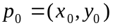, is decoded directly, where 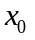 and 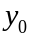 are specified w.r.t. to the origin of the local coordinate system. All the other node point coordinates are computed by adding a 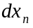, resp. 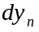 value to, resp. the x- and y-coordinate of the previously decoded node point. Thus, the coordinates of the initial node point is decoded as is, whereas the coordinates of all other node points , 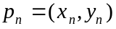, nÊ=Ê1,Ê...,ÊNÊ-Ê1, are obtained by adding a decoded value to the previously decoded node point coordinates:
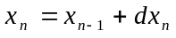 and 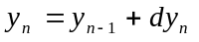.

The ordering in the sequence of decoded locations is such that the first N_{b} locations correspond to boundary nodes. Thus, after receiving the first N_{b} locations, the decoder is able to reconstruct the boundary of the mesh by connecting each pair of successive boundary nodes, as well as the first and the last, by straight-line edge segments. The next N - N_{b} values in the sequence of decoded locations correspond to interior node points. Thus, after receiving N nodes, the locations of both the boundary and interior nodes can be reconstructed, in addition to the polygonal shape of the boundary. This is illustrated with an example in Figure 7-40.
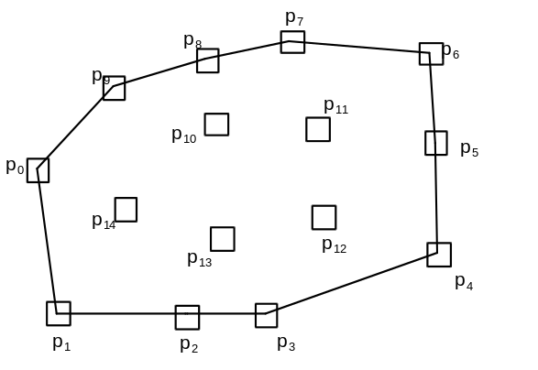
Figure 7-40 Decoded node points and mesh boundary edge.
The mesh is finally obtained by applying constrained Delaunay triangulation to the set of decoded node points, where the polygonal mesh boundary is used as a constraint. A constrained triangulation of a set of node points 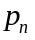 contains the line segments between successive node points on the boundary as edges and contains triangles only in the interior of the region defined by the boundary. Each triangle 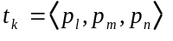 of a constrained Delaunay triangulation furthermore satisfies the property that the circumcircle of does not contain in its interior any node point 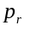 visible from all three vertices of . A node point is visible from another node point if a straight line drawn between them falls entirely inside or exactly on the constraining polygonal boundary. The Delaunay triangulation process is defined as any algorithm that is equivalent to enumerating all Delaunay triangles as defined above and inserting them into the mesh. An example of a mesh obtained by constrained triangulation of the node points of Figure 7-40 is shown in Figure 7-41.

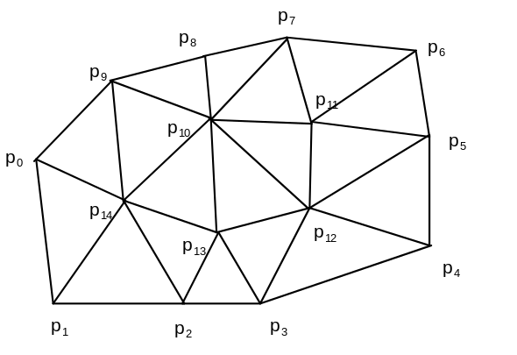

Figure 7-41 Decoded triangular mesh obtained by constrained Delaunay triangulation

Decoding of mesh motion vectors
Each node point of a 2D Mesh Object Plane numbered k in the sequence of Mesh Object Planes has a 2D motion vector 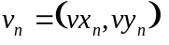, defined from Mesh Object Plane k to k+1. By decoding these motion vectors, one is able to reconstruct the locations of node points in Mesh Object Plane numbered k+1. The triangular topology of the mesh remains the same throughout the sequence. Node point motion vectors are decoded according to a predictive method, i.e., the components of each motion vector are predicted using the components of already decoded motion vectors of other node points.

Motion vector prediction
To decode the motion vector of a node point that is part of a triangle , where the two motion vectors vectors and 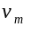 of the nodes 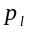 and 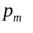 have already been decoded, one can use the values of and to predict 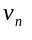 and add the prediction vector to a decoded prediction error vector. Starting from an initial triangle of which all three node motion vectors have been decoded, there must be at least one other, neighboring, triangle that has two nodes in common with . Since the motion vectors of the two nodes that and have in common have already been decoded, one can use these two motion vectors to predict the motion vector of the third node in . The actual prediction vector 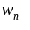 is computed by averaging of the two prediction motion vectors and the components of the prediction vector are rounded to half-pixel accuracy, as follows:
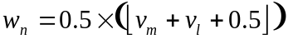 ,
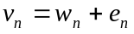 .
Here, 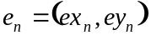 denotes the prediction error vector, the components of which are decoded from variable length codes. This procedure is repeated while traversing the triangles and nodes of the mesh, as explained below. While visiting all triangles of the mesh, the motion vector data of each node is decoded from the bitstream one by one. Note that no prediction is used to code the first motion vector,
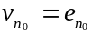 ,
and that only the first coded motion vector is used as a predictor to code the second motion vector,
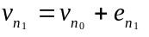 .
Note further that the prediction error vector is specified only for node points with a nonzero motion vector. For all other node points, the motion vector is simply 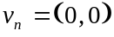.

Mesh traversal
We use a breadth-first traversal to order all the triangles and nodes in the mesh numbered k, and to decode the motion vectors defined from mesh k to k+1. The breadth-first traversal is determined uniquely by the topology and geometry of the mesh. The breadth-first traversal of the mesh triangles is defined as follows (see for an illustration).
First, define the initial triangle as follows. Define the top left mesh node as the node n with minimum 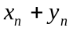, assuming the origin of the local coordinate system is at the top left. If there is more than one node with the same value of , then choose the node point among these with minimum y. The initial triangle is the triangle that contains the edge between the top-left node of the mesh and the next clockwise node on the boundary. Label the initial triangle with the number 0.
Next, all other triangles are iteratively labeled with numbers 1,Ê2,Ê...,ÊMÊ-Ê1, where M is the number of triangles in the mesh, as follows.
Among all labeled triangles that have adjacent triangles which are not yet labeled, find the triangle with the lowest number label. This triangle is referred to in the following as the current triangle. Define the base edge of this triangle as the edge that connects this triangle to the already labeled neighboring triangle with the lowest number. In the case of the initial triangle, the base edge is defined as the edge between the top-left node and the next clockwise node on the boundary. Define the right edge of the current triangle as the next counterclockwise edge of the current triangle with respect to the base edge; and define the left edge as the next clockwise edge of the current triangle with respect to the base edge. That is, for a triangle , where the vertices are in clockwise order, if 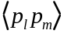 is the base edge, then 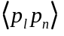 is the right edge and 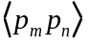 is the left edge.
Now, check if there is an unlabeled triangle adjacent to the current triangle, sharing the right edge. If there is such a triangle, label it with the next available number. Then check if there is an unlabeled triangle adjacent to the current triangle, sharing the left edge. If there is such a triangle, label it with the next available number.
This process is continued iteratively until all triangles have been labeled with a unique number m.
The ordering of the triangles according to their assigned label numbers implicitly defines the order in which the motion vector data of each node point is decoded, as described in the following. Initially, motion vector data for the top-left node of the mesh is retrieved from the bitstream. No prediction is used for the motion vector of this node, hence this data specifies the motion vector itself. Then, motion vector data for the second node, which is the next clockwise node on the boundary w.r.t. the top-left node, is retrieved from the bitstream. This data contains the prediction error for the motion vector of this node, where the motion vector of the top-left node is used as a prediction. Mark these first two nodes (that form the base edge of the initial triangle) with the label ÔdoneÕ.
Next, process each triangle as determined by the label numbers. For each triangle, the base edge is determined as defined above. The motion vectors of the two nodes of the base edge of a triangle are used to form a prediction for the motion vector of the third node of that triangle. If that third node is not yet labeled ÔdoneÕ, motion vector data is retrieved and used as prediction error values, i.e. the decoded values are added to the prediction to obtain the actual motion vector. Then, that third node is labeled ÔdoneÕ. If the third note is already labeled ÔdoneÕ, then it is simply ignored and no data is retrieved. Note that due to the ordering of the triangles as defined above, the two nodes on the base edge of a triangle are guaranteed to be labeled ÔdoneÕ when that triangle is processed, signifying that their motion vectors have already been decoded and may be used as predictors.
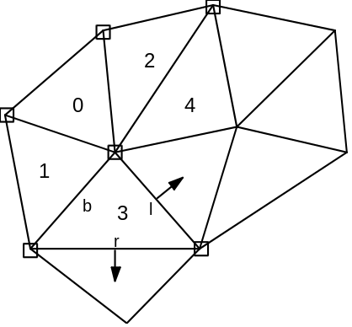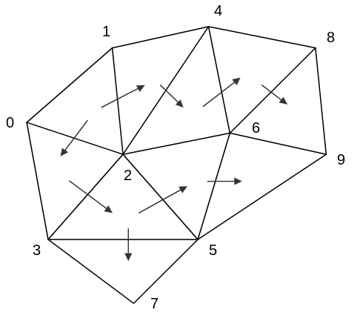

Figure 7-42 Breadth-first traversal of a 2D triangular example mesh.
In Figure 7-42 an example is shown of breadth-first traversal. On the left, the traversal is halfway through the mesh - five triangles have been labeled (with numbers) and the motion vectors of six node points have been decoded (marked with a box symbol). The triangle which has been labeled Ô3Õ is the Ôcurrent triangleÕ; the base edge is ÔbÕ; the right and left edge are ÔrÕ and ÔlÕ. The triangles that will be labeled next are the triangles sharing the right, resp. left edge with the current triangle. After those triangles are labeled, the triangle which has been labeled Ô4Õ will be the next Ôcurrent triangleÕ and another motion vector will be decoded. On the right, the traversed 2D triangular mesh is shown, illustrating the transitions between triangles and final order of node points according to which respective motion vectors are decoded.

Face object decoding

Frame based face object decoding
This clause specifies the additional decoding process required for face object decoding.
The coded data is decoded by an arithmetic decoding process. The arithmetic decoding process is described in detail in Annex B. Following the arithmetic decoding, the data is de-quantized by an inverse quantization process. The FAPs are obtained by a predictive decoding scheme as shown in Figure 7-43.
The base quantization step size QP for each FAP is listed in Table 12-1. The quantization parameter FAP_QUANT is applied uniformly to all FAPs. The magnitude of the quantization scaling factor ranges from 1 to 8. The value of FAP_QUANT == 0 has a special meaning, it is used to indicate lossless coding mode, so no dequantization is applied. The quantization stepsize is obtained as follows:
if (FAP_QUANT)
qstep = QP * FAP_QUANT
else
qstep = 1
The dequantized FAP’(t) is obtained from the decoded coefficient FAP’’(t) as follows:
FAP’(t) = qstep * FAP’’(t)
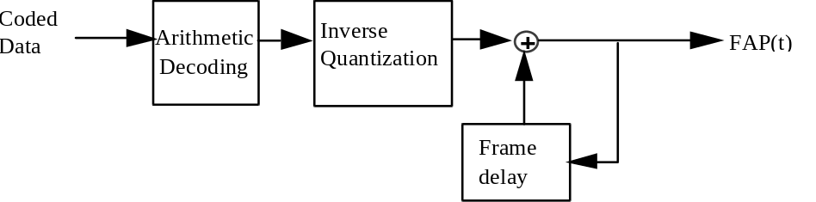
Figure 7-43 FAP decoding

Decoding of faps
For a given frame FAPs in the decoder assume one of three of the following states:
- set by a value transmitted by the encoder
- retain a value previously sent by the encoder
- interpolated by the decoder
FAP values which have been initialized in an intra coded FAP set are assumed to retain those values if subsequently masked out unless a special mask mode is used to indicate interpolation by the decoder. FAP values which have never been initialized must be estimated by the decoder. For example, if only FAP group 2 (inner lip) is used and FAP group 8 (outer lip) is never used, the outer lip points must be estimated by the decoder. In a second example the FAP decoder is also expected to enforce symmetry when only the left or right portion of a symmetric FAP set is received (e.g. if the left eye is moved and the right eye is subject to interpolation, it is to be moved in the same way as the left eye).

DCT based face object decoding
The bitstream is decoded into segments of FAPs, where each segment is composed of a temporal sequence of 16 FAP object planes. The block diagram of the decoder is shown in Figure 7-44.
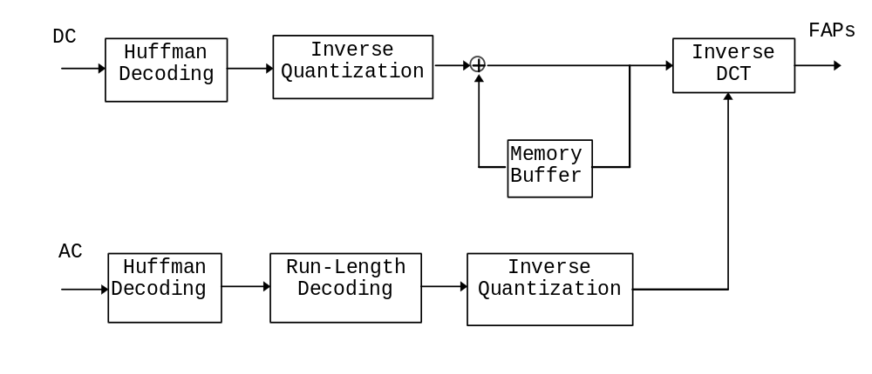
Figure 7-44 Block diagram of the DCT-based decoding process.
The DCT-based decoding process consists of the following three basic steps:
- Differential decoding the DC coefficient of a segment.
- Decoding the AC coefficients of the segment
- Determining the 16 FAP values of the segment using inverse discrete cosine transform (IDCT).
A uniform quantization step size is used for all AC coefficients. The quantization step size for AC coefficients is obtained as follows:
qstep[i] = fap_scale[fap_quant_inex] * DCTQP[i]
where DCTQP[i] is the base quantization step size and its value is defined in Section 6.3.11.10. The quantization step size of the DC coefficient is one-third of the AC coefficients. Different quantization step sizes are used for different FAPs.
The DCT-based decoding process is applied to all FAP segments except the viseme (FAP #1) and expression (FAP #2) parameters. The latter two parameters are differential decoded without transform. The decoding of viseme and expression segments are described at the end of this section.
For FAP #3 to FAP #68, the DC coefficient of an intra coded segment is stored as a 16-bit signed integer if its value is within the 16-bit range. Otherwise, it is stored as a 31-bit signed integer. For an inter coded segment, the DC coefficient of the previous segment is used as a prediction of the current DC coefficient. The prediction error is decoded using a Huffman table of 512 symbols. . An "ESC" symbol, if obtained, indicates that the prediction error is out of the range [-255, 255]. In this case, the next 16 bits extracted from the bitstream are represented as a signed 16-bit integer for the prediction error. If the value of the integer is equal to -256*128, it means that the value of the prediction error is over the 16-bit range. Then the following 32 bits from the bitstream are extracted as a signed 32-bit integer, in twos complement format and the most significant bit first
The AC coefficients, for both inter and intra coded segments, are decoded using Huffman tables. The run-length code indicates the number of leading zeros before each non-zero AC coefficient. The run-length ranges from 0 to 14 and proceeds the code for the AC coefficient. The symbol 15 in the run length table indicates the end of non-zero symbols in a segment. Therefore, the Huffman table of the run-length codes contains 16 symbols. The values of non-zero AC coefficients are decoded in a way similar to the decoding of DC prediction errors but with a different Huffman table.
The bitstreams corresponding to viseme and expression segments are basically differential decoded without IDCT. For an intra coded segment, the quantized values of of the first viseme_select1, viseme_select2, viseme_blend, expression_select1, expression_select2, expression_intensity1, and expression_intensity2 within the segment are decoded using fixed length code. These first values are used as the prediction for the second viseme_select1, viseme_select2, … etc of the segment and the prediction error are differential decoded using Huffman tables. For an inter coded segment, the last viseme_select1, for example, of the previous decoded segment is used to predict the first viseme_select1 of the current segment. In general, the decoded values (before inverse quantization) of differential coded viseme and expression parameter fields are obtained
byviseme_segment_select1Q[k] = viseme_segment_select1Q[k-1] +
viseme_segment_select1Q_diff[k] - 14
viseme_segment_select2Q[k] = viseme_segment_select2Q[k-1] +
viseme_segment_select2Q_diff[k] - 14

viseme_segment_blendQ[k] = viseme_segment_blendQ[k-1] +
viseme_segment_blendQ_diff[k] - 63
expression_segment_select1Q[k] = expression_segment_select1Q[k-1] +
expression_segment_select1Q_diff[k] - 6
expression_segment_select2Q[k] = expression_segment_select2Q[k-1] +
expression_segment_select2Q_diff[k] - 6
expression_segment_intensity1Q[k] = expression_segment_intensity1Q[k-1] +
expression_segment_intensity1Q_diff[k] - 63
expression_segment_intensity2Q[k] = expression_segment_intensity2Q[k-1] +
expression_segment_intensity2Q_diff[k] - 63

Decoding of the viseme parameter fap 1
Fourteen visemes have been defined for selection by the Viseme Parameter FAP 1, the definition is given in Annex C. The viseme parameter allows two visemes from a standard set to be blended together. The viseme parameter is composed of a set of values as follows.

viseme () { | Range
viseme_select1 | 0-14
viseme_select2 | 0-14
viseme_blend | 0-63
viseme_def | 0-1
}
Viseme_blend is quantized (step size = 1) and defines the blending of viseme1 and viseme2 in the decoder by the following symbolic expression where viseme1 and 2 are graphical interpretations of the given visemes as suggested in the non-normative annex.
final viseme = (viseme 1) * (viseme_blend / 63) + (viseme 2) * (1 - viseme_blend / 63)
The viseme can only have impact on FAPs that are currently allowed to be interpolated.
If the viseme_def bit is set, the current mouth FAPs can be used by the decoder to define the selected viseme in terms of a table of FAPs. This FAP table can be used when the same viseme is invoked again later for FAPs which must be interpolated.

Decoding of the viseme parameter fap 2
The expression parameter allows two expressions from a standard set to be blended together.The expression parameter is composed of a set of values as follows.

expression () { | Range
expression_select1 | 0-6
expression_intensity1 | 0-63
expression_select2 | 0-6
expression_intensity2 | 0-63
init_face | 0-1
expression_def | 0-1
}
Expression_intensity1 and expression_intensity2 are quantized (step size = 1) and define excitation of expressions 1 and 2 in the decoder by the following equations where expressions 1 and 2 are graphical interpretations of the given expression as suggested by the non-normative reference:
final expression = expression1 * (expression_intensity1 / 63)+ expression2 * (expression_intensity2 / 63)
The decoder displays the expressions according to the above fomula as a superposition of the 2 expressions.
The expression can only have impact on FAPs that are currently allowed to be interpolated. If the init_face bit is set, the neutral face may be modified within the neutral face constraints of mouth closure, eye opening, gaze direction, and head orientation before FAPs 3-68 are applied. If the expression_def bit is set, the current FAPs can be used to define the selected expression in terms of a table of FAPs. This FAP table can then be used when the same expression is invoked again later.

Fap masking
The face is animated by sending a stream of facial animation parameters. FAP masking, as indicated in the bitstream, is used to select FAPs. FAPs are selected by using a two level mask hierarchy. The first level contains two bit code for each group indicating the following options:
- no FAPs are sent in the group.
- a mask is sent indicating which FAPs in the group are sent. FAPs not selected by the group mask retain their previous value if any previously set value (not interpolated by decoder if previously set)
- a mask is sent indicating which FAPs in the group are sent. FAPs not selected by the group mask retain must be interpolated by the decoder.
- all FAPs in the group are sent.

Output of the decoding process
This section describes the output of the theoretical model of the decoding process that decodes bitstreams conforming to this specification.
The visual decoding process input is one or more coded visual bitstreams (one for each of the layers). The visual layers are generally multiplexed by the means of a system stream that also contains timing information.

Video data
The output of the video decoding process is a series of vops that are normally the input of a display process. The order in which fields or vops are output by the decoding process is called the display order, and may be different from the coded order (when B-vops are used).

2D Mesh data
The output of the decoding process is a sequence of meshes, defined for each time instant, a series of one or more mesh object planes. The meshes are normally inpout to a compositor that maps the texture of a related video object onto the mesh. The coded order and the displayed order of the mesh are identical. Mesh object planes can be used to deform a video object plane or still texture object by piece-wise warping.

Face animation parameter data
The output of the decoding process is a sequence of facial animation parameters. They are input to a display process that uses the parameters to animate a face object.

Visual-Systems Composition Issues

Temporal Scalability Composition
Background composition is used in forming the background region for objects at the enhancement layer of temporal scalability when the value of both enhancement_type and background_composition is one. This process is useful when the enhancement VOP corresponds to the partial region of the VOP belonging to the reference layer. In this process, the background of a current enhancement VOP is composed using the previous and the next VOPs in display order belonging to the reference layer.
Figure 8-1 shows the background composition for the current frame at the enhancement layer. The dotted line represents the shape of the selected object at the previous VOP in the reference layer (called “forward shape”). As the object moves, its shape at the next VOP in the reference layer is represented by a broken line (called “backward shape”).
For the region outside these shapes, the pixel value from the nearest VOP at the reference layer is used for the composed background. For the region occupied only by the forward shape, the pixel value from the next VOP at the reference layer is used for the composed frame. This area is shown as lightly shaded in Figure 8-1. On the other hand, for the region occupied only by the backward shape, pixel values from the previous VOP in the reference layer are used. This is the area shaded dark in Figure 8-1. For the region where the areas enclosed by these shapes overlap, the pixel value is given by padding from the surrounding area. The pixel value which is outside of the overlapped area should be filled before the padding operation.

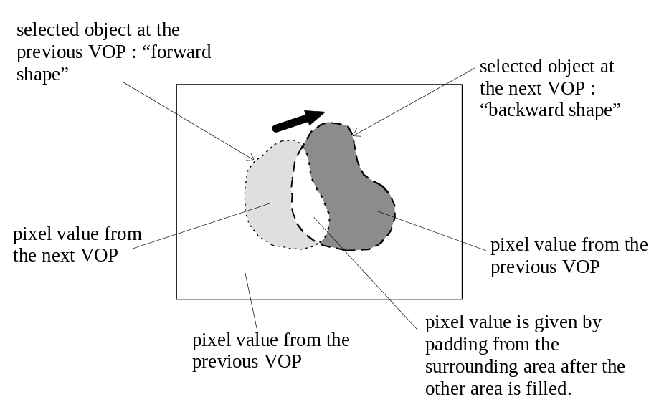
Figure 8-1– Background composition
The following process is a mathematical description of the background composition method.
If s(x,y,ta)=0 and s(x,y,td)=0
fc(x,y,t) = f(x,y,td) (|t-ta|>|t-td|)
fc(x,y,t) = f(x,y,ta) (otherwise),
if s(x,y,ta)=1 and s(x,y,td)=0
fc(x,y,t) = f(x,y,td)
if s(x,y,ta)=0 and s(x,y,td)=1
fc(x,y,t) = f(x,y,ta)
if s(x,y,ta)=1 and s(x,y,td)=1
The pixel value of fc(x,y,t) is given by repetitive padding from the surrounding area.
where
fc composed background
f decoded VOP at the reference layer
s shape information (alpha plane) , 0: transparent, 1: opaque
(x,y) the spatial coordinate
t time of the current VOP
ta time of the previous VOP
td time of the next VOP
Two types of shape information, s(x, y, ta) and s(x, y, td), are necessary for the background composition. s(x, y, ta) is called a “forward shape” and s(x, y, td) is called a “backward shape”. If f(x, y, td) is the last VOP in the bitstream of the reference layer, it should be made by copying f(x, y, ta). In this case, two shapes s(x, y, ta) and s(x, y, td) should be identical to the previous backward shape.

Sprite Composition
The static sprite technology enables to encode very efficiently video objects which content is expected not to vary in time along a video sequence. For example, it is particularly well suited to represent backgrounds of scenes (decor, landscapes) or logos.
A static sprite (sometimes referred as mosaic in the literature) is a frame containing spatial information for a single object, obtained by gathering information for this object throughout the sequence in which it appears. A static sprite can be a very large frame: it can correspond for instance to a wide angle view of a panorama.
The MPEG-4 syntax defines a dedicated coding mode to obtain VOPs from static sprites: the so-called “Sprite-VOPs”. Sprite-VOPs are extracted from a static sprite using a warping operation consisting in a global spatial transformation driven by few motion parameters (0,2,4 or 8).
For composition with other VOPs, there are no special rules for Sprite-VOPs. However, it is classical to use Sprite-VOPs as background objects over which “classical” objects are superimposed.

Profiles and Levels
NOTE - In this Specification the word ÒprofileÓ is used as defined below. It should not be confused with other definitions of ÒprofileÓ and in particular it does not have the meaning that is defined by JTC1/SGFS.
Profiles and levels provide a means of defining subsets of the syntax and semantics of this Specification and thereby the decoder capabilities required to decode a particular bitstream. A profile is a defined sub-set of the entire bitstream syntax that is defined by this Specification. A level is a defined set of constraints imposed on parameters in the bitstream. Conformance tests will be carried out against defined profiles at defined levels.
The purpose of defining conformance points in the form of profiles and levels is to facilitate bitstream interchange among different applications. Implementers of this Specification are encouraged to produce decoders and bitstreams which correspond to those defined conformance regions. The discretely defined profiles and levels are the means of bitstream interchange between applications of this Specification.
In this clause the constrained parts of the defined profiles and levels are described. All syntactic elements and parameter values which are not explicitly constrained may take any of the possible values that are allowed by this Specification. In general, a decoder shall be deemed to be conformant to a given profile at a given level if it is able to properly decode all allowed values of all syntactic elements as specified by that profile at that level.

Object Profiles
Two object profiles for natural video are being defined, also, work on a third profile is in progress. The work on profiles and levels will evolve and thus some reorganization of profile structure is possible.

Simple Video Object Profile
A bit-depth of 8 bits for luminance component isassumed for this profile.
- Intra mode (I-vop)
- Predicted mode (P-vop)
- DC and AC prediction
- Slice synchronization
- Reversible Variable Length codes
- Data partitioning
- Binary Shape
- P-vop based arbitrary shape temporal scalability

12-bit Video Object Profile
A bit-depth of 12 bits for luminance component isassumed for this profile. This profile uses the same tools listed in simple video object profile with the exception that scaling, dequantization and vop boundary resets are done in a generalized manner supporting coding of video with bit depth of 4 to 12 bits.

Main Profile (in progress)
This profile is expected to be a syntactic superset of simple video object profile and will support additional coding tools.

Annex A
Coding Transforms
(This annex forms an integral part of the committee draft of this International Standard)

Discrete cosine transform for video texture
The NxN two dimensional DCT is defined as:
with u, v, x, y = 0, 1, 2, … N-1
where x, y are spatial coordinates in the sample domain
u, v are coordinates in the transform domain
The inverse DCT (IDCT) is defined as:
The input to the forward transform and output from the inverse transform is represented with 9 bits. The coefficients are represented in 12 bits. The dynamic range of the DCT coefficients is [-2048:+2047].
The N by N inverse discrete transform shall conform to IEEE Standard Specification for the Implementations of 8 by 8 Inverse Discrete Cosine Transform, Std 1180-1990, DecemberÊ6, 1990.
NOTES -
1 ClauseÊ 2.3 Std 1180-1990 ÒConsiderations of Specifying IDCT Mismatch ErrorsÓ requires the specification of periodic intra-picture coding in order to control the accumulation of mismatch errors. Every macroblock is required to be refreshed before it is coded 132 times as predictive macroblocks. Macroblocks in B-pictures (and skipped macroblocks in P-pictures) are excluded from the counting because they do not lead to the accumulation of mismatch errors. This requirement is the same as indicated in 1180-1990 for visual telephony according to ITU-T Recommendation H.261.
2 Whilst the IEEE IDCT standard mentioned above is a necessary condition for the satisfactory implementation of the IDCT function it should be understood that this is not sufficient. In particular attention is drawn to the following sentence from 5.4 of this specification: ÒWhere arithmetic precision is not specified, such as the calculation of the IDCT, the precision shall be sufficient so that significant errors do not occur in the final integer values.Ó

Discrete wavelet transform for still texture

Adding the mean
Before applying the inverse wavelet transform, the mean of each color component (“mean_y”, “mean_u”, and “mean_v”) is added to the all wavelet coefficients of dc band.

wavelet filter
A 2-D separable inverse wavelet transfrom is used to synthesize the still texture. The default wavelet composition is performed using Daubechies (9,3) tap biorthogonal filter bank. The inverse DWT is performed either in floating or integer operations depending on the field “wavelet_filter_type”, defined in the syntax. The floating filter coefficients are:

Lowpass | g[ ] =
[ 0.35355339059327 | 0.70710678118655 | 0.35355339059327]

Highpas | h[ ] =
[ 0.03314563036812 | 0.06629126073624 | -0.17677669529665
-0.41984465132952 | 0.99436891104360 | -0.41984465132952
-0.17677669529665 | 0.06629126073624 | 0.03314563036812 ]

The integer filter coefficients are:

Lowpass | g[ ] =
32 | 64 | 32

Highpass | h[ ] =
3 | 6 | -16
-38 | 90 | -38
-16 | 6 | 3

The synthesis filtering operation is defined as follows:
1 4
y[n] = ∑ L[n+i]*g[i+1] + ∑ H[n+i]*h[i+4]
i=-1 i=-4
where

- n = 0, 1, ... N-1, and N is the number of output points;
- L[2*i] = xl[i] and L[2*i+1] = 0 for i=0,1,...,N/2-1, and {xl[i]} are the N/2 input wavelet coefficients in the low-pass band;
- H[2*i+1] = xh[i] and H[2*i] = 0 for i=0,1,...,N/2-1, and {xh[i]} are the N/2 input wavelet coefficients in the high-pass band.

Note:
- the index range for h[] is from 0 to 8;
- the index range for g[] is from 0 to 2;
- the index range for L[] is from -1 to N;
- the index range for H[] is from -4 to N+3; and
- the values of L[] and H[] for indexes less than 0 or greater than N-1 are obtained by symmetric extension described in the following section.

In the case of integer wavelet, the outputs at each composition level are scaled down with dividing by 8096 with rounding to the nearest integer.

Symmetric extension
A symmetric extension of the input wavelet coefficients is performed before up-sampling and applying the wavelet composition at each level. Two types of symmetric extensions are needed, both mirror the boundary pixels. Type A replicates the edge pixel and Type B does not replicate the edge pixel. This is illustrated in Figure 10-1 and Figure 10-2, where the edge pixel is indicated by z. The types of extension for the input data to the wavelet filters are shown in Table 10-1.

Type A …v w x y z | z y x w v…
Type B …...v w x y | z y x w v…

Figure 10-1 Symmetrical extensions at leading boundary

Type A …v w x y z | z y x w v…
Type B …v w x y z | y x w v…

Figure 10-2 Symmetrical extensions at the trailing boundary

Table 10-1Extension method for the input data to the synthesis filters
 | boundary | Extension
lowpass input xl[] | leading | TypeB
to 3-tap filter g[] | trailing | TypeA
highpass input xh[] | leading | TypeA
to 9-tap filter h[] | trailing | TypeB

Decomposition level
The number of decomposition levels of the luminance component is defined in the input bitstream. The number of decompostion level for the chrominance components is one level less than the luminance components.

Shape adaptive wavelet filtering and symmetric extension

Shape adaptive wavelet
The 2-D inverse shape adaptive wavelet transform uses the same wavelet filter as specified in Table 10-1. According to the shape information, segments of consecutive output points are reconstructed and put into the correct locations. The filtering operation of shape adaptive wavelet is a generalization of that for the regular wavelet. The generalization allows the number of output points to be an odd number as well as an even number. Relative to the bounding box, the starting point of the output is also allowed to be an odd number as well as an even number according to the shape information. Within the generalized wavelet filtering, the regular wavelet filtering is a special case where the number of output points is an even number and the starting point is an even number (0) too. Another special case is for reconstruction of rectangular textures with an arbitrary size where the number of output points may be even or odd and the starting point is always even (0).
The same synthesis filtering is applied for shape-adaptive wavelet composition, i.e:
1 4
y[n] = ∑ L[n+i]*g[i+1] + ∑ H[n+i]*h[i+4]
i=-1 i=-4
where
- n = 0, 1, ... N-1, and N is the number of output points;
- L[2*i+s] = xl[i] and L[2*i+1-s] = 0 for i=0,1,...,(N+1-s)/2-1, and {xl[i]} are the (N+1-s)/2 input wavelet coefficients in the low-pass band;
- H[2*i+1-s] = xh[i] and H[2*i+s] = 0 for i=0,1,...,(N+s)/2-1, and {xh[i]} are the (N+s)/2 input wavelet coefficients in the high-pass band.
The only difference from the regular synthesis filtering is to introduce a binary parameter s in up-sampling, where s = 0 if the starting point of the output is an even number and s = 1 if the starting point of the output is an odd number.
The symmetric extension for the generalized synthesis filtering is specified in Table 10-2 if N is an even number and in Table 10-3 if N is an odd number.

Table 10-2 Extension method for the data to the synthesis wavelet filters if N is even
 | Boundary | extension (s=0) | extension(s=1)
lowpass input xl[] | Leading | TypeB | TypeA
to 3-tap filter g[] | Trailing | TypeA | TypeB
highpass input xh[] | Leading | TypeA | TypeB
to 9-tap filter h[] | Trailing | TypeB | TypeA

Table 10-3 Extension method for the data to the synthesis wavelet filters if N is odd
 | Boundary | extension(s=0) | extension(s=1)
lowpass input xl[] | Leading | TypeB | TypeA
to 3-tap filter g[] | Trailing | TypeB | TypeA
highpass input xh[] | Leading | TypeA | TypeB
to 9-tap filter h[] | Trailing | TypeA | TypeB

Annex B
Variable length codes and Arithmetic Decoding
(This annex forms an integral part of the committee draft of this International Standard)

Variable length codes

Macroblock type
Table 11-1Macroblock types and included data elements for I- and P-vops in combined motion-shape-texture coding
vop type | mb type | Name | not_coded | mcbc | cbpy | dquant | mvd | mvd₂₋₄
P | not coded | - | 1
P | 0 | inter | 1 | 1 | 1 |  | 1
P | 1 | inter+q | 1 | 1 | 1 | 1 | 1
P | 2 | inter4v | 1 | 1 | 1 |  | 1 | 1
P | 3 | intra | 1 | 1 | 1
P | 4 | intra+q | 1 | 1 | 1 | 1
P | stuffing | - | 1 | 1
I | 3 | intra |  | 1 | 1
I | 4 | intra+q |  | 1 | 1 | 1
I | stuffing | - |  | 1
Note: “1” means that the item is present in the macroblock

Table 11-2 Macroblock types and included data elements for a P-VOP (scalability && ref_select_code == ‘11’)
VOP Type | Index | Name | COD | MCBPC | CBPY | DQUANT | MVD | MVD₂₋₄
P | not coded | - | 1
P | 1 | INTER | 1 | 1 | 1
P | 2 | INTER+Q | 1 | 1 | 1 | 1
P | 3 | INTRA | 1 | 1 | 1
P | 4 | INTRA+Q | 1 | 1 | 1 | 1
P | stuffing | - | 1 | 1
Note: “1” means that the item is present in the macroblock

Table 11-3 --- VLC table for MODB in combined motion-shape-texture coding
Code | cbpb | mb_type
0
10 |  | 1
11 | 1 | 1

Table 11-4 --- MBTYPES and included data elements in coded macroblocks in B-vops (ref_select_code != ‘00’||scalability==’0’) for combined motion-shape-texture coding
Code | dquant | mvd_{f} | mvd_{b} | mvdb | MBTYPE
1 |  |  |  | 1 | direct
01 | 1 | 1 | 1 |  | interpolate mc+q
001 | 1 |  | 1 |  | backward mc+q
0001 | 1 | 1 |  |  | forward mc+q

Table 11-5 --- MBTYPES and included data elements in coded macroblocks in B-vops (ref_select_code == ‘00’&&scalability!=’0’) for combined motion-shape-texture coding
Code | dquant | mvd_{f} | mvd_{b} | MBTYPE
01 | 1 | 1 |  | interpolate mc+q
001 | 1 |  |  | backward mc+q
1 | 1 | 1 |  | forward mc+q

Macroblock pattern
Table 11-6-- VLC table for MCBPC for I-VOPs in combined-motion-shape-texture coding
Code | mbtype | cbpc  (56)
1 | 3 | 00
001 | 3 | 01
010 | 3 | 10
011 | 3 | 11
0001 | 4 | 00
0000 01 | 4 | 01
0000 10 | 4 | 10
0000 11 | 4 | 11
0000 0000 1 | Stuffing | --

Table 11-7 --- VLC table for MCBPC for P-VOPs in combined-motion-shape-texture
Code | MB type | CBPC  (56)
1 | 0 | 00
0011 | 0 | 01
0010 | 0 | 10
0001 01 | 0 | 11
011 | 1 | 00
0000 111 | 1 | 01
0000 110 | 1 | 10
0000 0010 1 | 1 | 11
010 | 2 | 00
0000 101 | 2 | 01
0000 100 | 2 | 10
0000 0101 | 2 | 11
0001 1 | 3 | 00
0000 0100 | 3 | 01
0000 0011 | 3 | 10
0000 011 | 3 | 11
0001 00 | 4 | 00
0000 0010 0 | 4 | 01
0000 0001 1 | 4 | 10
0000 0001 0 | 4 | 11
0000 0000 1 | Stuffing | --

Table 11-8 --- VLC table for CBPY in case of four non-transparent macroblocks
Code | CBPY(I)  (12  34) |  | CBPY(P),  (12  34)
0011 | 00  00  0  00 | 11  11
0010 1 | 00  01 | 11  10
0010 0 | 00  10 | 11  01
1001 | 00  11 | 11  00
0001 1 | 01  00 | 10  11
0111 | 01  01 | 10  10
0000 10 | 01  10 | 10  01
1011 | 01  11 | 10  00
0001 0 | 10  00 | 01  11
0000 11 | 10  01 | 01  10
0101 | 10  10 | 01  01
1010 | 10  11 | 01  00
0100 | 11  00 | 00  11
1000 | 11  01 | 00  10
0110 | 11  10 | 00  01
11 | 11  11 | 00  00

Table 11-9 VLC table for CBPY in the case of two non transparent blocks.
Code | CBPY (I) | CBPY (P)
111 | 00 | 11
110 | 01 | 10
10 | 10 | 01
0 | 11 | 00

Table 11-10 VLC table for CBPY in the case of three non transparent blocks
Code | CBPY (I) | CBPY (P)
100 | 000 | 111
11111 | 001 | 110
11110 | 010 | 101
101 | 011 | 100
11101 | 100 | 011
11100 | 101 | 010
110 | 110 | 001
0 | 111 | 000

Motion vector
Table 11-11 --- VLC table for MVD
Codes | Vector differences
0000 0000 0010 1 | -16
0000 0000 0011 1 | -15.5
0000 0000 0101 | -15
0000 0000 0111 | -14.5
0000 0000 1001 | -14
0000 0000 1011 | -13.5
0000 0000 1101 | -13
0000 0000 1111 | -12.5
0000 0001 001 | -12
0000 0001 011 | -11.5
0000 0001 101 | -11
0000 0001 111 | -10.5
0000 0010 001 | -10
0000 0010 011 | -9.5
0000 0010 101 | -9
0000 0010 111 | -8.5
0000 0011 001 | -8
0000 0011 011 | -7.5
0000 0011 101 | -7
0000 0011 111 | -6.5
0000 0100 001 | -6
0000 0100 011 | -5.5
0000 0100 11 | -5
0000 0101 01 | -4.5
0000 0101 11 | -4
0000 0111 | -3.5
0000 1001 | -3
0000 1011 | -2.5
0000 111 | -2
0001 1 | -1.5
0011 | -1
011 | -0.5
1 | 0
010 | 0.5
0010 | 1
0001 0 | 1.5
0000 110 | 2
0000 1010 | 2.5
0000 1000 | 3
0000 0110 | 3.5
0000 0101 10 | 4
0000 0101 00 | 4.5
0000 0100 10 | 5
0000 0100 010 | 5.5
0000 0100 000 | 6
0000 0011 110 | 6.5
0000 0011 100 | 7
0000 0011 010 | 7.5
0000 0011 000 | 8
0000 0010 110 | 8.5
0000 0010 100 | 9
0000 0010 010 | 9.5
0000 0010 000 | 10
0000 0001 110 | 10.5
0000 0001 100 | 11
0000 0001 010 | 11.5
0000 0001 000 | 12
0000 0000 1110 | 12.5
0000 0000 1100 | 13
0000 0000 1010 | 13.5
0000 0000 1000 | 14
0000 0000 0110 | 14.5
0000 0000 0100 | 15
0000 0000 0011 0 | 15.5

DCT coefficients
Table 11-12 --- Variable length codes for dct_dc_size_luminance
Variable length code | dct_dc_size_luminance
011 | 0
11 | 1
10 | 2
010 | 3
001 | 4
0001 | 5
0000 1 | 6
0000 01 | 7
0000 001 | 8
0000 0001 | 9
0000 0000 1 | 10
0000 0000 01 | 11
0000 0000 001 | 12

Table 11-13 --- Variable length codes for dct_dc_size_chrominance
Variable length code | dct_dc_size_chrominance
11 | 0
10 | 1
01 | 2
001 | 3
0001 | 4
0000 1 | 5
0000 01 | 6
0000 001 | 7
0000 0001 | 8
0000 0000 1 | 9
0000 0000 01 | 10
0000 0000 001 | 11
0000 0000 0001 | 12

Table 11-14 --- Differential DC additional codes
ADDITIONAL CODE | DIFFERENTIAL DC | SIZE
000000000000 to 011111111111 | -2048 to -4095 | 12
00000000000 to 01111111111 | -1024 to -2047 | 11
0000000000 to 0111111111 | -512 to -1023 | 10
000000000 to 011111111 | -256 to -511 | 9
00000000 to 01111111 | -255 to -128 | 8
0000000 to 0111111 | -127 to -64 | 7
000000 to 011111 | -63 to -32 | 6
00000 to 01111 | -31 to -16 | 5
0000 to 0111 | -15 to -8 | 4
000 to 011 | -7 to -4 | 3
00 to 01 | -3 to -2 | 2
0 | -1 | 1
 | 0 | 0
1 | 1 | 1
10 to 11 | 2 to 3 | 2
100 to 111 | 4 to 7 | 3
1000 to 1111 | 8 to 15 | 4
10000 to 11111 | 16 to 31 | 5
100000 to 111111 | 32 to 63 | 6
1000000 to 1111111 | 64 to 127 | 7
10000000 to 11111111 | 128 to 255 | 8
100000000 to 111111111 * | 256 to 511 | 9
1000000000 to 1111111111 * | 512 to 1023 | 10
1000000000 to 1111111111 * | 1024 to 2047 | 11
1000000000 to 1111111111 * | 2048 to 4095 | 12
In cases where dct_dc_size is greater than 8, marked ‘*’ in , a marker bit is inserted after the dct_dc_additional_code to prevent start code emulations.

Table 11-15 --- VLC Table for Intra Luminance and Chrominance TCOEF
VLC CODE | LAST | RUN | LEVEL |  | VLC CODE | LAST | RUN | LEVEL
10s | 0 | 0 | 1 |  | 0111 s | 1 | 0 | 1
1111 s | 0 | 0 | 3 |  | 0000 1100 1s | 0 | 11 | 1
0101 01s | 0 | 0 | 6 |  | 0000 0000 101s | 1 | 0 | 6
0010 111s | 0 | 0 | 9 |  | 0011 11s | 1 | 1 | 1
0001 1111 s | 0 | 0 | 10 |  | 0000 0000 100s | 1 | 0 | 7
0001 0010 1s | 0 | 0 | 13 |  | 0011 10s | 1 | 2 | 1
0001 0010 0s | 0 | 0 | 14 |  | 0011 01s | 0 | 5 | 1
0000 1000 01s | 0 | 0 | 17 |  | 0011 00s | 1 | 0 | 2
0000 1000 00s | 0 | 0 | 18 |  | 0010 011s | 1 | 5 | 1
0000 0000 111s | 0 | 0 | 21 |  | 0010 010s | 0 | 6 | 1
0000 0000 110s | 0 | 0 | 22 |  | 0010 001s | 1 | 3 | 1
0000 0100 000s | 0 | 0 | 23 |  | 0010 000s | 1 | 4 | 1
110s | 0 | 0 | 2 |  | 0001 1010 s | 1 | 9 | 1
0101 00s | 0 | 1 | 2 |  | 0001 1001 s | 0 | 8 | 1
0001 1110 s | 0 | 0 | 11 |  | 0001 1000 s | 0 | 9 | 1
0000 0011 11s | 0 | 0 | 19 |  | 0001 0111 s | 0 | 10 | 1
0000 0100 001s | 0 | 0 | 24 |  | 0001 0110 s | 1 | 0 | 3
0000 0101 0000s | 0 | 0 | 25 |  | 0001 0101 s | 1 | 6 | 1
1110 s | 0 | 1 | 1 |  | 0001 0100 s | 1 | 7 | 1
0001 1101 s | 0 | 0 | 12 |  | 0001 0011 s | 1 | 8 | 1
0000 0011 10s | 0 | 0 | 20 |  | 0000 1100 0s | 0 | 12 | 1
0000 0101 0001s | 0 | 0 | 26 |  | 0000 1011 1s | 1 | 0 | 4
0110 1s | 0 | 0 | 4 |  | 0000 1011 0s | 1 | 1 | 2
0001 0001 1s | 0 | 0 | 15 |  | 0000 1010 1s | 1 | 10 | 1
0000 0011 01s | 0 | 1 | 7 |  | 0000 1010 0s | 1 | 11 | 1
0110 0s | 0 | 0 | 5 |  | 0000 1001 1s | 1 | 12 | 1
0001 0001 0s | 0 | 4 | 2 |  | 0000 1001 0s | 1 | 13 | 1
0000 0101 0010s | 0 | 0 | 27 |  | 0000 1000 1s | 1 | 14 | 1
0101 1s | 0 | 2 | 1 |  | 0000 0001 11s | 0 | 13 | 1
0000 0011 00s | 0 | 2 | 4 |  | 0000 0001 10s | 1 | 0 | 5
0000 0101 0011s | 0 | 1 | 9 |  | 0000 0001 01s | 1 | 1 | 3
0100 11s | 0 | 0 | 7 |  | 0000 0001 00s | 1 | 2 | 2
0000 0010 11s | 0 | 3 | 4 |  | 0000 0100 100s | 1 | 3 | 2

VLC CODE | LAST | RUN | LEVEL |  | VLC CODE | LAST | RUN | LEVEL
0000 0101 0100s | 0 | 6 | 3 |  | 0000 0100 101s | 1 | 4 | 2
0100 10s | 0 | 0 | 8 |  | 0000 0100 110s | 1 | 15 | 1
0000 0010 10s | 0 | 4 | 3 |  | 0000 0100 111s | 1 | 16 | 1
0100 01s | 0 | 3 | 1 |  | 0000 0101 1000s | 0 | 14 | 1
0000 0010 01s | 0 | 8 | 2 |  | 0000 0101 1001s | 1 | 0 | 8
0100 00s | 0 | 4 | 1 |  | 0000 0101 1010s | 1 | 5 | 2
0000 0010 00s | 0 | 5 | 3 |  | 0000 0101 1011s | 1 | 6 | 2
0010 110s | 0 | 1 | 3 |  | 0000 0101 1100s | 1 | 17 | 1
0000 0101 0101s | 0 | 1 | 10 |  | 0000 0101 1101s | 1 | 18 | 1
0010 101s | 0 | 2 | 2 |  | 0000 0101 1110s | 1 | 19 | 1
0010 100s | 0 | 7 | 1 |  | 0000 0101 1111s | 1 | 20 | 1
0001 1100 s | 0 | 1 | 4 |  | 0000 011 | escape
0001 1011 s | 0 | 3 | 2
0001 0000 1s | 0 | 0 | 16
0001 0000 0s | 0 | 1 | 5
0000 1111 1s | 0 | 1 | 6
0000 1111 0s | 0 | 2 | 3
0000 1110 1s | 0 | 3 | 3
0000 1110 0s | 0 | 5 | 2
0000 1101 1s | 0 | 6 | 2
0000 1101 0s | 0 | 7 | 2
0000 0100 010s | 0 | 1 | 8
0000 0100 011s | 0 | 9 | 2
0000 0101 0110s | 0 | 2 | 5
0000 0101 0111s | 0 | 7 | 3

Table 11-16--- VLC table for Inter Lumimance and Chrominance TCOEF
VLC CODE | LAST | RUN | LEVEL |  | VLC CODE | LAST | RUN | LEVEL
10s | 0 | 0 | 1 |  | 0111 s | 1 | 0 | 1
1111 s | 0 | 0 | 2 |  | 0000 1100 1s | 1 | 0 | 2
0101 01s | 0 | 0 | 3 |  | 0000 0000 101s | 1 | 0 | 3
0010 111s | 0 | 0 | 4 |  | 0011 11s | 1 | 1 | 1
0001 1111 s | 0 | 0 | 5 |  | 0000 0000 100s | 1 | 1 | 2
0001 0010 1s | 0 | 0 | 6 |  | 0011 10s | 1 | 2 | 1
0001 0010 0s | 0 | 0 | 7 |  | 0011 01s | 1 | 3 | 1
0000 1000 01s | 0 | 0 | 8 |  | 0011 00s | 1 | 4 | 1
0000 1000 00s | 0 | 0 | 9 |  | 0010 011s | 1 | 5 | 1
0000 0000 111s | 0 | 0 | 10 |  | 0010 010s | 1 | 6 | 1
0000 0000 110s | 0 | 0 | 11 |  | 0010 001s | 1 | 7 | 1
0000 0100 000s | 0 | 0 | 12 |  | 0010 000s | 1 | 8 | 1
110s | 0 | 1 | 1 |  | 0001 1010 s | 1 | 9 | 1
0101 00s | 0 | 1 | 2 |  | 0001 1001 s | 1 | 10 | 1
0001 1110 s | 0 | 1 | 3 |  | 0001 1000 s | 1 | 11 | 1
0000 0011 11s | 0 | 1 | 4 |  | 0001 0111 s | 1 | 12 | 1
0000 0100 001s | 0 | 1 | 5 |  | 0001 0110 s | 1 | 13 | 1
0000 0101 0000s | 0 | 1 | 6 |  | 0001 0101 s | 1 | 14 | 1
1110 s | 0 | 2 | 1 |  | 0001 0100 s | 1 | 15 | 1
0001 1101 s | 0 | 2 | 2 |  | 0001 0011 s | 1 | 16 | 1
0000 0011 10s | 0 | 2 | 3 |  | 0000 1100 0s | 1 | 17 | 1
0000 0101 0001s | 0 | 2 | 4 |  | 0000 1011 1s | 1 | 18 | 1
0110 1s | 0 | 3 | 1 |  | 0000 1011 0s | 1 | 19 | 1
0001 0001 1s | 0 | 3 | 2 |  | 0000 1010 1s | 1 | 20 | 1
0000 0011 01s | 0 | 3 | 3 |  | 0000 1010 0s | 1 | 21 | 1
0110 0s | 0 | 4 | 1 |  | 0000 1001 1s | 1 | 22 | 1
0001 0001 0s | 0 | 4 | 2 |  | 0000 1001 0s | 1 | 23 | 1
0000 0101 0010s | 0 | 4 | 3 |  | 0000 1000 1s | 1 | 24 | 1
0101 1s | 0 | 5 | 1 |  | 0000 0001 11s | 1 | 25 | 1
0000 0011 00s | 0 | 5 | 2 |  | 0000 0001 10s | 1 | 26 | 1
0000 0101 0011s | 0 | 5 | 3 |  | 0000 0001 01s | 1 | 27 | 1
0100 11s | 0 | 6 | 1 |  | 0000 0001 00s | 1 | 28 | 1
0000 0010 11s | 0 | 6 | 2 |  | 0000 0100 100s | 1 | 29 | 1
0000 0101 0100s | 0 | 6 | 3 |  | 0000 0100 101s | 1 | 30 | 1
0100 10s | 0 | 7 | 1 |  | 0000 0100 110s | 1 | 31 | 1
0000 0010 10s | 0 | 7 | 2 |  | 0000 0100 111s | 1 | 32 | 1
0100 01s | 0 | 8 | 1 |  | 0000 0101 1000s | 1 | 33 | 1
0000 0010 01s | 0 | 8 | 2 |  | 0000 0101 1001s | 1 | 34 | 1
0100 00s | 0 | 9 | 1 |  | 0000 0101 1010s | 1 | 35 | 1
0000 0010 00s | 0 | 9 | 2 |  | 0000 0101 1011s | 1 | 36 | 1
0010 110s | 0 | 10 | 1 |  | 0000 0101 1100s | 1 | 37 | 1
0000 0101 0101s | 0 | 10 | 2 |  | 0000 0101 1101s | 1 | 38 | 1
0010 101s | 0 | 11 | 1 |  | 0000 0101 1110s | 1 | 39 | 1
0010 100s | 0 | 12 | 1 |  | 0000 0101 1111s | 1 | 40 | 1
0001 1100 s | 0 | 13 | 1 |  | 0000 011 | escape
0001 1011 s | 0 | 14 | 1
0001 0000 1s | 0 | 15 | 1
0001 0000 0s | 0 | 16 | 1
0000 1111 1s | 0 | 17 | 1
0000 1111 0s | 0 | 18 | 1
0000 1110 1s | 0 | 19 | 1
0000 1110 0s | 0 | 20 | 1
0000 1101 1s | 0 | 21 | 1
0000 1101 0s | 0 | 22 | 1
0000 0100 010s | 0 | 23 | 1
0000 0100 011s | 0 | 24 | 1
0000 0101 0110s | 0 | 25 | 1
0000 0101 0111s | 0 | 26 | 1

Table 11-17 --- FLC table for RUNS and LEVELS
Code | Run |  | Code | Level
000 000 | 0 |  | forbidden | -128
000 001 | 1 |  | 1000 0001 | -127
000 010 | 2 |  | . | .
. | . |  | 1111 1110 | -2
. | . |  | 1111 1111 | -1
111 111 | 63 |  | forbidden | 0
 |  |  | 0000 0001 | 1
 |  |  | 0000 0010 | 2
 |  |  | . | .
 |  |  | 0111 1111 | 127

Table 11-18 ESCL(a), LMAX values of intra macroblocks
LAST | RUN | LMAX |  | LAST | RUN | LMAX
0 | 0 | 27 |  | 1 | 0 | 8
0 | 1 | 10 |  | 1 | 1 | 3
0 | 2 | 5 |  | 1 | 2-6 | 2
0 | 3 | 4 |  | 1 | 7-20 | 1
0 | 4-7 | 3 |  | 1 | others | N/A
0 | 8-9 | 2
0 | 10-14 | 1
0 | others | N/A

Table 11-19 ESCL(b), LMAX values of inter macroblocks
LAST | RUN | LMAX |  | LAST | RUN | LMAX
0 | 0 | 12 |  | 1 | 0 | 3
0 | 1 | 6 |  | 1 | 1 | 2
0 | 2 | 4 |  | 1 | 2-40 | 1
0 | 3-6 | 3 |  | 1 | others | N/A
0 | 7-10 | 2
0 | 11-26 | 1
0 | others | N/A

Table 11-20 ESCR(a), RMAX values of intra macroblocks
LAST | LEVEL | RMAX |  | LAST | LEVEL | RMAX
0 | 1 | 14 |  | 1 | 1 | 20
0 | 2 | 9 |  | 1 | 2 | 6
0 | 3 | 7 |  | 1 | 3 | 1
0 | 4 | 3 |  | 1 | 4-8 | 0
0 | 5 | 2 |  | 1 | others | N/A
0 | 6-10 | 1
0 | 11-27 | 0
0 | others | N/A

Table 11-21 ESCR(b), RMAX values of inter macroblocks
LAST | LEVEL | RMAX |  | LAST | LEVEL | RMAX
0 | 1 | 26 |  | 1 | 1 | 40
0 | 2 | 10 |  | 1 | 2 | 1
0 | 3 | 6 |  | 1 | 3 | 0
0 | 4 | 2 |  | 1 | others | N/A
0 | 5-6 | 1
0 | 7-12 | 0
0 | others | N/A

Table 11-22 RVLC table for TCOEF
ESCAPE code is added at the beginning and the end of these fixed-length codes for realizing two-way decode as shown below.
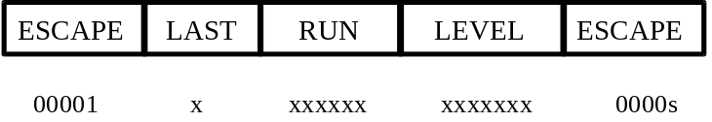
Note: There are two types for ESCAPE added at the end of these fixed-length codes, and codewords are “0000s”. Also, S=0 : LEVEL is positive and S=1 : LEVEL is negative.

 |  | intra |  |  | inter
INDEX | LAST | RUN | LEVEL | LAST | RUN | LEVEL | BITS | VLC_CODE
0 | 0 | 0 | 1 | 0 | 0 | 1 | 4 | 110s
1 | 0 | 0 | 2 | 0 | 1 | 1 | 4 | 111s
2 | 0 | 1 | 1 | 0 | 0 | 2 | 5 | 0001s
3 | 0 | 0 | 3 | 0 | 2 | 1 | 5 | 1010s
4 | 1 | 0 | 1 | 1 | 0 | 1 | 5 | 1011s
5 | 0 | 2 | 1 | 0 | 0 | 3 | 6 | 00100s
6 | 0 | 3 | 1 | 0 | 3 | 1 | 6 | 00101s
7 | 0 | 1 | 2 | 0 | 4 | 1 | 6 | 01000s
8 | 0 | 0 | 4 | 0 | 5 | 1 | 6 | 01001s
9 | 1 | 1 | 1 | 1 | 1 | 1 | 6 | 10010s
10 | 1 | 2 | 1 | 1 | 2 | 1 | 6 | 10011s
11 | 0 | 4 | 1 | 0 | 1 | 2 | 7 | 001100s
12 | 0 | 5 | 1 | 0 | 6 | 1 | 7 | 001101s
13 | 0 | 0 | 5 | 0 | 7 | 1 | 7 | 010100s
14 | 0 | 0 | 6 | 0 | 8 | 1 | 7 | 010101s
15 | 1 | 3 | 1 | 1 | 3 | 1 | 7 | 011000s
16 | 1 | 4 | 1 | 1 | 4 | 1 | 7 | 011001s
17 | 1 | 5 | 1 | 1 | 5 | 1 | 7 | 100010s
18 | 1 | 6 | 1 | 1 | 6 | 1 | 7 | 100011s
19 | 0 | 6 | 1 | 0 | 0 | 4 | 8 | 0011100s
20 | 0 | 7 | 1 | 0 | 2 | 2 | 8 | 0011101s
21 | 0 | 2 | 2 | 0 | 9 | 1 | 8 | 0101100s
22 | 0 | 1 | 3 | 0 | 10 | 1 | 8 | 0101101s
23 | 0 | 0 | 7 | 0 | 11 | 1 | 8 | 0110100s
24 | 1 | 7 | 1 | 1 | 7 | 1 | 8 | 0110101s
25 | 1 | 8 | 1 | 1 | 8 | 1 | 8 | 0111000s
26 | 1 | 9 | 1 | 1 | 9 | 1 | 8 | 0111001s
27 | 1 | 10 | 1 | 1 | 10 | 1 | 8 | 1000010s
28 | 1 | 11 | 1 | 1 | 11 | 1 | 8 | 1000011s
29 | 0 | 8 | 1 | 0 | 0 | 5 | 9 | 00111100s
30 | 0 | 9 | 1 | 0 | 0 | 6 | 9 | 00111101s
31 | 0 | 3 | 2 | 0 | 1 | 3 | 9 | 01011100s
32 | 0 | 4 | 2 | 0 | 3 | 2 | 9 | 01011101s
33 | 0 | 1 | 4 | 0 | 4 | 2 | 9 | 01101100s
34 | 0 | 1 | 5 | 0 | 12 | 1 | 9 | 01101101s
35 | 0 | 0 | 8 | 0 | 13 | 1 | 9 | 01110100s
36 | 0 | 0 | 9 | 0 | 14 | 1 | 9 | 01110101s
37 | 1 | 0 | 2 | 1 | 0 | 2 | 9 | 01111000s
38 | 1 | 12 | 1 | 1 | 12 | 1 | 9 | 01111001s
39 | 1 | 13 | 1 | 1 | 13 | 1 | 9 | 10000010s
40 | 1 | 14 | 1 | 1 | 14 | 1 | 9 | 10000011s
41 | 0 | 10 | 1 | 0 | 0 | 7 | 10 | 001111100s
42 | 0 | 5 | 2 | 0 | 1 | 4 | 10 | 001111101s
43 | 0 | 2 | 3 | 0 | 2 | 3 | 10 | 010111100s
44 | 0 | 3 | 3 | 0 | 5 | 2 | 10 | 010111101s
45 | 0 | 1 | 6 | 0 | 15 | 1 | 10 | 011011100s
46 | 0 | 0 | 10 | 0 | 16 | 1 | 10 | 011011101s
47 | 0 | 0 | 11 | 0 | 17 | 1 | 10 | 011101100s
48 | 1 | 1 | 2 | 1 | 1 | 2 | 10 | 011101101s
49 | 1 | 15 | 1 | 1 | 15 | 1 | 10 | 011110100s
50 | 1 | 16 | 1 | 1 | 16 | 1 | 10 | 011110101s
51 | 1 | 17 | 1 | 1 | 17 | 1 | 10 | 011111000s
52 | 1 | 18 | 1 | 1 | 18 | 1 | 10 | 011111001s
53 | 1 | 19 | 1 | 1 | 19 | 1 | 10 | 100000010s
54 | 1 | 20 | 1 | 1 | 20 | 1 | 10 | 100000011s
55 | 0 | 11 | 1 | 0 | 0 | 8 | 11 | 0011111100s
56 | 0 | 12 | 1 | 0 | 0 | 9 | 11 | 0011111101s
57 | 0 | 6 | 2 | 0 | 1 | 5 | 11 | 0101111100s
58 | 0 | 7 | 2 | 0 | 3 | 3 | 11 | 0101111101s
59 | 0 | 8 | 2 | 0 | 6 | 2 | 11 | 0110111100s
60 | 0 | 4 | 3 | 0 | 7 | 2 | 11 | 0110111101s
61 | 0 | 2 | 4 | 0 | 8 | 2 | 11 | 0111011100s
62 | 0 | 1 | 7 | 0 | 9 | 2 | 11 | 0111011101s
63 | 0 | 0 | 12 | 0 | 18 | 1 | 11 | 0111101100s
64 | 0 | 0 | 13 | 0 | 19 | 1 | 11 | 0111101101s
65 | 0 | 0 | 14 | 0 | 20 | 1 | 11 | 0111110100s
66 | 1 | 21 | 1 | 1 | 21 | 1 | 11 | 0111110101s
67 | 1 | 22 | 1 | 1 | 22 | 1 | 11 | 0111111000s
68 | 1 | 23 | 1 | 1 | 23 | 1 | 11 | 0111111001s
69 | 1 | 24 | 1 | 1 | 24 | 1 | 11 | 1000000010s
70 | 1 | 25 | 1 | 1 | 25 | 1 | 11 | 1000000011s
71 | 0 | 13 | 1 | 0 | 0 | 10 | 12 | 00111111100s
72 | 0 | 9 | 2 | 0 | 0 | 11 | 12 | 00111111101s
73 | 0 | 5 | 3 | 0 | 1 | 6 | 12 | 01011111100s
74 | 0 | 6 | 3 | 0 | 2 | 4 | 12 | 01011111101s
75 | 0 | 7 | 3 | 0 | 4 | 3 | 12 | 01101111100s
76 | 0 | 3 | 4 | 0 | 5 | 3 | 12 | 01101111101s
77 | 0 | 2 | 5 | 0 | 10 | 2 | 12 | 01110111100s
78 | 0 | 2 | 6 | 0 | 21 | 1 | 12 | 01110111101s
79 | 0 | 1 | 8 | 0 | 22 | 1 | 12 | 01111011100s
80 | 0 | 1 | 9 | 0 | 23 | 1 | 12 | 01111011101s
81 | 0 | 0 | 15 | 0 | 24 | 1 | 12 | 01111101100s
82 | 0 | 0 | 16 | 0 | 25 | 1 | 12 | 01111101101s
83 | 0 | 0 | 17 | 0 | 26 | 1 | 12 | 01111110100s
84 | 1 | 0 | 3 | 1 | 0 | 3 | 12 | 01111110101s
85 | 1 | 2 | 2 | 1 | 2 | 2 | 12 | 01111111000s
86 | 1 | 26 | 1 | 1 | 26 | 1 | 12 | 01111111001s
87 | 1 | 27 | 1 | 1 | 27 | 1 | 12 | 10000000010s
88 | 1 | 28 | 1 | 1 | 28 | 1 | 12 | 10000000011s
89 | 0 | 10 | 2 | 0 | 0 | 12 | 13 | 001111111100s
90 | 0 | 4 | 4 | 0 | 1 | 7 | 13 | 001111111101s
91 | 0 | 5 | 4 | 0 | 2 | 5 | 13 | 010111111100s
92 | 0 | 6 | 4 | 0 | 3 | 4 | 13 | 010111111101s
93 | 0 | 3 | 5 | 0 | 6 | 3 | 13 | 011011111100s
94 | 0 | 4 | 5 | 0 | 7 | 3 | 13 | 011011111101s
95 | 0 | 1 | 10 | 0 | 11 | 2 | 13 | 011101111100s
96 | 0 | 0 | 18 | 0 | 27 | 1 | 13 | 011101111101s
97 | 0 | 0 | 19 | 0 | 28 | 1 | 13 | 011110111100s
98 | 0 | 0 | 22 | 0 | 29 | 1 | 13 | 011110111101s
99 | 1 | 1 | 3 | 1 | 1 | 3 | 13 | 011111011100s
100 | 1 | 3 | 2 | 1 | 3 | 2 | 13 | 011111011101s
101 | 1 | 4 | 2 | 1 | 4 | 2 | 13 | 011111101100s
102 | 1 | 29 | 1 | 1 | 29 | 1 | 13 | 011111101101s
103 | 1 | 30 | 1 | 1 | 30 | 1 | 13 | 011111110100s
104 | 1 | 31 | 1 | 1 | 31 | 1 | 13 | 011111110101s
105 | 1 | 32 | 1 | 1 | 32 | 1 | 13 | 011111111000s
106 | 1 | 33 | 1 | 1 | 33 | 1 | 13 | 011111111001s
107 | 1 | 34 | 1 | 1 | 34 | 1 | 13 | 100000000010s
108 | 1 | 35 | 1 | 1 | 35 | 1 | 13 | 100000000011s
109 | 0 | 14 | 1 | 0 | 0 | 13 | 14 | 0011111111100s
110 | 0 | 15 | 1 | 0 | 0 | 14 | 14 | 0011111111101s
111 | 0 | 11 | 2 | 0 | 0 | 15 | 14 | 0101111111100s
112 | 0 | 8 | 3 | 0 | 0 | 16 | 14 | 0101111111101s
113 | 0 | 9 | 3 | 0 | 1 | 8 | 14 | 0110111111100s
114 | 0 | 7 | 4 | 0 | 3 | 5 | 14 | 0110111111101s
115 | 0 | 3 | 6 | 0 | 4 | 4 | 14 | 0111011111100s
116 | 0 | 2 | 7 | 0 | 5 | 4 | 14 | 0111011111101s
117 | 0 | 2 | 8 | 0 | 8 | 3 | 14 | 0111101111100s
118 | 0 | 2 | 9 | 0 | 12 | 2 | 14 | 0111101111101s
119 | 0 | 1 | 11 | 0 | 30 | 1 | 14 | 0111110111100s
120 | 0 | 0 | 20 | 0 | 31 | 1 | 14 | 0111110111101s
121 | 0 | 0 | 21 | 0 | 32 | 1 | 14 | 0111111011100s
122 | 0 | 0 | 23 | 0 | 33 | 1 | 14 | 0111111011101s
123 | 1 | 0 | 4 | 1 | 0 | 4 | 14 | 0111111101100s
124 | 1 | 5 | 2 | 1 | 5 | 2 | 14 | 0111111101101s
125 | 1 | 6 | 2 | 1 | 6 | 2 | 14 | 0111111110100s
126 | 1 | 7 | 2 | 1 | 7 | 2 | 14 | 0111111110101s
127 | 1 | 8 | 2 | 1 | 8 | 2 | 14 | 0111111111000s
128 | 1 | 9 | 2 | 1 | 9 | 2 | 14 | 0111111111001s
129 | 1 | 36 | 1 | 1 | 36 | 1 | 14 | 1000000000010s
130 | 1 | 37 | 1 | 1 | 37 | 1 | 14 | 1000000000011s
131 | 0 | 16 | 1 | 0 | 0 | 17 | 15 | 00111111111100s
132 | 0 | 17 | 1 | 0 | 0 | 18 | 15 | 00111111111101s
133 | 0 | 18 | 1 | 0 | 1 | 9 | 15 | 01011111111100s
134 | 0 | 8 | 4 | 0 | 1 | 10 | 15 | 01011111111101s
135 | 0 | 5 | 5 | 0 | 2 | 6 | 15 | 01101111111100s
136 | 0 | 4 | 6 | 0 | 2 | 7 | 15 | 01101111111101s
137 | 0 | 5 | 6 | 0 | 3 | 6 | 15 | 01110111111100s
138 | 0 | 3 | 7 | 0 | 6 | 4 | 15 | 01110111111101s
139 | 0 | 3 | 8 | 0 | 9 | 3 | 15 | 01111011111100s
140 | 0 | 2 | 10 | 0 | 13 | 2 | 15 | 01111011111101s
141 | 0 | 2 | 11 | 0 | 14 | 2 | 15 | 01111101111100s
142 | 0 | 1 | 12 | 0 | 15 | 2 | 15 | 01111101111101s
143 | 0 | 1 | 13 | 0 | 16 | 2 | 15 | 01111110111100s
144 | 0 | 0 | 24 | 0 | 34 | 1 | 15 | 01111110111101s
145 | 0 | 0 | 25 | 0 | 35 | 1 | 15 | 01111111011100s
146 | 0 | 0 | 26 | 0 | 36 | 1 | 15 | 01111111011101s
147 | 1 | 0 | 5 | 1 | 0 | 5 | 15 | 01111111101100s
148 | 1 | 1 | 4 | 1 | 1 | 4 | 15 | 01111111101101s
149 | 1 | 10 | 2 | 1 | 10 | 2 | 15 | 01111111110100s
150 | 1 | 11 | 2 | 1 | 11 | 2 | 15 | 01111111110101s
151 | 1 | 12 | 2 | 1 | 12 | 2 | 15 | 01111111111000s
152 | 1 | 38 | 1 | 1 | 38 | 1 | 15 | 01111111111001s
153 | 1 | 39 | 1 | 1 | 39 | 1 | 15 | 10000000000010s
154 | 1 | 40 | 1 | 1 | 40 | 1 | 15 | 10000000000011s
155 | 0 | 0 | 27 | 0 | 0 | 19 | 16 | 001111111111100s
156 | 0 | 3 | 9 | 0 | 3 | 7 | 16 | 001111111111101s
157 | 0 | 6 | 5 | 0 | 4 | 5 | 16 | 010111111111100s
158 | 0 | 7 | 5 | 0 | 7 | 4 | 16 | 010111111111101s
159 | 0 | 9 | 4 | 0 | 17 | 2 | 16 | 011011111111100s
160 | 0 | 12 | 2 | 0 | 37 | 1 | 16 | 011011111111101s
161 | 0 | 19 | 1 | 0 | 38 | 1 | 16 | 011101111111100s
162 | 1 | 1 | 5 | 1 | 1 | 5 | 16 | 011101111111101s
163 | 1 | 2 | 3 | 1 | 2 | 3 | 16 | 011110111111100s
164 | 1 | 13 | 2 | 1 | 13 | 2 | 16 | 011110111111101s
165 | 1 | 41 | 1 | 1 | 41 | 1 | 16 | 011111011111100s
166 | 1 | 42 | 1 | 1 | 42 | 1 | 16 | 011111011111101s
167 | 1 | 43 | 1 | 1 | 43 | 1 | 16 | 011111101111100s
168 | 1 | 44 | 1 | 1 | 44 | 1 | 16 | 011111101111101s
169 | ESCAPE |  |  |  |  |  | 5 | 0000s

Table 11-23 RVLC table for TCOF
RUN | CODE
0 | 000000
1 | 000001
2 | 000010
: | :
63 | 111111

Table 11-24 FLC table for RUN
LEVEL | CODE
0 | FORBIDDEN
1 | 0000001
2 | 0000010
: | :
127 | 1111111

Shape Coding
Table 11-25 Meaning of shape mode
Index | Shape mode
0 | = “MVDs==0 && No Update”
1 | = “MVDs!=0 && No Update”
2 | transparent
3 | opaque
4 | “intraCAE”
5 | “interCAE && MVDs==0”
6 | “interCAE && MVDs!=0”

Table 11-26 bab_type for I-VOP
Index | (2) | (3) | (4) | Index | (2) | (3) | (4)
0 | 1 | 001 | 01 | 41 | 001 | 01 | 1
1 | 001 | 01 | 1 | 42 | 1 | 01 | 001
2 | 01 | 001 | 1 | 43 | 001 | 1 | 01
3 | 1 | 001 | 01 | 44 | 001 | 01 | 1
4 | 1 | 01 | 001 | 45 | 1 | 01 | 001
5 | 1 | 01 | 001 | 46 | 001 | 01 | 1
6 | 1 | 001 | 01 | 47 | 01 | 001 | 1
7 | 1 | 01 | 001 | 48 | 1 | 01 | 001
8 | 01 | 001 | 1 | 49 | 001 | 01 | 1
9 | 001 | 01 | 1 | 50 | 01 | 001 | 1
10 | 1 | 01 | 001 | 51 | 1 | 001 | 01
11 | 1 | 01 | 001 | 52 | 001 | 1 | 01
12 | 001 | 01 | 1 | 53 | 01 | 001 | 1
13 | 1 | 01 | 001 | 54 | 1 | 001 | 01
14 | 01 | 1 | 001 | 55 | 01 | 001 | 1
15 | 001 | 01 | 1 | 56 | 01 | 001 | 1
16 | 1 | 01 | 001 | 57 | 1 | 01 | 001
17 | 1 | 01 | 001 | 58 | 1 | 01 | 001
18 | 01 | 001 | 1 | 59 | 1 | 01 | 001
19 | 1 | 01 | 001 | 60 | 1 | 01 | 001
20 | 001 | 01 | 1 | 61 | 1 | 01 | 001
21 | 01 | 001 | 1 | 62 | 01 | 001 | 1
22 | 1 | 01 | 001 | 63 | 1 | 01 | 001
23 | 001 | 01 | 1 | 64 | 001 | 01 | 1
24 | 01 | 001 | 1 | 65 | 001 | 01 | 1
25 | 001 | 01 | 1 | 66 | 01 | 001 | 1
26 | 001 | 01 | 1 | 67 | 001 | 1 | 01
27 | 1 | 01 | 001 | 68 | 001 | 1 | 01
28 | 1 | 01 | 001 | 69 | 01 | 001 | 1
29 | 1 | 01 | 001 | 70 | 001 | 1 | 01
30 | 1 | 01 | 001 | 71 | 001 | 01 | 1
31 | 1 | 01 | 001 | 72 | 1 | 001 | 01
32 | 1 | 01 | 001 | 73 | 001 | 01 | 1
33 | 1 | 01 | 001 | 74 | 01 | 001 | 1
34 | 1 | 01 | 001 | 75 | 01 | 001 | 1
35 | 001 | 01 | 1 | 76 | 001 | 1 | 01
36 | 1 | 01 | 001 | 77 | 001 | 01 | 1
37 | 001 | 01 | 1 | 78 | 1 | 001 | 01
38 | 001 | 01 | 1 | 79 | 001 | 1 | 01
39 | 1 | 01 | 001 | 80 | 001 | 01 | 1
40 | 001 | 1 | 01

Table 11-27 bab_type for P-VOP
 |  | bab_type in current VOP (n)
 |  | 0 | 1 | 2 | 3 | 4 | 5 | 6
 | 0 | 1 | 01 | 00001 | 000001 | 0001 | 0010 | 0011
bab_type | 1 | 01 | 1 | 00001 | 000001 | 001 | 0000001 | 0001
in previous | 2 | 0001 | 001 | 1 | 000001 | 01 | 0000001 | 00001
VOP(n-1) | 3 | 1 | 0001 | 000001 | 001 | 01 | 0000001 | 00001
 | 4 | 011 | 001 | 0001 | 00001 | 1 | 000001 | 010
 | 5 | 01 | 0001 | 00001 | 000001 | 001 | 11 | 10
 | 6 | 001 | 0001 | 00001 | 000001 | 01 | 10 | 11

Table 11-28 VLC table for MVDs
MVDs | Codes
0 | 0
±1 | 10s
±2 | 110s
±3 | 1110s
±4 | 11110s
±5 | 111110s
±6 | 1111110s
±7 | 11111110s
±8 | 111111110s
±9 | 1111111110s
±10 | 11111111110s
±11 | 111111111110s
±12 | 1111111111110s
±13 | 11111111111110s
±14 | 111111111111110s
±15 | 1111111111111110s
±16 | 11111111111111110s

Table 11-29 VLC table for MVDs (Horizontal element is 0)
MVDs | Codes
±1 | 0s
±2 | 10s
±3 | 110s
±4 | 1110s
±5 | 11110s
±6 | 111110s
±7 | 1111110s
±8 | 11111110s
±9 | 111111110s
±10 | 1111111110s
±11 | 11111111110s
±12 | 111111111110s
±13 | 1111111111110s
±14 | 11111111111110s
±15 | 111111111111110s
±16 | 1111111111111110s
s: sign bit (if MVDs is positive s=”1”, otherwise s=”0”).
Table 11-30 VLC for conv_ratio
conv_ratio | Code
1 | 0
2 | 10
4 | 11
These tables contain the probabilities for a binary alpha pixel being equal to 0 for intra and inter shape coding using CAE. All probabilities are normalised to the range [1,65535].
As an example, given an INTRA context number C, the probability that the pixel is zero is given by intra_prob[C].
Table 11-31 Probabilities for arithmetic decoding of shape
USInt intra_prob[1024] = {
65267,16468,65003,17912,64573,8556,64252,5653,40174,3932,29789,277,45152,1140,32768,2043,
4499,80,6554,1144,21065,465,32768,799,5482,183,7282,264,5336,99,6554,563,
54784,30201,58254,9879,54613,3069,32768,58495,32768,32768,32768,2849,58982,54613,32768,12892,
31006,1332,49152,3287,60075,350,32768,712,39322,760,32768,354,52659,432,61854,150,
64999,28362,65323,42521,63572,32768,63677,18319,4910,32768,64238,434,53248,32768,61865,13590,
16384,32768,13107,333,32768,32768,32768,32768,32768,32768,1074,780,25058,5461,6697,233,
62949,30247,63702,24638,59578,32768,32768,42257,32768,32768,49152,546,62557,32768,54613,19258,
62405,32569,64600,865,60495,10923,32768,898,34193,24576,64111,341,47492,5231,55474,591,
65114,60075,64080,5334,65448,61882,64543,13209,54906,16384,35289,4933,48645,9614,55351,7318,
49807,54613,32768,32768,50972,32768,32768,32768,15159,1928,2048,171,3093,8,6096,74,
32768,60855,32768,32768,32768,32768,32768,32768,32768,32768,32768,32768,32768,55454,32768,57672,
32768,16384,32768,21845,32768,32768,32768,32768,32768,32768,32768,5041,28440,91,32768,45,
65124,10923,64874,5041,65429,57344,63435,48060,61440,32768,63488,24887,59688,3277,63918,14021,
32768,32768,32768,32768,32768,32768,32768,32768,690,32768,32768,1456,32768,32768,8192,728,
32768,32768,58982,17944,65237,54613,32768,2242,32768,32768,32768,42130,49152,57344,58254,16740,
32768,10923,54613,182,32768,32768,32768,7282,49152,32768,32768,5041,63295,1394,55188,77,
63672,6554,54613,49152,64558,32768,32768,5461,64142,32768,32768,32768,62415,32768,32768,16384,
1481,438,19661,840,33654,3121,64425,6554,4178,2048,32768,2260,5226,1680,32768,565,
60075,32768,32768,32768,32768,32768,32768,32768,32768,32768,32768,32768,32768,32768,32768,32768,
16384,261,32768,412,16384,636,32768,4369,23406,4328,32768,524,15604,560,32768,676,
49152,32768,49152,32768,32768,32768,64572,32768,32768,32768,54613,32768,32768,32768,32768,32768,
4681,32768,5617,851,32768,32768,59578,32768,32768,32768,3121,3121,49152,32768,6554,10923,
32768,32768,54613,14043,32768,32768,32768,3449,32768,32768,32768,32768,32768,32768,32768,32768,
57344,32768,57344,3449,32768,32768,32768,3855,58982,10923,32768,239,62259,32768,49152,85,
58778,23831,62888,20922,64311,8192,60075,575,59714,32768,57344,40960,62107,4096,61943,3921,
39862,15338,32768,1524,45123,5958,32768,58982,6669,930,1170,1043,7385,44,8813,5011,
59578,29789,54613,32768,32768,32768,32768,32768,32768,32768,32768,32768,58254,56174,32768,32768,
64080,25891,49152,22528,32768,2731,32768,10923,10923,3283,32768,1748,17827,77,32768,108,
62805,32768,62013,42612,32768,32768,61681,16384,58982,60075,62313,58982,65279,58982,62694,62174,
32768,32768,10923,950,32768,32768,32768,32768,5958,32768,38551,1092,11012,39322,13705,2072,
54613,32768,32768,11398,32768,32768,32768,145,32768,32768,32768,29789,60855,32768,61681,54792,
32768,32768,32768,17348,32768,32768,32768,8192,57344,16384,32768,3582,52581,580,24030,303,
62673,37266,65374,6197,62017,32768,49152,299,54613,32768,32768,32768,35234,119,32768,3855,
31949,32768,32768,49152,16384,32768,32768,32768,24576,32768,49152,32768,17476,32768,32768,57445,
51200,50864,54613,27949,60075,20480,32768,57344,32768,32768,32768,32768,32768,45875,32768,32768,
11498,3244,24576,482,16384,1150,32768,16384,7992,215,32768,1150,23593,927,32768,993,
65353,32768,65465,46741,41870,32768,64596,59578,62087,32768,12619,23406,11833,32768,47720,17476,
32768,32768,2621,6554,32768,32768,32768,32768,32768,32768,5041,32768,16384,32768,4096,2731,
63212,43526,65442,47124,65410,35747,60304,55858,60855,58982,60075,19859,35747,63015,64470,25432,
58689,1118,64717,1339,24576,32768,32768,1257,53297,1928,32768,33,52067,3511,62861,453,
64613,32768,32768,32768,64558,32768,32768,2731,49152,32768,32768,32768,61534,32768,32768,35747,
32768,32768,32768,32768,13107,32768,32768,32768,32768,32768,32768,32768,20480,32768,32768,32768,
32768,32768,32768,54613,40960,5041,32768,32768,32768,32768,32768,3277,64263,57592,32768,3121,
32768,32768,32768,32768,32768,10923,32768,32768,32768,8192,32768,32768,5461,6899,32768,1725,
63351,3855,63608,29127,62415,7282,64626,60855,32768,32768,60075,5958,44961,32768,61866,53718,
32768,32768,32768,32768,32768,32768,6554,32768,32768,32768,32768,32768,2521,978,32768,1489,
58254,32768,58982,61745,21845,32768,54613,58655,60075,32768,49152,16274,50412,64344,61643,43987,
32768,32768,32768,1638,32768,32768,32768,24966,54613,32768,32768,2427,46951,32768,17970,654,
65385,27307,60075,26472,64479,32768,32768,4681,61895,32768,32768,16384,58254,32768,32768,6554,
37630,3277,54613,6554,4965,5958,4681,32768,42765,16384,32768,21845,22827,16384,32768,6554,
65297,64769,60855,12743,63195,16384,32768,37942,32768,32768,32768,32768,60075,32768,62087,54613,
41764,2161,21845,1836,17284,5424,10923,1680,11019,555,32768,431,39819,907,32768,171,
65480,32768,64435,33803,2595,32768,57041,32768,61167,32768,32768,32768,32768,32768,32768,1796,
60855,32768,17246,978,32768,32768,8192,32768,32768,32768,14043,2849,32768,2979,6554,6554,
65507,62415,65384,61891,65273,58982,65461,55097,32768,32768,32768,55606,32768,2979,3745,16913,
61885,13827,60893,12196,60855,53248,51493,11243,56656,783,55563,143,63432,7106,52429,445,
65485,1031,65020,1380,65180,57344,65162,36536,61154,6554,26569,2341,63593,3449,65102,533,
47827,2913,57344,3449,35688,1337,32768,22938,25012,910,7944,1008,29319,607,64466,4202,
64549,57301,49152,20025,63351,61167,32768,45542,58982,14564,32768,9362,61895,44840,32768,26385,
59664,17135,60855,13291,40050,12252,32768,7816,25798,1850,60495,2662,18707,122,52538,231,
65332,32768,65210,21693,65113,6554,65141,39667,62259,32768,22258,1337,63636,32768,64255,52429,
60362,32768,6780,819,16384,32768,16384,4681,49152,32768,8985,2521,24410,683,21535,16585,
65416,46091,65292,58328,64626,32768,65016,39897,62687,47332,62805,28948,64284,53620,52870,49567,
65032,31174,63022,28312,64299,46811,48009,31453,61207,7077,50299,1514,60047,2634,46488,235
};

USInt inter_prob[512] = {
65532,62970,65148,54613,62470,8192,62577,8937,65480,64335,65195,53248,65322,62518,62891,38312,
65075,53405,63980,58982,32768,32768,54613,32768,65238,60009,60075,32768,59294,19661,61203,13107,
63000,9830,62566,58982,11565,32768,25215,3277,53620,50972,63109,43691,54613,32768,39671,17129,
59788,6068,43336,27913,6554,32768,12178,1771,56174,49152,60075,43691,58254,16384,49152,9930,
23130,7282,40960,32768,10923,32768,32768,32768,27307,32768,32768,32768,32768,32768,32768,32768,
36285,12511,10923,32768,45875,16384,32768,32768,16384,23831,4369,32768,8192,10923,32768,32768,
10175,2979,18978,10923,54613,32768,6242,6554,1820,10923,32768,32768,32768,32768,32768,5461,
28459,593,11886,2030,3121,4681,1292,112,42130,23831,49152,29127,32768,6554,5461,2048,
65331,64600,63811,63314,42130,19661,49152,32768,65417,64609,62415,64617,64276,44256,61068,36713,
64887,57525,53620,61375,32768,8192,57344,6554,63608,49809,49152,62623,32768,15851,58982,34162,
55454,51739,64406,64047,32768,32768,7282,32768,49152,58756,62805,64990,32768,14895,16384,19418,
57929,24966,58689,31832,32768,16384,10923,6554,54613,42882,57344,64238,58982,10082,20165,20339,
62687,15061,32768,10923,32768,10923,32768,16384,59578,34427,32768,16384,32768,7825,32768,7282,
58052,23400,32768,5041,32768,2849,32768,32768,47663,15073,57344,4096,32768,1176,32768,1320,
24858,410,24576,923,32768,16384,16384,5461,16384,1365,32768,5461,32768,5699,8192,13107,
46884,2361,23559,424,19661,712,655,182,58637,2094,49152,9362,8192,85,32768,1228,
65486,49152,65186,49152,61320,32768,57088,25206,65352,63047,62623,49152,64641,62165,58986,18304,
64171,16384,60855,54613,42130,32768,61335,32768,58254,58982,49152,32768,60985,35289,64520,31554,
51067,32768,64074,32768,40330,32768,34526,4096,60855,32768,63109,58254,57672,16384,31009,2567,
23406,32768,44620,10923,32768,32768,32099,10923,49152,49152,54613,60075,63422,54613,46388,39719,
58982,32768,54613,32768,14247,32768,22938,5041,32768,49152,32768,32768,25321,6144,29127,10999,
41263,32768,46811,32768,267,4096,426,16384,32768,19275,49152,32768,1008,1437,5767,11275,
5595,5461,37493,6554,4681,32768,6147,1560,38229,10923,32768,40960,35747,2521,5999,312,
17052,2521,18808,3641,213,2427,574,32,51493,42130,42130,53053,11155,312,2069,106,
64406,45197,58982,32768,32768,16384,40960,36864,65336,64244,60075,61681,65269,50748,60340,20515,
58982,23406,57344,32768,6554,16384,19661,61564,60855,47480,32768,54613,46811,21701,54909,37826,
32768,58982,60855,60855,32768,32768,39322,49152,57344,45875,60855,55706,32768,24576,62313,25038,
54613,8192,49152,10923,32768,32768,32768,32768,32768,19661,16384,51493,32768,14043,40050,44651,
59578,5174,32768,6554,32768,5461,23593,5461,63608,51825,32768,23831,58887,24032,57170,3298,
39322,12971,16384,49152,1872,618,13107,2114,58982,25705,32768,60075,28913,949,18312,1815,
48188,114,51493,1542,5461,3855,11360,1163,58982,7215,54613,21487,49152,4590,48430,1421,
28944,1319,6868,324,1456,232,820,7,61681,1864,60855,9922,4369,315,6589,14
};

Sprite Coding
Table 11-32 Code table for the first trajectory point
dmv value | dmv_length value | dmv_length VLC | dmv_code
-2047...-1024, 1024...2047 | 11 | 111111110 | 00000000000...01111111111, 10000000000...11111111111
-1023...-512, 512...1024 | 10 | 11111110 | 0000000000...0111111111, 1000000000...1111111111
-511...-256, 256...511 | 9 | 1111110 | 000000000...011111111, 100000000...111111111
-255...-128, 128...255 | 8 | 111110 | 00000000...01111111, 10000000...11111111
-127...-64, 64...127 | 7 | 11110 | 0000000...0111111, 1000000...1111111
-63...-32, 32...63 | 6 | 1110 | 000000...011111, 100000...111111
-31...-16, 16...31 | 5 | 110 | 00000...01111, 10000...1111
-15...-8, 8...15 | 4 | 101 | 0000...0111, 1000...1111
-7...-4, 4...7 | 3 | 100 | 000...011, 100...111
-3...-2, 2...3 | 2 | 011 | 00...01, 10...11
-1, 1 | 1 | 010 | 0, 1
0 | 0 | 00 | -

Table 11-33 Code table for scaled brightness change factor
brightness_change_factor value | brightness_change_factor_length value | brightness_change_factor_length VLC | brightness_change_factor
-16...-1, 1...16 | 1 | 0 | 00000...01111, 10000...11111
-48...-17, 17...48 | 2 | 10 | 000000...011111, 100000...111111
112...-49, 49...112 | 3 | 110 | 0000000...0111111, 1000000...1111111
113…624 | 4 | 1110 | 000000000...111111111
625...1648 | 4 | 1111 | 0000000000…1111111111

DCT based facial object decoding
Table 11-34 Viseme_select_table, 29 symbols

symbol | bits | code | symbol | bits | code | symbol | bits | code
0 | 6 | 001000 | 10 | 6 | 010001 | 20 | 6 | 010000
1 | 6 | 001001 | 11 | 6 | 011001 | 21 | 6 | 010010
2 | 6 | 001011 | 12 | 5 | 00001 | 22 | 6 | 011010
3 | 6 | 001101 | 13 | 6 | 011101 | 23 | 5 | 00010
4 | 6 | 001111 | 14 | 1 | 1 | 24 | 6 | 011110
5 | 6 | 010111 | 15 | 6 | 010101 | 25 | 6 | 010110
6 | 6 | 011111 | 16 | 6 | 010100 | 26 | 6 | 001110
7 | 5 | 00011 | 17 | 6 | 011100 | 27 | 6 | 001100
8 | 6 | 011011 | 18 | 5 | 00000 | 28 | 6 | 001010
9 | 6 | 010011 | 19 | 6 | 011000

Table 11-35 Expression_select_table, 13 symbols

symbol | bits | code | symbol | bits | code | symbol | bits | code
0 | 5 | 01000 | 5 | 4 | 0011 | 10 | 5 | 01110
1 | 5 | 01001 | 6 | 1 | 1 | 11 | 5 | 01100
2 | 5 | 01011 | 7 | 4 | 0001 | 12 | 5 | 01010
3 | 5 | 01101 | 8 | 4 | 0000
4 | 5 | 01111 | 9 | 4 | 0010

Table 11-36 Viseme and Expression intensity_table, 127 symbols

symbol | bits | code | symbol | bits | code | symbol | bits | code
0 | 17 | 10010001101010010 | 43 | 16 | 1001000110100111 | 86 | 16 | 1001000110100110
1 | 17 | 10010001101010011 | 44 | 8 | 10011100 | 87 | 16 | 1001000110100100
2 | 17 | 10010001101010101 | 45 | 11 | 10010001111 | 88 | 16 | 1001000110100010
3 | 17 | 10010001101010111 | 46 | 9 | 100100010 | 89 | 16 | 1001000110100000
4 | 17 | 10010001101011001 | 47 | 10 | 1110001011 | 90 | 16 | 1001000110011110
5 | 17 | 10010001101011011 | 48 | 9 | 100011011 | 91 | 16 | 1001000110011100
6 | 17 | 10010001101011101 | 49 | 10 | 1110001001 | 92 | 16 | 1001000110011010
7 | 17 | 10010001101011111 | 50 | 9 | 100011010 | 93 | 16 | 1001000110011000
8 | 17 | 10010001101100001 | 51 | 9 | 100111010 | 94 | 16 | 1001000110010110
9 | 17 | 10010001101100011 | 52 | 10 | 1110001000 | 95 | 16 | 1001000110010100
10 | 17 | 10010001101100101 | 53 | 7 | 1000111 | 96 | 16 | 1001000110010010
11 | 17 | 10010001101100111 | 54 | 7 | 1000010 | 97 | 16 | 1001000110010000
12 | 17 | 10010001101101001 | 55 | 8 | 10010000 | 98 | 16 | 1001000110001110
13 | 17 | 10010001101101011 | 56 | 7 | 1001111 | 99 | 16 | 1001000110001100
14 | 17 | 10010001101101101 | 57 | 7 | 1110000 | 100 | 16 | 1001000110001010
15 | 17 | 10010001101101111 | 58 | 6 | 100000 | 101 | 16 | 1001000110001000
16 | 17 | 10010001101110001 | 59 | 6 | 100101 | 102 | 16 | 1001000110000110
17 | 17 | 10010001101110011 | 60 | 6 | 111010 | 103 | 16 | 1001000110000100
18 | 17 | 10010001101110111 | 61 | 5 | 11111 | 104 | 16 | 1001000110000010
19 | 17 | 10010001101111001 | 62 | 3 | 101 | 105 | 16 | 1001000110000000
20 | 17 | 10010001101111011 | 63 | 1 | 0 | 106 | 17 | 10010001101111110
21 | 17 | 10010001101111101 | 64 | 3 | 110 | 107 | 17 | 10010001101111100
22 | 17 | 10010001101111111 | 65 | 5 | 11110 | 108 | 17 | 10010001101111010
23 | 16 | 1001000110000001 | 66 | 6 | 111001 | 109 | 17 | 10010001101111000
24 | 16 | 1001000110000011 | 67 | 6 | 111011 | 110 | 17 | 10010001101110110
25 | 16 | 1001000110000101 | 68 | 6 | 100010 | 111 | 17 | 10010001101110010
26 | 16 | 1001000110000111 | 69 | 7 | 1001100 | 112 | 17 | 10010001101110000
27 | 16 | 1001000110001001 | 70 | 7 | 1001001 | 113 | 17 | 10010001101101110
28 | 16 | 1001000110001011 | 71 | 7 | 1001101 | 114 | 17 | 10010001101101100
29 | 16 | 1001000110001101 | 72 | 8 | 10001100 | 115 | 17 | 10010001101101010
30 | 16 | 1001000110001111 | 73 | 8 | 10000111 | 116 | 17 | 10010001101101000
31 | 16 | 1001000110010001 | 74 | 8 | 10000110 | 117 | 17 | 10010001101100110
32 | 16 | 1001000110010011 | 75 | 17 | 10010001101110100 | 118 | 17 | 10010001101100100
33 | 16 | 1001000110010101 | 76 | 9 | 111000110 | 119 | 17 | 10010001101100010
34 | 16 | 1001000110010111 | 77 | 11 | 11100010100 | 120 | 17 | 10010001101100000
35 | 16 | 1001000110011001 | 78 | 11 | 10011101111 | 121 | 17 | 10010001101011110
36 | 16 | 1001000110011011 | 79 | 17 | 10010001101110101 | 122 | 17 | 10010001101011100
37 | 16 | 1001000110011101 | 80 | 10 | 1001110110 | 123 | 17 | 10010001101011010
38 | 16 | 1001000110011111 | 81 | 16 | 1001000110101000 | 124 | 17 | 10010001101011000
39 | 16 | 1001000110100001 | 82 | 11 | 10010001110 | 125 | 17 | 10010001101010110
40 | 16 | 1001000110100011 | 83 | 10 | 1110001111 | 126 | 17 | 10010001101010100
41 | 11 | 11100010101 | 84 | 11 | 10011101110
42 | 16 | 1001000110100101 | 85 | 10 | 1110001110

Table 11-37 Runlength_table, 16 symbols
symbol | bits | code | symbol | bits | code | symbol | bits | code
0 | 1 | 1 | 6 | 9 | 000001011 | 12 | 8 | 00000000
1 | 2 | 01 | 7 | 9 | 000001101 | 13 | 8 | 00000010
2 | 3 | 001 | 8 | 9 | 000001111 | 14 | 9 | 000001110
3 | 4 | 0001 | 9 | 8 | 00000011 | 15 | 9 | 000001100
4 | 5 | 00001 | 10 | 8 | 00000001
5 | 9 | 000001010 | 11 | 8 | 00000100

Table 11-38 DC_table, 512 symbols
symbol | bits | code | symbol | bits | code | symbol | bits | code
0 | 17 | 11010111001101010 | 171 | 17 | 11010111001111001 | 342 | 17 | 11010111001111000
1 | 17 | 11010111001101011 | 172 | 17 | 11010111010000001 | 343 | 17 | 11010111001110000
2 | 17 | 11010111001101101 | 173 | 17 | 11010111010001001 | 344 | 17 | 11010111001110010
3 | 17 | 11010111001101111 | 174 | 17 | 11010111010010001 | 345 | 17 | 11010111001111010
4 | 17 | 11010111001110101 | 175 | 17 | 11010111010011001 | 346 | 17 | 11010111010000010
5 | 17 | 11010111001110111 | 176 | 17 | 11010111010101001 | 347 | 17 | 11010111010001010
6 | 17 | 11010111001111101 | 177 | 17 | 11010111010110001 | 348 | 17 | 11010111010010010
7 | 17 | 11010111001111111 | 178 | 17 | 11010111010111001 | 349 | 17 | 11010111010011010
8 | 17 | 11010111010000101 | 179 | 17 | 11010111011000001 | 350 | 17 | 11010111010101010
9 | 17 | 11010111010000111 | 180 | 17 | 11010111011001001 | 351 | 17 | 11010111010110010
10 | 17 | 11010111010001101 | 181 | 17 | 11010111011011001 | 352 | 17 | 11010111010111010
11 | 17 | 11010111010001111 | 182 | 17 | 11010111011111001 | 353 | 17 | 11010111011000010
12 | 17 | 11010111010010101 | 183 | 17 | 11010111100000001 | 354 | 17 | 11010111011001010
13 | 17 | 11010111010010111 | 184 | 17 | 11010111100001001 | 355 | 17 | 11010111011011010
14 | 17 | 11010111010011101 | 185 | 17 | 11010111100011001 | 356 | 17 | 11010111011111010
15 | 17 | 11010111010011111 | 186 | 17 | 11010111100100001 | 357 | 17 | 11010111100000010
16 | 17 | 11010111010101101 | 187 | 17 | 11010111100101001 | 358 | 17 | 11010111100001010
17 | 17 | 11010111010101111 | 188 | 17 | 11010111100111001 | 359 | 17 | 11010111100011010
18 | 17 | 11010111010110111 | 189 | 17 | 11010111101000001 | 360 | 17 | 11010111100100010
19 | 17 | 11010111010111101 | 190 | 17 | 11010111101001001 | 361 | 17 | 11010111100101010
20 | 17 | 11010111010111111 | 191 | 17 | 11010111101011001 | 362 | 17 | 11010111100111010
21 | 17 | 11010111011000111 | 192 | 17 | 11010111101111001 | 363 | 17 | 11010111101000010
22 | 17 | 11010111011001101 | 193 | 17 | 11010111110000001 | 364 | 17 | 11010111101001010
23 | 17 | 11010111011001111 | 194 | 17 | 11010111110001001 | 365 | 17 | 11010111101011010
24 | 17 | 11010111011011101 | 195 | 17 | 11010111110011001 | 366 | 17 | 11010111101111010
25 | 17 | 11010111011011111 | 196 | 17 | 11010111110111001 | 367 | 17 | 11010111110000010
26 | 17 | 11010111011111101 | 197 | 17 | 11010111111100001 | 368 | 17 | 11010111110001010
27 | 17 | 11010111011111111 | 198 | 17 | 11010111111101001 | 369 | 17 | 11010111110011010
28 | 17 | 11010111100000111 | 199 | 17 | 11010111111111001 | 370 | 17 | 11010111110111010
29 | 17 | 11010111100001101 | 200 | 16 | 1101011100000001 | 371 | 17 | 11010111111100010
30 | 17 | 11010111100001111 | 201 | 16 | 1101011100001001 | 372 | 17 | 11010111111101010
31 | 17 | 11010111100011101 | 202 | 16 | 1101011100011001 | 373 | 17 | 11010111111111010
32 | 17 | 11010111100011111 | 203 | 17 | 11010111111001001 | 374 | 16 | 1101011100000010
33 | 17 | 11010111100100101 | 204 | 17 | 11010111111010001 | 375 | 16 | 1101011100001010
34 | 17 | 11010111100100111 | 205 | 17 | 11010111111011001 | 376 | 16 | 1101011100011010
35 | 17 | 11010111100101101 | 206 | 16 | 1101011100101001 | 377 | 17 | 11010111111001010
36 | 17 | 11010111100101111 | 207 | 17 | 11010111110100001 | 378 | 17 | 11010111111010010
37 | 17 | 11010111100111101 | 208 | 17 | 11010111110101001 | 379 | 17 | 11010111111011010
38 | 17 | 11010111100111111 | 209 | 17 | 11010111101101001 | 380 | 16 | 1101011100101010
39 | 17 | 11010111101000101 | 210 | 17 | 11010111011100001 | 381 | 17 | 11010111110100010
40 | 17 | 11010111101000111 | 211 | 16 | 1101011100100000 | 382 | 17 | 11010111110101010
41 | 17 | 11010111101001101 | 212 | 16 | 1101011100100001 | 383 | 17 | 11010111101101010
42 | 17 | 11010111101001111 | 213 | 17 | 11010111111000001 | 384 | 17 | 11010111011100010
43 | 17 | 11010111101011101 | 214 | 16 | 1101011100010001 | 385 | 17 | 11010111011101010
44 | 17 | 11010111101011111 | 215 | 17 | 11010111111110001 | 386 | 17 | 11010111011101000
45 | 17 | 11010111101111101 | 216 | 17 | 11010111110110001 | 387 | 16 | 1101011100100010
46 | 17 | 11010111101111111 | 217 | 17 | 11010111110010001 | 388 | 17 | 11010111111000010
47 | 17 | 11010111110000101 | 218 | 11 | 11101100101 | 389 | 16 | 1101011100010010
48 | 17 | 11010111110000111 | 219 | 11 | 11011111011 | 390 | 17 | 11010111111110010
49 | 17 | 11010111110001101 | 220 | 11 | 11011110001 | 391 | 17 | 11010111110110010
50 | 17 | 11010111110001111 | 221 | 10 | 1101110011 | 392 | 17 | 11010111110010010
51 | 17 | 11010111110011101 | 222 | 17 | 11010111101110001 | 393 | 17 | 11010111101110010
52 | 17 | 11010111110011111 | 223 | 17 | 11010111010100000 | 394 | 17 | 11010111101010010
53 | 17 | 11010111110111101 | 224 | 17 | 11010111010100001 | 395 | 17 | 11010111101010000
54 | 17 | 11010111110111111 | 225 | 17 | 11010111011110100 | 396 | 17 | 11010111100010010
55 | 17 | 11010111111100101 | 226 | 17 | 11010111011110101 | 397 | 17 | 11010111100010000
56 | 17 | 11010111111100111 | 227 | 17 | 11010111011110001 | 398 | 17 | 11010111011010010
57 | 17 | 11010111111101101 | 228 | 17 | 11010111100010101 | 399 | 17 | 11010111011010000
58 | 17 | 11010111111101111 | 229 | 17 | 11010111100110000 | 400 | 16 | 1101011100110010
59 | 17 | 11010111111111101 | 230 | 17 | 11010111100110001 | 401 | 16 | 1101011100110000
60 | 17 | 11010111111111111 | 231 | 17 | 11010111101010101 | 402 | 17 | 11010111010100110
61 | 16 | 1101011100000101 | 232 | 11 | 11101100111 | 403 | 17 | 11010111010100100
62 | 16 | 1101011100000111 | 233 | 17 | 11010111101110101 | 404 | 17 | 11010111010100010
63 | 16 | 1101011100001101 | 234 | 11 | 11101100110 | 405 | 17 | 11010111011010110
64 | 16 | 1101011100001111 | 235 | 17 | 11010111110110101 | 406 | 17 | 11010111011010100
65 | 16 | 1101011100011101 | 236 | 17 | 11010111111000100 | 407 | 17 | 11010111011110110
66 | 16 | 1101011100011111 | 237 | 8 | 11010110 | 408 | 17 | 11010111011110010
67 | 17 | 11010111111001101 | 238 | 11 | 11011110010 | 409 | 17 | 11010111100010110
68 | 17 | 11010111111001111 | 239 | 9 | 110010100 | 410 | 17 | 11010111100110110
69 | 17 | 11010111111010101 | 240 | 10 | 1101110001 | 411 | 17 | 11010111100110100
70 | 17 | 11010111111010111 | 241 | 9 | 110001111 | 412 | 17 | 11010111100110010
71 | 17 | 11010111111011101 | 242 | 10 | 1101111100 | 413 | 17 | 11010111101010110
72 | 17 | 11010111111011111 | 243 | 9 | 110010101 | 414 | 17 | 11010111101110110
73 | 16 | 1101011100101101 | 244 | 9 | 110111111 | 415 | 17 | 11010111110010110
74 | 16 | 1101011100101111 | 245 | 10 | 1101110100 | 416 | 17 | 11010111110010100
75 | 17 | 11010111110100101 | 246 | 7 | 1100100 | 417 | 17 | 11010111110110110
76 | 17 | 11010111110100111 | 247 | 8 | 11101101 | 418 | 17 | 11010111111110110
77 | 17 | 11010111110101101 | 248 | 8 | 11001011 | 419 | 17 | 11010111111110100
78 | 17 | 11010111110101111 | 249 | 7 | 1101100 | 420 | 16 | 1101011100010110
79 | 17 | 11010111101101101 | 250 | 7 | 1101101 | 421 | 16 | 1101011100010100
80 | 17 | 11010111101101111 | 251 | 7 | 1110111 | 422 | 17 | 11010111111000110
81 | 17 | 11010111011100101 | 252 | 6 | 110100 | 423 | 16 | 1101011100100110
82 | 17 | 11010111011100111 | 253 | 6 | 111001 | 424 | 16 | 1101011100100100
83 | 17 | 11010111011101101 | 254 | 5 | 11111 | 425 | 17 | 11010111101100110
84 | 17 | 11010111011101111 | 255 | 3 | 100 | 426 | 17 | 11010111101100100
85 | 17 | 11010111101100001 | 256 | 1 | 0 | 427 | 17 | 11010111101100010
86 | 17 | 11010111101100011 | 257 | 3 | 101 | 428 | 17 | 11010111101100000
87 | 17 | 11010111101100101 | 258 | 5 | 11110 | 429 | 17 | 11010111011101110
88 | 17 | 11010111101100111 | 259 | 6 | 111000 | 430 | 17 | 11010111011101100
89 | 16 | 1101011100100101 | 260 | 6 | 111010 | 431 | 17 | 11010111011100110
90 | 16 | 1101011100100111 | 261 | 6 | 110000 | 432 | 17 | 11010111011100100
91 | 17 | 11010111111000111 | 262 | 7 | 1100111 | 433 | 17 | 11010111101101110
92 | 16 | 1101011100010101 | 263 | 7 | 1100110 | 434 | 17 | 11010111101101100
93 | 16 | 1101011100010111 | 264 | 7 | 1101010 | 435 | 17 | 11010111110101110
94 | 17 | 11010111111110101 | 265 | 8 | 11000101 | 436 | 17 | 11010111110101100
95 | 17 | 11010111111110111 | 266 | 8 | 11000110 | 437 | 17 | 11010111110100110
96 | 17 | 11010111110110111 | 267 | 8 | 11000100 | 438 | 17 | 11010111110100100
97 | 17 | 11010111110010101 | 268 | 17 | 11010111111000101 | 439 | 16 | 1101011100101110
98 | 17 | 11010111110010111 | 269 | 9 | 111011000 | 440 | 16 | 1101011100101100
99 | 17 | 11010111101110111 | 270 | 11 | 11011111010 | 441 | 17 | 11010111111011110
100 | 17 | 11010111101010111 | 271 | 11 | 11011110101 | 442 | 17 | 11010111111011100
101 | 17 | 11010111100110011 | 272 | 17 | 11010111100000101 | 443 | 17 | 11010111111010110
102 | 17 | 11010111100110101 | 273 | 10 | 1101111011 | 444 | 17 | 11010111111010100
103 | 17 | 11010111100110111 | 274 | 17 | 11010111011000101 | 445 | 17 | 11010111111001110
104 | 17 | 11010111100010111 | 275 | 11 | 11011110011 | 446 | 17 | 11010111111001100
105 | 17 | 11010111011110011 | 276 | 9 | 110001110 | 447 | 16 | 1101011100011110
106 | 17 | 11010111011110111 | 277 | 11 | 11011110000 | 448 | 16 | 1101011100011100
107 | 17 | 11010111011010101 | 278 | 10 | 1101110111 | 449 | 16 | 1101011100001110
108 | 17 | 11010111011010111 | 279 | 17 | 11010111010110101 | 450 | 16 | 1101011100001100
109 | 17 | 11010111010100011 | 280 | 16 | 1101011100110100 | 451 | 16 | 1101011100000110
110 | 17 | 11010111010100101 | 281 | 10 | 1101110010 | 452 | 16 | 1101011100000100
111 | 17 | 11010111010100111 | 282 | 10 | 1101110000 | 453 | 17 | 11010111111111110
112 | 16 | 1101011100110001 | 283 | 11 | 11011101010 | 454 | 17 | 11010111111111100
113 | 16 | 1101011100110011 | 284 | 17 | 11010111010110100 | 455 | 17 | 11010111111101110
114 | 17 | 11010111011010001 | 285 | 17 | 11010111011000100 | 456 | 17 | 11010111111101100
115 | 17 | 11010111011010011 | 286 | 17 | 11010111100000100 | 457 | 17 | 11010111111100110
116 | 17 | 11010111100010001 | 287 | 11 | 11011101100 | 458 | 17 | 11010111111100100
117 | 17 | 11010111100010011 | 288 | 17 | 11010111110110100 | 459 | 17 | 11010111110111110
118 | 17 | 11010111101010001 | 289 | 17 | 11010111101110100 | 460 | 17 | 11010111110111100
119 | 17 | 11010111101010011 | 290 | 17 | 11010111101010100 | 461 | 17 | 11010111110011110
120 | 17 | 11010111101110011 | 291 | 11 | 11101100100 | 462 | 17 | 11010111110011100
121 | 17 | 11010111110010011 | 292 | 17 | 11010111100010100 | 463 | 17 | 11010111110001110
122 | 17 | 11010111110110011 | 293 | 17 | 11010111011110000 | 464 | 17 | 11010111110001100
123 | 17 | 11010111111110011 | 294 | 11 | 11011110100 | 465 | 17 | 11010111110000110
124 | 16 | 1101011100010011 | 295 | 11 | 11011101011 | 466 | 17 | 11010111110000100
125 | 17 | 11010111111000011 | 296 | 17 | 11010111101110000 | 467 | 17 | 11010111101111110
126 | 16 | 1101011100100011 | 297 | 17 | 11010111110010000 | 468 | 17 | 11010111101111100
127 | 17 | 11010111011101001 | 298 | 17 | 11010111110110000 | 469 | 17 | 11010111101011110
128 | 17 | 11010111011101011 | 299 | 17 | 11010111111110000 | 470 | 17 | 11010111101011100
129 | 17 | 11010111011100011 | 300 | 16 | 1101011100010000 | 471 | 17 | 11010111101001110
130 | 17 | 11010111101101011 | 301 | 17 | 11010111111000000 | 472 | 17 | 11010111101001100
131 | 17 | 11010111110101011 | 302 | 11 | 11011101101 | 473 | 17 | 11010111101000110
132 | 17 | 11010111110100011 | 303 | 17 | 11010111011100000 | 474 | 17 | 11010111101000100
133 | 16 | 1101011100101011 | 304 | 17 | 11010111101101000 | 475 | 17 | 11010111100111110
134 | 17 | 11010111111011011 | 305 | 17 | 11010111110101000 | 476 | 17 | 11010111100111100
135 | 17 | 11010111111010011 | 306 | 17 | 11010111110100000 | 477 | 17 | 11010111100101110
136 | 17 | 11010111111001011 | 307 | 16 | 1101011100101000 | 478 | 17 | 11010111100101100
137 | 16 | 1101011100011011 | 308 | 17 | 11010111111011000 | 479 | 17 | 11010111100100110
138 | 16 | 1101011100001011 | 309 | 17 | 11010111111010000 | 480 | 17 | 11010111100100100
139 | 16 | 1101011100000011 | 310 | 17 | 11010111111001000 | 481 | 17 | 11010111100011110
140 | 17 | 11010111111111011 | 311 | 16 | 1101011100011000 | 482 | 17 | 11010111100011100
141 | 17 | 11010111111101011 | 312 | 16 | 1101011100001000 | 483 | 17 | 11010111100001110
142 | 17 | 11010111111100011 | 313 | 16 | 1101011100000000 | 484 | 17 | 11010111100001100
143 | 17 | 11010111110111011 | 314 | 17 | 11010111111111000 | 485 | 17 | 11010111100000110
144 | 17 | 11010111110011011 | 315 | 17 | 11010111111101000 | 486 | 17 | 11010111011111110
145 | 17 | 11010111110001011 | 316 | 17 | 11010111111100000 | 487 | 17 | 11010111011111100
146 | 17 | 11010111110000011 | 317 | 17 | 11010111110111000 | 488 | 17 | 11010111011011110
147 | 17 | 11010111101111011 | 318 | 17 | 11010111110011000 | 489 | 17 | 11010111011011100
148 | 17 | 11010111101011011 | 319 | 17 | 11010111110001000 | 490 | 17 | 11010111011001110
149 | 17 | 11010111101001011 | 320 | 17 | 11010111110000000 | 491 | 17 | 11010111011001100
150 | 17 | 11010111101000011 | 321 | 17 | 11010111101111000 | 492 | 17 | 11010111011000110
151 | 17 | 11010111100111011 | 322 | 17 | 11010111101011000 | 493 | 17 | 11010111010111110
152 | 17 | 11010111100101011 | 323 | 17 | 11010111101001000 | 494 | 17 | 11010111010111100
153 | 17 | 11010111100100011 | 324 | 17 | 11010111101000000 | 495 | 17 | 11010111010110110
154 | 17 | 11010111100011011 | 325 | 17 | 11010111100111000 | 496 | 17 | 11010111010101110
155 | 17 | 11010111100001011 | 326 | 17 | 11010111100101000 | 497 | 17 | 11010111010101100
156 | 17 | 11010111100000011 | 327 | 17 | 11010111100100000 | 498 | 17 | 11010111010011110
157 | 17 | 11010111011111011 | 328 | 17 | 11010111100011000 | 499 | 17 | 11010111010011100
158 | 17 | 11010111011011011 | 329 | 17 | 11010111100001000 | 500 | 17 | 11010111010010110
159 | 17 | 11010111011001011 | 330 | 17 | 11010111100000000 | 501 | 17 | 11010111010010100
160 | 17 | 11010111011000011 | 331 | 17 | 11010111011111000 | 502 | 17 | 11010111010001110
161 | 17 | 11010111010111011 | 332 | 17 | 11010111011011000 | 503 | 17 | 11010111010001100
162 | 17 | 11010111010110011 | 333 | 17 | 11010111011001000 | 504 | 17 | 11010111010000110
163 | 17 | 11010111010101011 | 334 | 17 | 11010111011000000 | 505 | 17 | 11010111010000100
164 | 17 | 11010111010011011 | 335 | 17 | 11010111010111000 | 506 | 17 | 11010111001111110
165 | 17 | 11010111010010011 | 336 | 17 | 11010111010110000 | 507 | 17 | 11010111001111100
166 | 17 | 11010111010001011 | 337 | 17 | 11010111010101000 | 508 | 17 | 11010111001110110
167 | 17 | 11010111010000011 | 338 | 17 | 11010111010011000 | 509 | 17 | 11010111001110100
168 | 17 | 11010111001111011 | 339 | 17 | 11010111010010000 | 510 | 17 | 11010111001101110
169 | 17 | 11010111001110011 | 340 | 17 | 11010111010001000 | 511 | 17 | 11010111001101100
170 | 17 | 11010111001110001 | 341 | 17 | 11010111010000000

Table 11-39 AC_table, 512 symbols
symbol | no_of_bits | code | symbol | no_of_bits | code | symbol | no_of_bits | code
0 | 16 | 1000011100011000 | 171 | 16 | 1000011101100001 | 342 | 16 | 1000011101100000
1 | 16 | 1000011100011001 | 172 | 16 | 1000011110100001 | 343 | 15 | 100001110000000
2 | 16 | 1000011100011011 | 173 | 16 | 1000011111000001 | 344 | 16 | 1000011101101000
3 | 16 | 1000011100011101 | 174 | 16 | 1000011111100001 | 345 | 16 | 1000011110101000
4 | 16 | 1000011100011111 | 175 | 15 | 100001000100001 | 346 | 16 | 1000011111001000
5 | 16 | 1000011100100101 | 176 | 15 | 100001001100001 | 347 | 16 | 1000011111101000
6 | 16 | 1000011100100111 | 177 | 15 | 100001011000001 | 348 | 15 | 100001000101000
7 | 16 | 1000011100101101 | 178 | 15 | 100001011100001 | 349 | 15 | 100001001101000
8 | 16 | 1000011100101111 | 179 | 15 | 100001010100001 | 350 | 15 | 100001011001000
9 | 16 | 1000011100111101 | 180 | 15 | 100001010000001 | 351 | 15 | 100001011101000
10 | 16 | 1000011100111111 | 181 | 15 | 100001001000001 | 352 | 15 | 100001010101000
11 | 16 | 1000011101111101 | 182 | 15 | 100001000000001 | 353 | 15 | 100001010001000
12 | 16 | 1000011101111111 | 183 | 16 | 1000011110000001 | 354 | 15 | 100001001001000
13 | 16 | 1000011110111111 | 184 | 16 | 1000011101000001 | 355 | 15 | 100001000001000
14 | 16 | 1000011111011101 | 185 | 16 | 1000011101010001 | 356 | 16 | 1000011110001000
15 | 16 | 1000011111011111 | 186 | 16 | 1000011110010001 | 357 | 16 | 1000011101001000
16 | 16 | 1000011111111101 | 187 | 15 | 100001000010001 | 358 | 16 | 1000011101011000
17 | 16 | 1000011111111111 | 188 | 15 | 100001001010001 | 359 | 16 | 1000011110011000
18 | 15 | 100001000111101 | 189 | 15 | 100001010010001 | 360 | 15 | 100001000011000
19 | 15 | 100001000111111 | 190 | 15 | 100001010110001 | 361 | 15 | 100001001011000
20 | 15 | 100001001111101 | 191 | 15 | 100001011110001 | 362 | 15 | 100001010011000
21 | 15 | 100001001111111 | 192 | 15 | 100001011010001 | 363 | 15 | 100001010111000
22 | 15 | 100001011011101 | 193 | 15 | 100001001110001 | 364 | 15 | 100001011111000
23 | 15 | 100001011011111 | 194 | 15 | 100001000110001 | 365 | 15 | 100001011011000
24 | 15 | 100001011111101 | 195 | 16 | 1000011111110001 | 366 | 15 | 100001001111000
25 | 15 | 100001011111111 | 196 | 16 | 1000011111010001 | 367 | 15 | 100001000111000
26 | 15 | 100001010111111 | 197 | 16 | 1000011110110001 | 368 | 16 | 1000011111111000
27 | 15 | 100001010011101 | 198 | 16 | 1000011101110001 | 369 | 16 | 1000011111011000
28 | 15 | 100001010011111 | 199 | 16 | 1000011100110001 | 370 | 16 | 1000011110111000
29 | 15 | 100001001011111 | 200 | 15 | 100001110001001 | 371 | 16 | 1000011101111000
30 | 15 | 100001000011111 | 201 | 16 | 1000011100110101 | 372 | 16 | 1000011100111000
31 | 16 | 1000011110011111 | 202 | 16 | 1000011101110101 | 373 | 16 | 1000011100101000
32 | 16 | 1000011101011111 | 203 | 16 | 1000011110110101 | 374 | 16 | 1000011100100000
33 | 16 | 1000011101001111 | 204 | 16 | 1000011111010101 | 375 | 16 | 1000011100100010
34 | 16 | 1000011110001111 | 205 | 16 | 1000011111110101 | 376 | 16 | 1000011100101010
35 | 15 | 100001000001111 | 206 | 15 | 100001000110101 | 377 | 16 | 1000011100111010
36 | 15 | 100001001001111 | 207 | 15 | 100001001110101 | 378 | 16 | 1000011101111010
37 | 15 | 100001010001111 | 208 | 15 | 100001011010101 | 379 | 16 | 1000011110111010
38 | 15 | 100001010101111 | 209 | 15 | 100001011110101 | 380 | 16 | 1000011111011010
39 | 15 | 100001011101111 | 210 | 15 | 100001010110101 | 381 | 16 | 1000011111111010
40 | 15 | 100001011001111 | 211 | 15 | 100001010010101 | 382 | 15 | 100001000111010
41 | 15 | 100001001101111 | 212 | 15 | 100001001010101 | 383 | 15 | 100001001111010
42 | 15 | 100001000101111 | 213 | 15 | 100001000010101 | 384 | 15 | 100001011011010
43 | 16 | 1000011111101111 | 214 | 16 | 1000011110010101 | 385 | 15 | 100001011111010
44 | 16 | 1000011111001111 | 215 | 16 | 1000011101010101 | 386 | 15 | 100001010111010
45 | 16 | 1000011110101111 | 216 | 16 | 1000011101000101 | 387 | 15 | 100001010011010
46 | 16 | 1000011101101111 | 217 | 16 | 1000011110000101 | 388 | 15 | 100001001011010
47 | 15 | 100001110000111 | 218 | 15 | 100001000000101 | 389 | 15 | 100001000011010
48 | 16 | 1000011101100111 | 219 | 15 | 100001001000101 | 390 | 16 | 1000011110011010
49 | 16 | 1000011110100111 | 220 | 15 | 100001010000101 | 391 | 16 | 1000011101011010
50 | 16 | 1000011111000111 | 221 | 15 | 100001010100101 | 392 | 16 | 1000011101001010
51 | 16 | 1000011111100111 | 222 | 15 | 100001011100101 | 393 | 16 | 1000011110001010
52 | 15 | 100001000100111 | 223 | 15 | 100001011000101 | 394 | 15 | 100001000001010
53 | 15 | 100001001100111 | 224 | 15 | 100001001100101 | 395 | 15 | 100001001001010
54 | 15 | 100001011000111 | 225 | 15 | 100001000100101 | 396 | 15 | 100001010001010
55 | 15 | 100001011100111 | 226 | 16 | 1000011111100101 | 397 | 15 | 100001010101010
56 | 15 | 100001010100111 | 227 | 16 | 1000011111000101 | 398 | 15 | 100001011101010
57 | 15 | 100001010000111 | 228 | 16 | 1000011110100101 | 399 | 15 | 100001011001010
58 | 15 | 100001001000111 | 229 | 16 | 1000011101100101 | 400 | 15 | 100001001101010
59 | 15 | 100001000000111 | 230 | 15 | 100001110000101 | 401 | 15 | 100001000101010
60 | 16 | 1000011110000111 | 231 | 16 | 1000011101101101 | 402 | 16 | 1000011111101010
61 | 16 | 1000011101000111 | 232 | 16 | 1000011110101101 | 403 | 16 | 1000011111001010
62 | 16 | 1000011101010111 | 233 | 16 | 1000011111001101 | 404 | 16 | 1000011110101010
63 | 16 | 1000011110010111 | 234 | 16 | 1000011111101101 | 405 | 16 | 1000011101101010
64 | 15 | 100001000010111 | 235 | 15 | 100001000101101 | 406 | 15 | 100001110000010
65 | 15 | 100001001010111 | 236 | 15 | 100001001101101 | 407 | 16 | 1000011101100010
66 | 15 | 100001010010111 | 237 | 15 | 100001011001101 | 408 | 16 | 1000011110100010
67 | 15 | 100001010110111 | 238 | 15 | 100001011101101 | 409 | 16 | 1000011111000010
68 | 15 | 100001011110111 | 239 | 15 | 100001010101101 | 410 | 16 | 1000011111100010
69 | 15 | 100001011010111 | 240 | 15 | 100001010001101 | 411 | 15 | 100001000100010
70 | 15 | 100001001110111 | 241 | 15 | 100001001001101 | 412 | 15 | 100001001100010
71 | 15 | 100001000110111 | 242 | 15 | 100001000001101 | 413 | 15 | 100001011000010
72 | 16 | 1000011111110111 | 243 | 16 | 1000011110001101 | 414 | 15 | 100001011100010
73 | 16 | 1000011111010111 | 244 | 16 | 1000011101001101 | 415 | 15 | 100001010100010
74 | 16 | 1000011110110111 | 245 | 16 | 1000011101011101 | 416 | 15 | 100001010000010
75 | 16 | 1000011101110111 | 246 | 16 | 1000011110011101 | 417 | 15 | 100001001000010
76 | 16 | 1000011100110111 | 247 | 15 | 100001000011101 | 418 | 15 | 100001000000010
77 | 15 | 100001110001011 | 248 | 6 | 100000 | 419 | 16 | 1000011110000010
78 | 16 | 1000011100110011 | 249 | 15 | 100001001011101 | 420 | 16 | 1000011101000010
79 | 16 | 1000011101110011 | 250 | 15 | 100001010111101 | 421 | 16 | 1000011101010010
80 | 16 | 1000011110110011 | 251 | 7 | 1001110 | 422 | 16 | 1000011110010010
81 | 16 | 1000011111010011 | 252 | 6 | 100110 | 423 | 15 | 100001000010010
82 | 16 | 1000011111110011 | 253 | 5 | 10010 | 424 | 15 | 100001001010010
83 | 15 | 100001000110011 | 254 | 4 | 1010 | 425 | 15 | 100001010010010
84 | 15 | 100001001110011 | 255 | 2 | 11 | 426 | 15 | 100001010110010
85 | 15 | 100001011010011 | 256 | 16 | 1000011110111100 | 427 | 15 | 100001011110010
86 | 15 | 100001011110011 | 257 | 1 | 0 | 428 | 15 | 100001011010010
87 | 15 | 100001010110011 | 258 | 4 | 1011 | 429 | 15 | 100001001110010
88 | 15 | 100001010010011 | 259 | 6 | 100011 | 430 | 15 | 100001000110010
89 | 15 | 100001001010011 | 260 | 6 | 100010 | 431 | 16 | 1000011111110010
90 | 15 | 100001000010011 | 261 | 7 | 1001111 | 432 | 16 | 1000011111010010
91 | 16 | 1000011110010011 | 262 | 16 | 1000011110111101 | 433 | 16 | 1000011110110010
92 | 16 | 1000011101010011 | 263 | 8 | 10000110 | 434 | 16 | 1000011101110010
93 | 16 | 1000011101000011 | 264 | 15 | 100001010111100 | 435 | 16 | 1000011100110010
94 | 16 | 1000011110000011 | 265 | 15 | 100001001011100 | 436 | 15 | 100001110001010
95 | 15 | 100001000000011 | 266 | 15 | 100001000011100 | 437 | 16 | 1000011100110110
96 | 15 | 100001001000011 | 267 | 16 | 1000011110011100 | 438 | 16 | 1000011101110110
97 | 15 | 100001010000011 | 268 | 16 | 1000011101011100 | 439 | 16 | 1000011110110110
98 | 15 | 100001010100011 | 269 | 16 | 1000011101001100 | 440 | 16 | 1000011111010110
99 | 15 | 100001011100011 | 270 | 16 | 1000011110001100 | 441 | 16 | 1000011111110110
100 | 15 | 100001011000011 | 271 | 15 | 100001000001100 | 442 | 15 | 100001000110110
101 | 15 | 100001001100011 | 272 | 15 | 100001001001100 | 443 | 15 | 100001001110110
102 | 15 | 100001000100011 | 273 | 15 | 100001010001100 | 444 | 15 | 100001011010110
103 | 16 | 1000011111100011 | 274 | 15 | 100001010101100 | 445 | 15 | 100001011110110
104 | 16 | 1000011111000011 | 275 | 15 | 100001011101100 | 446 | 15 | 100001010110110
105 | 16 | 1000011110100011 | 276 | 15 | 100001011001100 | 447 | 15 | 100001010010110
106 | 16 | 1000011101100011 | 277 | 15 | 100001001101100 | 448 | 15 | 100001001010110
107 | 15 | 100001110000011 | 278 | 15 | 100001000101100 | 449 | 15 | 100001000010110
108 | 16 | 1000011101101011 | 279 | 16 | 1000011111101100 | 450 | 16 | 1000011110010110
109 | 16 | 1000011110101011 | 280 | 16 | 1000011111001100 | 451 | 16 | 1000011101010110
110 | 16 | 1000011111001011 | 281 | 16 | 1000011110101100 | 452 | 16 | 1000011101000110
111 | 16 | 1000011111101011 | 282 | 16 | 1000011101101100 | 453 | 16 | 1000011110000110
112 | 15 | 100001000101011 | 283 | 15 | 100001110000100 | 454 | 15 | 100001000000110
113 | 15 | 100001001101011 | 284 | 16 | 1000011101100100 | 455 | 15 | 100001001000110
114 | 15 | 100001011001011 | 285 | 16 | 1000011110100100 | 456 | 15 | 100001010000110
115 | 15 | 100001011101011 | 286 | 16 | 1000011111000100 | 457 | 15 | 100001010100110
116 | 15 | 100001010101011 | 287 | 16 | 1000011111100100 | 458 | 15 | 100001011100110
117 | 15 | 100001010001011 | 288 | 15 | 100001000100100 | 459 | 15 | 100001011000110
118 | 15 | 100001001001011 | 289 | 15 | 100001001100100 | 460 | 15 | 100001001100110
119 | 15 | 100001000001011 | 290 | 15 | 100001011000100 | 461 | 15 | 100001000100110
120 | 16 | 1000011110001011 | 291 | 15 | 100001011100100 | 462 | 16 | 1000011111100110
121 | 16 | 1000011101001011 | 292 | 15 | 100001010100100 | 463 | 16 | 1000011111000110
122 | 16 | 1000011101011011 | 293 | 15 | 100001010000100 | 464 | 16 | 1000011110100110
123 | 16 | 1000011110011011 | 294 | 15 | 100001001000100 | 465 | 16 | 1000011101100110
124 | 15 | 100001000011011 | 295 | 15 | 100001000000100 | 466 | 15 | 100001110000110
125 | 15 | 100001001011011 | 296 | 16 | 1000011110000100 | 467 | 16 | 1000011101101110
126 | 15 | 100001010011011 | 297 | 16 | 1000011101000100 | 468 | 16 | 1000011110101110
127 | 15 | 100001010111011 | 298 | 16 | 1000011101010100 | 469 | 16 | 1000011111001110
128 | 15 | 100001011111011 | 299 | 16 | 1000011110010100 | 470 | 16 | 1000011111101110
129 | 15 | 100001011011011 | 300 | 15 | 100001000010100 | 471 | 15 | 100001000101110
130 | 15 | 100001001111011 | 301 | 15 | 100001001010100 | 472 | 15 | 100001001101110
131 | 15 | 100001000111011 | 302 | 15 | 100001010010100 | 473 | 15 | 100001011001110
132 | 16 | 1000011111111011 | 303 | 15 | 100001010110100 | 474 | 15 | 100001011101110
133 | 16 | 1000011111011011 | 304 | 15 | 100001011110100 | 475 | 15 | 100001010101110
134 | 16 | 1000011110111011 | 305 | 15 | 100001011010100 | 476 | 15 | 100001010001110
135 | 16 | 1000011101111011 | 306 | 15 | 100001001110100 | 477 | 15 | 100001001001110
136 | 16 | 1000011100111011 | 307 | 15 | 100001000110100 | 478 | 15 | 100001000001110
137 | 16 | 1000011100101011 | 308 | 16 | 1000011111110100 | 479 | 16 | 1000011110001110
138 | 16 | 1000011100100011 | 309 | 16 | 1000011111010100 | 480 | 16 | 1000011101001110
139 | 16 | 1000011100100001 | 310 | 16 | 1000011110110100 | 481 | 16 | 1000011101011110
140 | 16 | 1000011100101001 | 311 | 16 | 1000011101110100 | 482 | 16 | 1000011110011110
141 | 16 | 1000011100111001 | 312 | 16 | 1000011100110100 | 483 | 15 | 100001000011110
142 | 16 | 1000011101111001 | 313 | 15 | 100001110001000 | 484 | 15 | 100001001011110
143 | 16 | 1000011110111001 | 314 | 16 | 1000011100110000 | 485 | 15 | 100001010011110
144 | 16 | 1000011111011001 | 315 | 16 | 1000011101110000 | 486 | 15 | 100001010011100
145 | 16 | 1000011111111001 | 316 | 16 | 1000011110110000 | 487 | 15 | 100001010111110
146 | 15 | 100001000111001 | 317 | 16 | 1000011111010000 | 488 | 15 | 100001011111110
147 | 15 | 100001001111001 | 318 | 16 | 1000011111110000 | 489 | 15 | 100001011111100
148 | 15 | 100001011011001 | 319 | 15 | 100001000110000 | 490 | 15 | 100001011011110
149 | 15 | 100001011111001 | 320 | 15 | 100001001110000 | 491 | 15 | 100001011011100
150 | 15 | 100001010111001 | 321 | 15 | 100001011010000 | 492 | 15 | 100001001111110
151 | 15 | 100001010011001 | 322 | 15 | 100001011110000 | 493 | 15 | 100001001111100
152 | 15 | 100001001011001 | 323 | 15 | 100001010110000 | 494 | 15 | 100001000111110
153 | 15 | 100001000011001 | 324 | 15 | 100001010010000 | 495 | 15 | 100001000111100
154 | 16 | 1000011110011001 | 325 | 15 | 100001001010000 | 496 | 16 | 1000011111111110
155 | 16 | 1000011101011001 | 326 | 15 | 100001000010000 | 497 | 16 | 1000011111111100
156 | 16 | 1000011101001001 | 327 | 16 | 1000011110010000 | 498 | 16 | 1000011111011110
157 | 16 | 1000011110001001 | 328 | 16 | 1000011101010000 | 499 | 16 | 1000011111011100
158 | 15 | 100001000001001 | 329 | 16 | 1000011101000000 | 500 | 16 | 1000011110111110
159 | 15 | 100001001001001 | 330 | 16 | 1000011110000000 | 501 | 16 | 1000011101111110
160 | 15 | 100001010001001 | 331 | 15 | 100001000000000 | 502 | 16 | 1000011101111100
161 | 15 | 100001010101001 | 332 | 15 | 100001001000000 | 503 | 16 | 1000011100111110
162 | 15 | 100001011101001 | 333 | 15 | 100001010000000 | 504 | 16 | 1000011100111100
163 | 15 | 100001011001001 | 334 | 15 | 100001010100000 | 505 | 16 | 1000011100101110
164 | 15 | 100001001101001 | 335 | 15 | 100001011100000 | 506 | 16 | 1000011100101100
165 | 15 | 100001000101001 | 336 | 15 | 100001011000000 | 507 | 16 | 1000011100100110
166 | 16 | 1000011111101001 | 337 | 15 | 100001001100000 | 508 | 16 | 1000011100100100
167 | 16 | 1000011111001001 | 338 | 15 | 100001000100000 | 509 | 16 | 1000011100011110
168 | 16 | 1000011110101001 | 339 | 16 | 1000011111100000 | 510 | 16 | 1000011100011100
169 | 16 | 1000011101101001 | 340 | 16 | 1000011111000000 | 511 | 16 | 1000011100011010
170 | 15 | 100001110000001 | 341 | 16 | 1000011110100000

Arithmetic Decoding
To fully initialize the decoder, the function ac_decoder_init is called followed by ac_model_init respectively:
void ac_decoder_init (ac_decoder *acd) {
int i, t;
acd->bits_to_go = 0;
acd->total_bits = 0;
acd->value = 0;
for (i=1; i<=Code_value_bits; i++) {
acd->value = 2*acd->value + input_bit(acd);
}
acd->low = 0;
acd->high = Top_value;
return;
}

void ac_model_init (ac_model *acm, int nsym) {
int i;
acm->nsym = nsym;
acm->freq = (unsigned short *) malloc (nsym*sizeof (unsigned short));
check (!acm->freq, "arithmetic coder model allocation failure");
acm->cfreq = (unsigned short *) calloc (nsym+1, sizeof (unsigned short));
check (!acm->cfreq, "arithmetic coder model allocation failure");
for (i=0; i<acm->nsym; i++) {
acm->freq[i] = 1;
acm->cfreq[i] = acm->nsym - i;
}
acm->cfreq[acm->nsym] = 0;
return;
}
The acd is structures which contains the decoding variables and whose addresses act as handles for the decoded symbol/bit streams. The fields bits_to_go, buffer, bitstream, and bitstream_len are used to manage the bits in memory. The low, high, and fbits fields describe the scaled range corresponding to the symbols which have been decoded. The value field contains the currently seen code value inside the range. The total_bits field contains the total number of bits encoded or used for decoding so far. The values Code_value_bits and Top_value describe the maximum number of bits and the maximum size of a coded value respectively. The ac_model structure contains the variables used for that particular probability model and it's address acts as a handle. The nsym field contains the number of symbols in the symbol set, the freq field contains the table of frequency counts for each of the nsym symbols, and the cfreq field contains the cumulative frequency count derived from freq.
The bits are read from the bitstream using the function:

static int input_bit (ac_decoder *acd) {
int t;
unsigned int tmp;
if (acd->bits_to_go==0) {
acd->buffer = ace->bitstream[ace->bitstream_len++];
acd->bits_to_go = 8;
}
t = acd->buffer & 0x080;
acd->buffer <<= 1;
acd->buffer &= 0x0ff;
acd->total_bits += 1;
acd->bits_to_go -= 1;
t = t >> 7;
return t;
}
The decoding process has four main steps. The first step is to decode the symbol based on the current state of the probability model (frequency counts) and the current code value (value) which is used to represent (and is a member of) the current range. The second step is to get the new range. The third step is to rescale the range and simultaneously load in new code value bits. The fourth step is to update the model. To decode symbols, the following function is called:

int ac_decode_symbol (ac_decoder *acd, ac_model *acm) {
long range;
int cum;
int sym;
range = (long)(acd->high-acd->low)+1;
/*--- decode symbol ---*/
cum = (((long)(acd->value-acd->low)+1)*(int)(acm->cfreq[0])-1)/range;
for (sym = 0; (int)acm->cfreq[sym+1]>cum; sym++)
/* do nothing */ ;
check (sym<0||sym>=acm->nsym, "symbol out of range");
/*--- Get new range ---*/
acd->high = acd->low + (range*(int)(acm->cfreq[sym]))/(int)(acm->cfreq[0])-1;
acd->low = acd->low + (range*(int)(acm->cfreq[sym+1]))/(int)(acm->cfreq[0]);
/*--- rescale and load new code value bits ---*/
for (;;) {
if (acd->high<Half) {
/* do nothing */
} else if (acd->low>=Half) {
acd->value -= Half;
acd->low -= Half;
acd->high -= Half;
} else if (acd->low>=First_qtr && acd->high<Third_qtr) {
acd->value -= First_qtr;
acd->low -= First_qtr;
acd->high -= First_qtr;
} else
break;
acd->low = 2*acd->low;
acd->high = 2*acd->high+1;
acd->value = 2*acd->value + input_bit(acd);
}
/*--- Update probability model ---*/
update_model (acm, sym);
return sym;
}
The bits_plus_follow function mentioned above calls another function, output_bit. They are:

static void output_bit (ac_encoder *ace, int bit) {
ace->buffer <<= 1;
if (bit)
ace->buffer |= 0x01;
ace->bits_to_go -= 1;
ace->total_bits += 1;
if (ace->bits_to_go==0) {
if (ace->bitstream) {
if (ace->bitstream_len >= MAX_BUFFER)
if ((ace->bitstream = (uChar *)realloc(ace->bitstream, sizeof(uChar)*
(ace->bitstream_len/MAX_BUFFER+1)*MAX_BUFFER))==NULL) {
fprintf(stderr, "Couldn't reallocate memory for ace->bitstream in output_bit.\n");
exit(-1);
}
ace->bitstream[ace->bitstream_len++] = ace->buffer;
}
ace->bits_to_go = 8;
}
return;
}

static void bit_plus_follow (ac_encoder *ace, int bit) {
output_bit (ace, bit);
while (ace->fbits > 0) {
output_bit (ace, !bit);
ace->fbits -= 1;
}
return;
}

The update of the probability model used in the decoding of the symbols is shown in the following function:
static void update_model (ac_model *acm, int sym)
{
int i;
if (acm->cfreq[0]==Max_frequency) {
int cum = 0;
acm->cfreq[acm->nsym] = 0;
for (i = acm->nsym-1; i>=0; i--) {
acm->freq[i] = ((int)acm->freq[i] + 1) / 2;
cum += acm->freq[i];
acm->cfreq[i] = cum;
}
}
acm->freq[sym] += 1;
for (i=sym; i>=0; i--)
acm->cfreq[i] += 1;
return;
}
This function simply updates the frequency counts based on the symbol just decoded. It also makes sure that the maximum frequency allowed is not exceeded. This is done by rescaling all frequency counts by 2.

Arithmetic decoding for shape decoding

Structures and Typedefs
typedef void Void;
typedef int Int;
typedef unsigned short int USInt;
#define CODE_BIT 32
#define HALF ((unsigned) 1 << (CODE_BITS-1))
#define QUARTER (1 << (CODE_BITS-2))
struct arcodec {
UInt L; /* lower bound */
UInt R; /* code range */
UInt V; /* current code value */
UInt arpipe;
Int bits_to_follow; /* follow bit count */
Int first_bit;
Int nzeros;
Int nonzero;
Int nzerosf;
Int extrabits;
};
typedef struct arcodec ArCoder;
typedef struct arcodec ArDecoder;
#define MAXHEADING 8
#define MAXMIDDLE 16
#define MAXTRAILING 8

Decoder Source
Void StartArDecoder(ArDecoder *decoder, Bitstream *bitstream) {
Int i,j;
decoder->V = 0;
decoder->nzerosf = MAXHEADING;
decoder->extrabits = 0;
for (i = 1; i<CODE_BITS; i++) {
j=BitstreamLookBit(bitstream,i+decoder->extrabits);
decoder->V += decoder->V + j;
if (j == 0) {
decoder->nzerosf--;
if (decoder->nzerosf == 0) {
decoder->extrabits++;
decoder->nzerosf = MAXMIDDLE;
}
}
else
decoder->nzerosf = MAXMIDDLE;
}
decoder->L = 0;
decoder->R = HALF - 1;
decoder->bits_to_follow = 0;
decoder->arpipe = decoder->V;
decoder->nzeros = MAXHEADING;
decoder->nonzero = 0;
}
Void StopArDecoder(ArDecoder *decoder, Bitstream *bitstream) {
Int a = decoder->L >> (CODE_BITS-3);
Int b = (decoder->R + decoder->L) >> (CODE_BITS-3);
Int nbits,i;
if (b == 0)
b = 8;
if (b-a >= 4 || (b-a == 3 && a&1))
nbits = 2;
else
nbits = 3;
for (i = 1; i <= nbits-1; i++)
AddNextInputBit(bitstream, decoder);
if (decoder->nzeros < MAXMIDDLE-MAXTRAILING || decoder->nonzero == 0)
BitstreamFlushBits(bitstream,1);
}
Void AddNextInputBit(Bitstream *bitstream, ArDecoder *decoder) {
Int i;
if (((decoder->arpipe >> (CODE_BITS-2))&1) == 0) {
decoder->nzeros--;
if (decoder->nzeros == 0) {
BitstreamFlushBits(bitstream,1);
decoder->extrabits--;
decoder->nzeros = MAXMIDDLE;
decoder->nonzero = 1;
}
}
else {
decoder->nzeros = MAXMIDDLE;
decoder->nonzero = 1;
}
BitstreamFlushBits(bitstream,1);
i = (Int)BitstreamLookBit(bitstream, CODE_BITS-1+decoder->extrabits);
decoder->V += decoder->V + i;
decoder->arpipe += decoder->arpipe + i;
if (i == 0) {
decoder->nzerosf--;
if (decoder->nzerosf == 0) {
decoder->nzerosf = MAXMIDDLE;
decoder->extrabits++;
}
}
else
decoder->nzerosf = MAXMIDDLE;
}
Int ArDecodeSymbol(USInt c0, ArDecoder *decoder, Bitstream *bitstream ) {
Int bit;
Int c1 = (1<<16) - c0;
Int LPS = c0 > c1;
Int cLPS = LPS ? c1 : c0;
unsigned long rLPS;
rLPS = ((decoder->R) >> 16) * cLPS;
if ((decoder->V - decoder->L) >= (decoder->R - rLPS)) {
bit = LPS;
decoder->L += decoder->R - rLPS;
decoder->R = rLPS;
}
else {
bit = (1-LPS);
decoder->R -= rLPS;
}
DECODE_RENORMALISE(decoder,bitstream);
return(bit);
}
Void DECODE_RENORMALISE(ArDecoder *decoder, Bitstream *bitstream) {
while (decoder->R < QUARTER) {
if (decoder->L >= HALF) {
decoder->V -= HALF;
decoder->L -= HALF;
decoder->bits_to_follow = 0;
}
else
if (decoder->L + decoder->R <= HALF)
decoder->bits_to_follow = 0;
else{
decoder->V -= QUARTER;
decoder->L -= QUARTER;
(decoder->bits_to_follow)++;
}
decoder->L += decoder->L;
decoder->R += decoder->R;
AddNextInputBit(bitstream, decoder);
}
}
- BitstreamLookBit(bitstream,nbits) : Looks nbits ahead in the bitstream beginning from the current position in the bitstream and returns the bit.
- BitstreamFlushBits(bitstream,nbits) : Moves the current bitstream position forward by nbits.
The parameter c0 (used in ArDecodeSymbol()) is taken directly from the probability tables of USint inter_prob or .Usint intra_prob in Table 11-28. That is, for the pixel to be coded/decoded, c0 is the probability than this pixel is equal to zero. The value of c0 depends on the context number of the given pixel to be decoded.

Face Object Decoding
In FAP decoder, a symbol is decoded by using a specific model based on the syntax and by calling the following procedure which is specified in C.

static long low, high, code_value, bit, length, sacindex, cum, zerorun=0;

int aa_decode(int cumul_freq[ ])
{
length = high - low + 1;
cum = (-1 + (code_value - low + 1) * cumul_freq[0]) / length;
for (sacindex = 1; cumul_freq[sacindex] > cum; sacindex++);
high = low - 1 + (length * cumul_freq[sacindex-1]) / cumul_freq[0];
low += (length * cumul_freq[sacindex]) / cumul_freq[0];

for ( ; ; ) {
if (high < q2) ;
else if (low >= q2) {
code_value -= q2;
low -= q2;
high -= q2;
}
else if (low >= q1 && high < q3) {
code_value -= q1;
low -= q1;
high -= q1;
}
else {
break;
}
low *= 2;
high = 2*high + 1;
bit_out_psc_layer();
code_value = 2*code_value + bit;
used_bits++;
}
return (sacindex-1);
}

void bit_out_psc_layer()
{
bit = getbits(1);
}
Again the model is specified through cumul_freq[ ]. The decoded symbol is returned through its index in the model. The decoder is initialized to start decoding an arithmetic coded bitstream by calling the following procedure.

void decoder_reset( )
{
int i;
zerorun = 0; /* clear consecutive zero's counter */
code_value = 0;
low = 0;
high = top;
for (i = 1; i <= 16; i++) {
bit_out_psc_layer();
code_value = 2 * code_value + bit;
}
used_bits = 0;
}

Annex C
Face object decoding tables and definitions
(This annex forms an integral part of the committee draft of this International Standard)
FAPs names may contain letters with the following meaning: l = left, r = right, t = top, b = bottom, i = inner, o = outer, m = middle. The sum of two corresponding top and bottom eyelid FAPs must equal 1024 when the eyelids are closed. Inner lips are closed when the sum of two corresponding top and bottom lip FAPs equals zero. For example: (lower_t_midlip + raise_b_midlip) = 0 when the lips are closed. All directions are defined with respect to the face and not the image of the face.
Table 12-1 FAP definitions, group assignments and step sizes
# | FAP name | FAP description | units | Uni- or Bidir | Pos  motion | Grp | FDP subgrp num | Quant step size
1 | viseme | Set of values determining the mixture of two visemes for this frame (e.g. pbm, fv, th) | na | na | na | 1 | na | 1
2 | expression | A set of values determining the mixture of two facial expression | na | na | na | 1 | na | 1
3 | open_jaw | Vertical jaw displacement (does not affect mouth opening) | MNS | U | down | 2 | 1 | 8
4 | lower_t_midlip | Vertical top middle inner lip displacement | MNS | B | down | 2 | 2 | 5
5 | raise_b_midlip | Vertical bottom middle inner lip displacement | MNS | B | up | 2 | 3 | 5
6 | stretch_l_cornerlip | Horizontal displacement of left inner lip corner | MW | B | left | 2 | 4 | 5
7 | stretch_r_cornerlip | Horizontal displacement of right inner lip corner | MW | B | right | 2 | 5 | 5
8 | lower_t_lip_lm | Vertical displacement of midpoint between left corner and middle of top inner lip | MNS | B | down | 2 | 6 | 5
9 | lower_t_lip_rm | Vertical displacement of midpoint between right corner and middle of top inner lip | MNS | B | down | 2 | 7 | 5
10 | raise_b_lip_lm | Vertical displacement of midpoint between left corner and middle of bottom inner lip | MNS | B | up | 2 | 8 | 5
11 | raise_b_lip_rm | Vertical displacement of midpoint between right corner and middle of bottom inner lip | MNS | B | up | 2 | 9 | 5
12 | raise_l_cornerlip | Vertical displacement of left inner lip corner | MNS | B | up | 2 | 4 | 5
13 | raise_r_cornerlip | Vertical displacement of right inner lip corner | MNS | B | up | 2 | 5 | 5
14 | thrust_jaw | Depth displacement of jaw | MNS | U | forward | 2 | 1 | 3
15 | shift_jaw | Side to side displacement of jaw | MNS | B | right | 2 | 1 | 3
16 | push_b_lip | Depth displacement of bottom middle lip | MNS | B | forward | 2 | 3 | 3
17 | push_t_lip | Depth displacement of top middle lip | MNS | B | forward | 2 | 2 | 3
18 | depress_chin | Upward and compressing movement of the chin  (like in sadness) | MNS | U | up | 2 | 10 | 1
19 | close_t_l_eyelid | Vertical displacement of top left eyelid | IRISD | B | down | 3 | 1 | 3
20 | close_t_r_eyelid | Vertical displacement of top right eyelid | IRISD | B | down | 3 | 2 | 3
21 | close_b_l_eyelid | Vertical displacement of bottom left eyelid | IRISD | B | up | 3 | 3 | 2
22 | close_b_r_eyelid | Vertical displacement of bottom right eyelid | IRISD | B | up | 3 | 4 | 2
23 | yaw_l_eyeball | Horizontal orientation of left eyeball | AU | B | left | 3 | na | 2048
24 | yaw_r_eyeball | Horizontal orientation of right eyeball | AU | B | left | 3 | na | 2048
25 | pitch_l_eyeball | Vertical orientation of left eyeball | AU | B | down | 3 | na | 2048
26 | pitch_r_eyeball | Vertical orientation of right eyeball | AU | B | down | 3 | na | 2048
27 | thrust_l_eyeball | Depth displacement of left eyeball | IRISD | B | forward | 3 | na | 1
28 | thrust_r_eyeball | Depth displacement of right eyeball | IRISD | B | forward | 3 | na | 1
29 | dilate_l_pupil | Dilation of left pupil | IRISD | U | growing | 3 | 5 | 1
30 | dilate_r_pupil | Dilation of right pupil | IRISD | U | growing | 3 | 6 | 1
31 | raise_l_i_eyebrow | Vertical displacement of left inner eyebrow | ENS | B | up | 4 | 1 | 4
32 | raise_r_i_eyebrow | Vertical displacement of right inner eyebrow | ENS | B | up | 4 | 2 | 4
33 | raise_l_m_eyebrow | Vertical displacement of left middle eyebrow | ENS | B | up | 4 | 3 | 4
34 | raise_r_m_eyebrow | Vertical displacement of right middle eyebrow | ENS | B | up | 4 | 4 | 4
35 | raise_l_o_eyebrow | Vertical displacement of left outer eyebrow | ENS | B | up | 4 | 5 | 4
36 | raise_r_o_eyebrow | Vertical displacement of right outer eyebrow | ENS | B | up | 4 | 6 | 4
37 | squeeze_l_eyebrow | Horizontal displacement of left eyebrow | ES | B | right | 4 | 1 | 2
38 | squeeze_r_eyebrow | Horizontal displacement of right eyebrow | ES | B | left | 4 | 2 | 2
39 | puff_l_cheek | Maximum horizontal displacement of left cheeck | ES | B | left | 5 | 1 | 4
40 | puff_r_cheek | Maximum horizontal displacement of right cheeck | ES | B | right | 5 | 2 | 4
41 | lift_l_cheek | Vertical displacement of left cheek | ENS | U | up | 5 | 1 | 4
42 | lift_r_cheek | Vertical displacement of right cheek | ENS | U | up | 5 | 2 | 4
43 | shift_tongue_tip | Horizontal displacement of tongue tip | MW | B | right | 6 | 1 | 2
44 | raise_tongue_tip | Vertical displacement of tongue tip | MW | B | up | 6 | 1 | 2
45 | thrust_tongue_tip | Depth displacement of tongue tip | MW | B | forward | 6 | 1 | 2
46 | raise_tongue | Vertical displacement of tongue | MW | B | up | 6 | 2 | 2
47 | tongue_roll | Rolling of the tongue into U shape | AU | U | concave  upward | 6 | 3, 4 | 2048
48 | head_pitch | Head pitch angle from top of spine | AU | B | down | 7 | na | 2048
49 | head_yaw | Head yaw angle from top of spine | AU | B | left | 7 | na | 2048
50 | head_roll | Head roll angle from top of spine | AU | B | right | 7 | na | 2048
51 | lower_t_midlip _o | Vertical top middle outer lip displacement | MNS | B | down | 8 | 1 | 5
52 | raise_b_midlip_o | Vertical bottom middle outer lip displacement | MNS | B | up | 8 | 2 | 5
53 | stretch_l_cornerlip_o | Horizontal displacement of left outer lip corner | MW | B | left | 8 | 3 | 5
54 | stretch_r_cornerlip_o | Horizontal displacement of right outer lip corner | MW | B | right | 8 | 4 | 5
55 | lower_t_lip_lm _o | Vertical displacement of midpoint between left corner and middle of top outer lip | MNS | B | down | 8 | 5 | 5
56 | lower_t_lip_rm _o | Vertical displacement of midpoint between right corner and middle of top outer lip | MNS | B | down | 8 | 6 | 5
57 | raise_b_lip_lm_o | Vertical displacement of midpoint between left corner and middle of bottom outer lip | MNS | B | up | 8 | 7 | 5
58 | raise_b_lip_rm_o | Vertical displacement of midpoint between right corner and middle of bottom outer lip | MNS | B | up | 8 | 8 | 5
59 | raise_l_cornerlip_o | Vertical displacement of left outer lip corner | MNS | B | up | 8 | 3 | 5
60 | raise_r_cornerlip _o | Vertical displacement of right outer lip corner | MNS | B | up | 8 | 4 | 5
61 | stretch_l_nose | Horizontal displacement of left side of nose | ENS | B | left | 9 | 1 | 3
62 | stretch_r_nose | Horizontal displacement of right side of nose | ENS | B | right | 9 | 2 | 3
63 | raise_nose | Vertical displacement of nose tip | ENS | B | up | 9 | 3 | 3
64 | bend_nose | Horizontal displacement of nose tip | ENS | B | right | 9 | 3 | 3
65 | raise_l_ear | Vertical displacement of left ear | ENS | B | up | 10 | 1 | 2
66 | raise_r_ear | Vertical displacement of right ear | ENS | B | up | 10 | 2 | 2
67 | pull_l_ear | Horizontal displacement of left ear | ENS | B | left | 10 | 3 | 2
68 | pull_r_ear | Horizontal displacement of right ear | ENS | B | right | 10 | 4 | 2

Table 12-2 FAP grouping
Group | Number of FAPs
1: visemes and expressions | 2
2: jaw, chin, inner lowerlip, cornerlips, midlip | 16
3: eyeballs, pupils, eyelids | 12
4: eyebrow | 8
5: cheeks | 4
6: tongue | 5
7: head rotation | 3
8: outer lip positions | 10
9: nose | 4
10: ears | 4

In the following, each facial expression is defined by a textual description and a pictorial example. (reference [10], page 114.) This reference was also used for the characteristics of the described expressions.
Table 12-3 Values for expression_select
expression_select | expression name | textual description
0 | na | na
1 | joy | The eyebrows are relaxed. The mouth is open and the mouth corners pulled back toward the ears.
2 | sadness | The inner eyebrows are bent upward. The eyes are slightly closed. The mouth is relaxed.
3 | anger | The inner eyebrows are pulled downward and together. The eyes are wide open. The lips are pressed against each other or opened to expose the teeth.
4 | fear | The eyebrows are raised and pulled together. The inner eyebrows are bent upward. The eyes are tense and alert.
5 | disgust | The eyebrows and eyelids are relaxed. The upper lip is raised and curled, often asymmetrically.
6 | surprise | The eyebrows are raised. The upper eyelids are wide open, the lower relaxed. The jaw is opened.

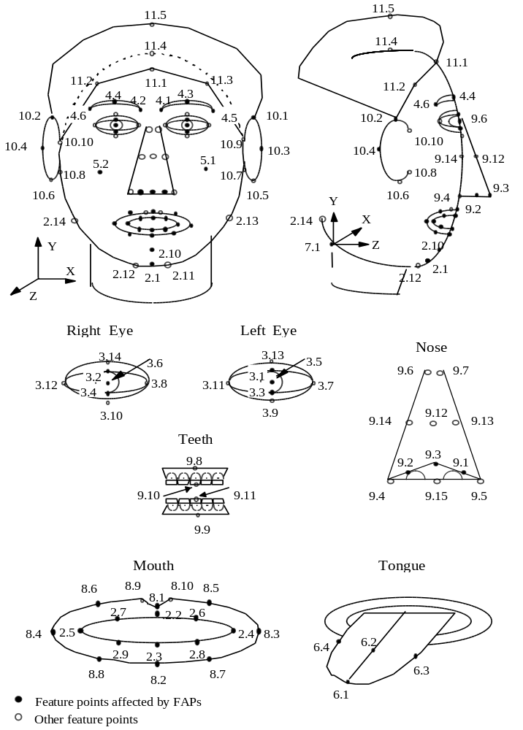
Figure 12-1 FDP feature point set

Table 12-4 FDP fields
FDP field | Description
featurePointsCoord | contains a Coordinate node. Specifies feature points for the calibration of the proprietary face. The coordinates are listed in the ‘point’ field in the Coordinate node in the prescribed order, that a feature point with a lower label is listed before a feature point with at higher label (e.g. Figure 12-1 feature point 3.14 before feature point 4.1).
textureCoord4FeaturePoints | contains a TextureCoordinate node. Specifies the texture coordinates for the feature points.
calibrationMesh | contains an IndexedFaceSet node. Specifies a 3D mesh for the calibration of the proprietary face model. All fields in the IndexedFaceSet node can be used as calibration information.
faceTexture | contains an ImageTexture or PixelTexture node. Specifies texture to be applied on the proprietary face model.
animationDefinitionTables | contains AnimationDefinitionTable nodes. If a face model is downloaded, the behavior of FAPs is defined in this field.
faceSceneGraph | contains a Group node. Grouping node for face model rendered in the compositor. Can also be used to download a face model: in this case the effect of Facial Animation Parameters is defined in the ‘animationDefinitionTables’ field.

Table 12-5 Values for viseme_select
viseme_select | phonemes | example
0 | none | na
1 | p, b, m | put, bed, mill
2 | f, v | far, voice
3 | T,D | think, that
4 | t, d | tip, doll
5 | k, g | call, gas
6 | tS, dZ, S | chair, join, she
7 | s, z | sir, zeal
8 | n, l | lot, not
9 | r | red
10 | A: | car
11 | e | bed
12 | I | tip
13 | Q | top
14 | U | book

Annex D
Video buffering verifier
(This annex forms an integral part of the committee draft of this International Standard)

Coded video bitstreams shall meet constraints imposed through a Video Buffering Verifier (VBV) defined in this clause. Each bitstream in a scalable hierarchy shall not violate the VBV constraints defined in this annex.
The VBV is a hypothetical decoder, which is conceptually connected to the output of an encoder. It has an input buffer known as the VBV buffer.

Annex E
Features supported by the algorithm
(This annex does not form an integral part of the committee draft of this International Standard)

Overview

Object based coding

Scalability

Error resilience

Resynchronization
Resynchronization tools, as the name implies, attempt to enable resynchronization between the decoder and the bitstream after a residual error or errors have been detected. Generally, the data between the synchronization point prior to the error and the first point where synchronization is reestablished, is discarded. If the resynchronization approach is effective at localizing the amount of data discarded by the decoder, then the ability of other types of tools which recover data and/or conceal the effects of errors is greatly enhanced.
The resynchronization approach adopted by MPEG-4, referred to as a packet approach, is similar to the Group of Blocks (GOBs) structure utilized by the ITU-T standards of H.261 and H.263. In these standards a GOB is defined as one or more rows of macroblocks (MB). At the start of a new GOB, information called a GOB header is placed within the bitstream. This header information contains a GOB start code, which is different from a picture start code, and allows the decoder to locate this GOB. Furthermore, the GOB header contains information which allows the decoding process to be restarted (i.e., resynchronize the decoder to the bitstream and reset all coded data that is predicted).
The GOB approach to resynchronization is based on spatial resynchronization. That is, once a particular macroblock location is reached in the encoding process, a resynchronization marker is inserted into the bitstream. A potential problem with this approach is that since the encoding process is variable rate, these resynchronization markers will most likely be unevenly spaced throughout the bitstream. Therefore, certain portions of the scene, such as high motion areas, will be more susceptible to errors, which will also be more difficult to conceal.
The video packet approach adopted by MPEG-4, is based on providing periodic resynchronization markers throughout the bitstream. In other words, the length of the video packets are not based on the number of macroblocks, but instead on the number of bits contained in that packet. If the number of bits contained in the current video packet exceeds a predetermined threshold, then a new video packet is created at the start of the next macroblock.

Resync  Marker | MB  Address | QP | HEC | Macroblock Data | Resync  Marker

Figure 14-1 Error Resilient Video Packet
In Figure 1, a typical video packet is described. A resynchronization marker is used to distinguished the start of a new video packet. This marker is distinguishable from all possible VLC code words as well as the VOP start code. Header information is also provided at the start of a video packet. Contained in this header is the information necessary to restart the decoding process and includes: the macroblock address of the first macroblock contained in this packet and the quantization parameter (QP) necessary to decode that first macroblock. The macroblock number provides the necessary spatial resynchronization while the quantization parameter allows the differential decoding process to be resynchronized. Following the QP is the Header Extension Code (HEC). As the name implies, the HEC is a single to indicate whether additional information will be available in this header. If the HEC is equal to one then the following additoinal information is available in this packet header: modulo time base, temporal reference, VOP prediction type.
When utilizing the error resilience tools within MPEG-4, some of the compression efficiency tools are modified. For example, all predictively encoded information must be confined within a video packet so as to prevent the propagation of errors. In other words, when predicting (i.e., AC/DC prediction and motion vector prediction) a video packet boundary is treated like a VOP boundary.
In conjunction with the video packet approach to resynchronization, a second method called fixed interval synchronization has also been adopted by MPEG-4. This method requires that VOP start codes and resynchronization markers (i.e., the start of a video packet) appear only at legal fixed interval locations in the bitstream. This helps to avoid the problems associated with start codes emulations. That is, when errors are present in a bitstream it is possible for these errors to emulate a VOP start code. In this case, when fixed interval synchronization is utilized the decoder is only required to search for a VOP start code at the beginning of each fixed interval. The fixed interval synchronization method extends this approach to be any predetermined interval.

Data Recovery
After synchronization has been reestablish, data recovery tools attempt to recover data that in general would be lost. These tools are not simply error correcting codes, but instead techniques which encode the data in an error resilient manner. For instance, one particular tool that has been endorsed by the Video Group is Reversible Variable Length Codes (RVLC). In this approach, the variable length code words are designed such that they can be read both in the forward as well as the reverse direction. Examples of such code words are 111, 101, 010. Code words such as 100 would not be used.
An example illustrating the use of a RVLC is given below.
This section describes a decoding methodology for Reversible Variable Length Codes (RVLC) when errors in the video bitstream are detected during the decoding process . This particular decoding methodology was developed during the RVLC core experiment process.

Process for detecting errors for both forward and backward decoding
(1) In the case that illegal RVLC is found, where an illegal RVLC is defined as follows:
- A codeword whose pattern is not listed in RVLC table (e.g. 169 codeword patterns and escape codes).
- When escape coding is used (i.e., a legal codeword is not available in the RVLC table) the decoded value for LEVEL is zero.
- Second escape code is incorrect (e.g. codeword is not “00000” or “00001” for forward decoding, and/or is not “00001” for backward decoding).
- There is a decoded value of FLC part using escape codes (e.g. LAST, RUN, LEVEL) in the RVLC table.
- Incorrect number of stuffing bits for byte alignment (e.g. eight or more 1’s are followed after 0 at the last part of a Video packet (VP), or the remaining bit pattern is not “0111...” after decoding process is finished).
(2) More than 64 DCT coefficients are decoded in a block.

Decoding information
The bitstream is decoded in a forward direction first. If no errors are detected, the bitstream is assumed to be valid and the decoding process is finished for that video packet. If an error is detected however, two-way decoding is applied. The following strategies for determining which bits to discard are used. These strategies are described using the figures given below along with the following definitions:
L : Total number of bits for DCT coefficients part in a VP.
N : Total number of macroblocks (MBs) in a VP.
L1 : Number of bits which can be decoded in a forward decoding.
L2 : Number of bits which can be decoded in a backward decoding.
N1 : Number of MBs which can completely be decoded in a forward decoding.
N2 : Number of MBs which can completely be decoded in a backward decoding.
f_mb(S) : Number of decoded MBs when S bits can be decoded in a forward direction.
(Equal to or more than one bit can be decoded in a MB, f_mb(S) counter is up.)
b_mb(S) : Number of decoded MBs when S bits can be decoded in a backward direction.
T : Threshold (90 is used now).

Strategies for decoding RVLC
(1) Strategy 1 : L1+L2 < L and N1+N2 < N
MBs of f_mb(L1-T) from the beginning and MBs of b_mb(L2-T) from the end are used. In the figure below, the MBs of the dark are discarded.
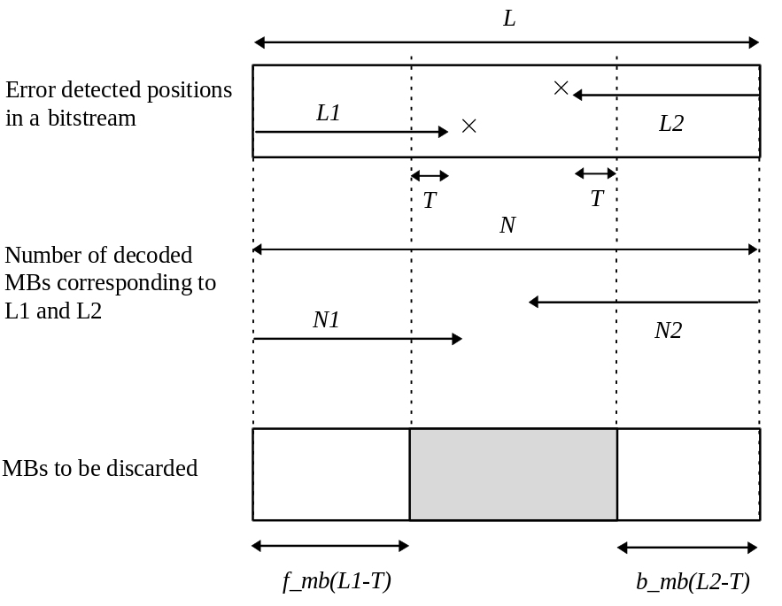

(2) Strategy 2 : L1+L2 < L and N1+N2 >= N
MBs of N-N2-1 from the beginning and MBs of N-N1-1 from the end are used. MBs of the dark part are discarded.
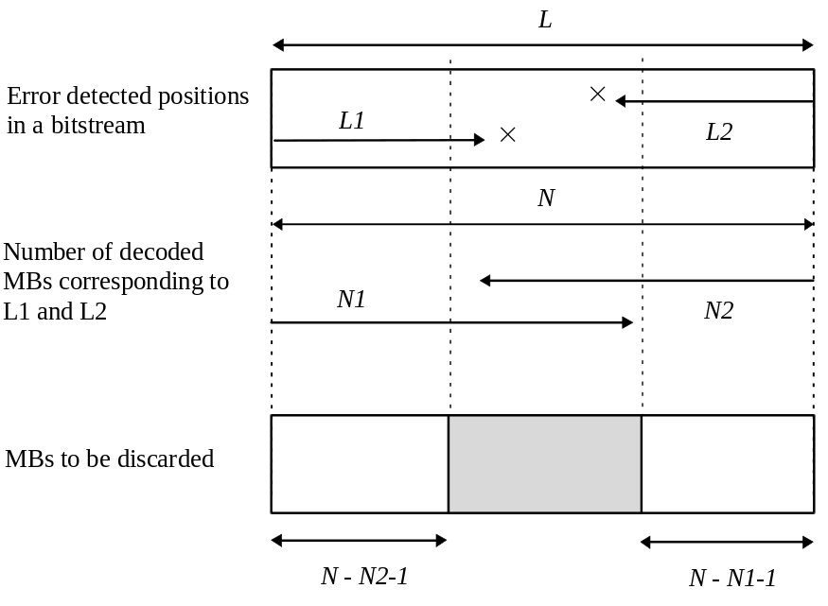

(3) Stratey 3 : L1+L2 >= L and N1+N2 < N
MBs of N-b_mb(L2) from the beginning and MBs of N-f_mb(L1) from the end are used. MBs of the dark part are discarded.
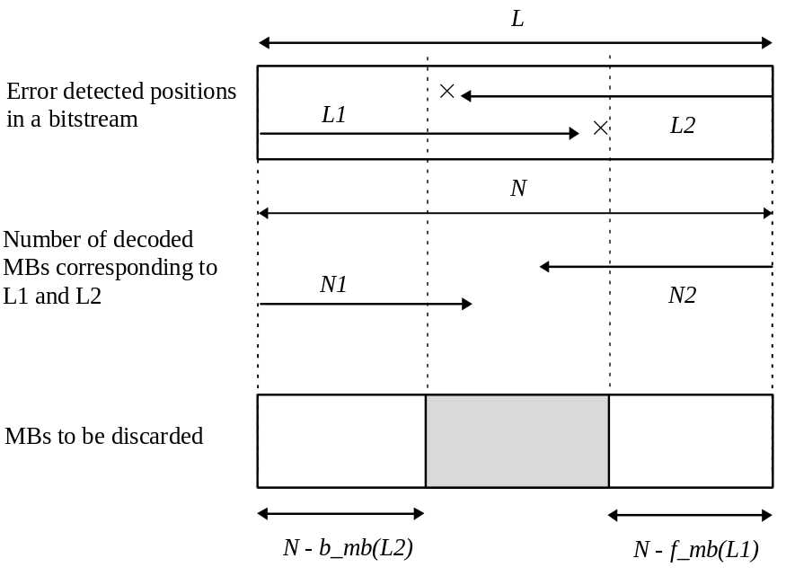
(4) Strategy 4 : L1+L2 >= L and N1+N2 >= N
MBs of min{N-b_mb(L2), N-N2-1} from the beginning and MBs of min{N-f_mb(L1), N-N1-1} from the end are used. MBs of the dark part are discarded.
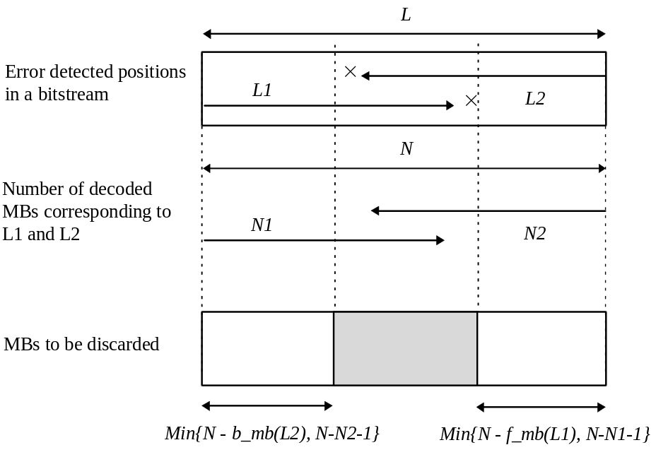

INTRA MBs within a bitstream
In the above strategies (Strategy 1 - Stratey 4), INTRA MBs are discarded even though they could have been decoded. An example of such a case is shown below.
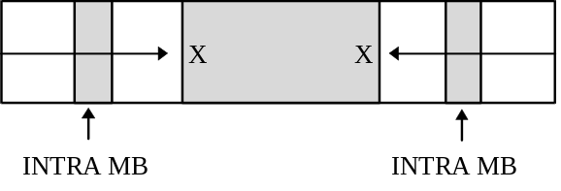
Although these intra MBs are thought to be correct, the result of displaying an Intra MB that does contain an error can substantially degrade the quality of the video. Thereofre, when a video packet is determined to contain errors, all Intra MBs are not displayed, but instead concealled.

Concealment
MBs whose DCT coefficients are discarded are treated as skipped MBs by the decoder (i.e., MC_NOT_CODED in a P_VOP). When the vop_coding_type is “Intra”, discarded MBs can also be treated as NOT_CODED.

Error Concealment
Error concealment is an extremely important component of any error robust video codec. Similar to the error resilience tools discussed above, the effectiveness of a error concealment strategy is highly dependent on the performance of the resynchronization scheme. Basically, if the resynchronization method can effectively localize the error then the error concealment problem becomes much more tractable. For low bitrate, low delay applications the current resynchronization scheme provides very acceptable results with a simple concealment strategy, such as copying blocks from the previous frame.
In recognizing the need to provide enhanced concealment capabilities, the Video Group has developed an additional error resilient mode that further improves the ability of the decoder to localize an error. Specifically, this approach utilizes data partitioning. This data partitioning is achieved by separating the motion and macroblock header information away from the texture information. This approach requires that a second resynchronization marker be inserted between motion and texture information. Data partitioning, like the use of RVLCs is signaled to the decoder in the VOL. Figure 3 illustrates the syntatic structure of the data partitioning mode. If the texture information is lost, this approach utilizes the motion information to conceal these errors. That is, due to the errors the texture information is discarded, while the motion is used to motion compensate the previous decoded VOP.

Resync  Marker | MB  Address | QP | HEC | Motion &Header  Information | Motion Marker | Texture  Information | Resync  Marker

Figure 14-2 Data Partitioning

Decoder Operation
When an error is detected in the bitstream, the decoder should resynchronize at the next suitable resynchronization point. Where a VOP header is missed or received with obvious errors, the next resynchronization point should be the next VOP start code. Otherwise, the next resynchronization point in the bitstream should be used.
Under the following error conditions, the decoder should resynchronize at the next resynchronization point in the bitstream:
- An illegal VLC is received.
- More than 64 DCT coefficients are decoded in a single block.
- Inconsistent resynchronization header information (i.e., QP out of range, MBA(k) < MBA(k-1), etc.)
- Resynchronization marker / Motion marker is corrupted.

Under the following error conditions, the decoder should resynchronize at the next VOP header:
- VOP start code corrupted.
For other resynchronization techniques, conditions for error detection and resynchronization should be as close as possible to those outlined above.
Missing blocks should be replaced with the same block from the previous frame.

Complexity Estimation

The Complexity Estimation Tool enables the estimation of decoding complexity without the need of the actual decoding of the incoming VOPs. The tool is based on the trasmission of the statistic of the actual encoding algorithms, modes and parameters used to encode the incoming VOP. The ‘cost’ in complexity for the execution of each algorithm is measured or eastimated on each decoder platform. The actual statistic of the decoding algorithms is transmitted in the video bitstream and can be converted by means of the mentioned ‘costs’ into the VOP actual decoding cost for the specific decoder.
The tool is flexible since it enables, for each VO, the definition of the set of used statistics. Such definition is done in the VO header. The actual values of the defined statistics is then inserted into each VOP header according to the ‘complexity estimation syntax’.
For the implementation of the Complexity Estimation Tool, the following modifications to the video syntax, indicated by the gray background, are necessary :

Video Object Layer Class

Video Object Layer

Syntax | No. of bits | Mnemonic
VideoObjectLayer() {
video_object_layer_start_code | sc+4=28
video_object_layer_id | 4
video_object_layer_shape | 2
if ( video_object_layer_shape == ‘00’) {
video_object_layer_width | 13
video_object_layer_height | 13
}
…………………………..
…………………………..
…………………………..
…………………………..

if(load_gray_nonintra_quant_mat)
Gray_nonintra_quant_mat[64] | 8*64
}
}
Complexity_estimation_disable | 1
if (!Complexity_estimation_disable){
Parameter_list | 8
Estimation_method | 2
if (Estimation_method ==’00’){
Shape_complexity_estimation_disable | 1
if (Shape_complexity_estimation_disable) {
Shape_Binary | 1
Shape_Gray | 1
}
Texture_complexity_estimation_set_1_disable | 1
if (!Texture_complexity_estimation_set_1_disable) {
Intra
Inter | 1
Inter4v | 1
Not_Coded | 1
}
Texture_complexity_estimation_set_2_disable | 1
if (!Texture_complexity_ estimation_set_2_disable) {
DctCoef | 1
DctLine | 1
VlcSymbols | 1
VlcBits | 1
}
Motion_compensation_complexity_disable | 1
if (!Motion_compensation_complexity_disable) {
APM (Advanced Prediction Mode) | 1
NPM (Normal Prediction Mode) | 1
InterpolateMC+Q | 1
Forw+Back+MC+Q | 1
HalfPel2 | 1
HalfPel4 | 1
}
}
}
Error_resilient_disable | 1
if (!error_resilient_disable) {
data_partitioning | 1
Reversible_VLC | 1
}
Intra_acdc_pred_disable | 1
……………………….
……………………….
………………………..

Parameter definition of Complexity Estimation Syntax

Complexity_estimation_disable: flag for disabling complexity estimation header in each VOP
Parameter_list: number of complexity estimation parameters.
Estimation_method: definition of the estimation method.
Shape_complexity_estimation_disable: flag to disable setting of shape parameters
Shape_Binary: flag enabling transmission of the number of luminance and chrominance blocks coded using binary alpha block shape coding information in % of the total number of blocks (bounding box).
Shape_Gray: flag enabling transmission of the number of luminance and chrominance blocks coded using gray scale shape coding information in % of the total number of blocks (bounding box).
Texture_complexity_estimation_set_1_disable: flag to disable parameter set 1.
Intra: flag enabling transmission of the number of luminance and chrominance Intra or Intra+Q coded blocks in % of the total number of blocks (bounding box).
Inter: flag enabling transmission of the number of luminance and chrominance Inter and Inter+Q coded blocks in % of the total number of blocks (bounding box).
Inter4v: flag enabling transmission of the number of luminance and chrominance Inter4V coded blocks in % of the total number of blocks (bounding box).
Not-Coded: flag enabling transmission of the number of luminance and chrominance Non Coded blocks in % of the total number of blocks (bounding box).
Texture_complexity_estimation_set_2_disable: flag to disable parameter set 2.
DctCoef: flag enabling transmission of the number of DCT coefficients % of the maximum number of coefficients (coded blocks).
DctLine: flag enabling transmission of the number of DCT8x1 in % of the maximum number of DCT8x1 (coded blocks).
VlcSymbols: flag enabling transmission of the average number of VLC symbols for macroblock.
VlcBits: flag enabling transmission of the average number of bits for each symbol.
Motion_compensation_complexity_disable: flag to disable motion compensation parameter set.
APM (Advanced Prediction Mode): flag enabling transmission of the number of luminance block predicted using APM in % of the total number of blocks for VOP (bounding box).
NPM (Normal Prediction Mode): flag enabling transmission of the number of luminance and chrominance blocks predicted using NPM in % of the total number of luminance and chrominance for VOP (bounding box).
InterpolateMC+Q: flag enabling transmission of the number of luminance and chrominance interpolated blocks in % of the total number of blocks for VOP (bounding box).
Forw+Back+MC+Q: flag enabling transmission of the number of luminance and chrominance predicted blocks in % of the total number of blocks for VOP (bounding box).
HalfPel2: flag enabling transmission of the number of luminance and chrominance block predicted by a half-pel vector on one dimension (horizontal or vertical) in % of the total number of blocks (bounding box).
HalfPel4: flag enabling transmission of the number of luminance and chrominance block predicted by a half-pel vector on two dimensions (horizontal and vertical) in % of the total number of blocks (bounding box).

Video Object Plane Class

Video Object Plane

Syntax | No. of bits | Mnemonic
VideoObjectPlane() {
VOP_start_code | Sc+8=32
do {
modulo_time_base | 1
} while ( modulo_time_base != “0”)
VOP_time_increment | 10
VOP_prediction_type | 2
if (video_object_layer_sprite_usage != SPRITE_NOT_USED )
………………….
………………….
………………….
………………….
Interlaced | 1
if (interlaced)
Top_field_first | 1
if (VOP_prediction_type==‘10’)
VOP_dbquant | 2
else {
VOP_quant | Quant_precision
If(video_object_layer_shape == “10”)
VOP_gray_quant | 6
}
if ((video_object_layer_shape_effects == ‘0010’) ||
(video_object_layer_shape_effects == ‘0011’) ||
(video_object_layer_shape_effects == ‘0101’)) {
VOP_constant_alpha | 1
If (VOP_constant_alpha)
VOP_constant_alpha_value | 8
}
if (!Complexity_estimation_disable){
if (estimation_method==’00’){
If (VOP_prediction_type==‘00’){
If(Shape_Gray) DCECS_Shape_Binary | 8
If (Shape_Binary) DCECS_Shape_Gray | 8
If (Intra) DCECS_Intra | 8
If (Not_Coded) DCECS_Not_Coded | 8
If (DctCoef) DCECS_DctCoef | 8
If (DctLine) DCECS_DctLine | 8
If (VlcSymbols) DCECS_VlcSymbols | 8
If (VlcBits) DCECS_VlcBits | 4
}
If (VOP_prediction_type==‘01’){
If(Shape_Gray) DCECS_Shape_Binary | 8
If (Shape_Binary) DCECS_Shape_Gray | 8
If (Intra) DCECS_Intra | 8
If (Not_Coded) DCECS_Not_Coded | 8
If (DctCoef) DCECS_DctCoef | 8
If (DctLine) DCECS_DctLine | 8
If (VlcSymbols) DCECS_VlcSymbols | 8
If (VlcBits) DCECS_VlcBits | 4
If (Inter) DCECS_Inter | 8
If (Inter4v) DCECS_Inter4v | 8
If(APM) DCECS_APM | 8
If(NPM) DCECS_NPM | 8
If(Forw+Back+MC+Q) DCECS_Forw+Back+MC+Q | 8
If(HalfPel2) DCECS_HalfPel2 | 8
If(HalfPel4) DCECS_HalfPel4 | 8
}
If (VOP_prediction_type==‘10’){
If(Shape_Gray) DCECS_Shape_Binary | 8
If (Shape_Binary) DCECS_Shape_Gray | 8
If (Intra) DCECS_Intra | 8
If (Not_Coded) DCECS_Not_Coded | 8
If (DctCoef) DCECS_DctCoef | 8
If (DctLine) DCECS_DctLine | 8
If (VlcSymbols) DCECS_VlcSymbols | 8
If (VlcBits) DCECS_VlcBits | 4
If (Inter) DCECS_Inter | 8
If (Inter4v) DCECS_Inter4v | 8
If(APM) DCECS_APM | 8
If(NPM) DCECS_NPM | 8
If(Forw+Back+MC+Q) DCECS_ Forw+Back+MC+Q | 8
If(HalfPel2) DCECS_ HalfPel2 | 8
If(HalfPel4) DCECS_ HalfPel4 | 8
If(InterpolateMC+Q) DCECS_InterpolateMC+Q | 8
}
If (VOP_prediction_type==‘11’){
If (Intra) DCECS_Intra | 8
If (Not_Coded) DCECS_Not_Coded | 8
If (DctCoef) DCECS_DctCoef | 8
If (DctLine) DCECS_DctLine | 8
If (VlcSymbols) DCECS_VlcSymbols | 8
If (VlcBits) DCECS_VlcBits | 4
If (Inter) DCECS_Inter | 8
If (Inter4v) DCECS_Inter4v | 8
If(APM) DCECS_APM | 8
If(NPM) DCECS_NPM | 8
If(Forw+Back+Q) DCECS_ Forw+Back+Q | 8
If(HalfPel2) DCECS_ HalfPel2 | 8
If(HalfPel4) DCECS_ HalfPel4 | 8
If(InterpolateMC+Q) DCECS_InterpolateMC+Q | 8
}
}
}
if (!scalability) {
if (!separate_motion_shape_texture)

Definition of DCECS Parameter Values
The semantic of all DCECS parameters is defined at the VO syntax level. They represents % values. The actual values of all 8 bit words are normalized to 256 plus the addition of a binary 1 to prevent start code emulation (i.e 0% = ‘00000001’, 99.5% = ‘11111111’ and 100% = ‘11111111’). The binary ‘00000000’ string is a forbidden value. The only parameter expressed in absolute value is the DCEDS_VlcBits parameter expressed in absolute value in a 4 bit word.

Annex F
Preprocessing and Postprocessing
(This annex does not form an integral part of the committee draft of this International Standard)

Segmentation for VOP Generation

Introduction
The video coding scheme defined by this standard offers several content-based functionalities, demanding the description of the scene in terms of so-called video-objects (VOs). The separate coding of the video objects may enrich the user interaction in several multimedia services due to flexible access to the bit-stream and an easy manipulation of the video information. In this framework, the coder may perform a locally defined pre-processing, aimed at the automatic identification of the objects appearing in the sequence. Hence, segmentation is a key issue in efficiently applying the MPEG-4 coding scheme, although not affecting at all the bit-stream syntax and thus not being a normative part of the standard.
Usually, the term segmentation denotes the operation aimed at partitioning an image or a video sequence into regions extracted according to a given criterion. In the case of video sequences, this partition should achieve the temporal coherence of the resulting sequence of object masks representing the video object. In the recent literature, different methods have been proposed for segmentation of video sequences, based on either a spatial homogeneity, a motion coherence criterion [[8]] or on joint processing of spatio-temporal information [[4]][[9]][[11]][[15]]. These algorithms are expected to identify classes of moving objects, according to some luminance homogeneity and motion coherence criterion.
In this annex, a framework aiming at an appropriate combination of temporal and spatial segmentation strategies, developed throughout the standardisation phase of MPEG-4 Version 1, is described. The description is given only for informative purposes as the technique to extract objects from the scene is not standardised. The classification of the pels in a video sequence is performed into two classes, namely moving objects (foreground) and background. This framework will continue to be investigated throughout the standardisation phase of MPEG-4 Version 2, leading to improved segmentation results. Only the general principles are shortly described, however, if more detail is required a number of references containing much more detailed descriptions are given.

Description of a combined temporal and spatial segmentation framework
Throughout the work on automatic segmentation of moving objects, different proposals for temporal and spatial segmentation algorithms have been proposed and investigated. This resulted at the end in a combined temporal and spatial segmentation framework [[6]] which is shown in a high level block diagram in Figure 15-1.

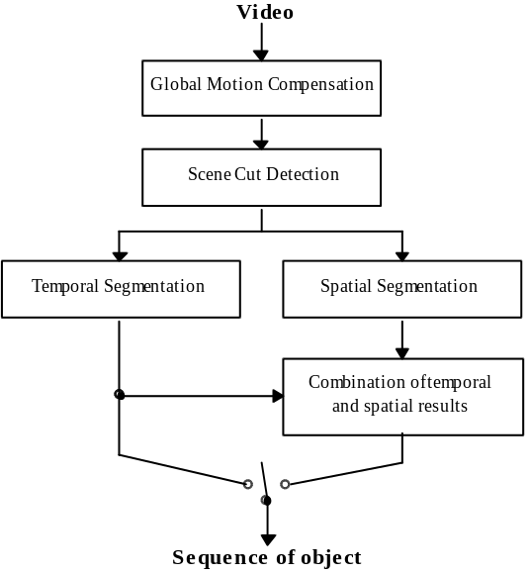
Figure 15-1 Block diagram of combined temporal and spatial segmentation framework
The combined scheme applies in a first step the general blocks of camera motion estimation and compensation [[17]][[18]] and scene cut detection [[13]] which can be seen as a kind of pre-processing in order to eliminate the influence of a moving camera.
In a second step, either temporal or combined spatio-temporal segmentation of each image are carried out, depending on the requirements. The reason for this is, that in general only performing temporal segmentation requires less computational complexity. On the other hand, taking into account also spatial segmentation leads to more accurate segmentation results, but increases the computational complexity of the segmentation.
For temporal segmentation, two possible algorithms are under consideration, both having been verified by extensive cross-checking. It will be one main task for the group which will be working on segmentation for MPEG-4 Version 2, to decide which of these algorithms performs better. For spatial segmentation, only one algorithm is considered, which however has not been cross-checked by the group.
Finally, if temporal and spatial segmentation is performed, both temporal and spatial segmentation results are combined. It will be the second main task of the group to work out an appropriate algorithm for combining the temporal and spatial segmentation results.
The three algorithms for temporal and spatial segmentation will be shortly described in the following. For more details on them as well as on the possible combination approaches [[15]][[10]][[7]], the reader is referred to the given references, where more detailed descriptions can be found.
Temporal segmentation based on change detection: this segmentation algorithm [[16]][[17]][[18]], which is mainly based on a change detection, can be subdivided into two main steps, assuming that a possible camera motion has already been compensated: by the first step, a change detection mask between two successive frames is estimated. In this mask, pels for which the image luminance has changed due to a moving object are labelled as changed. For that, first an initial change detection mask between the two successive frames is generated by global thresholding the frame difference. After that, boundaries of changed image areas are smoothed by a relaxation technique using local adaptive thresholds [[1]][[2]]. Thereby, the algorithm adapts frame-wise automatically to camera noise. In order to finally get temporal stable object regions, an object mask memory with scene adaptive memory length is applied. Finally, the mask is simplified and small regions are eliminated, resulting in the final change detection mask.
In the second step, an object mask is calculated by eliminating the uncovered background areas from the change detection mask as in [[12]]. Therefore, displacement information for pels within the changed regions is used. The displacement is estimated by a hierarchical blockmatcher (HBM) [[3]]. For a higher accuracy of the calculated displacement vector field (DVF), the change detection mask from the first step is considered by the HBM. Pels are set to foreground in the object mask, if foot- and top-point of the corresponding displacement vector are both inside the changed area in the current CDM. If not, these pels are set to background. Results for the described method can be found in [[14]][[16]][[18]].

Temporal segmentation using higher order moments and motion tracking: The algorithm [[8]][[9]][[19]][[20]] produces the segmentation map of each frame f_{k} of the sequence by processing a group of frames {f_{k-i}, i=0,..n}. The number of frames n varies on the basis of the estimated object speed [[8]]. For each frame f_{k}, the algorithm splits in three steps. First, the differences { d_{k-j} (x,y)=f_{k-j}(x,y)Ð f_{k-n}(x,y), j=0,..n-1 } of each frame of the group with respect to the first frame f_{k-n} are evaluated in order to detect the changed areas, due to object motion, uncovered background and noise. In order to reject the luminance variations due to noise, an Higher Order Statistic test is performed. Namely, for each pixel (x,y) the fourth-order moment 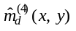of each inter-frame difference d(x,y) is estimated on a 3x3 window, it is compared with a threshold adaptively set on the basis of the estimated background activity [[8]], and set to zero if it is below the threshold. Then, on the sequence of the thresholded fourth-order moment maps 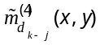, a motion detection procedure is performed. This step aims at distinguish changed areas representing uncovered background (which stands still in the HOS maps) and moving objects (moving in the HOS maps). At the j-th iteration, the pair of thresholded HOS maps 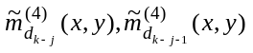 is examined. For each pixel (x,y) the displacement of is evaluated on a 3x3 window, adopting a SAD criterion, and if the displacement is not null the pixel is classified as moving. Then, the lag j is increased (i.e. the pair of maps slides) and the motion analysis is repeated, until j=n-2. Pixels presenting null displacements on all the observed pairs are classified as still. Finally, a regularization algorithm re-assigns still regions, internal to moving regions, to foreground and refines the segmentation results imposing a priori topological constraints on the size of objects irregularities such as holes, isthmi, gulfs and isles by morphological filtering. A post-processing operation refines the results on the basis of spatial edges.
Spatial segmentation based on watershed algorithm: In the spatial segmentation, images are first simplified to make easier the image segmentation [[21]]. Morphological filters are used for the purpose of image simplification. These filters remove regions that are smaller than a given size but preserve the contours of the remaining objects. By the second step, the spatial gradient of the simplified image is approximated by the use of a morphological gradient operator [[21]]. The spatial gradient can be used as an input of watershed algorithm to partition an image into homogeneous intensity regions. For the problem of ambiguous boundaries by spatial gradient, we incorporate color information into gradient computation in which the largest values among the weighed gradients obtained in 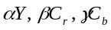are chosen [[5]]. In the boundary decision step, the boundary decision is taken through the use of a watershed algorithm that assigns pixels in the uncertainty area to the most similar region with some segmentation criterion such as difference of intensity values [[22]]. To merge into semantic regions the genetically over-segmented regions from watershedding, a region merging algorithm is then incorporated [[5]]. The final output of the spatial segmentation is the images that are composed of semantically meaningful regions with precise boundaries. Moving objects are therefore represented with semantic regions with precise boundaries and can be segmented in conjunction with temporal information that localizes the moving objects.

References
- T. Aach, A. Kaup, R. Mester, „Statistical model-based change detection in moving video“, Signal Processing, Vol. 31, No. 2, pp. 165-180, March 1993.
- T. Aach, A. Kaup, R. Mester, „Change detection in image sequences using Gibbs random fields: a Bayesian approach“, Proceedings Int. Workshop on Intelligent Signal Processing and Communication Systems, Sendai, Japan, pp. 56-61, October 1993.
- M. Bierling, „Displacement estimation by hierarchical blockmatching“, 3rd SPIE Symposium on Visual Communications and Image Processing, Cambridge, USA, pp. 942-951, November 1988.
- P. Bouthemy, E. François, „Motion segmentation and qualitative dynamic scene analysis from an image sequenceÓ in Int. Journal of Computer Vision vol.10, no.2, pp157-182, 1993.
- J. G. Choi, M. Kim, M. H. Lee, C. Ahn, „Automatic segmentation based on spatio-temporal information“, Doc. ISO/IEC JTC1/SC29/WG11 MPEG97/2091, April 1997.
- J. G. Choi, M. Kim, M. H. Lee, C. Ahn (ETRI); S. Colonnese, U. Mascia, G. Russo, P. Talone (FUB); Roland Mech, Michael Wollborn (UH), „Merging of temporal and spatial segmentation“, Doc. ISO/IEC JTC1/SC29/WG11 MPEG97/2383, July 1997.
- J. G. Choi, M. Kim, M. H. Lee, C. Ahn, „New ETRI results on core experiment N2 on automatic segmentation techniques“, Doc. ISO/IEC JTC1/SC29/WG11 MPEG97/2641, October 1997.
- S. Colonnese, A. Neri, G. Russo, C. Tabacco, „Adaptive Segmentation of Moving Object versus Background for Video CodingÓ, Proceedings of SPIE Annual Symposium, Vol. 3164, San Diego, August 1997.
- S. Colonnese, U. Mascia, G. Russo, P. Talone, „Core Experiment N2: Preliminary FUB results on combination of automatic segmentation techniques“, Doc. ISO/IEC JTC1/SC29/WG11 MPEG97/2365, July 1997.
- S. Colonnese, U. Mascia, G. Russo, „Automatic segmentation techniques: updated FUB results on core experiment N2“, Doc. ISO/IEC JTC1/SC29/WG11 MPEG97/2664, October 1997.
- J. Dugelay, H. Sanson, „Differential methods for the identification of 2D and 3D motion models in image sequences“, Signal Processing, Vol.7, pp. 105-127, Sept. 1995.
- M. Hötter, R. Thoma, „Image Segmentation based on object oriented mapping parameter estimation“, Signal Processing, Vol. 15, No. 3, pp. 315-334, October 1988.
- M. Kim, J. G. Choi, M. H. Lee, C. Ahn; „Performance analysis of an ETRI’s global motion compensation and scene cut detection algorithms for automatic segmentation“, Doc. ISO/IEC JTC1/SC29/WG11 MPEG97/2387, July 1997.
- R. Mech, P. Gerken, „Automatic segmentation of moving objects (Partial results of core experiment N2), Doc. ISO/IEC JTC1/SC29/WG11 MPEG97/1949, April 1997.
- R. Mech, M. Wollborn, „Automatic segmentation of moving objects (Partial results of core experiment N2)“, Doc. ISO/IEC JTC1/SC29/WG11 MPEG97/2703, October 1997.
- R. Mech, M. Wollborn, „A Noise Robust Method for Segmentation of Moving Objects in Video Sequences“, International Conference on Acoustic, Speech and Signal, Munich, Germany, April 1997.
- R. Mech, M. Wollborn, „A Noise Robust Method for 2D Shape Estimation of Moving Objects in Video Sequences Considering a Moving Camera“, Workshop on Image Analysis for Multimedia Interactive Services, Louvain-la-Neuve, Belgium, June 1997.
- R. Mech, M. Wollborn, „A Noise Robust Method for 2D Shape Estimation of Moving Objects in Video Sequences Considering a Moving Camera“, accepted for publication in Signal Processing: Special Issue on Video Sequence Segmentation for Content-based Processing and Manipulation, to be published in the beginning of 1998.
- A. Neri, S. Colonnese, G. Russo, „Video Sequence Segmentation for Object-based Coders using Higher Order Statistics“, ISCAS Ô97, Hongkong, June 1997.
- A. Neri, S. Colonnese, G. Russo, „Automatic Moving Objects and Background Segmentation by means of Higher Order Statistics“, IS&T Electronic Imaging Ô97 Conference: Visual Communication and Image Processing, San JoseÕ, 8-14 February 1997, SPIE Vol. 3024.
- P. Salembier, M. Pardàs, „Hierarchical Morphological Segmentation for Image Sequence CodingÓ, IEEE Transactions on Image Processing, Vol.3, No.5, pp. 639-651, September 1994.
- Luc Vincent, Pierre Soille, „Watersheds in digital spaces: an efficient algorithm based on immersion simulations“, IEEE Transactions on PAMI, Vol.13, No. 6, pp. 583-598, June 1991.

VOP Formation
This section describes the vop formation process. The formation of the vop is based on the segmented shape information. The following explains the process to achieve a vop in such a way that the minimum number of macroblocks containing the object will be attained in order to achieve a higher coding efficiency.
- Generate the tightest rectangle whose top left poition is an even number.
- If the top left position of this rectangle is not the same as the origin of the image, the following steps have to be performed. Otherwise no further processing is necessary.
- Form a control macroblock at the top left corner of the tightest rectangle as shown in Figure 15-2.
- Count the number of macroblocks that completely contain the object for all even numbered point of the control macroblock using the following procedure.
- Generate a bounding rectangle from the control point to the right bottom side of the object which consists of multiples of 16x16 blocks.
- Count the number of macroblocks in this bounding rectangle, which contain at least one object pel. To do so, it would suffice to take into account the boundary pels of a macroblock only.
- Select the control point that results in the smallest number of macroblocks for the given object.
- Extend the top left coordinate of the tightest rectangle generated in Figure 15-2. to the selected control coordinate. This will create a rectangle that completely contains the object but with the minimum number of macroblocks in it. The vop horizontal and vertical spatial references are taken directly from the modified top-left coordinate.

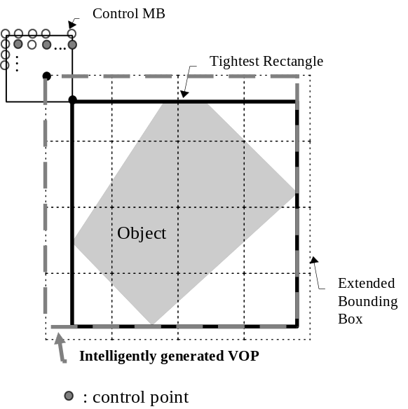
Figure 15-2 Intelligent VOP Formation

Postprocessing for Coding Noise Reduction
The post-filter consists of deblocking filter and deringing filter. Either one or both of them can be turned on as needed.

Deblocking filter
The filter operations are performed along the 8x8 block edges at the decoder as a post-processing operation. Luminance as well as chrominace data is filtered. Figure 15-3 shows the block boundaries.
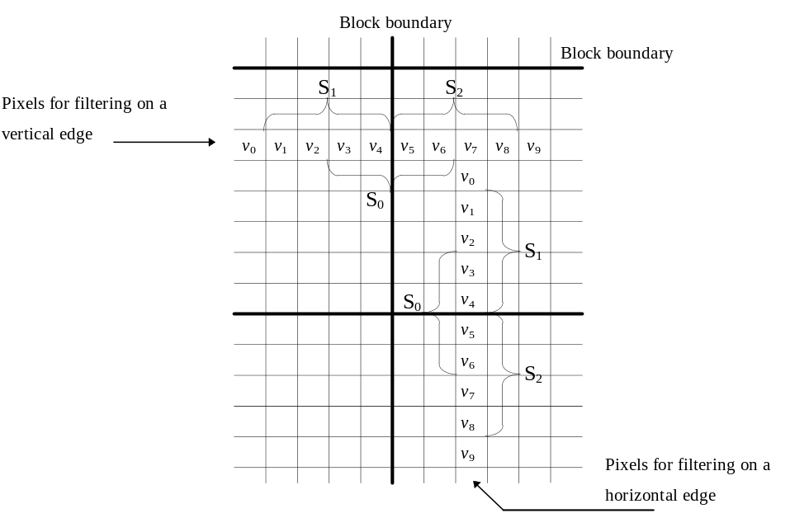

Figure 15-3 Boundary area around block of interest
In the filter operations, two modes are used separately depending on the pixel conditions around a boundary. The following procedure is used to find a very smooth region with blocking artifacts due to small dc offset and to assign it a DC offset mode. In the other case, default mode operations are applied.
eq_cnt = φ(v₀−v₁) + φ(v₁−v₂) + φ(v₂−v₃) + φ(v₃−v₄) + φ(v₄−v₅) + φ(v₅−v₆) + φ(v₆−v₇)
+ φ(v₇−v₈) + φ(v₈−v₉),
where φ(γ ) = 1 if |γ | ≤ THR1 and 0 otherwise.
If (eq_cnt ≥ THR2)
DC offset mode is applied,
else
Default mode is applied.
For the simulation, threshold values of THR1 = 2 and THR2 = 6 are used.
In the default mode, a signal adaptive smoothing scheme is applied by differentiating image details at the block discontinuities using the frequency information of neighbor pixel arrays, S₀, S₁, and S₂,. The filtering scheme in default mode is executed by replacing the boundary pixel values v₄ and v₅ with v₄′ and v₅′ as follows:
v₄′ = v₄−d,
v₅′ = v₅+d,
and d = CLIP(5⋅(a_{3,0}′− a_{3,0})//8, 0, (v₄−v₅)/2) ⋅ δ(|a_{3,0}| < QP)
where a_{3,0}′ = SIGN(a_{3,0}) ⋅ MIN(|a_{3,0}|, |a_{3,1}|, |a_{3,2}|).
Frequency components a_{3,0}, a_{3,1}, and a_{3,2} can be evaluated from the simple inner product of the approximated DCT kernel [2 -5 5 -2] with the pixel vectors, i.e.,
a_{3,0} = ([2 -5 5 -2] • [v₃ v₄ v₅ v₆]^{T} ) // 8,
a_{3,1} = ([2 -5 5 -2] • [v₁ v₂ v₃ v₄]^{T} ) // 8,
a_{3,2} = ([2 -5 5 -2] • [v₅ v₆ v₇ v₈]^{T} ) // 8.
Here CLIP(x,p,q) clips x to a value between p and q; and QP denotes the quantization parameter of the macroblock where pixel v₅ belongs. δ(condition)=1 if the "condition" is true and 0 otherwise..
In very smooth region, the filtering in the default mode is not good enough to reduce the blocking artifact due to dc offset. So we treat this case in the DC offset mode and apply a stronger smoothing filter as follows :
max = MAX (v₁, v₂, v₃, v₄, v₅, v₆, v₇, v₈),
min = MIN (v₁, v₂, v₃, v₄, v₅, v₆, v₇, v₈),
if ( |max−min| < 2⋅QP ) {
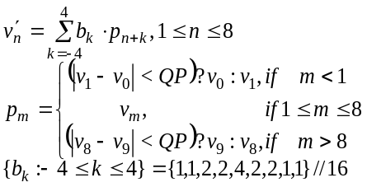
}
else
No change will be done.
The above filter operations are applied for all the block boundaries first along the horizontal edges followed by the vertical edges. If a pixel value is changed by the previous filtering operation, the updated pixel value is used for the next filtering.

Deringing filter
This filter comprises three subprocesses; threshold determination, index acquisition and adaptive smoothing. This filter is applied to the pixels on 8x8 block basis. More specifically 8x8 pixels are processed by referencing 10x10 pixels at each block. The following notation is used to specify the six blocks in a macroblock. For instance, block[5] corresponds to the Cb block whereas block[k] is used as a general representation in the following sections.

Threshold determination
Firstly, calculate maximum and minimum gray value within a block in the decoded image. Secondary, the threshold denoted by thr[k] and the dynamic range of gray scale denoted by range[k] are set:
An additional process is done only for the luminance blocks. Let max_range be the maximum value of the dynamic range among four luminance blocks.
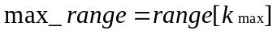
Then apply the rearrangement as follows.
for( k=1 ; k<5 ; k++ ){
if( range[k] < 32 && max_range > =64 )
thr[k] = thr[k_{max}];
if( max_range<16 )
thr[k] = 0;
}

Index acquisition
Once the threshold value is determined, the remaining operations are purely 8x8 block basis. Let rec(h,v) and bin(h,v) be the gray value at coordinates (h,v) where h,v=0,1,2,...,7, and the corresponding binary index, respectively. Then bin(h,v) can be obtained by:
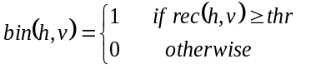
Note that (h,v) is use to address a pixel in a block, while (i,j) is for accessing a pixel in a 3x3 window.

Adaptive smoothing

Adaptive filtering
The figure below is the binary indices in 8x8 block level, whereas practically 10x10 binary indices are calculated to process one 8x8 block.

 | 0 | 0 | 0 | 0 | 0 | 0 | 0 | 0 | 0 | 0
 | 0 | 0 | 0 | 0 | 0 | 0 | 0 | 0 | 0 | 0
 | 1 | 0 | 0 | 0 | 0 | 0 | 0 | 0 | 1 | 1
 | 1 | 1 | 0 | 0 | 0 | 0 | 0 | 1 | 1 | 1
 | 1 | 1 | 1 | 0 | 0 | 0 | 1 | 1 | 1 | 1
 | 1 | 1 | 1 | 1 | 1 | 1 | 1 | 1 | 1 | 1
 | 1 | 1 | 1 | 1 | 1 | 1 | 1 | 1 | 1 | 1
 | 1 | 1 | 1 | 1 | 1 | 1 | 1 | 1 | 1 | 1
 | 1 | 1 | 1 | 1 | 1 | 1 | 1 | 1 | 1 | 0
 | 1 | 1 | 1 | 1 | 1 | 1 | 1 | 1 | 0 | 0

Figure 15-4: Example of adaptive filtering and binary index
The filter is applied only if the binary indices in a 3x3 window are all the same, i.e., all “0” indices or all “1” indices. Note 10x10 binary indices are obtained with a single threshold which corresponds to the 8x8 block shown in the above figure, where the shaded region represents the pixels to be filtered.
The filter coefficients used for both intra and non-intra blocks denoted by coef(i,j), where i,j=-1,0,1, are:

1 | 2 | 1
2 | 4 | 2
1 | 2 | 1
Figure 15-5: Filter mask for adaptive smoothing
Here the coefficient at the center pixel, i.e., coef(0,0), corresponds to the pixel to be filtered. The filter output flt’(i,j) is obtained by:
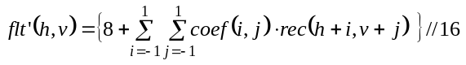

Clipping
The maximum gray level change between the reconstructed pixel and the filtered one is limited according to the quantization parameter, i.e., QP. Let flt(h,v) and flt’(h,v) be the filtered pixel value and the pixel value before limitation, respectively.
if( flt’(h,v) - rec(h,v) > max_diff )
flt(h,v) = rec(h,v) + max_diff
else if( flt’(h,v) - rec(h,v) < -max_diff )
flt(h,v) = rec(h,v) - max_diff
else
flt(h,v) = flt’(h,v)
where max_diff=QP/2 for both intra and inetr macroblocks.

Further issues
In order to reduce the number of computations in post-filtering, two kinds of semaphores can be defined: the blocking semaphores and the ringing semaphore. Depending on the blocking semaphores, the horizontal and the vertical deblocking filtering is applied strongly and weakly on the block boundary. If the ringing semaphore (RS) of a current block is “1”, deringing filtering is applied. For extracting the semaphores in intra-frame, when only a DC component in the 8x8 inverse quantized coefficients (IQC), the DCT coefficients after inverse quantization, has a non-zero value, both the horizontal blocking semaphore (HBS) and the vertical blocking semaphore (VBS) of the block are set to “1”. When only the coefficients in the top row of the IQC have non-zero values, the VBS is set to “1”. When only the coefficients in the far left column of the IQC have non-zero values, the HBS is set to “1”. The RS is set to “1” if any non-zero coefficient exists in positions other than a DC component, the first horizontal AC component, and the first vertical AC comonent. Also the semaphores of the inter-frame are calculated from both the residual signal and the semaphores of the reference frame by using the motion vector.
[1] M2723 Y.L. Lee et al.

Annex G
Profile and level restrictions
(This annex does not form an integral part of the committee draft of this International Standard)
This annex specifies the syntax element restrictions and permissible layer combinations.

Annex H
Visual Bitstream Syntax in MSDL-S
(This annex forms an integral part of the committee draft of this International Standard)
{Note: This annex needs to be updated to be conformant to the bitstream specification of this part of the Comittee Draft.}

Annex I
Patent statements
(This annex does not form an integral part of this International Standard)

Annex J
Bibliography
(This annex does not form an integral part of this International Standard)
- Arun N. Netravali and Barry G. Haskell ÒDigital Pictures, representation and compressionÓ Plenum Press, 1988
- See the Normative Reference for Recommendation ITU-RÊBT.601
- See the Normative Reference for IEC Standard Publication 461
- See the Normative Reference for Recommendation ITU-TÊH.263
- See the Normative reference for IEEE Standard Specification P1180-1990
- ISO/IEC 10918-1 | ITU-T T.81 (JPEG)
- Barry G. Haskell, Atul Puri, Arun N. Netravali, "Digital Video: An Introduction to MPEG-2," Chapman & Hall, ISBN 0-412-08411-2, 1997.
- A. Puri, R. L. Schmidt and B. G. Haskell, "Improvements in DCT Based Video Coding," Proc. SPIE Visual Communications and Image Processing, San Jose, Feb. 1997.
- A. Puri, R. L. Schmidt and B. G. Haskell, "Performance Evaluation of the MPEG-4 Visual Coding Standard," to appear in SPIE Visual Communications and Image Processing, San Jose, Jan 1998.
- F. I. Parke, K. Waters, Computer Facial Animation, A K Peters, Wellesley, MA, USA, 1996

